Keeping Ourselves Safe – Senior primary

Focus area 2 – I’m responsible for others, too

The six focus areas in the Keeping Ourselves Safe (KOS) senior primary programme are:

1. Keeping one step ahead
2. I’m responsible for others, too
3. Finding out about abuse
4. Families working together
5. Reporting abuse
6. What happens now?

Research suggests that an effective programme should include learning experiences from each of the six focus areas.

**Contents**

Focus area 2 – I’m responsible for others, too 3

Notes for the teacher: preparation 3

Explanation 3

Curriculum links 3

Success criteria 3

Learning intentions 4

Resources 4

Activities 4

At the Disco 6

Playground Bully 7

When I Forgot 8

# Focus area 2 – I’m responsible for others, too

## Notes for the teacher: preparation

* Ensure that safety guidelines are in place.
* All school staff, not just the teachers concerned, must know what to do if a student discloses abuse to them during or after Keeping Ourselves Safe.
* Parents should also be made aware of what to do. See the Child Protection Guidelines available on the NZ Police School Portal at <https://www.police.govt.nz/advice-services/personal-community-safety/school-portal/information-and-guidelines/child-protection>

## Explanation

Students will, from time to time, be responsible for the safety of others. They need strategies to enable them to do this with confidence. In this focus area they explore situations involving:

* the care of siblings and a dependent grandparent
* looking out for others online
* peers’ need for support when being bullied.

If bullying is a problem at your school, ask your School Community Officer for information on the Kia Kaha programme.

## Curriculum links

Key competencies: Managing self, Relating to others, Participating and contributing

Learning area:

Level 3 Health and Physical Education – Strand C: Interpersonal skills

* Identify the pressures that can influence interactions with other people and demonstrate basic assertiveness strategies to manage these.

Level 4 Health and Physical Education – Strand C: Interpersonal skills

* Describe and demonstrate a range of assertive communication skills and processes that enable them to interact appropriately with other people.

## Success criteria

Students can:

* act to protect their own rights and those of other people
* use assertive communication skills to interact with others.

## Learning intentions

Students are learning to:

* have a positive influence on others in unsafe situations
* take action when they see others are at risk.

## Resources

Copysheet cartoon strips:

* At the Disco
* Playground Bully

Story: When I Forgot

## Activities

### 1 – Bullying

View one or both of the cartoon strips in turn. Discuss them, using the questions below as a guide.

**At the Disco**

Two friends arrive at the disco. One joins another group and her friend is left out.

Should the first girl go back to her friend or go off with the group?

Ask students to discuss the following questions in small groups:

* What has happened?
* How do you think the girl with the dark hair is feeling?
* What is the dilemma her friend has?
* What do you think the friend should do?
* Have you ever been in a situation like this?
* How did you feel?
* What did you do about it?
* Why do you think young people are sometimes unkind to each other?
* How can friends be supportive?

Invite the students to draw the last frame of the cartoon, to show a positive ending.

**Playground Bully**

Two friends are playing basketball. A group of boys arrive. One takes the ball and pushes one of the friends over.

What could his friend do to help?

Ask students to discuss the following questions in small groups:

* What has happened?
* Why do you think the bigger boys picked on the boy with the ball?
* How do you think he is feeling?
* How is his friend feeling?
* What can the friend do to help?
* Has anything like this ever happened to you?
* How did you cope?
* Have you ever helped a friend who was being bullied?
* How did that feel?

Invite the students to draw the last frame of the cartoon to show a positive ending.

### 2 – Caring for others

Read the story When I Forgot to the class or print off copies for students to read themselves.

Ask students to discuss the following questions in small groups:

* Why does Grandad need so much care?
* How well do you think Katie usually looks out for him?
* What happened on the day she forgot?
* How well do you think she handled the emergency situation?
* What did her family do to make things better?
* Who has an older family member living with them?
* How do you feel about this?
* What can you do to help them keep safe?

# 

# At the Disco

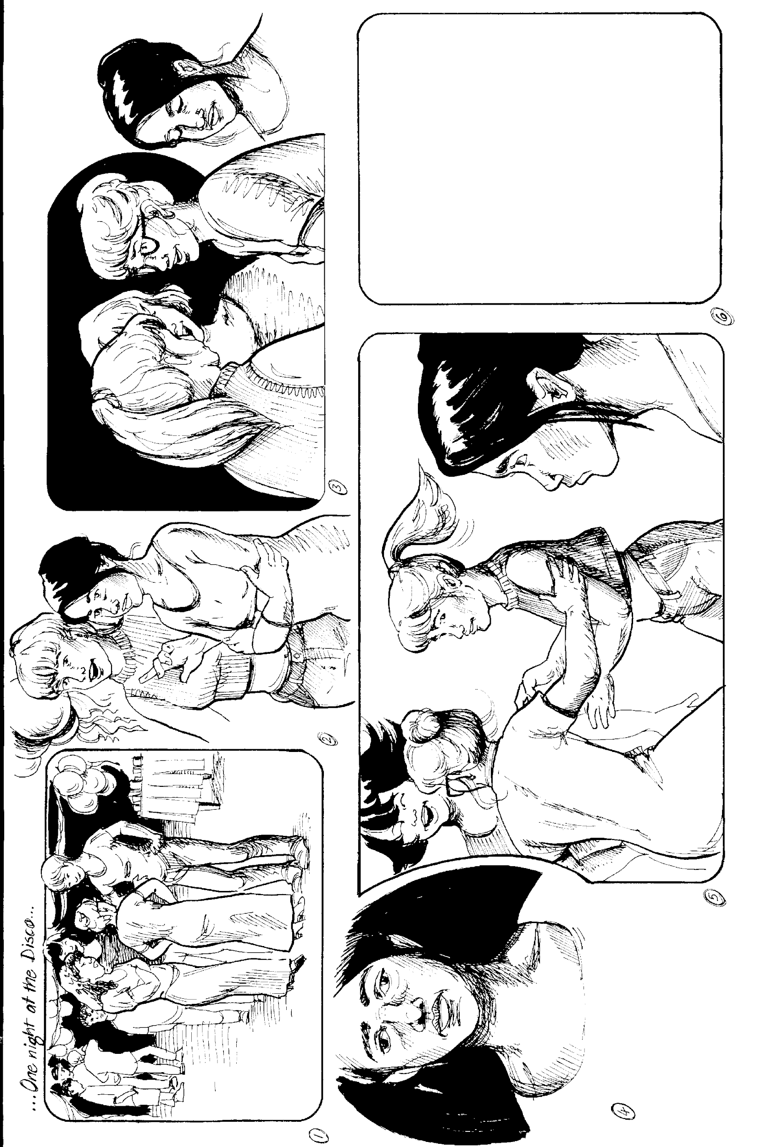

# Playground Bully

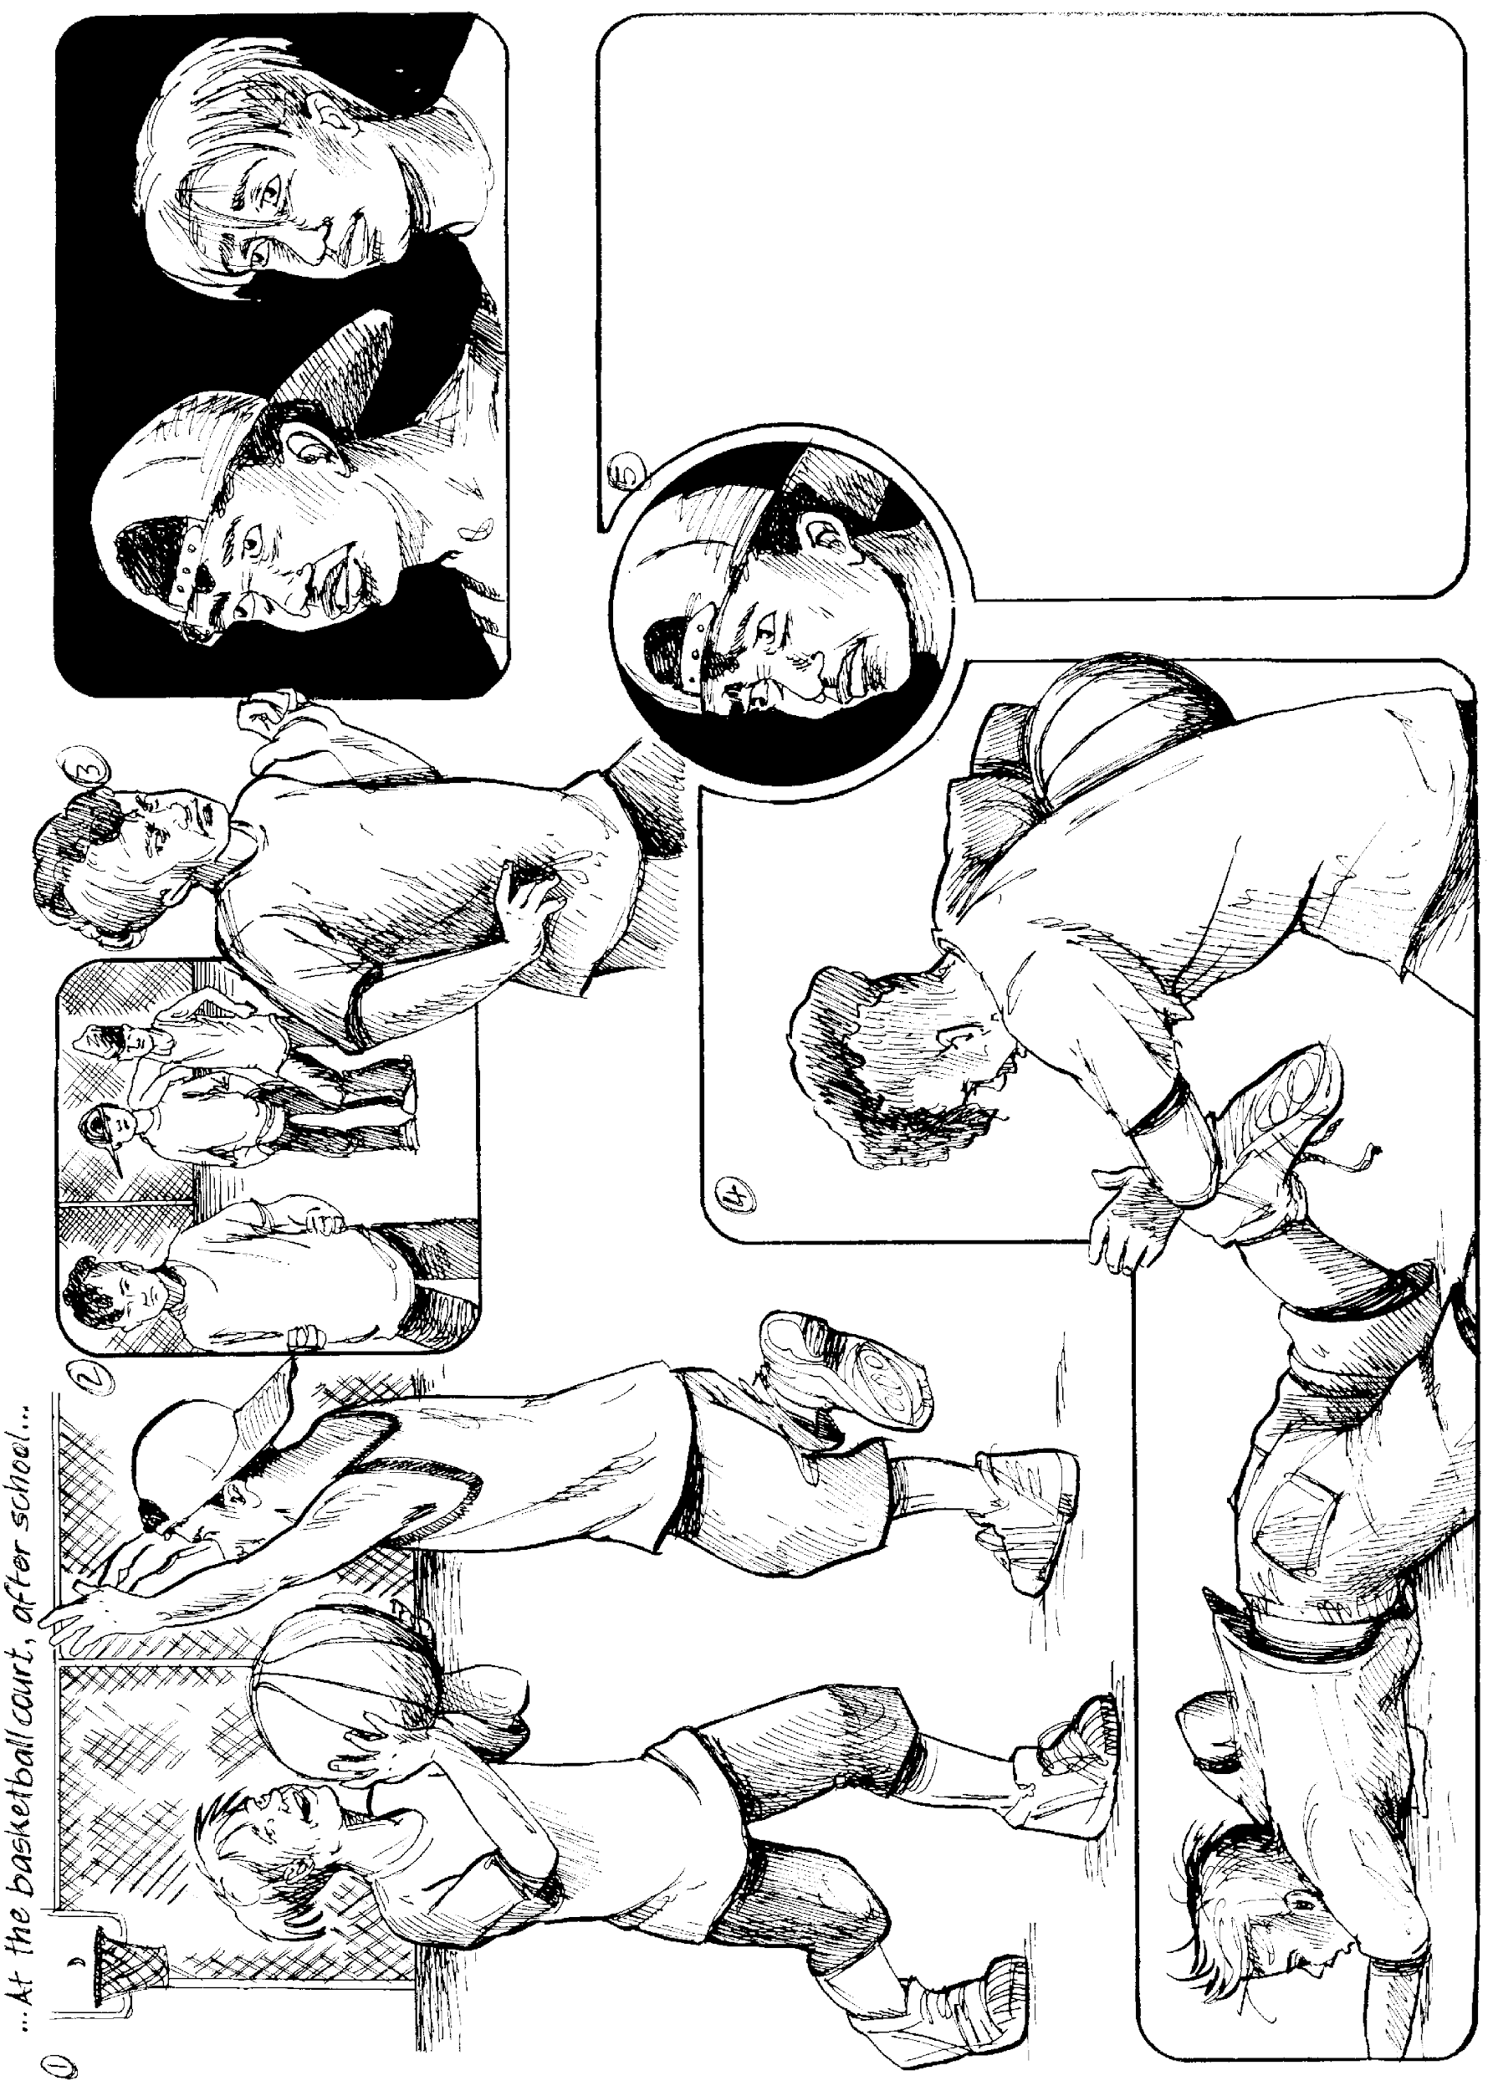

# When I Forgot

*by Janice Marriott (Copyright Janice Marriott 1996)*

I opened the airing cupboard to find a clean tea towel. On top of the towels was the sugar bowl. I returned it to its place on the kitchen bench. No need to tell anyone. It was just Grandad doing his thing.

Mum rushed through the kitchen with piles of baby clothes and old cut up blankets.

“You will keep an eye on him, won’t you? Don’t let him out of your sight.”

“Sure, Mum.”

She was referring to Grandad.

“It’s just that he gets so agitated in someone else’s house now, even Keri’s, and heaven knows he’s been there often enough. And with the baby, and Dad picking things up and putting them down somewhere else, well, I just thought - “

“Yes Mum. Go! We’ll be fine!”

Mum, Dad, and all my brothers and sisters rushed out the door and into the car. Mum knows she’s left Grandad in good hands. I’m great with him. I don’t crowd him like Aunt Megan does. She’s always, “What are you doing, Dad? Come and sit down.” I just let him potter, but I always have one eye following him to check what he’s up to. Otherwise I could find the hot water bottles all in the fridge, and the firewood in my bed.

I led him to his favourite chair, where he could sit and watch the birds in the tree outside. I’d made a hanging bird feeder out of old coat hangers and onion bags from the supermarket so there were lots of birds to look at. I checked he had his slippers on because he often kicks them off and his feet get cold so quickly.

I sat at the dining table in the alcove between the kitchen and sitting room where I could do my homework and keep an eye on Grandad. And that’s how we were, for a while. We both were glad the rest of them had gone, or scarpered, to use one of Grandad’s words.

The phone rang. Melissa! I hadn’t heard from her for ages because she’d been on a school camp. She had to tell me everything that went on in the bunkroom, and especially what had happened when she’d sprayed Karen’s perfume all inside Jarad’s sleeping bag.

“You did do that, didn’t you? You promised.”

We gabbled and giggled away for yonks. I forgot my homework.

“Hey, no one in your huge family’s hearing this, are they?” she asked.

“Nope. They’re all out. And I’m on the cordless. I’ve taken it into my bedroom.”

That’s when I remembered Grandad!

“Gotta go, Melissa.”

I ran into the lounge. One slipper was lying on its side beside the empty chair.

I ran into every room in the house, calling. I had to make sure he wasn’t in cupboards. He could get into some very strange places. It took time. I was panicking by the time I’d scoped the whole house and was sure he wasn’t there.

I ran outside and looked up and down the road. Nothing. No one. It was no use running door to door because I might be going in the wrong direction.

There was only one thing to do. I had to do it. I didn’t want to.

“Hi Keri, can I have Mum please . . . Mum, it’s about Grandad. He’s disappeared.”

Mum is ace. She didn’t say “Why weren’t you looking after him?” She said, “We’ll be over. Go and start asking neighbours on our side of the road going towards the school.”

And I had to, even though I hate walking up the drives of people I don’t know very well.

In the first few houses there was no reply. The third one said they hadn’t seen him. The fourth one didn’t speak English or Māori. I ran out and walked into the fifth place. It was a huge house, old, set back from the road with big leafy trees making it dark and spooky. I walked down the path, feeling scared. I wished I’d told Melissa what I was about to do. But I didn’t want to own up to her that I’d forgotten Grandad. It would have been nice, at that moment, to know she was thinking about me.

I heard a rustle in a bush. I stopped. Then I heard a high voice.

“That ball’s somewhere. Got to be.”

And I knew it was Grandad.

He was covered in scratches. One foot was bare. He was shaking and confused. And worst of all, he wasn’t pleased to see me.

“Leave me be,” he shouted as I tried to pull him towards me.

It was a big shock to me. At that moment, in that strange place, he didn’t recognise me! And he must have seen me every day of my life.

“Be off with you.”

I felt so hurt.

Then I heard the familiar pinking sound of our badly tuned old car. I ran down that path, into the sunshine and waved. Everyone piled out of the car. Together we coaxed Grandad out of the bush.

When I saw how frightened he was, and that he was limping, I didn’t feel so hurt for myself. I knew he wasn’t well and needed all our care.

We took him home and Mum ran him a bath. After that I sat with him, watching the birds, while Dad made dinner. In the evening Keri came round with the baby. She laid him in Grandad’s arms for a photo. All the family stuff made me feel a bit better.

Mum never told me off. When I was kissing everyone goodnight she just said, “Sleep tight, Katie love. You’re not Superman. Just remember no one’s perfect. You do your best, that’s all.”