Keeping Ourselves Safe – Senior primary

Focus area 1 – Keeping one step ahead

The six focus areas in the Keeping Ourselves Safe (KOS) senior primary programme are:

1. Keeping one step ahead
2. I’m responsible for others, too
3. Finding out about abuse
4. Families working together
5. Reporting abuse
6. What happens now?

Research suggests that an effective programme should include learning experiences from each of the six focus areas.

## 

## 

**Contents**

Focus area 1 – Keeping one step ahead 3

Notes for the teacher: preparation 3

Explanation 3

Curriculum links 3

Success criteria 3

Learning intentions 4

Resources 4

Activities 4

The Unwelcome Visitor 9

The Bullies 10

At a Party 11

Copysheet: Choosing safe options 12

Appendix: Role-play for developing social skills 13

# Focus area 1 – Keeping one step ahead

## Notes for the teacher: preparation

* Ensure that safety guidelines are in place.
* All school staff, not just the teachers concerned, must know what to do if a student discloses abuse to them during or after Keeping Ourselves Safe.
* Parents should also be made aware of what to do. See the Child Protection Guidelines available on the NZ Police School Portal at <https://www.police.govt.nz/advice-services/personal-community-safety/school-portal/information-and-guidelines/child-protection>

## Explanation

At this age, students are becoming more independent. They need to learn to take care of themselves as their range of social contacts and responsibilities widens. They need to know:

* what the dangers are
* who could get hurt
* what they can do to keep themselves safe.

In this focus area, students practise choosing safe options.

## Curriculum links

Key competencies: Managing self, Relating to others, Participating and contributing

Learning area:

Level 3 Health and Physical Education, Strand A: Safety Management

* Identify risks and their causes and describe safe practices to manage these.
* Access and use information to make and action safe choices in a range of contexts.

Level 4 Health and Physical Education, Strand A: Safety Management

* Access and use information to make and action safe choices in a range of contexts.

## Success criteria

Students can:

* recognise potential risks and their causes
* choose safe options that will help them to help manage risks
* Access and use information to make safe choices.

## Learning intentions

Students are learning to:

* evaluate how safe a situation is
* identify and act on the safest option.

## Resources

A “post box”. Could be lockable. Teacher supplies.

Stories:

* The Unwelcome Visitor
* The Bullies
* At a Party

Copysheet: Choosing safe options

Appendix: Role-play for developing social skills

## Activities

### 1 – Introduction

Remind students that when they were younger they may have done the Keeping Ourselves Safe programme.

* Ask them to recall some of the things that they learnt during the programme.
* Record these on a chart and discuss each item.

Explain that now they are older and becoming more independent they will be meeting more people and will need to develop more skills to handle this.

Introduce a **post box** to the class.

* Explain that during the lessons they can write any questions they want answered on a piece of paper and ‘post’ them in the box. These questions can be anonymous.
* They could also ‘post’ suggestions about ways to keep kids safe at school.
* From time to time the teacher and the School Community Officer will open the box and answer the questions and discuss the suggestions.
* Work out some guidelines for the class about the use of the post box.

Invite students to write down on a piece of paper a time when they, or someone they know, felt unsafe. No names are required.

* Students ‘post’ these in the post box.
* The teacher collates these to get similar ideas and writes them on a chart as ‘What if” situations that will be used for the role-play later in this session.
* The chart should be displayed on the wall.

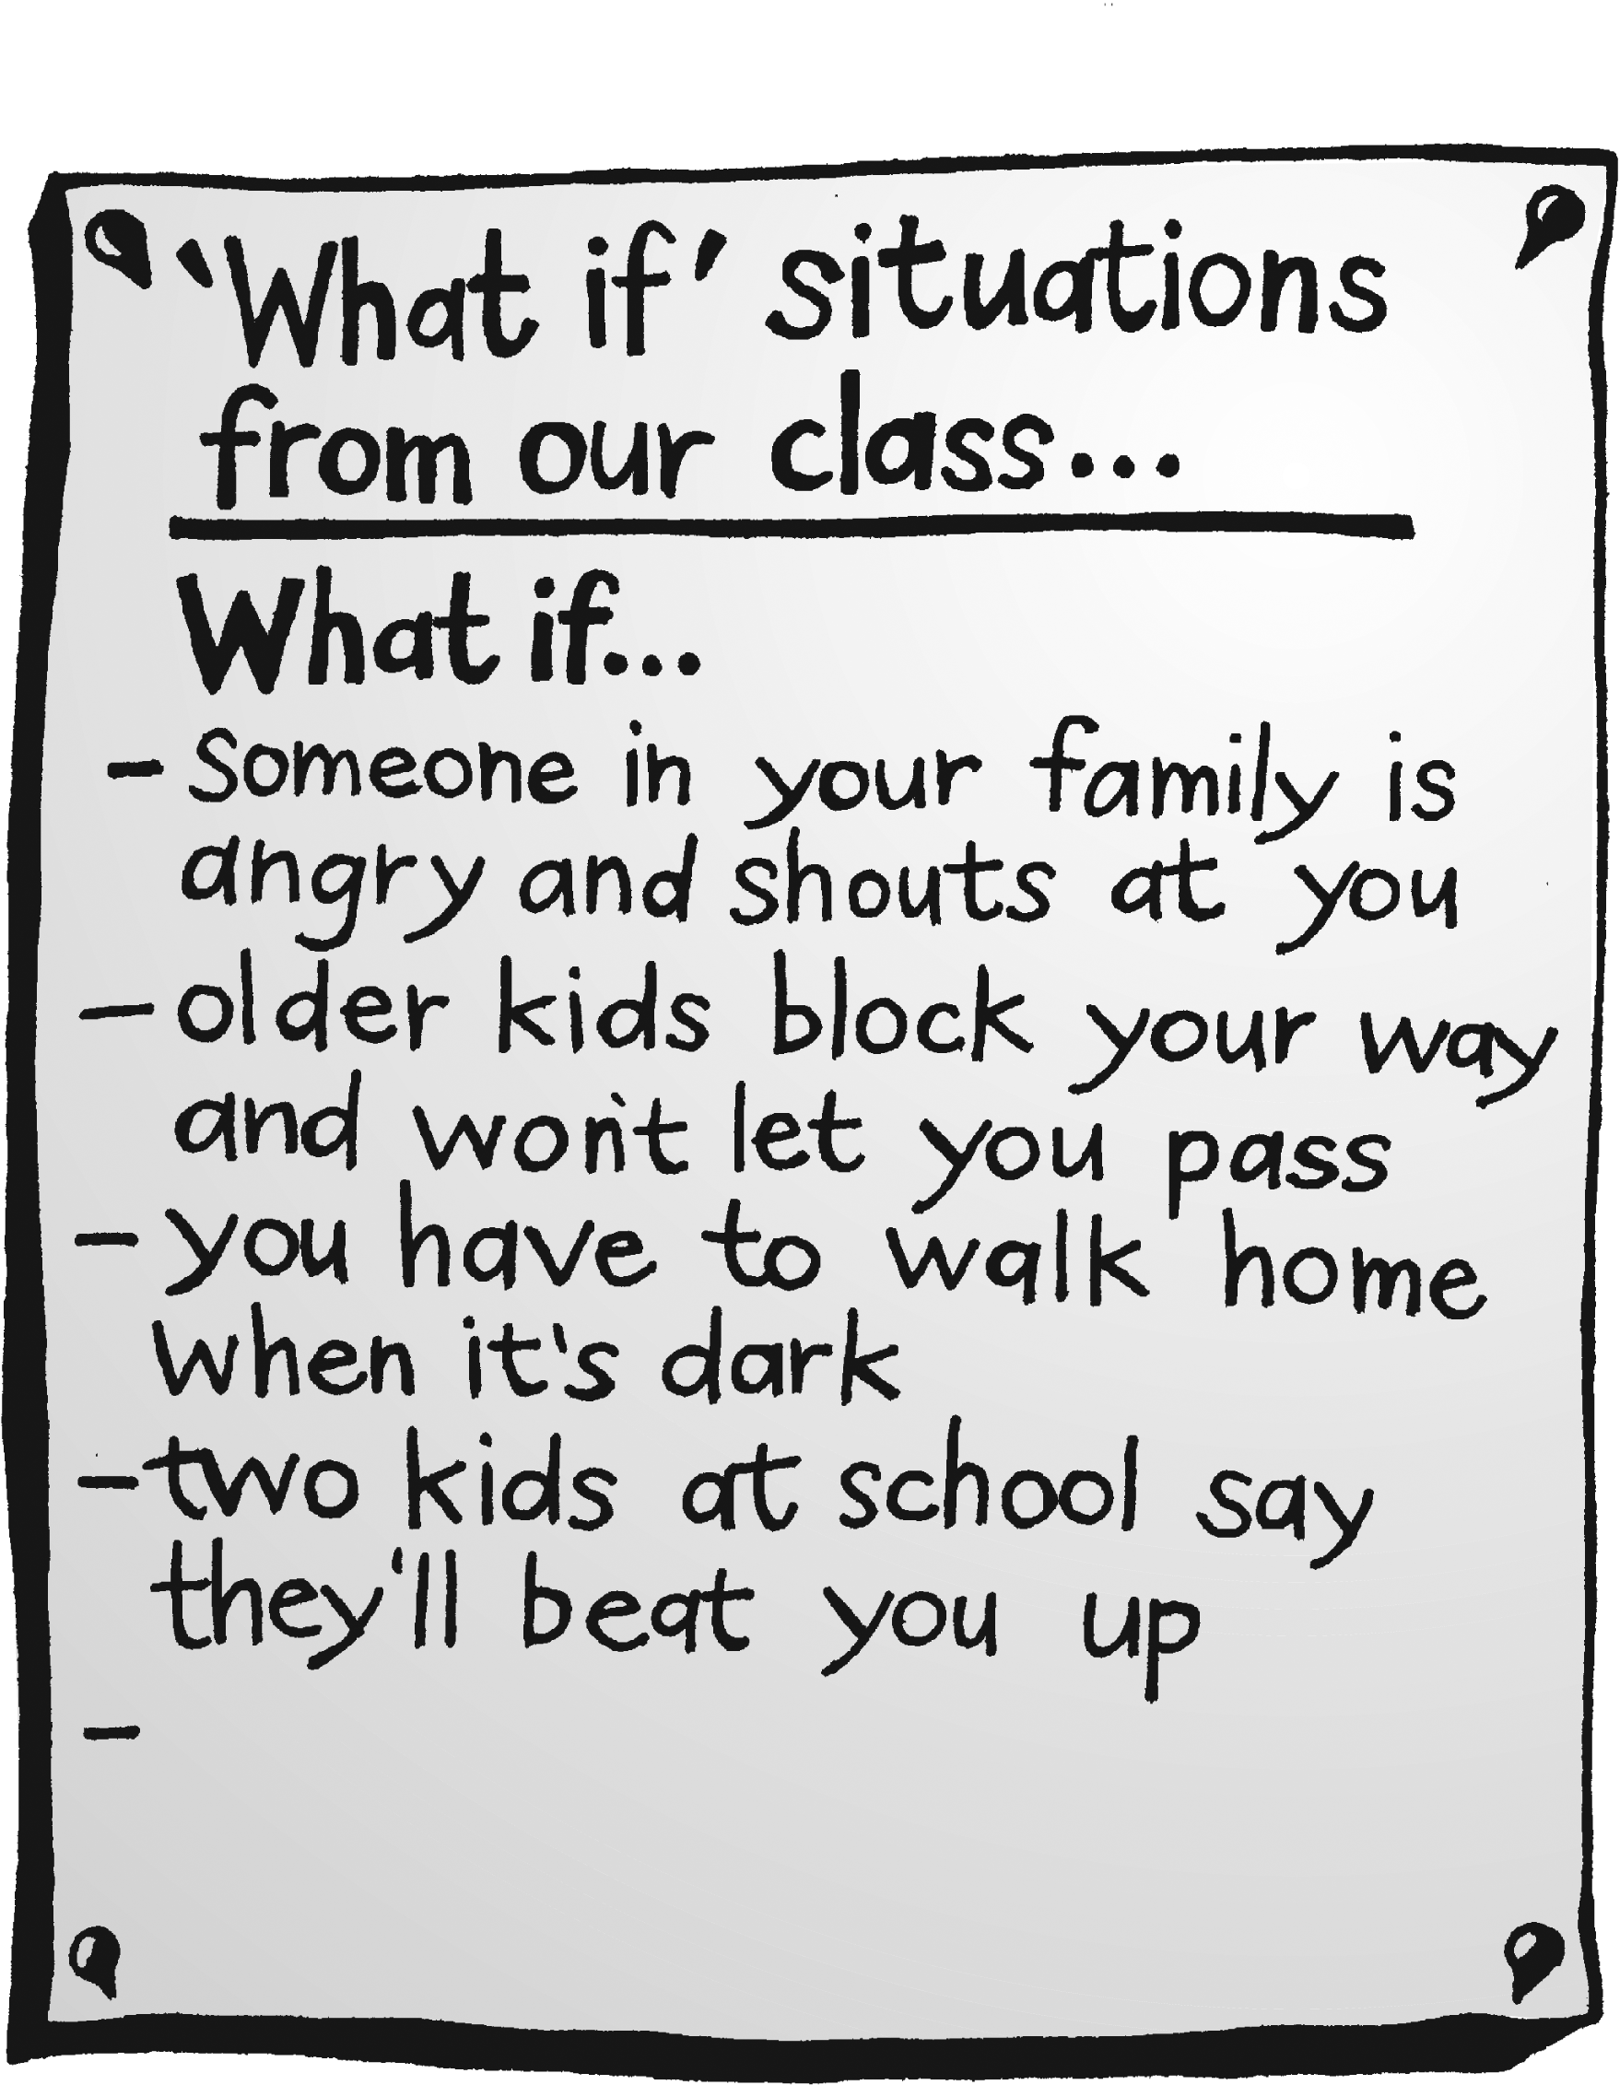

### 2 – Choosing safe options

Choose one or more of the following stories, using a reading approach that suits your class.

**The Unwelcome Visitor**

Read the story with the class or print off copies for students to read themselves.

Ask:

* What is the potential danger?
* What could the young person do?

Put students into groups. Give each group Copysheet: **Choosing safe options**.

* Each group works through the sheet to find what they think is the best and safest option for the main character (see the example in the diagram below).

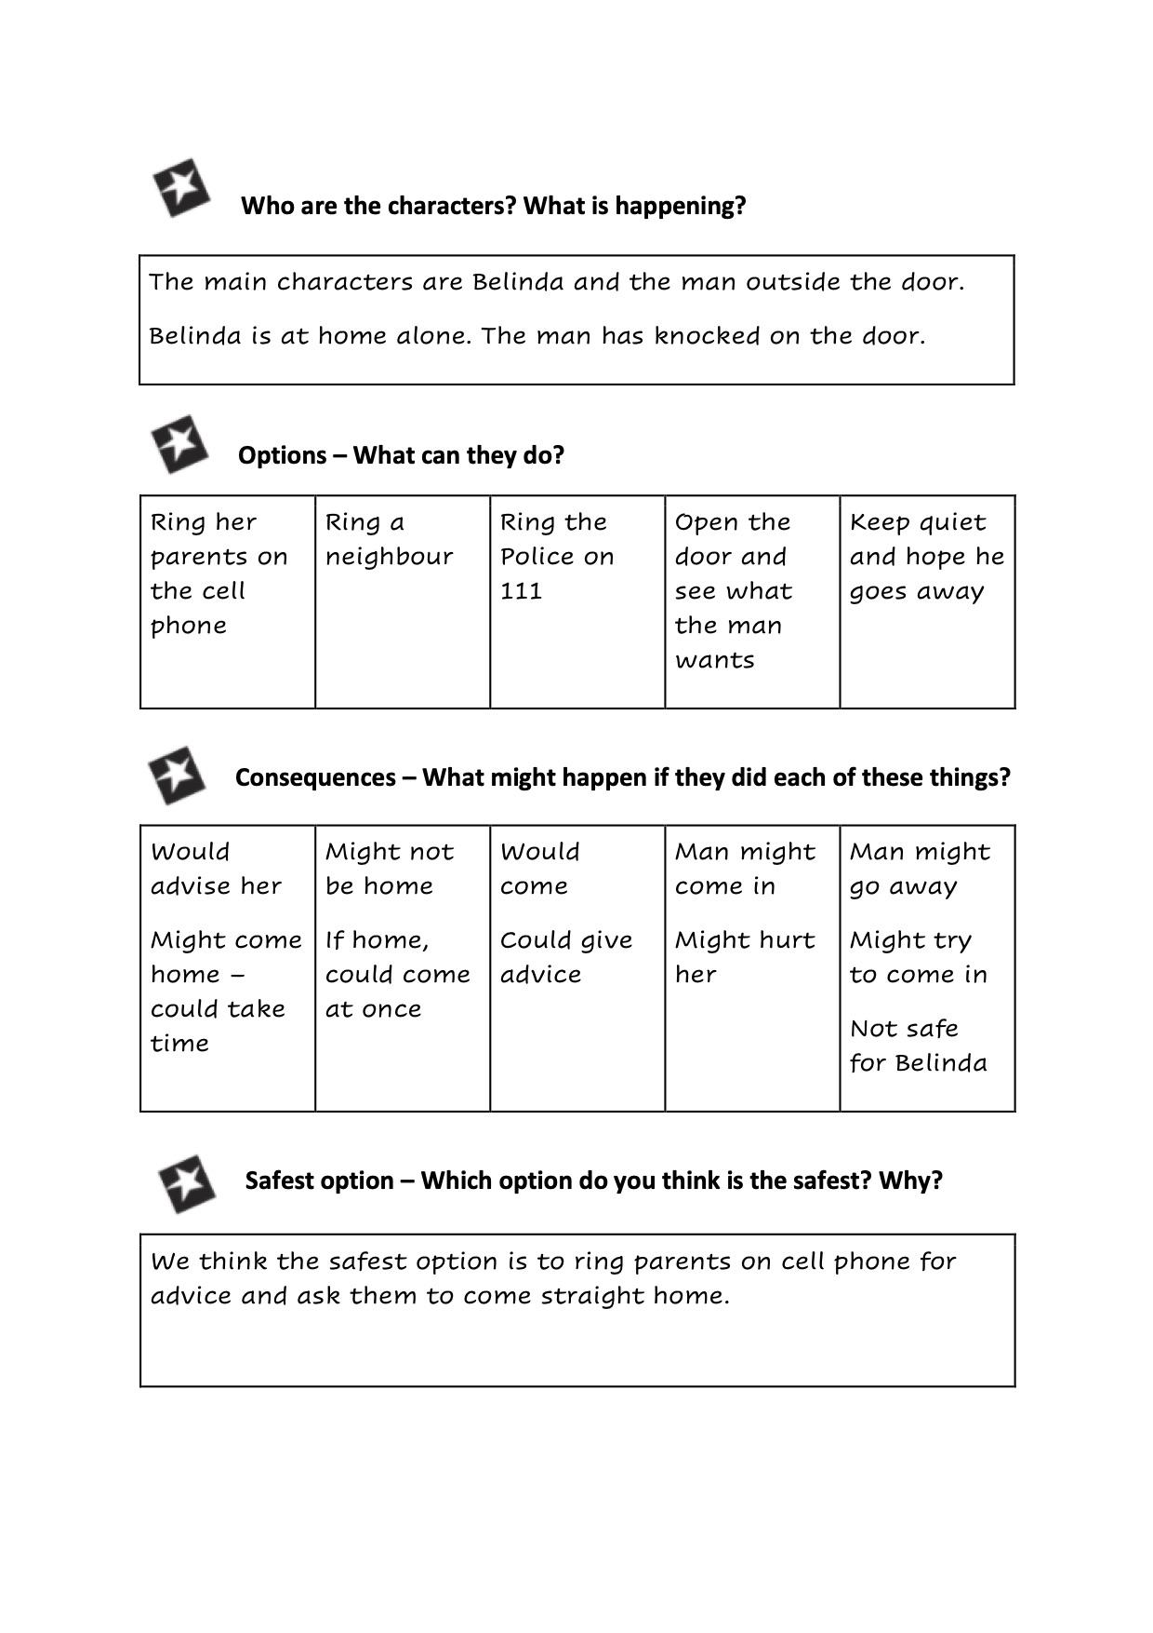

Ask each group in turn what their safest option is. Discuss these. Discuss the consequences of each option.

* If any unrealistic or violent options are given, work through these using questions to help the class accept that there might be better, safer options.

Ask: Which do you think is the safest choice? Why?

**The Bullies**

Read the story with the class or print off copies for students to read themselves.

Ask:

* How did the main character feel at the beginning of the story?
* How did this feeling change?
* What is the danger?
* What could the main character do to solve it?

Put students into groups. Give each group **Copysheet: Choosing safe options**.

* Each group works through the sheet to find what they think is the best and safest option for the main character.
* Ask each group in turn what their best option is. Discuss these.

Suggestions from the class could include:

* shout for help from people passing
* leave the bike and run for it
* give Dean the money
* fight the boys.

Discuss the consequences of each option.

* If any unrealistic or violent options are given, work through these using questions to help the class accept that there might be better, safer options.

Ask: Which do you think is the safest choice? Why?

#### At a Party

Read the story with the class or print off copies for students to read themselves.

Ask:

* How did Huia feel when her mother dropped her off?
* What issues or problems did Huia have to think about?
* What are the potential dangers?
* What could she do?

Put students into groups. Give each group Copysheet: **Choosing safe options**.

* Each group works through the sheet to find what they think is the best and safest option for the main character.
* Ask each group in turn what their best option is. Discuss these.

Suggestions from the class could include:

* join in with the others
* make an excuse for not drinking
* ring her mother and go home
* tell the others that she thinks drinking is stupid.

Discuss the consequences of each option.

* If any unrealistic or violent options are given, work through these using questions to help the class accept that there might be better, safer options.

Ask: Which do you think is the safest choice? Why?

### 3 – Role-playing safety strategies

Do some role-play warm-ups with the class. See **Appendix: role-play for developing social skills**.

Divide the class into small groups.

* Display the ‘What if’ situations from Activity 1 and ask each group to choose one situation to role-play.
* Some groups may choose to use the scenario from one of the stories in Activity 2.
* Explain that the object of the role-play is to find a strategy to keep safe in that situation.

The group follows these steps:

1. Work out a scene for the situation.
2. Allocate roles.
3. Decide on a safety strategy to try.
4. Role-play the scene.

View each role-play in turn with the class. After each ask:

* How effective was this safety strategy?
* Could you use this strategy in real life? Why or why not?
* How would you feel if you managed to keep yourself safe in this situation?

Other strategies could be tried if desired.

# The Unwelcome Visitor

by Beverley Dunlop

One wet Saturday night, my family left me at home on my own. Mum was worried.

“Perhaps we shouldn’t go to the hospital to visit Auntie,” she fretted. “We’ve never left you on your own before.”

Dad smiled at me and ruffled my hair. “You’re a big kid now,” he said.

“We’ll be home by eight-thirty and you can get us on the cellphone if you need to.”

I smiled back. I felt important and grown-up. There was nothing to be scared of in our warm friendly house.

When they had gone I went into the sitting room and turned on the heater. It was lovely having the room all to myself.

I sat down to watch a horror film. The film was creepy. A young kid ran down a dark, windy street. A man was chasing him. I shuddered and huddled down in my chair. I began to feel scared. I could hear the wind blowing around the house and the rain splattering against the windows. I got up and checked to see that the doors were locked and the windows shut.

I heard a car door bang outside. I wondered who it could be. I went to the window and parted the curtains. A taxi was just moving off down the street. A big, rough-looking man was standing under the streetlight at our gate. The man staggered – was he sick, or drunk? He pushed open our gate. My heart started to pound. I remembered that an old lady had been badly beaten in a house in the next street. I quickly closed the curtains.

I turned off the lights and went into the hallway. I thought it would be safer there, because there were no windows. I crouched down in the dark, listening. The house seemed alive with a million frightening sounds.

Suddenly, I heard footsteps coming up the path outside. There was a thundering knock on the door. I pushed my hand into my mouth to stifle a shriek. Should I answer the door?

# The Bullies

by Beverley Dunlop

I felt pretty important biking to the shops on my own. Mum had left me some money to choose some treats for our family movie night.

I patted my back pocket to make sure the money was still there. Usually Sam went to get the treats. I felt ten metres high!

I got off my bike and began walking down the street. Then I stopped. Two big boys, Elliot and Dean, were walking towards me. I began to feel scared. They were both older than me. They came by bus to town every day from the country and they were the meanest, toughest kids at our school.

Elliot stepped in front of me. He folded his arms and winked at his brother Dean.

“Hey,” he said to me, “what’s a little kid like you doing here alone?”

I gulped. I was getting really scared. “I’m on a message for Mum,” I said in a shaky voice. “I have to get some treats for our movie night.”

Elliot and Dean fell about, laughing. “On a message for Mummy,” mimicked Dean. “Oh dear me.”

Elliot giggled. “Has to get some treats,” he repeated. “That’s great!”

I tried to rush past the boys, but Dean grabbed me and twisted my arm behind my back. He thrust his red face close to mine. Elliott grabbed my bike and gave it a kick. The back wheel buckled.

“Today is my birthday and I want to go to the movies,” Dean grinned nastily. “But I haven’t any money. How about giving your old friend Dean some money for a birthday present?”

I fought for my life and my bike. Then Elliot dropped the bike and grabbed me too. “I won’t give you Mum’s money,” I shouted. “Leave me alone.”

Dean twisted my arm harder, and I screamed with pain. What could I do? Dean and Elliot might beat me up if I didn’t give them the money. I looked around frantically.

# At a Party

by Beverley Dunlop

I was a bit late for Sophia’s party. Mum dropped me off. I was almost out of the car before it stopped moving. Although I had been looking forward to Sophia’s party, and was scared I’d missed all the fun, I was still feeling guilty about deceiving Mum. She thought it was Sophia’s birthday and that her parents would be there.

“I’ll be back at eleven o’clock to pick you up, Huia,” Mum called after me as I ran up the Anderson’s winding drive. “And remember to thank Sophia and her parents for asking you to her party.”

“I’ll remember, Mum,” I called back. I hurried up the drive. Sophia had told me that her parents were away for the night. Her big sister, Ella, was minding her. But she’d be out with her boyfriend.

“My parents trust me,” Sophia had said, giving me a smug look. “They say thirteen is quite grown-up.”

“You’re lucky,” I’d said enviously. “My parents would never leave me alone at home.”

The door of the Anderson house was open. I slipped inside. Rosa and Maryam were there and I could hear the others laughing in the kitchen. Music was blaring. Sophia was standing by the table, a glass in her hand.

“Here’s Huia, everyone,” she called to the others. “Come and have a drink, Huia. We’re trying out some of my parent’s booze.”

I called “Hello” to the rest of the kids and walked over to join Sophia. Sophia’s face was red and she seemed wobbly on her feet.

“Get Huia a drink, Rosa,” Sophia called.

Rosa slopped something from a bottle into a glass and handed it to me.

“Drink up, Huia.” She grinned. “This is great fun.”

I tasted the drink. My mouth burned like fire. I spluttered and spat it out.

Sophia shrieked with laughter. “The first drink’s always the worst,” she cried. “Hold your nose and drink it down, quick. Then you can have another.” Sophia waved her arms as if conducting an orchestra. “To the count of three,” she chanted. “One, two, three, down the hatch,”

Feeling miserable, I looked at the other kids. They were all waiting . . .

# Copysheet: Choosing safe options

**Who are the characters? What is happening?**

|  |
| --- |
|  |



**Options – What can they do?**

|  |  |  |  |
| --- | --- | --- | --- |
|  |  |  |  |



**Consequences – What might happen if they did each of these things?**

|  |  |  |  |
| --- | --- | --- | --- |
|  |  |  |  |



**Safest option – Which option do you think is the safest? Why?**

|  |
| --- |
|  |

# 

# Appendix: Role-play for developing social skills

by Gillian Tasker

## Why use role-play?

Role-play is a highly successful strategy for helping young people to develop social skills. Used effectively, it is safe, controlled, gives confidence and builds self esteem, encourages the exploration of options, allows individuals to be different, increases awareness of the feelings of others and – most importantly – provides opportunities for practice.

## Establishing the classroom climate

Since it is essential that role-play is carried out in an atmosphere of support and trust, time will need to be spent establishing a classroom climate in which children feel valued, safe, and relaxed.

Time needs to be spent negotiating with the students ground rules for their behaviour in role-play sessions. Points worth considering include:

* one person speaks at a time
* speak for yourself
* no “put-downs”
* everyone’s ideas are of value
* confidentiality.

A comfortable physical environment also contributes to good interpersonal relations. In setting up the role-play room, consider:

* using a carpeted room if one is available
* arranging the seating in a circle for initial discussion
* ensuring there is adequate ventilation
* having things set up before the students arrive.

## Suggestions for directors

Identify themes/issues clearly and specifically; define the limits of the role-play.

Be flexible.

Use “open-ended” questions; don’t set up particular responses.

Be aware of, and draw attention to, different value systems.

Care for and respect the participants.

Facilitate rather than control; do not assume participants’ roles.

Be prepared to intervene when:

* discussion would be beneficial
* the action becomes stuck
* the energy level of the participants is low
* violence seems likely
* the participants show signs of becoming upset
* the role-play has reached its end.

Anticipate the possibility of sabotage. If there is an element of risk in the activity to be done, discuss possible problems with the class at the start, for example in a role-play where strong feelings could lead to violent actions.

Be conscious of time. Remember that all sessions need to end with a debriefing and summarising time to help integrate the students’ learning from a session.

Sometimes it may be necessary to use an “ice-breaker” at the end of a session if a mood change seems desirable before class departs.

## Getting into a role

A useful strategy is to place an empty chair in the middle of the group to represent a character.

Encourage the group to build up the character by asking questions such as:

* Is this person male or female?
* How old are they?
* What kind of school do they go to?
* How successful are they at their school work?
* What are their hobbies
* What kind of clothes do they wear?
* What is their family situation?
* What is their image of themselves?
* How do their classmates generally view this person?

When the character has been well defined and has begun to seem real, invite a class member to step into the role.

Repeat this process for the other characters in the role-play situation.

## 

## Enactment

There are a number of ways in which this stage can be conducted. Here are some suggestions.

**Whole class working together**

1. When characters are developed using an empty chair, and class members take on the roles, the director may direct an enactment for the whole class. (Note: this should only be done if the role-players are really warmed up to their roles, and are willing to participate in this way.)
2. The director may assume one of the roles and ask for perhaps three volunteers to represent the other role (this redresses the power imbalance between director and students). The director then encourages the students to “coach” him/her in the chosen option.

**Small groups**

1. The role-play is enacted in small groups. If everyone is willing, each group in turn performs their role-play for the whole class.
2. The role-play is enacted in small groups. The director invites one or two groups to perform their role-play for the whole class.

## De-roling

When a role has been quite demanding, or if a player becomes agitated or upset, it can be important to de-role the player to separate the student from the character they play.

The director should stand close to the player and say something like: “I am going to take you out of the role now, but before I do, is there anything you would like to say as (the character)?” Allow the player to talk about how things are for the character.

Ask the class if there is anything they wish to say to the character.

Now say: “But you are not (the character). You are (their own name).” Touch the player’s shoulders as you say their real name to anchor them back to their self.

Ask them to identify similarities between themselves and the character they played, then to identify the differences.

Finally, ask them if there is anything they would like to say to the character they have just played. Try to encourage them to say something positive about their role even if they did not identify very closely with it.

Repeat this procedure with all the role-players.

## The role-play process

|  |  |  |
| --- | --- | --- |
| **Organisation** | **Stages** | **Notes** |
| Whole class | TRIGGER | Generated by an incident from a TV programme, video, newspaper article, story, actual event. |
| Whole class or small groups | DEFINE ISSUES | Make it relevant to all, for example, “Tell the person next to you about a time this was (or could be) an issue for you.” |
| Whole class | BUILD CHARACTER | See Getting into a role. |
| Whole class | SET THE SCENE | Identify time, place, event; use available items to recreate the setting symbolically. |
| Whole class or small groups | BRAINSTORM OPTIONS | Ask questions such as:   * What could ... do? * When could ... do it? * Who could help? |
| Whole class chooses one option, or small groups choose different options | CHOOSE OPTIONS | Ask questions such as:   * What will be the consequences of this option? * Which will be the best for me? |
| Whole class, or small groups | ENACT | It is often helpful to provide the first line of the scenario, for example, “Let’s start from when X says ...”; see Enactment |
| Whole class | DE-ROLING | Not always necessary – director’s judgement needed; see De-roling. |
| Whole class | SUMMARISE | Ask a question such as:   * What was difficult? * What do you need to be careful about? * What would you do differently next time? |
| Small groups, or every individual in turn, in front of whole class | PRACTISE | Recreate the scene; individuals try out the alternative that best suits them. |