Keeping Ourselves Safe

Implementation guide for primary schools

**Contents**

Aim of the programme 2

A whole-school approach 3

Implementation process 5

Summary of the role of School Community Officers 9

Policy, protocols and preparedness 9

Curriculum planning 10

Planning for learning – teachers 11

Letter of agreement for Keeping Ourselves Safe 12

Sample letter to parents and caregivers 13

Frequently asked questions about KOS 14

FAQs from school staff 14

FAQS from parents 14

About abuse 17

Key messages 17

Child abuse 17

How does abuse affect children? 19

Reporting abuse 19

What to do if a student discloses 20

**All Keeping Ourselves Safe programme materials are available through the NZ Police** [**School portal**](https://www.police.govt.nz/advice-services/personal-and-community-safety/school-portal) **– search for Keeping Ourselves Safe.**

# Aim of the programme

Keeping Ourselves Safe is a comprehensive personal safety programme for schools. Its purpose is to: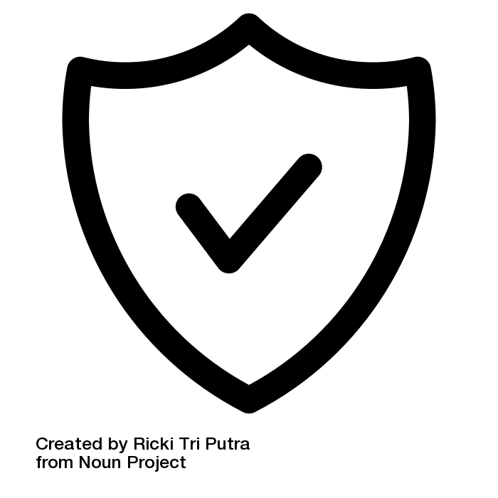

teach students a range of safe practices that they can use when interacting with other people, both online and face to face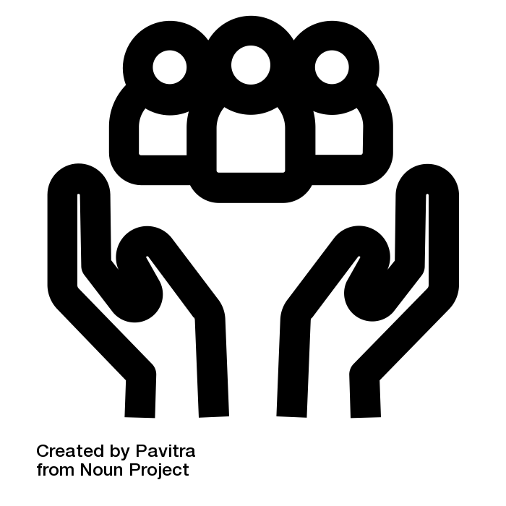

teach students how to recognise the difference between healthy and unhealthy relationships, and encourage students who have been or are being abused to seek help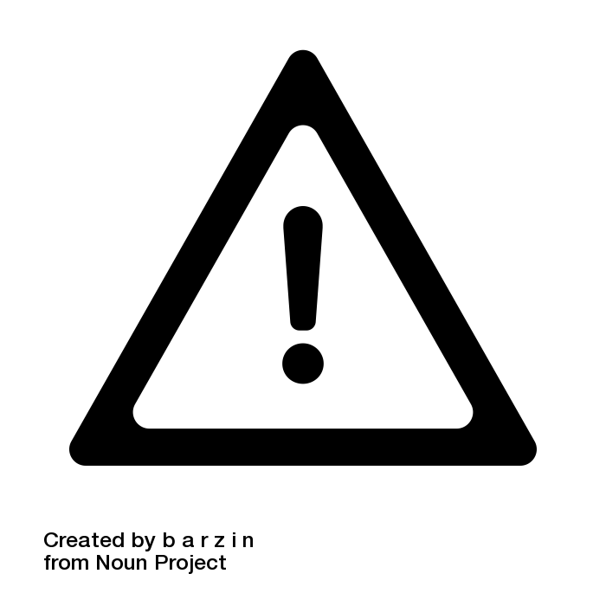

prevent abuse by making parents and teachers more aware of their responsibilities to help students avoid abuse.

**Why should your school implement Keeping Ourselves Safe?**

School should be a safe place for students and staff. (NAG 5)

* It is common for students to disclose to another student or a member of the staff they trust.
* Schools have responsibilities to protect children under the [Children’s Act 2014](http://www.education.govt.nz/school/health-safety-and-wellbeing/pastoral-care-and-wellbeing/childrens-act-2014-requirements-for-schools-and-kura/).

Keeping Ourselves Safe contributes to:

* achieving school and kāhui ako goals for student wellbeing
* behaviour management approaches such as Positive Behaviour for Learning (PB4L)
* learning in the Health and Physical Education curriculum
* developing students’ key competencies.

## 

## 

## 

## 

## 

## 

## 

*Acknowledgements: The icons used on this page come from* [*the noun project*](https://thenounproject.com/)*. They were created by: Ricki Tri Putra; Pavrita; barzin, respectively.*

# A whole-school approach

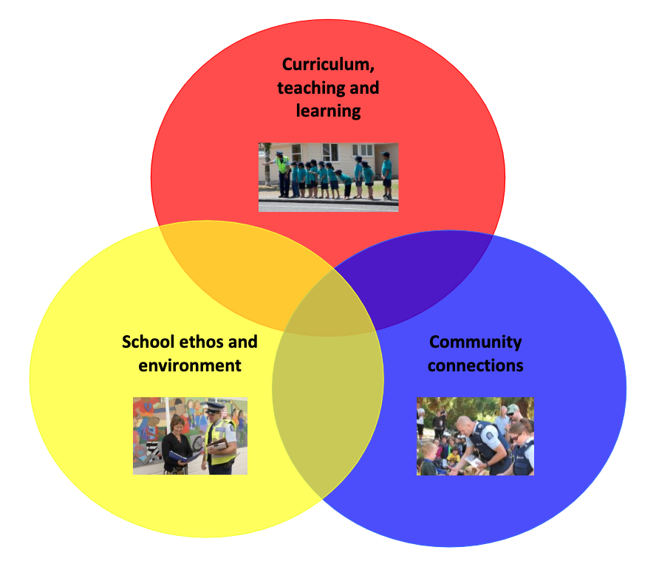The New Zealand Police recommends that schools use a whole-school approach. Their model has three inter-related categories, each of which has three components. A thorough implementation of Keeping Ourselves Safe will usually include all nine components.

|  |
| --- |
| **Curriculum teaching and learning**   * Myself * My family/ friends * My community |
| **School ethos and environment**   * Policies * Skilled staff * Safety focused environment |
| **Community connections**   * Consultation * Collaboration * Parent and whānau modelling |

For the details of this model, see:

* [Intervention planning tool](https://www.police.govt.nz/sites/default/files/publications/intervention-planning-tool-rev.pdf) (PDF) – NZ Police

The New Zealand Police recommends that schools ensure all staff have the same messages and are all working together to prevent abuse for all students.

## 

## Implementation process

There are eight steps for implementing a whole-school approach. Things to consider at each step follow the overview below.

### Overview of the process

|  |  |
| --- | --- |
| **Step 1**  **Initial contact** | The principal or a senior manager meets with the School Community Officer (SCO) to discuss the programme.   * If the school management team chooses to proceed with KOS, they appoint a KOS coordinator and inform the Board of Trustees (BOT). |
| **Step 2**  **First meeting** | The principal, KOS coordinator, School Community Officer and, where possible, a Board of Trustees representative meet to discuss:   * roles and responsibilities * the school's child protection policy – Is it up-to-date, accessible to staff and parents, and understood by all?   They may view and sign the Letter of agreement. |
| **Step 3**  **Implementation planning** | The KOS coordinator and the School Community Officer:   * plan when, what and how the programme will be delivered * identify any specific areas of professional learning that are needed to teach the programme successfully * plan communications – methods and messages – to explain the KOS programme to staff, parents, caregivers and whānau, and the community. |
| **Step 4**  **KOS presentation to school staff** | The KOS coordinator and School Community Officer introduce Keeping Ourselves Safe to all staff.  The purpose of the presentation is to:   * give all staff an outline of the programme, its aims and impacts * raise staff awareness of abuse and abuse reporting procedures * ensure that all staff are familiar with the relevant school policies and procedures and know what to do in the event of a disclosure.   This could be done over multiple sessions with different groups of staff. |
| **Step 5**  **KOS workshop/s for school staff** | The KOS coordinator works with syndicates/teachers to:   * explore the programme resources and plan delivery * discuss the professional learning teachers may need and plan ways to provide this. |
| **Step 6**  **Community engagement** | Schools have many channels for engaging with parents. Use what works best with your school community. |
| **Step 7**  **KOS taught in classes** | The KOS programme is implemented in the school.  Teaching is the responsibility of the classroom teacher. |
| **Step 8**  **Evaluating the programme** | Evaluate the programme. Seek the views of many people as possible in your context:   * KOS coordinator and teachers * principal and the School Community Officer * Students and community. |
| **Continuing the programme in subsequent years**  Every year, schools should:   * check the NZ Police website for updated programme materials * induct new staff by completing steps 4 and 5 with them before doing steps 6, 7 and 8.   Approximately every four years, schools should complete all eight steps again before teaching the programme, as there will be many new staff, students and whānau. | |

### 

### Things to consider at each step

|  |  |
| --- | --- |
| **Steps 1, 2**  **Initial contact**  **First meeting** | These meetings should give everyone a clear understanding of how the KOS programme fits with the school’s culture, community, strategic goals and curriculum. |
| **Step 3**  **Implementation planning** | Across the school, are we ready to teach this programme?   * Use the checklist Planning for learning – teachers to help you and your teachers critique and prepare the school and individual classroom environment.   What might different communities think about the Keeping Ourselves Safe programme?   * How will we engage with communities that might be uneasy about the gender or sexual content of the programme? Who in those communities might be able to help, for example, local community, church or mosque leaders? * How can we work together before delivering the programme to get community support for the programme and jointly promote it to parents? To what extent can we collaborate on decisions about what to do and how for their children and families?   What happens if a parent wishes to withdraw their child?   * Who will talk to them? What options can the school offer? Would the family like to work through some of the activities with their child themselves?   What do we need to plan and put in place, so we can evaluate the programme? |
| **Step 4**  **KOS presentation to school staff** | Consider and integrate:   * links to school goals and/or kāhui ako goals * previous experiences with KOS * understanding of the school’s child protection policy * any known or suspected incidents of abuse * there is often trauma around disclosures that is wider than just the kids and their families * the school may be criticised. How do staff feel safe? * How can teachers get help for themselves if they have their own problems? |
| **Step 5**  **KOS workshop/s for school staff** | There are many ways you could do this, for example:   * syndicate/team leaders take each team through that level of the resource * syndicates/teams explore a section of KOS and report back to the bigger group.   Plan to give all teachers an electronic copy of the checklist Planning for learning – teachers prior to the workshops, to prepare them for discussions about professional learning.  If a School Community Officer is going to assist with some of the learning experiences, organise for the School Community Officer and teachers to discuss how they will work together to do this. |
| **Step 6**  **Community engagement** | Many schools find specific meetings have low attendance, so consider other ways of engaging parents. Some ways that may work are:   * shared kai * providing childcare in a different room so parents can talk without children being present * online or virtual meetings * timing a meeting in parallel to other student events, for example, a disco.   If you do decide to hold a meeting, you can use or adapt the Sample letter to parents and caregivers included in this guide. |
| **Step 7**  **KOS taught in classes** | KOS coordinator monitors and supports implementation, through:   * checking in with teachers and students on progress and outcomes * sharing experiences, findings, and innovations across staff * refining the programme as needed. |
| **Step 8**  **Evaluating the programme** | Evaluation approaches could include:   * Teachers/teams use tools such as PMI or SWOT at the end of the programme to reflect on what they saw as a result of the programme, and to plan improvements. * School uses an independent survey such as NZCER’s wellbeing@school to monitor the effects of all the school’s strategies for keeping students safe and secure, of which KOS is one. |

## Summary of the role of School Community Officers

A school can implement KOS with or without the help of a School Community Officer. An SCO can support the school, by:

* briefing the principal and a representative of the Board of Trustees on KOS
* assisting the school with a review of its child protection policy
* assisting the KOS coordinator with implementation planning
* briefing staff on the KOS programme
* supporting community engagement activities
* supporting a few key class lessons, if required, in partnership with the teachers
* taking part in an evaluation of learning outcomes for students
* supporting the school to manage KOS in a self-sustaining way.

## Policy, protocols and preparedness

Schools must have effective abuse prevention policies and protocols.

The [Ministry of Education website](http://www.education.govt.nz/school/health-safety-and-wellbeing/pastoral-care-and-wellbeing/childrens-act-2014-requirements-for-schools-and-kura/) states:

From 1 July 2016 all schools and kura need to have a child protection policy in place.

Child protection policies encourage early identification and referral of suspected child abuse or neglect. They also help build a strong culture of child protection in your school or kura.

Key requirements of a child protection policy:

* It needs to be written down and in use.
* Say how suspected neglect and abuse will be identified and reported.
* Be reviewed every 3 years.
* Available on school websites or on request.

Child protection policies – [CA guide](http://www.education.govt.nz/assets/Documents/School/Running-a-school/VCAPracticalGuide.pdf#page=40)

The Oranga Tamariki website also has information that will assist schools to:

* meet the national requirements in relation to abuse and neglect
* develop child abuse reporting policies and protocols.

Visit their website to find these guides:

* [Safer organisations safer children](https://www.orangatamariki.govt.nz/working-with-children/childrens-act-requirements/child-protection-policies/) (2015)
* [Working Together guide](https://www.orangatamariki.govt.nz/support-for-families/support-programmes/working-together-seminars/) (2021)

There are community and private organisations that offer consultation and training to schools. Examples include:

* [Childmatters](https://www.childmatters.org.nz/)
* [Safeguarding Children](http://www.safeguardingchildren.org.nz/)
* [WellStop](https://www.wellstop.org.nz/education-consultation-training-services.html)

Schools can contact Oranga Tamariki with a concern, disclosure or questions on:

* 0508 332 774 (0508 EDASSIST)
* edassist@ot.govt.nz

# Curriculum planning

Students need to revisit the messages and skills they learn through the Keeping Ourselves Safe programmes in appropriate ways throughout their years at school.

* In the first three years of school, students should have the opportunity to do this every year.
* From year 4 onwards, they should have this opportunity at least every two years.

There are activities in Keeping Ourselves Safe that you can continue to use beyond the specific time frame of the programme, such as using a KOS box or similar throughout the year.

There are also other programmes and resources available you can use to reinforce Keeping Ourselves Safe in years you are not teaching a Keeping Ourselves programme. Examples include:

* [Bullying Free NZ](https://www.bullyingfree.nz/schools/) – Bullying prevention: activities for all ages (Bullying Prevention Advisory Group)
* [Digital Licence](https://www.digitallicence.co.nz/) – Cyber safety: includes modules on friends and strangers for under 13 year olds
* [Inside Out](https://insideout.ry.org.nz/) – Gender and sexuality; years 7-8 and above. (Rainbow Youth)
* [Life Education Trust](https://www.lifeeducation.org.nz/) – tailored lessons developed with each school selected across five areas: food and nutrition, human biology, relationships & communities, identity & resilience and substances
* [Navigating the Journey](https://www.familyplanning.org.nz/catalog/resources) – Sexuality education; programmes for years 1-2, 3-4, 5-6, 7-8, 9, 10. (Family Planning)
* [Netsafe](https://www.netsafe.org.nz/the-kit/resources/classroom/) – Cyber safety; trusted sources and curated resources from all over the world on aspects of digital citizenship and being safe online.

## 

## Planning for learning – teachers

Consider how you will plan for and design learning that is responsive to the diverse needs of your students. The following links are to selected sections of the guides on the Inclusive Education website on TKI, <https://www.inclusive.tki.org.nz/>.

|  |  |
| --- | --- |
| I have intentionally implemented strategies to build a respectful, supportive and safe environment for all my learners. | Consider:   * class and group expectations * systems for feedback that include privacy and options to respond in different ways * social behaviours   Explore   * [Collaboratively develop a safe and caring culture and climate](https://www.inclusive.tki.org.nz/guides/behaviour-and-learning/#collaboratively-develop-a-safe-and-caring-culture-and-climate) * [Support emotional wellbeing and positive mental health](https://www.inclusive.tki.org.nz/guides/behaviour-and-learning/#support-emotional-wellbeing-and-positive-mental-health) |
| I know about my learners' culture and language, and what I might need to plan for. | Consider:   * religious beliefs and practices * cultural practices * English language learners   Work in partnership with whānau and students   * ask might get in the way and what will help * use students’ interests to support engagement   Explore key strategies   * [Know your Māori learners](https://www.inclusive.tki.org.nz/guides/supporting-akonga-maori/#know-your-maori-learners) * [Build a culturally responsive environment](https://www.inclusive.tki.org.nz/guides/supporting-akonga-maori/#build-a-culturally-responsive-environment) |
| I have thought about how to support and create inclusive spaces for LGBTIQA+ students. | Consider:   * inclusive language and routines   Explore   * [Develop inclusive classroom routines](https://www.inclusive.tki.org.nz/guides/supporting-lgbtiqa-students/develop-inclusive-classroom-roles-routines-and-systems) |
| I have identified and planned for learners who require support with understanding and communicating the key concepts and big ideas in KOS. | Explore 5 key strategies   * [Supporting language and communication skills](https://www.inclusive.tki.org.nz/guides/behaviour-and-learning/#supporting-language-and-communication-skills)   Use visuals and social stories to support conversations and class discussions   * [Support communication](https://www.inclusive.tki.org.nz/guides/speech-language-and-communication-needs/support-communication) |
| I have considered the diversity of my learners and planned to offer a range of ways to engage, share information and support participation in KOS activities. | Explore 3 key strategies   * [Provide flexible options to support student interest](https://www.inclusive.tki.org.nz/guides/universal-design-for-learning/provide-flexible-options-to-support-student-interest) * [Present information in different ways](https://www.inclusive.tki.org.nz/guides/dyslexia-and-learning/present-information-in-different-ways) * [Provide options for expression and communication](https://www.inclusive.tki.org.nz/guides/universal-design-for-learning/provide-options-for-expression-and-communication) |

# Letter of agreement for Keeping Ourselves Safe

__________________________________________ School is committed to providing a safe physical and emotional environment for our students. To help achieve this, we intend to implement Keeping Ourselves Safe (KOS).

**The School agrees to**:

* use KOS in the way intended
* make KOS part of its ongoing health education programme
* train all new staff in KOS
* teach all focus areas of KOS, although choices may be made within these.

**The Board of Trustees agrees to**:

* support the school in the implementation of KOS
* establish and regularly review effective policies about the safety and wellbeing of students
* sign communications to parents and whānau at the beginning of KOS
* send a representative to any parent, caregiver, whānau meeting.

**The School Community Officer agrees to**:

* provide ongoing support for the school and its community in its implementation of KOS.

Date: ___________________________

Principal: ______________________________________________

Board of Trustees: ______________________________________________

School Community Officer: ______________________________________________

# 

# 

# Sample letter to parents and caregivers

Dear

Over the next few weeks we will be teaching the personal safety programme Keeping Ourselves Safe.

Keeping Ourselves Safe has been designed to give students the skills to cope in situations involving abuse. It has three overall aims:

* to develop and strengthen children’s skills to keep themselves safe with other people, both online and face to face
* to support and encourage abused children to get help from caring adults
* to make teachers and parents and caregivers more aware of the need to keep children safe from abuse by adults or other children.

Keeping Ourselves Safe will be taught by your child’s teacher, with support from the local Police School Community Officer as required.

To be successful, Keeping Ourselves Safe needs your help and support. Your child may have home activities to work on with you. It is important that you participate as much as possible and talk to your child about what they have been learning. This will reinforce the messages the school is giving, and help your child to use his or her new skills with confidence.

A parent and caregiver meeting will be held as follows:

* Date:
* Time:
* Venue:

Please contact the school if you would like any more information about the programme or about child abuse.

Return slip

**Keeping Ourselves Safe parent and caregiver meeting**

Child’s name:

* YES, we will be coming to the meeting. Number attending: _______________
* NO, we are unable to come to the meeting.

# Frequently asked questions about KOS

## FAQs from school staff

**Why should the school include KOS in an ongoing way?**

Children need abuse prevention education throughout their schooling, as their needs and experiences change. They need to have the opportunity to practise skills and to have the learning reinforced.

**What’s the point of reporting when the agencies don’t follow up?**

Oranga Tamariki and Police are obliged to follow up cases. Once a child has reported abuse, the personal healing process can start. The school can play an important part in this.

**Supposing the child reports to someone who doesn’t listen?**

The first person may not be the right person. Children need to keep on telling until someone listens and acts.

**How can we maintain confidentiality over a disclosure?**

The school’s protocol for reporting abuse should carefully limit the people who need to become involved.

**Our policy states we should report the abuse to the principal, but the principal never passes it on to Police or Oranga Tamariki. What should we do?**

It is time to review the policy and have the reporting protocols changed. Seek support from the Board of Trustees for this. Any individual can, of course, report abuse.

**Does this mean that I can’t touch a child or be alone with one?**

You must comply with your school policies on professional conduct and safe practice. Teachers will come into physical contact with students and this is acceptable when carried out in a professional and responsible manner that is age appropriate. You should have another child or adult present whenever possible.

These links provide advice from the Ministry of Education and sector professional bodies:

* [Our code, Our standards](https://teachingcouncil.nz/resource-centre/our-code-our-standards/) (PDF, 2017) – Teaching Council
* [Safe interactions with students](https://www.ppta.org.nz/advice-and-issues/behaviour-management/document/136) (PDF, 2021) – PPTA
* [Using physical restraint in schools](https://parents.education.govt.nz/primary-school/your-child-at-school/using-physical-restraint-in-schools/) – Ministry of Education

## FAQS from parents

**Why does my child need KOS?**

Any child can be abused. While the family home may be a safe place, the child will have contact with many people and enter a number of other homes. You can’t keep them safe all the time. If it doesn’t happen to your child, and we hope it doesn’t, it may happen to their friend.

**Doesn’t KOS destroy a child’s innocence?**

Children have the right to be protected from all types of abuse and to learn how to keep safe. Abusers may take advantage of children's innocence and their ignorance about what is inappropriate reportable behaviour. KOS teaches children safety skills appropriate to their age, in a safe, positive classroom environment. KOS also supports parents and whänau with information to help them protect their children from all types of abuse.

**Isn’t this just an anti-male programme?**

It is accepted that anyone can be an abuser. The stories and scenarios in KOS demonstrate a variety of abusers: male, female, young, old. They also present adults in positive, caring roles.

**Does this mean my male partner can’t bathe my child?**

Positive family interactions, such as those involved with caring for a child, are very important for a child’s wellbeing. So are hugs and cuddles.

**What should I do if I suspect abuse?**

Ensure the child is safe from immediate harm. Show love, concern and support and reassure the child that it is not their fault. Report the abuse to Police or Oranga Tamariki.

**What happens when abuse is reported to Oranga Tamariki or Police?**

A child protection social worker from Oranga Tamariki will have the job of ensuring the young person is safe. A member of the Police Child Protection Team will investigate whether an offence has been committed and will find out who is responsible.

**I teach my child about stranger danger. Isn’t that enough?**

Most children are abused by someone they know. If you teach them that abuse only happens from people they don’t know, they will not recognise it when it is done by a known and often trusted person.

**What sort of abuse are we talking about?**

There are five types of child maltreatment – physical, emotional, sexual, neglect and family violence. The programme also addresses cyber abuse. All forms are damaging for a child.

**How will I know what is being taught?**

The school will send information home, and your child will bring home activities to complete with you. Lesson plans are available on the NZ Police website for you to see what is being taught. You can contact your school at any time.

**Can I withdraw my child from KOS?**

You can withdraw your child if the school agrees to this. Remember, though, that any child can be abused and your child does need some education on how to avoid abuse.

**Should I prevent my child from going on the internet?**

There are unsafe situations that can arise online. However, the internet is also a valuable information and social tool.

To help your child keep safe, make sure the computer is in a family space, personal devices are not in bedrooms overnight, and your child knows never to give out their name and address online, or to agree to meet someone they have met online.

Talk to your child about what they do and enjoy online, in the same way you ask them about their day at school.

Visit the [Parent section](https://www.netsafe.org.nz/advice/parenting/) on Netsafe’s website for more advice and support.

# About abuse

## Key messages

Key messages for all

* Abuse is unacceptable and is a crime.
* Abuse can take a number of forms, all of which can be damaging to the victim.
* Abuse is never the victim’s fault.
* No one deserves to be abused.

Key messages for adults

* Everyone in schools and the school community has a responsibility to help prevent the abuse of children.
* Students can be taught the skills, knowledge and attitudes that will help them recognise, avoid and report abuse.
* Teaching children only about danger from strangers makes it easier for adults known to a child to abuse them.
* Reports of abuse must be listened to and acted on.
* Students need ongoing abuse prevention education throughout their schooling.

## Child abuse

The World Health Organisation has defined child maltreatment as:

All forms of physical and/or emotional ill-treatment, sexual abuse, neglect or negligent treatment or commercial or other exploitation, resulting in actual or potential harm to the child’s health, survival, development or dignity in the context of a relationship of responsibility, trust or power.

### Five types of abuse

There are five types of child maltreatment or abuse.

**Physical abuse** is non-accidental injury. This can be caused by smacking, punching, kicking, shaking, biting, burning or throwing the child. The injuries to the child may vary in severity and range from minor bruising, welts or bite marks, major fractures of the long bones or skull, to, in its most extreme form, the death of a child.

**Sexual abuse** is the involvement of a child in sexual activities they do not fully understand and to which they are unable to give informed consent. Examples include indecent exposure, sexual intercourse (anal or vaginal), sexual harassment, involving children in pornographic activities or prostitution, penetration of a child’s vagina or anus with fingers or objects, and oral sex.

**Emotional abuse** is when the child’s emotional and physical development is restricted because of the way the child is treated by adults. Examples include verbal abuse, denigration, active rejection, lack of love and support.

**Neglect** is when the basic survival needs of the child are not being met. Examples include withholding food, not providing adequate shelter or clothing, depriving the child of medical or dental care, not providing love or security.

**Family harm** is adults hurting children, or adults hurting other adults. This is of particular concern for children, both as victims and as witnesses. It is not just physical violence like slapping, shaking, beating or hitting. It’s throwing things, constant shouting and swearing, put-downs, any threatening or controlling behaviour – all the things that make children frightened or scared.

(Adapted from Protecting Our Children is Everyone’s Business, the Campaign for Action on Family Violence. See [www.areyouok.org.nz](http://www.areyouok.org.nz) )

### Keeping safe in cyberspace

The significant changes to technology and the way it is used present new challenges for schools in creating an environment where teachers and students are confident in the safe and secure use of online technologies. Students need to build the skills and knowledge to effectively manage cyber challenges and become confident and successful digital citizens.

Online hazards include:

* exposure to inappropriate or illegal material
* disclosure of personal information that may place students or their families at risk of fraud, burglary or other crimes
* younger children may copy older siblings who are involved in inappropriate activities
* cyberbullying and harassment
* contact from people who mean to harm children and young people.

**Support services**

[Netsafe Schools](https://www.netsafe.org.nz/the-kit/) supports schools to establish, develop and promote online safety, citizenship and wellbeing in their school community. Their website is a hub of content about all cyber-safety topics, including social networking and cyberbullying.

The Department of Internal Affairs handles complaints about objectionable material under the Film, Videos and Publication Classification Act 1993, including illegal pornography. The page [Prevention of online harms](https://www.dia.govt.nz/Preventing-online-exploitation) has information on classifications, legislation and online safety.

## 

## How does abuse affect children?

Abused children find it hard to concentrate at school. Often they are anxious, depressed, or hostile, and sometimes they behave in sexually inappropriate ways. They may be less mature than their peers and show physical signs of abuse and neglect.

In later life, child abuse may lead to sadness and anger, a sense of isolation and stigma, problems in trusting people and creating relationships and, at times, self-destructive behaviour. There may also be a link between child abuse and adolescent depression and suicide.

A very high proportion of child abusers were themselves abused as children.

Abusers typically make their victims feel guilty and responsible for what happens, thus making it all the more difficult to break the abuse cycle.

Youth offenders must be identified and given professional help, to prevent them becoming repeat offenders.

Victims of abuse must be identified and given professional help, to prevent them from being victimised again.

# Reporting abuse

If you believe that any child or young person has been or is likely to be harmed, ill-treated, abused, neglected or deprived you should report this.

A suspicion is enough for action, because intuition and gut feelings are often right. The most important consideration is always the safety and wellbeing of the child or young person.

Child abuse occurs in all groups in society and abusers can cover a wide age range, from elderly people to children the same age as the abused. Child sexual abuse is most often perpetrated by someone known to the child, often in a family relationship.

It is especially hard to report abuse if you know the family well and find it hard to believe that a child in that family could be maltreated.

It is very important to report all suspicions of abuse.

* The Oranga Tamariki Act 1989 states that anyone who believes a child or young person has been, or is likely to be, harmed, ill-treated, abused (whether physically, emotionally or sexually), neglected, or deprived; or who has concerns about the wellbeing of a child or young person, may report the matter to a social worker or a member of Police.
* They will be protected, provided the information they give has been given in good faith. The Oranga Tamariki member or Police member is required to undertake an investigation if that is shown to be necessary.

You should report abuse in the way outlined in your school’s child protection policy

## What to do if a student discloses

**Ensure the safety of the student**

If the student is in immediate danger or unsafe, act immediately to secure their safety. Do not alert the alleged abuser.

**Listen**

Do not ask leading questions or put words into the student’s mouth. Use "Tell me..... eg what that looked like, felt like, where that was.

Allow them to tell you as much as they want.

**Believe**

Believe what they say, don’t criticise.

**Say**

I’m glad you told me. I’m sorry this happened. It’s not your fault. I’ll do something to help.

**Keep calm**

If the student detects your discomfort or anxiety, they may not want to share any more of their problem.

**Document**

Listen carefully to what they are saying – is it sexual? physical? Ask the very basics – who? when? Once you have found out the basics, DO NOT question them further.

Document what the child has said – include date, time, and who was present. Document any observations of their physical state and behaviour.

DO NOT begin your own investigation. That is not your role.

**Keep the student safe** in a safe place.

**Follow your school policy**

It will have practical procedures for you to follow. Respect confidentiality.

**Find support for yourself**

You may need to have access to an employee support programme or similar counselling service. It is unwise to talk to other staff because this may affect the integrity of the evidence.

# 