Keeping Ourselves Safe – Middle primary

Focus area 4 – Why should I tell?

The four focus areas in the Keeping Ourselves Safe (KOS) middle primary programme are:

1. Confident me
2. Safe or unsafe?
3. No excuse for abuse
4. Why should I tell?

Research suggests that an effective programme should include learning experiences from each of the four focus areas.

**Contents**

Focus area 4 – Why should I tell? 3

Notes for the teacher: preparation 3

Explanation 3

Curriculum links 3

Success criteria 4

Key messages 4

Learning experience 1 – Getting help 5

Learning intentions 5

Notes for the teacher 5

Resources 5

Activities 6

Homework activity 7

Copysheet: Getting help scenario cards 8

Copysheet: Getting help, Te whiwhi āwhina 9

Copysheet: School Community Officer’s story 10

Homework activity: Harakeke helpers 11

Learning experience 2 – What now? 12

Learning intentions 12

Resources 12

Activities 12

Optional activities 13

Why Danny Wouldn’t Play 14

# Focus area 4 – Why should I tell?

## Notes for the teacher: preparation

* Ensure that safety guidelines are in place.
* All school staff, not just the teachers concerned, must know what to do if a student discloses abuse to them during or after Keeping Ourselves Safe.
* Parents should also be made aware of what to do. See the Child Protection Guidelines available on the NZ Police School Portal at <https://www.police.govt.nz/advice-services/personal-community-safety/school-portal/information-and-guidelines/child-protection>

## Explanation

Children need to know that they can stop touch or behaviour that is inappropriate, that worries or confuses them, or that makes them feel unsafe.

Children need to be able to say ‘no’ confidently, move away, and report what has happened. This applies in both the real world and in digital environments.

## Curriculum links

Key Competencies: Managing self, Relating to others, Thinking

Values: Integrity, Respect themselves, others, and human rights

Learning area: Level 2 Health and Physical Education

Strand A: Personal Health and Physical Development:

* Safety Management: Identify risk and use safe practices in a range of contexts.

Strand C: Relationships with Other People:

* Interpersonal Skills: Express their ideas, needs, wants, and feelings appropriately and listen sensitively to other people and affirm them.

Strand D: Healthy Communities and Environments:

* Societal attitudes and values: Explore how people’s attitudes, values, and actions contribute to healthy physical and social environments.

Level 3 Health and Physical Education

Strand A: Personal Health and Physical Development:

* Safety Management: Identify risks and their causes and describe safe practices to manage these.

Strand C: Relationships with Other People:

* Interpersonal Skills: Identify the pressures that can influence interactions with other people and demonstrate basic assertiveness strategies to manage these.

## Success criteria

Students can:

* identify adults who they can ask for help
* report incidents involving other people that bother them.

## Key messages

### Ask for help and go on asking until someone listens and takes action. Help is out there.

Work with the class to come up with two key messages for Focus area 4 that are the same or similar to the ones above.

Record this on the Take the tui tour poster – see Focus area 1 for further instructions). Students also record it on their personal Take the tui tour charts.

# Learning experience 1 – Getting help

## Learning intentions

Students are learning to:

* identify situations that need adult intervention and support
* identify the most appropriate adult to report to
* list at least two accessible support agencies.

## Notes for the teacher

In some situations when children feel unsafe they can take responsibility and act appropriately to keep themselves safe.

* For example, if they saw a group of noisy teenagers in the distance they could change their route to avoid contact with them.

In other situations, the child may or may not be able to do something to get out of the unsafe situation, but they still need to report what has happened to an older responsible person and seek adult help and support.

* For example, a child who witnesses family harm may be able to remove themselves to a safe place, but still needs to later seek the help of an adult to see if this family behaviour can be stopped.

## Resources

Copysheet: Getting help scenario cards

Copysheet: Getting help, Te whiwhi āwhina

Scenario cards made by students

Copysheet: School Community Officer’s story

Homework activity sheet: Harakeke helpers

## Activities

### 1 – Getting help, Te whiwhi āwhina

*For some students the scenarios used here will be familiar. Others will not have experienced these problems. It is important that all students know what to do in situations like these. The scenarios should generate a lot of discussion about what is happening.*

Read this scenario to the class: A kid steals your ball at lunchtime.

Remind them about Stop, Walk, Talk in Focus area 2.

Ask:

* What do you think the child/children should do?
* Do you think they should report this incident? Why or why not?
* Is there an adult that they can get help from straight away? If so, who?
* Who else could they get help and support from later on?
* What could they do if the people they told didn’t help?

Divide students into six groups and allocate each group a scenario from Copysheet: **Getting help scenario cards**. Give them the questions on Copysheet: **Getting help, Te whiwhi āwhina** to answer. Take group reports.

Reinforce that abuse must be reported and that if the first person they tell doesn’t listen, or do anything to help, they must go on telling until someone takes action.

### 2. How to ask for help role-play

Working in threes, students write scenario cards describing potentially unsafe situations that involve other people. The teacher gathers these in and then hands them out so each group has a scenario card they did not create.

Check that each group understands their scenario, then ask them to discuss:

* Who they would ask for help
* What they would say
* What they could do if that person didn’t believe them.

Ask the groups to create a role-play showing someone asking for help in their scenario.

### 

### 3 – School Community Officer’s story

Read Copysheet: **School Community Officer’s story** to the class.

### Students think, pair, share the following questions:

* Do you think the girl made a good decision? Why, or why not?
* Do you think it was an easy decision to make? Why, or why not?
* Why do you think the girl is feeling better now?
* What do you think will happen to the person who touched the girl?

## Homework activity

Give students Homework activity sheet: **Harakeke helpers** to complete with someone at home.

# Copysheet: Getting help scenario cards

**Card 1 Skateboarding**

A group of bigger skateboarders block you from walking across a path.

**Card 2 Mum**

Mum gets angry and starts threatening you and your sister.

**Card 3 Computer**

Someone online messages you and asks you to send them a video of yourself with no clothes on.

**Card 4 School**

A kid at school pushes you over and calls you names.

**Card 5 Home**

No one is home when you get home from school, so you have to sit on the steps and wait.

**Card 6 Dad**

Dad has been drinking and is hugging you too tightly.

# Copysheet: Getting help, Te whiwhi āwhina

What do you think the child or children should do?

Do you think they should report this incident? Why, or why not?

Is there an adult that they can get help from straight away? If so, who is it?

Who else might they get help and support from later on?

What could they do if the people they told didn’t help?

# 

# Copysheet: School Community Officer’s story

The school had been doing Keeping Ourselves Safe during Term 2. I was their School Community Officer, so the students got to know me quite well.

Later in the year I went back to the school to teach some other lessons. A girl approached me and said she wanted to talk to me about something that had happened the day before. She told me she had been touched by an adult in a way and place that she knew wasn’t okay. She said that she remembered that during Keeping Ourselves Safe I had said that if anything happened that wasn’t okay, to tell an adult you trust.

The girl said that straight after the incident happened she told her grandparent about it and they agreed that she should talk to me at school the next day, because she knew that I would be there.

Before I arrived at school the girl had gone to the principal and asked if the principal could arrange for her to meet me. She was scared that she would chicken out before I got to school.

The girl told me her story. I said that she had done the right thing and I was pleased that she had told me. I noted down what she had said and explained that I wouldn’t ask any more questions because she would be interviewed by a specialist.

Then I explained the process – I would talk to the principal and then report the abuse to the Child Protection Team, and that they would follow it up.

I saw the girl the next week, and she told me that the interview had gone really well. She said the interviewer was really nice and she felt much better now.

Because the incident was reported, the person who had touched the girl was arrested and had to go to Court.

# Homework activity: Harakeke helpers

In Keeping Ourselves Safe we have been talking about who children can go to for help if they feel unsafe or worried. Reinforce the following messages with your child.

* You must tell someone if other people make you feel unsafe, worried or scared.
* If the first person doesn’t help, go on telling until someone listens and takes action.
* You can always come to me and I will listen and help you.

Work with your child to complete the Family/Whānau part of the harakeke drawing below. Give specific names and contact details.

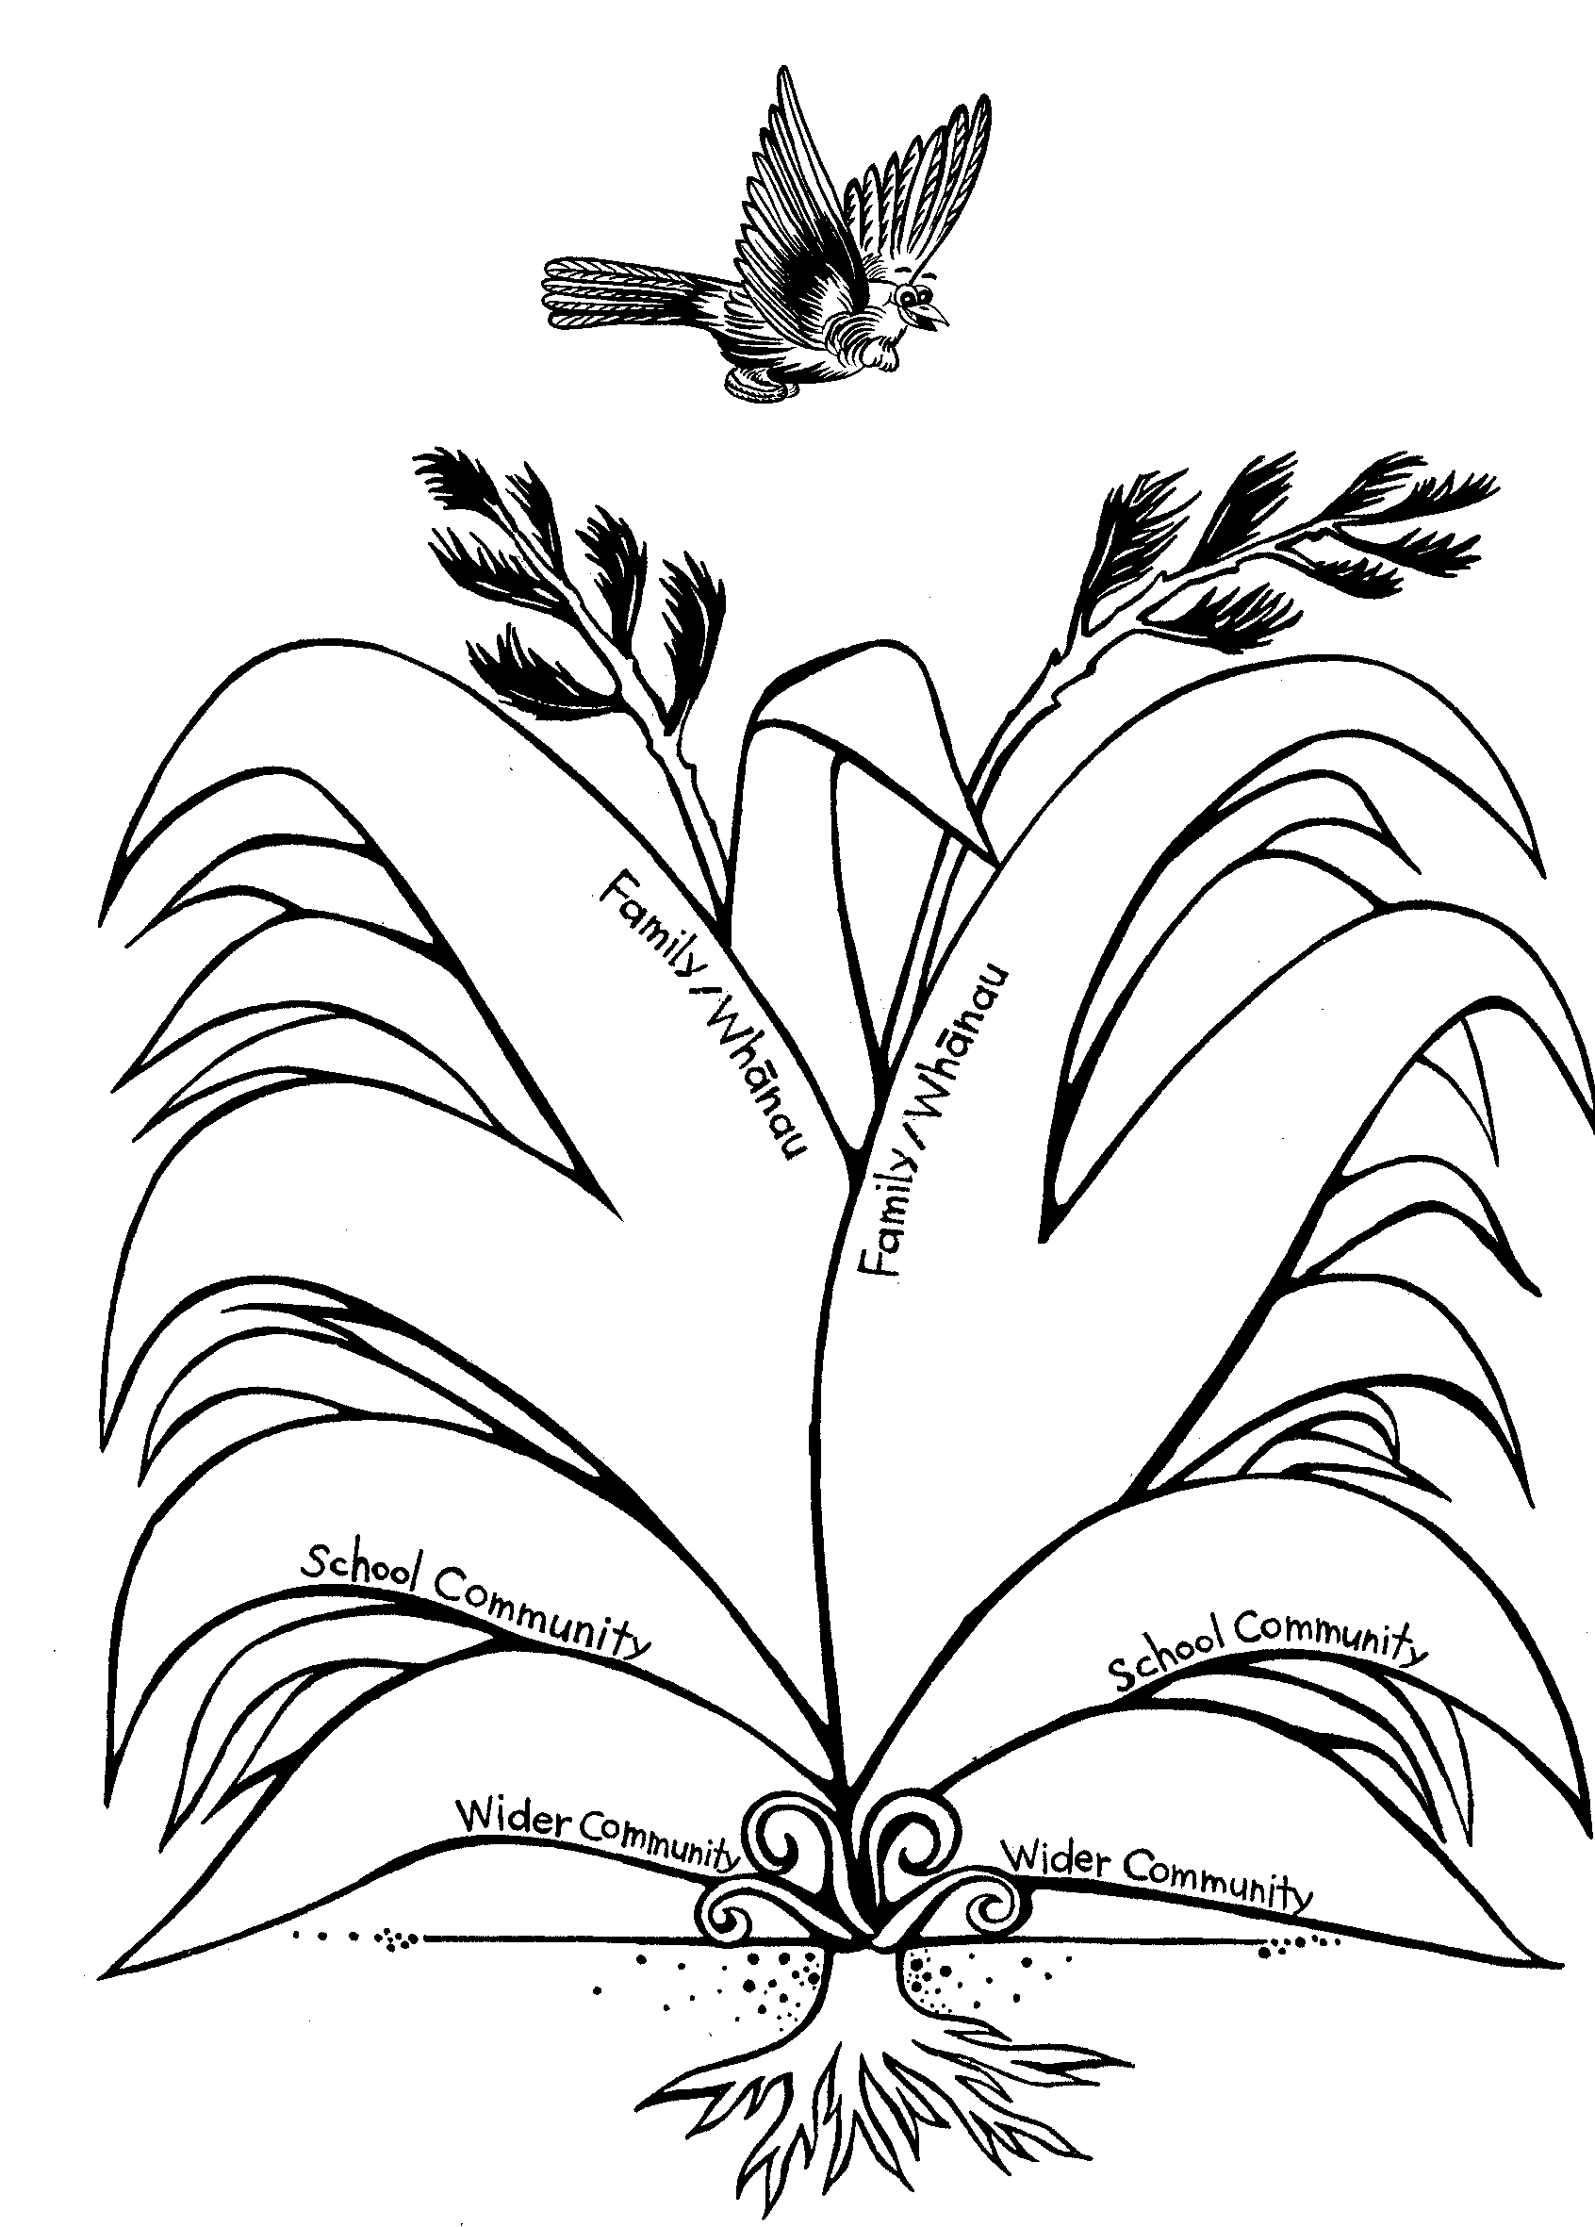

# Learning experience 2 – What now?

## Learning intentions

Students are learning to:

* identify what happens when abuse has been reported.

## Resources

Story: Why Danny Wouldn’t Play

For optional activities:

* Each student’s “child” (eggs or alternatives)
* Completed Take the tui tour poster

## Activities

### 1 – What happens when we report abuse?

Ask each student to complete the first two columns of a KWL chart like the one below. The last column can be completed at the end of the following activities.

|  |  |  |  |
| --- | --- | --- | --- |
| **Prompt questions** | **What I know** | **What I want to know** | **What I have learnt** |
| Who is involved? |  |  |  |
| What do they do? |  |  |  |
| What else happens? |  |  |  |

### 2 – Why Danny Wouldn’t Play

Read the story Why Danny Wouldn’t Play.

Ask:

* Who do you think Ana is?
* Do you think Danny deserved to be punished like that? Why, or why not?
* Why do you think Danny didn’t tell anybody what was happening?
* What was Mr Smith going to do to make sure Ana didn’t punish Danny for telling?
* What might happen to Danny now?
* What might happen to Ana?
* What does the law say about harming children?

Give the information below to the class:

**What happened after Danny told**

* The Police talked to Ana, Danny’s stepmother, and to his father.
* Ana and Danny’s Dad had to go to court to speak with a judge.
* The judge arranged for some things to help them become better parents.
* The judge said that Danny had done the right thing to tell.
* Ana didn’t hit Danny any more after this.

## Optional activities

What have we learnt?

### 1 – Mind the "child"

If you chose to begin this activity earlier in the programme, inspect the students’ “children” (their eggs or other item chosen for children to mind) to see if they are safe.

Ask:

* Whose “child” remained safe and unharmed all week?
* How did some of your “children” get hurt or damaged?
* Who were the best babysitters that you used?
* How similar was this “child” minding to looking after a real younger child?
* What has this experience taught you about looking after young children?

### 2 – Take the tui tour

If you chose to begin this activity earlier in the programme, go over the key messages from the poster. These are:

* Confident kids make safe decisions.
* I have a right to be safe with other people.
* Abuse must always be reported.
* Ask for help and go on asking until someone listens and takes action.
* Help is out there.

# Why Danny Wouldn’t Play

Danny wouldn’t play.

“Come on, Danny, come and play,” said Mary. Danny hung his head and just sat there.

“Aw, come on,” said Tom, grabbing Danny by the arm. “We need one more so we can make up a team.”

Danny let out a yell and began crying. Just at that moment, Mr Smith, the teacher, walked past.

“Tom,” he said sternly, “You’re too big to be knocking Danny around.”

“He didn’t,” said the other children. “He just grabbed Danny’s arm to try to get him to play. Tom didn’t do anything to hurt Danny.”

"Well, it sounded like it hurt,” said Mr Smith. It was true – Danny’s yell sounded like he was being hurt, and he was crying quietly, too.

“Danny’s just a cry-baby,” said one of the children. “You just touch him and he cries.”

Mr Smith looked at Danny.

“Come on, Danny, there’s something I want to talk to you about,” said Mr Smith. “Let’s go to the office.”

Danny slowly got up and followed Mr Smith.

“Oooh, Danny’s got to go to the office,” said one of the children.

“I don’t think it’s for anything bad,” said Mary. “Mr Smith didn’t sound mad.”

Mr Smith wasn’t angry. In fact, he sat Danny down in the teachers’ room, gave him a drink, and made himself a cup of coffee.

“Are you having trouble with the other kids?” asked Mr Smith. Danny shook his head.

“Do you like playing games with the others?” said Mr Smith. Danny nodded.

“You do?” Mr Smith sounded surprised. “But you wouldn’t when they ask you to.”

“It hurts,” said Danny. “I like to play with the others, but it hurts.”

Mr Smith looked at Danny again. “If something hurts, Danny,” he said kindly, “perhaps the school nurse could help. She’s here today. Would you like to see her?”

Danny shook his head again.

“You know, Danny, we’d like to help if something is hurting you,” said Mr Smith, “but you have to tell us what it is.”

Danny sat very still. Mr Smith waited.

At last, Danny gave a big sobbing sigh, and began to roll back his sleeve carefully. All over his arm were deep purple bruises. Mr Smith looked at them quietly. “What happened, Danny?” he asked.

The tears rolled silently down Danny’s face.

“Ana said I was bad,” he said. “She hit me hard with the big stick she keeps in the cupboard.”

“Well, Danny,” said Mr Smith, “No one is that bad. No one is allowed to hit another person with a stick, no matter how bad they think they are.”

“She has done it before,” said Danny quietly, and he pulled up his shirt so that Mr Smith could see cuts and bruises there as well. Some of the cuts were oozing.

Mr Smith thought for a while.

“The nurse is here today. We’ll get her to fix those cuts and make it more comfortable for you so they will heal quickly.”

Danny stood up. “There might be more hitting,” he said quietly. “Ana gets very angry with me. If I go home and she knows I’ve told you about what’s been happening …”

“No, she won’t,” said Mr Smith firmly. “We will have to tell the police about what Ana has been doing. There’s a law that stops anybody from doing things like that.”

Danny felt much better after that, and better still after the nurse fixed him up.

Mr Smith said “It’s like this, Danny. No one at home or anywhere else is allowed to hurt you or injure you on purpose. If that happens, then you must tell your teacher, or the school nurse or the doctor or the police. They’re all people who know the right thing to do to help you and your family. Do you understand that, Danny?”

Danny nodded. He was feeling much better – almost good enough to go out and play. Then he spied the plate of biscuits left over from the teachers’ morning tea.

“Could I have a squiggle-top biscuit, Mr Smith?” he said, looking up with a twinkle.

“Ooohh ... Just this once, Danny. Now out to play, you rascal!”

Danny ran out, giggling happily. It was a sound Mr Smith liked to hear.