Keeping Ourselves Safe – Middle primary

Focus area 2 – Safe or unsafe?

The four focus areas in the Keeping Ourselves Safe (KOS) middle primary programme are:

1. Confident me
2. Safe or unsafe?
3. No excuse for abuse
4. Why should I tell?

Research suggests that an effective programme should include learning experiences from each of the four focus areas.

**Contents**

Focus area 2 – Safe or unsafe? 3

Notes for the teacher: preparation 3

Explanation 3

Curriculum links 3

Success criteria 4

Key message 4

Learning experience 1 – The real world 5

Learning intentions 5

Notes for the teacher 5

Resources 6

Activities 6

Optional activity 9

Copysheet: Safety cards 10

Copysheet: Types of touch 13

Copysheet: “Child” minding 14

Learning experience 2 – The digital world 15

Learning intentions 15

Notes for the teacher 15

Resources 15

Activities 16

Homework activity 17

Copysheet: The path to safe decisions 18

Homework activity: Safety with people 19

# Focus area 2 – Safe or unsafe?

## Notes for the teacher: preparation

* Ensure that safety guidelines are in place.
* All school staff, not just the teachers concerned, must know what to do if a student discloses abuse to them during or after Keeping Ourselves Safe.
* Parents should also be made aware of what to do. See the Child Protection Guidelines available on the NZ Police School Portal at <https://www.police.govt.nz/advice-services/personal-community-safety/school-portal/information-and-guidelines/child-protection>

## Explanation

Students need to know how to identify potentially unsafe situations involving other people in both the real and the digital worlds.

* These situations may involve people they know, new people they meet, and people they only know through online communications.
* In the real world, people who wish to harm children are most likely to be known to them.
* In the digital world, the harm may come from people they know through email, cell phone or chat room messages, or from people they meet in social networking sites.

## Curriculum links

Key Competencies: Managing self, Relating to others, Using language, symbols, and texts

Values: Equity, Integrity, Respect for themselves, others and human rights

Learning areas: Level 2 Health and Physical Education

Strand A: Personal Health and Physical Development:

* Safety Management: Identify risk and use safe practices in a range of contexts.

Strand D: Healthy Communities and Environments:

* Rights, Responsibilities, and Laws: Contribute to and use simple guidelines and practices that promote physically and socially healthy classrooms, schools, and local environments.

Level 3 Health and Physical Education

Strand A: Personal Health and Physical Development:

* Safety Management: Identify risks and their causes and describe safe practices to manage these.

Strand D: Healthy Communities and Environments:

* Rights, Responsibilities, and Laws: Plan and implement a programme to enhance an identified social or physical aspect of their classroom or school environment.

## Success criteria

Students can:

* use Stop, Walk, Talk when faced with unsafe situations
* avoid unsafe situations in the digital world.

## Key message

### I have a right to be safe with other people

Work with the class to come up with a key message for Focus area 2 that is the same or similar to the one above.

Record this on the Take the tui tour poster – see Focus area 1 for further instructions). Students also record it on their personal Take the tui tour charts.

# Learning experience 1 – The real world

## Learning intentions

Students are learning to:

* identify behaviours of other people that make them feel unsafe or uncomfortable
* distinguish between touch they like, touch they don’t like, and touch that confuses them
* say “no" to unwanted touch
* use Stop, Walk, Talk in risky situations.

## Notes for the teacher

**Unsafe situations**

When we talk to students about situations involving other people that make them feel unsafe, or about different types of touch, they sometimes think that this only applies to people they don’t know.

* As a result, they may not recognise abuse if the perpetrator is someone known to them, especially if they love and trust that person.
* It is important to tell them that it is the behaviour that is wrong, whoever the person is.

**Consent**

Adults need to respect children’s rights and feelings about being touched in ways that make them feel uncomfortable.

* The safety rule is that touch or play for fun or for affection should be okay with each person, safe, and allowed by the adults in charge.
* Adults need to support the child’s right to say “no” if they feel unsafe or uncomfortable.

Sometimes it is hard for a child to say “no” to unwanted touch from family members or a close family friend.

* Children are reluctant to say anything in case it hurts the other person’s feelings, or they, or the person, get into trouble.
* Adults have to support a child in a situation like this. For example, if the child no longer wants to be kissed by granddad or auntie, parents should support the child’s decision, not side with the other adult. An alternative form of greeting could be used, such as shaking hands or a high five.

Some kinds of sexual touch may be pleasant for children, in particular boys, although they may sense that it is wrong.

* Adults must help children to understand that sexual touch, which includes the anus and mouth, is wrong and they must tell someone about it.
* The only genital touching that is okay is for hygiene or medical care.

Children need to know that if they have allowed some touch in the past, they can change their mind at a later date.

* For example, they may have enjoyed being tickled, but if the tickling moves to under the clothing, or gets too hard, they may want it to stop.

## Resources

Song: Stop, Walk, Talk, video available at <https://www.youtube.com/watch?v=fbsbgMkKiHE&feature=youtu.be>

Copysheet: Types of touch (enlarge the sheet, cut out the faces, and place each on a large sheet of paper)

Copysheet: Safety cards (cut these up into sets, one for each group; you may wish to include some cards that reflect real situations from your school)

Copysheet: “Child” minding

## Activities

### 1 – The extent barometer

Ask students to sit with their hands flat on their knees. Explain that you are going to read out some situations. When each situation is read the students move their hands up to show how unsafe they think this situation is. Depending on the situation, each student moves their hands to their hips, shoulders, or head.

**Situations**

Choose from the following list, and/or include examples of your own:

* You stay overnight at a friend’s house.
* You take a shortcut home.
* You are reading a book at home in bed.
* Your parent or caregiver shouts at you.
* You are playing in the park.
* You are chatting on the computer.
* The teacher is late to class.
* You walk to school with your friends.
* You message people you don’t know online.
* You bike home by yourself.
* You friend someone you don’t know online.
* You share your password with friends.

### 2 – The three types of touch

*Only do this activity if the students’ responses from the Kowhai KOS human bingo in Focus Area 1 – Confident Me showed that they are not confident in assessing the difference between touch they like, touch they don’t like, and touch that confuses them.*

Ask students if they can remember the three types of touch and how they make us feel. Remind them that they learnt about these when they did Keeping Ourselves Safe last time. The three types of touch are: touch we like, touch that hurts, and touch that confuses us.

Put up the three charts, each with one of the touch faces made from Copysheet: **Types of touch**. Students think/pair/share examples of each type.

They write each example of touch in a hand shape (Red = hurts; Black = confusing; Yellow = like) and glue it on the appropriate chart.

### 4 – Safety cards

Divide students into groups of four. Give each group a set of cards made from Copysheet: **Safety cards**.

The students rank the situations on these cards in order from most to least safe. Ask each group to share their first two rankings and the last one and to give a reason for their choices.

* There is no correct order for ranking these cards, as situations can be quite unsafe for some and not so unsafe for others.
* The important part of this activity is the discussion that goes on between students.
* If students are consistently failing to identify potentially unsafe situations, you could ask questions to clarify their thinking.

After the activity, ask:

* How do you feel when you are in an unsafe situation? (Unsure, scared, embarrassed, confused ...)
* How does your body tell you that something is unsafe? (Prickle down your spine, heart racing, tummy feels funny ...)

If the students are unsure whether a situation is safe or unsafe, or whether they should do something, they could ask themselves:

* Do I feel okay about this?
* Would my family want me to do it?
* Will I be able to get help?
* Will someone who cares about me know where I am?

### 4 – Stop, Walk, Talk

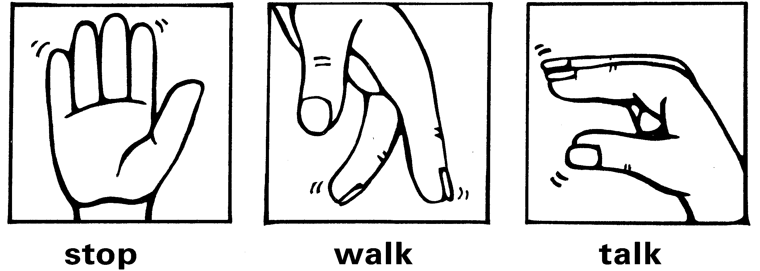

Remind students about Stop, Walk, Talk. You may like to play the song.

Explain that it is a very good strategy to use if they ever feel unsafe, scared, or uncomfortable about something.

Choose a card from the Copysheet: Safety cards, an unsafe one. Interview the School Community Officer or a confident student, to find out how they would use Stop, Walk, Talk in that situation.

For example: The adults in my family are fighting.

Stop I would stand still where I was.

Walk I would quietly go and hide in my bedroom.

Talk Next time I saw Nana I would tell her how they are fighting all the time.

Students then work in pairs to practise using Stop, Walk, Talk for other situations on the Safety cards. Then each pair tells their partner about a time when they felt really unsafe. The partner suggests how they could have used Stop, Walk, Talk in that situation.

### 5 – Post-it board

Put up a post-it board, one half labelled **Safe** and the other **Unsafe**.

Give each student some post-it notes. They write or draw times they felt unsafe or safe, one per note, and post them on the board.

(Based on Gardner, Howard (1993), *Multiple Intelligences: The Theory in Practice*, Basic Books, ISBN 046501822X)

## 

## Optional activity

### “Child” minding

In this activity, students are given responsibility for taking care of something vulnerable for two to four days. You decide the length of time.

If you plan to do the activity over the period of this KOS programme, you may wish to start it at this point. See focus area 4 for the conclusion of the activity.

Give each child either an egg to decorate as a little person, or a gingerbread person.

**Note:** If using food in this way is not appropriate for your students, for cultural or other reasons, you could use an alternative, for example, sprouting seedlings, or water balloons.

Discuss the following guidelines for “child” minding with the class:

* The “child” must be kept safe for the whole time.
* The “child” should not be left without a sitter who is responsible for its safety.

A sample letter for parents is included on Copysheet: **“Child” minding**.

# Copysheet: Safety cards

**5**

**4**

|  |  |
| --- | --- |
| Someone stops you to ask for directions. | You are approached by a group of older students who want to try out your new bike. |
| You are getting changed at the swimming pool and someone keeps staring at you. | You play a game on your phone while you walk home. |
| A family friend walks into the bathroom while you are in there. | Your stepfather shouts at you. |
| You are at a friend’s house and his older brother asks you to touch his penis. | After a sports game someone from the other team hassles you. |
| Your parents or caregivers are fighting. | Someone is close behind you as you are walking to the shops. |
| The babysitter tucks you into bed and puts their hand down between your legs. | You are at your uncle’s place and a group of adults are drinking alcohol. |
| You have been to a family BBQ. Your Dad has been drinking a lot, but still says he can drive home. | You are playing a game on the field when someone pulls your pants down. |
| You arrive home to an empty house. | Your parents or caregivers come into the bathroom to check if you are okay. |
| You are home on your own and someone comes to the door. | You get a ‘high 5’ when you bring a certificate home from school. |
| Your little sister or brother holds your hand. | Someone kicks you on purpose. |
| You have been called to the principal’s office. | You fall off your bike on the road. Someone offers you a ride home. |
| An adult friend of the family gives you a kiss and puts their tongue in your mouth. | Your older brother or sister invites their friends around while they are babysitting you. |
| Dad gives you a cuddle. | Someone you have met online asks for your photo. |
| The next door neighbour asks you over when no one else is home. | You are walking home in the rain when the people from the next farm offer you a ride. |
| You give your name and address to someone you have been chatting to on your computer. | A friend takes a photo of you on their cell phone while you are getting changed. |
| You are lost in the mall and ask a sales assistant to help you. | The coach asks you to stay behind after sports practice. |
| Grandma likes to give you a big hug and a kiss. | You have gone out on your own for an early morning ride on your horse. |
| You always go for a run around the neighbourhood before tea. | You arrange to meet someone that you have been talking to online. |
| The teacher gives you a pat on the back. | The person behind you pulls your hair really hard. |
| Mum gives you a kiss and cuddle at bed time. | Grandad likes to put you on his knee and cuddle you very tight. |
| Someone you met online sends you a picture of themselves with no clothes on. | You post pictures of yourself on social media. |

# Copysheet: Types of touch

Enlarge and put each ‘face’ and the associated heading on a sheet of chart paper.

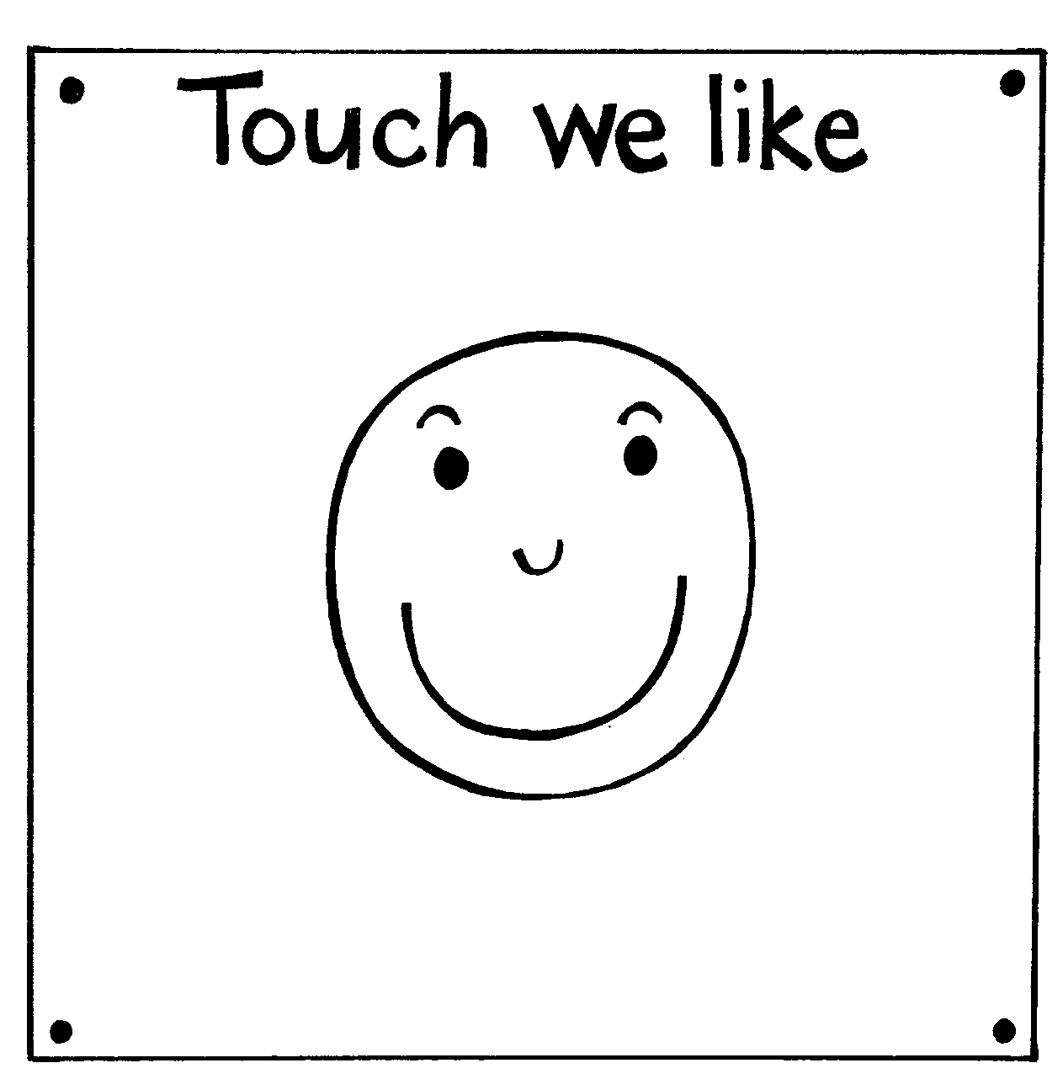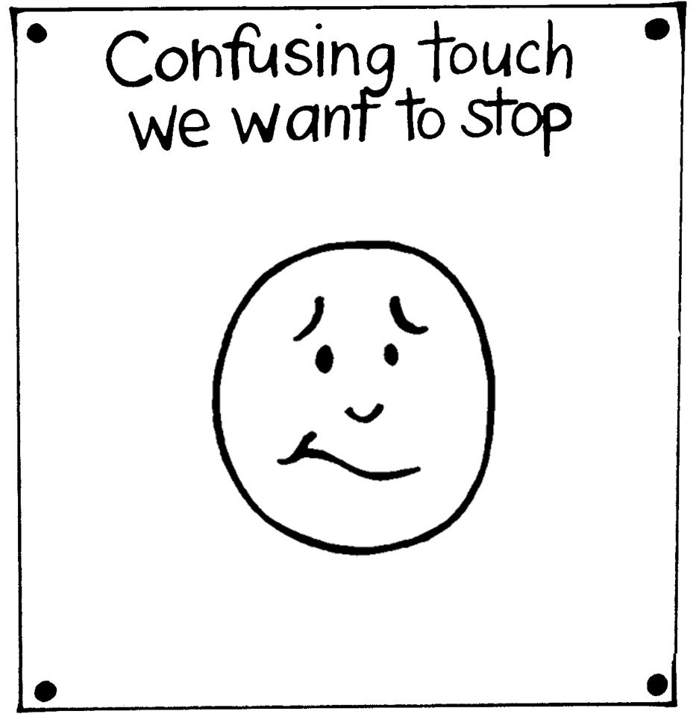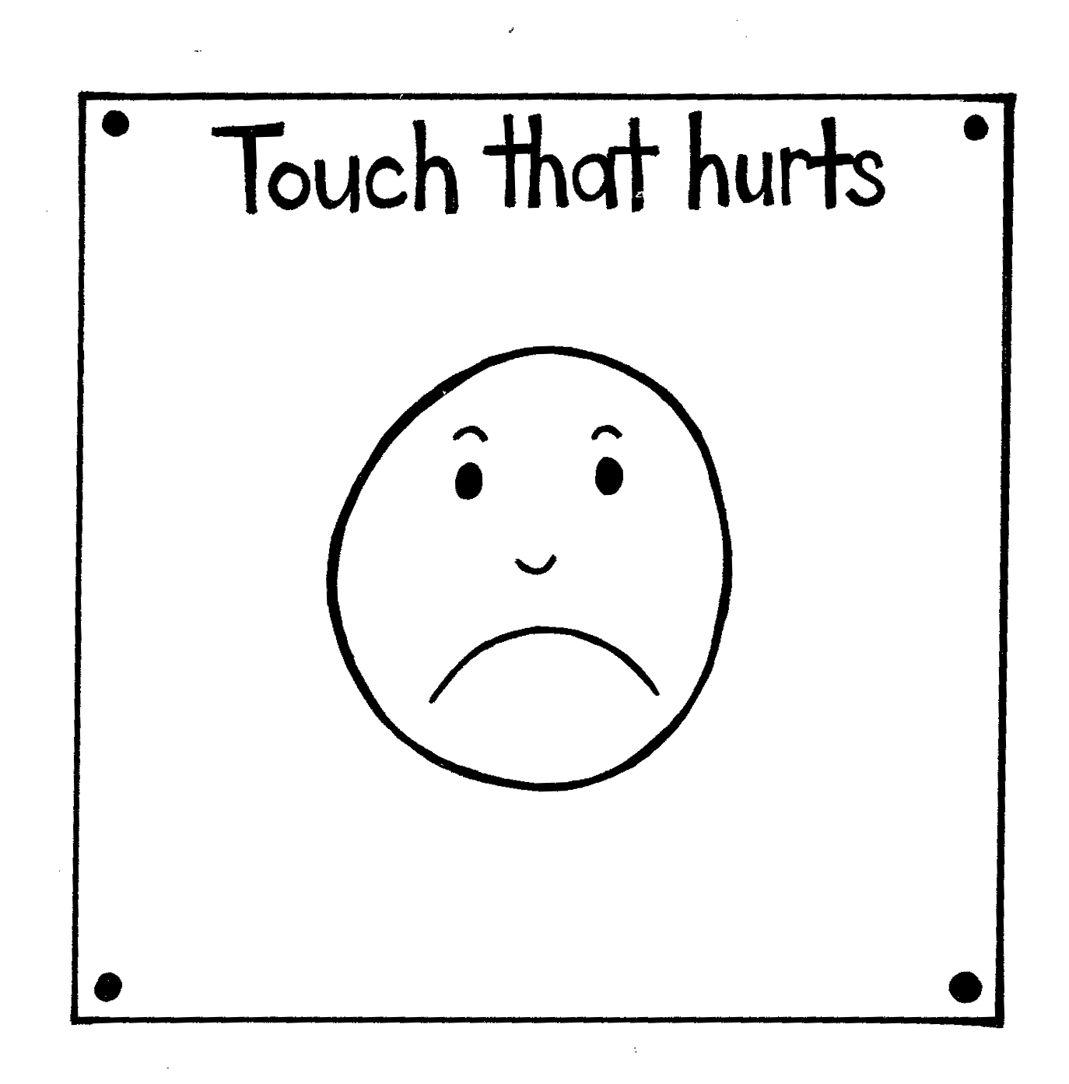

# Copysheet: “Child” minding

Dear parents,

As part of our Keeping Ourselves Safe (KOS) programme, the children are going to become chief babysitters for an egg! Yes – an egg! It is not allowed to be boiled, by the way.

The aim of this activity is for the children to learn to look after themselves and others – a theme that is woven through the Keeping Ourselves Safe programme.

The children will be responsible for the egg for **_____ days** and will have to care for the egg at all times.

The children can name their egg and create a bed (bassinet) for it. If the children want to leave their egg, they have to engage another person to egg-sit! If the child’s egg breaks, the challenge ends. They are not allowed to replace it.

Hopefully, the children will get an appreciation of the hard work you do as parents!

This will be an egg-citing challenge, and an egg-ceptional week. I am looking forward to watching your children become responsible and egg-stremely great parents!

Thank you for your cooperation.

# Learning experience 2 – The digital world

## Learning intentions

Students are learning to:

* identify various digital technologies
* describe how and when they use these technologies
* give some safety rules for using digital technologies.

## Notes for the teacher

Focus on the technologies that your students are currently using or are likely to use in the near future.

Refer to your school’s policy on internet and cell phone use. This may need to be reviewed.

* Schools that allow cell phone use during class need to be aware that there are mosquito ring tones that are impossible for an adult to hear.

Students sometimes invite teachers to be their friends on their social networking site.

* Teachers need to think carefully about the appropriateness of this, as it could be compromising.

A good tip for parents and caregivers is to insist that all cell phones are stored and charged in a parent’s bedroom overnight.

* This means that children are unable to be contacted, coerced into meeting someone outside, or text bullied at night.
* It can also help ensure they have cell phone-free time and are getting enough sleep.
* Paedophiles sometimes supply a child with, and top up, prepaid cell phones in order to contact the child at any time.

## Resources

Scenario 3 – The Many Faces of Lynn, (slides 35-41) from Making Good Choices Online (PDF), available on the Australian Government eSafety Commissioner website, at <https://www.esafety.gov.au/sites/default/files/2020-01/slides.pdf>

Saying things online you regret, on Netsafe website at <https://www.netsafe.org.nz/online-regret/>

Copysheet: Path to safe decisions

Homework activity sheet: Safety with people

## Activities

### 1 – Exploring digital technologies

Write ‘Digital technology’ on the board and explain what it means.

Brainstorm with the class all the examples of digital technology they know about. Examples may include:

* cell phone
* digital camera
* internet
* game consoles
* social networking sites
* emails
* computer
* laptop
* chromebook
* iPad/tablet.

Ask students to explain any technologies that you may not be familiar with.

Give each student some sticky dots. Ask them to stick one by each of the technologies they use.

Ask the students to give examples of risky situations for each of these technologies, then brainstorm together how someone could use Stop, Walk, Talk if they experienced that situation.

### 2 – Cyberbullying

“Cyberbullying is bullying that uses digital technology.”

As a class, discuss what this means. Explain that the cyberbullying can be worse than regular bullying because technology means that:

* something can be quickly shared with many more people than if it was a piece of paper passed around, or people saying things to others
* an image or mean comment can stay visible online for a long time
* it can happen any time which means it feels hard to get away from it
* it can be anonymous so it can be hard to find out who is doing it.

In small groups, look at scenario 3, The Many Faces on Lynn, (slides 35-41) from the resource [Making Good Choices Online](https://www.esafety.gov.au/sites/default/files/2020-01/slides.pdf) from the Australian Government eSafety Commissioner.

Use Copysheet: **The path to safe decisions**, or similar, to decide on the best choice in this situation. When students have finished they can share their choice with the class and explain why they thought it was the best idea.

**3 – Cyberbullying: What if you are the bully?**

Ask students to read the advice for young people from Netsafe at [Saying things online you regret](https://www.netsafe.org.nz/online-regret/).

In small groups, ask the students to make a plan for what the person who created the Many Faces of Lynn group could do if they realised it wasn’t okay.

## Homework activity

Give children the Homework activity sheet: **Safety with people** to complete with someone at home.

# 

# 

# 

# 

# 

# 

# 

# 

# Copysheet: The path to safe decisions

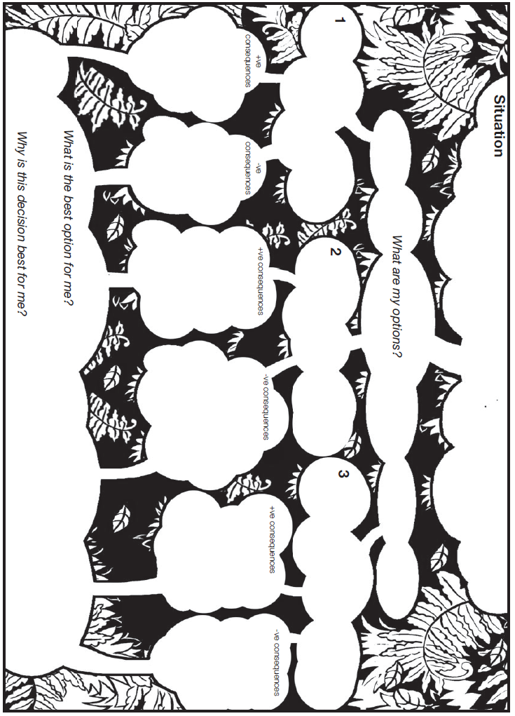

# Homework activity: Safety with people

As part of Keeping Ourselves Safe we talked in the classroom about how to identify potentially unsafe situations involving people.

* This could be people that children are with all the time, those they meet in the real world, or people that they meet online in the digital world.

Your child learnt how to use Stop, Walk, Talk when they feel unsafe.

* Talk to your child about situations that make them feel unsafe.
* Respect your child’s right to say no to touch or behaviour that they don’t like.
* Help them keep safe online.

Consider making a rule that children’s cell phones are stored/charged in your bedroom overnight. This means children cannot be contacted, coerced into meeting someone outside, or bullied, at night.

Please help your child with the following activities.

1. Ask them to explain Stop, Walk, Talk to you and to tell you when they might use it.
2. Ask them to demonstrate how they would use Stop, Walk, Talk in each of the following situations:

* Someone pushes you out of a line at school.
* Someone you have just met online asks for your address and a photo.
* A family friend kisses you on the mouth.
* You get a friend request from someone you don’t know.