Keeping Ourselves Safe – Junior primary

Focus area 3 – Unwanted behaviour or touch, Kore e hiahiatia te whanonga me te pā kino

The four focus areas in the Keeping Ourselves Safe (KOS) junior primary programme are:

1. I am unique, He taonga ahau
2. My body is my own, Nōku tōku tinana
3. Unwanted behaviour or touch, Kore e hiahiatia te whanonga me te pā kino
4. Adults who help, Ngā kaiāwhina pakeke

Research suggests that an effective programme should include learning experiences from each of the four focus areas.

**Contents**

Focus area 3 – Unwanted behaviour or touch, Kore e hiahiatia te whanonga me te pā kino 3

Notes for the teacher: preparation 3

Explanation 3

Curriculum links 3

Success criteria 3

Learning experience 1 – Saying “no” 4

Learning intentions 4

Notes for the teacher 4

Resources 4

Activities 5

Homework activity 7

Copysheet: Stop, Walk, Talk – Song words 8

Stop, Walk, Talk (emphasis for rapping) 9

Copysheet: Confident kids say “no” 10

Copysheet: Saying “no” sequence cards (a) 11

Copysheet: Saying “no” sequence cards (b) 12

Copysheet: Saying “no” sequence cards (c) 13

Homework activity: Saying “no” 14

Teacher reference: Telling sequence cards – set order 15

Learning experience 2 – Secrets and tricks 16

Learning intentions 16

Notes for the teacher 16

Resources 17

Activities 18

Homework activity 18

Copysheet: Trick card situations 19

Too Many Secrets for Mike 21

Homework activity: Secrets and tricks 25

# Focus area 3 – Unwanted behaviour or touch, Kore e hiahiatia te whanonga me te pā kino

## Notes for the teacher: preparation

* Ensure that safety guidelines are in place.
* All school staff, not just the teachers concerned, must know what to do if a student discloses abuse to them during or after Keeping Ourselves Safe.
* Parents should also be made aware of what to do. See the Child Protection Guidelines available on the NZ Police School Portal at <https://www.police.govt.nz/advice-services/personal-community-safety/school-portal/information-and-guidelines/child-protection>

## Explanation

* Students need to know that they can stop touch or behaviour that is inappropriate or that worries or confuses them, or makes them feel unsafe.
* Students need to be able to say “no” confidently, move away, and report what has happened.
* Students learn the difference between good secrets and bad secrets and know how to tell about bad secrets. They can recognise trick situations and deal with them safely.

## Curriculum links

Key Competencies: Managing self, Relating to others, Thinking

Learning areas: Level 1 Health and Physical Education

Strand A: Personal Health and Physical Development

* Safety Management: Describe and use safe practices in a range of contexts and identify people who can help.

Strand C: Relationships with other People

* Interpersonal Skills: Express their own ideas, needs, wants, and feelings clearly and listen to those of other people.

## Success criteria

Students can:

* describe what they would do when someone tells them a bad secret
* say what to do when people try to trick them
* identify who could help with a secret or trick
* express themselves clearly when they want to say no.

# Learning experience 1 – Saying “no”

## Learning intentions

Students are learning to:

* say “no” to touch, behavior, or words that worry or confuse them
* move away from a frightening situation and seek help.

## Notes for the teacher

**Saying “no”**

Children may find it hard to say “no” because:

* their personal safety is at risk
* they feel powerless and think they have to do what adults tell them
* they think they will be punished for ‘rude’ behaviour
* they think they will bring shame on the family, or break the family up
* the sexualisation of a relationship takes place gradually, moving from non-sexual touching to sexual touching. By the time this happens, the child feels already compromised
* they think they will be blamed for whatever happened on the computer
* abusers encourage children to feel guilty and often tell them they’ll be punished if they tell
* in a family harm situation this could lead to physical punishment (if this is the case, they should tell a trusted adult outside the family).

Children saying “no” to something that worries them or makes them feel unsafe is quite different from saying “no” to a reasonable request.

* They should say “no” when they feel unsafe. A reasonable request, such as being asked to help clear the table, doesn’t make children feel unsafe.
* A child who is being touched for health or welfare reasons, for example at the dentist, may feel unsafe but needs to comply, with adult support.

If children are facing a very violent situation such as physical abuse from a family member, or are witnessing family harm, it would not be safe for them to say “no”. The child should report this abuse to a trusted adult outside the immediate family.

## Resources

Available through the NZ Police School portal at <https://www.police.govt.nz/advice/personal-and-community-advice/school-portal/resources/successful-relationships/kos/junior-primary>:

* Touch Story Board 3, downloadable PDF
* Telling Sequence Cards, downloadable PDFs – Seven sets of cards. Choose sets appropriate for your class.

Teacher reference: Telling sequence cards – set order

Song: Stop, Walk, Talk video, available at <https://youtu.be/fbsbgMkKiHE>

Copysheet: Stop, Walk, Talk – Song words

Copysheet: Confident kids say “no”

Copysheet: Saying “no” sequence cards (a)

Copysheet: Saying “no” sequence cards (b)

Copysheet: Saying “no” sequence cards (c)

Homework activity sheet: Saying “no”

Sheets of paper and glue

## Activities

### 1 – Saying “no”

Review **Touch Story Board 3** with the class. 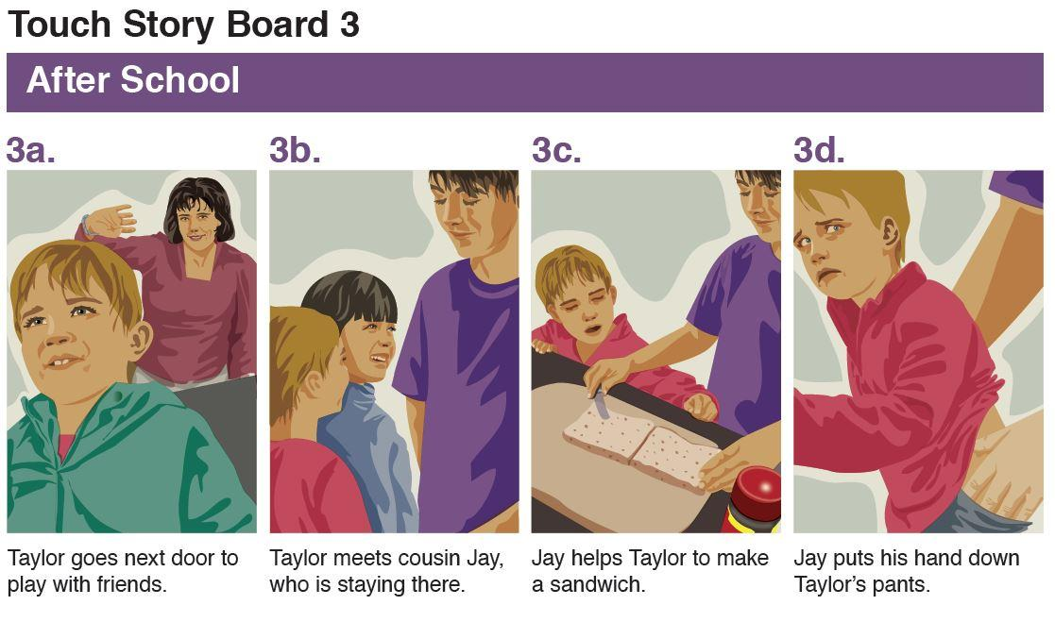

Children think/pair/share what Taylor could have said to Jay.

Take feedback from each group and record the children’s suggestions in the speech bubbles on Copysheet: **Confident kids say "no”**.

The table below shows some suggestions, in English, Māori and Samoan. You could ask your school community for suggestions from other relevant languages.

|  |  |  |
| --- | --- | --- |
| **English** | **Māori** | **Samoan** |
| No, I don’t like it. | Kāo, e kino ana ahau. | ‘Aua, e sā le mea lenā. |
| No! | Kāo! | ‘Aua! |
| No. I want you to stop. | Kāo. Me mutu tēnā. | ‘Aua. Aua ‘e te tago mai. |
| Stop it. I don’t like it. | Kāti. E kino ana ahau. | ‘Soia. E sā le mea lenā. |
| Stop it. I’m going to tell. | Kāti. Ka whāki atu ahau. | ‘Soia. Ou te ta’ua nei oe. |

Encourage students to describe the behaviour they want to stop – for example, “Stop pulling my hair”.

Have students stand up straight and say each of the phrases written in the speech bubbles on the copysheet, loudly and confidently. Praise them for this.

### 2 – Telling Sequence Cards

Work with one set of **Telling Sequence Cards** – we suggest using set 4 for this purpose.

Display the cards on the whiteboard and work with the class to put them in order. Ask the students what is happening in each picture. In general, the cards follow this sequence:

1. Something happens.
2. The child is scared, sad, or uncomfortable.
3. The child tells someone about this.
4. The adult does something to help.

The correct sequences are shown in Teacher reference: **Telling sequence cards – set order**.

Divide students into small groups, each group working with one set of the Telling Sequence Cards. When the sequence is complete they tell the story to each other.

Ask:

* When should you say “no”? (When you feel unsafe)
* Why is it sometimes hard to say “no”?
* Even if you can’t say “no”, what else could you do? (Walk away and tell an adult you trust)

With younger students you may prefer to work with the whole class on this activity.

### 3 – Song: Stop, Walk, Talk

Sing [Stop, Walk, Talk](https://youtu.be/fbsbgMkKiHE) with your students, using the words and link in the Copysheet: **Stop Walk Talk – Song words**. Encourage students to use the actions below.

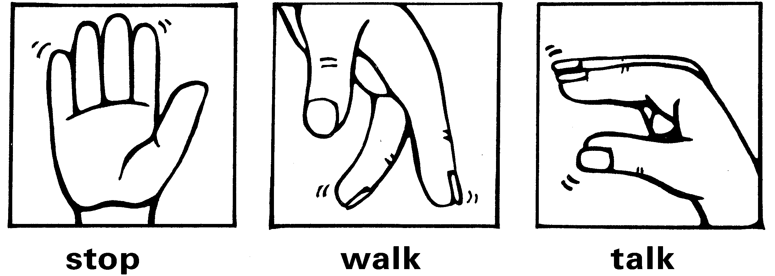

### 

### 4 – Saying “no” using sequence cards

Students work individually or in pairs using one of the copysheets.

**Saying “no” sequence cards (a)**

Students cut out the cards and glue them in the correct sequence on a sheet of paper.

Older students can write a story about what is happening.

**Saying “no” sequence cards (b)**

Students write in the speech bubbles to show what is happening.

**Saying “no” sequence cards (c)**

Students draw pictures in each box to show someone stopping an unsafe situation and asking for help. They show the pictures to a partner who tells the story about what is happening.

## Homework activity

Give children the Homework activity sheet: **Saying “no”** to complete with someone at home.

# Copysheet: Stop, Walk, Talk – Song words

© 2005 Radha Sahar, UCA Music. Available at <https://youtu.be/fbsbgMkKiHE>.

Verse 1 If someone touches you and you don’t feel safe

Tell them to stop, then walk away, just

Walk away, get outa there

Tell someone you can trust around here, say …

Chorus Stop! (I don’t like it)

Walk away (shoo!)

Go talk to someone who knows what to do

Whakamutua!

Haere atu!

Korerotia!

That’s what I’ll do!

Stop! Walk! Talk!

Verse 2 If someone touches me and I don’t feel safe

I tell them to stop, I walk away

I walk away, I get outa there

I tell someone I can trust around here. I say …

Chorus Stop! (I don’t like it)

Walk away (shoo!)

Go talk to someone who knows what to do

Whakamutua!

Haere atu!

Korerotia!

That’s what I’ll do!

Stop! Walk! Talk!

# Stop, Walk, Talk (emphasis for rapping)

© 2005 Radha Sahar, UCA Music

If someone touches you and you don’t feel safe

Tell them to stop, then walk a-way, just

Walk a-way, get out'a there

Tell someone you can trust around here, say

Stop! (I don’t like it)

Walk away (shoo!)

Go talk to someone who knows what to do

Whakamutua!

Haere atu!

Korerotia!

That’s what I’ll do!

Stop! Walk! Talk!

If someone touches me and I don’t feel safe

I tell them to stop, I walk a-way

I walk a-way, I get out'a there

I go and tell someone I can trust around here. I say …

# Copysheet: Confident kids say “no”

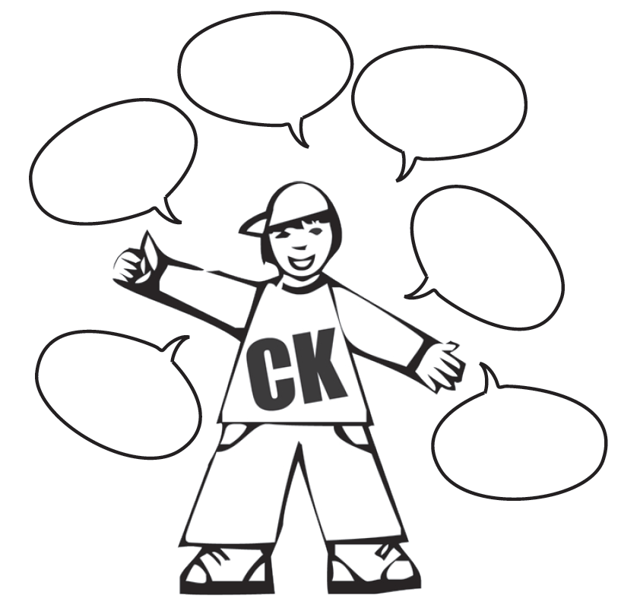

# Copysheet: Saying “no” sequence cards (a)

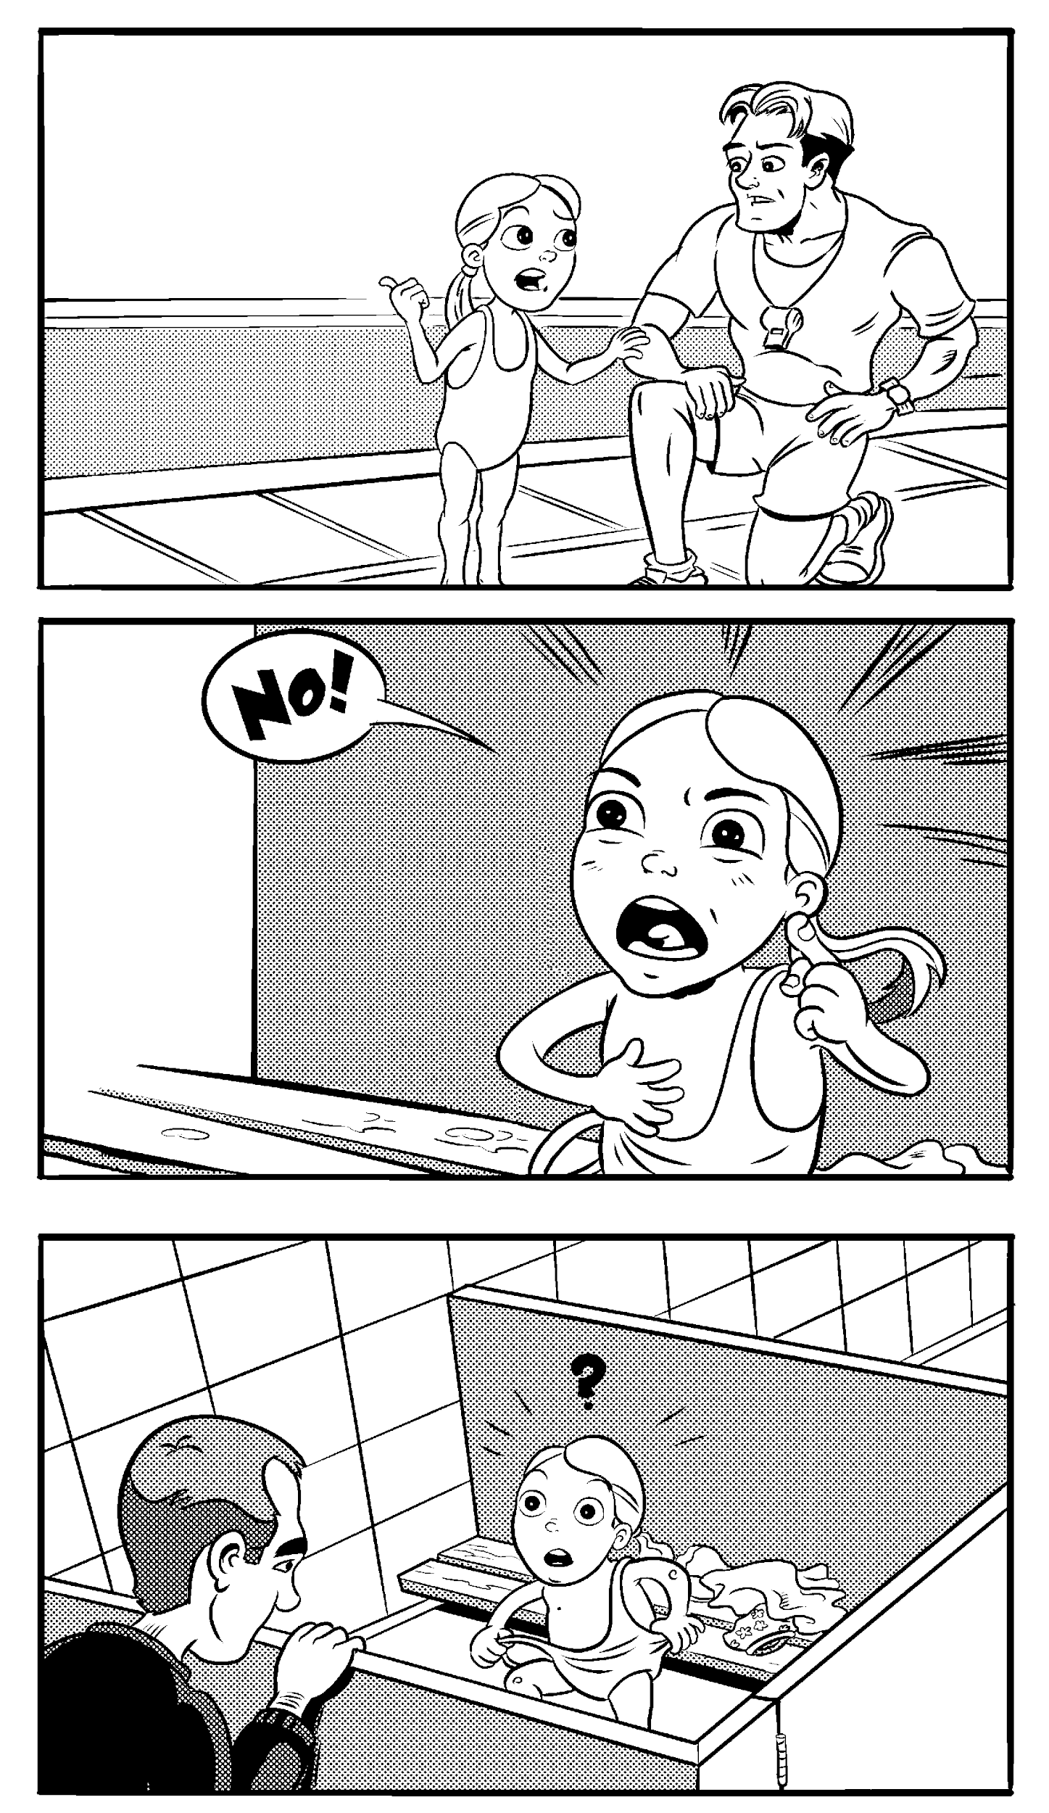

# Copysheet: Saying “no” sequence cards (b)

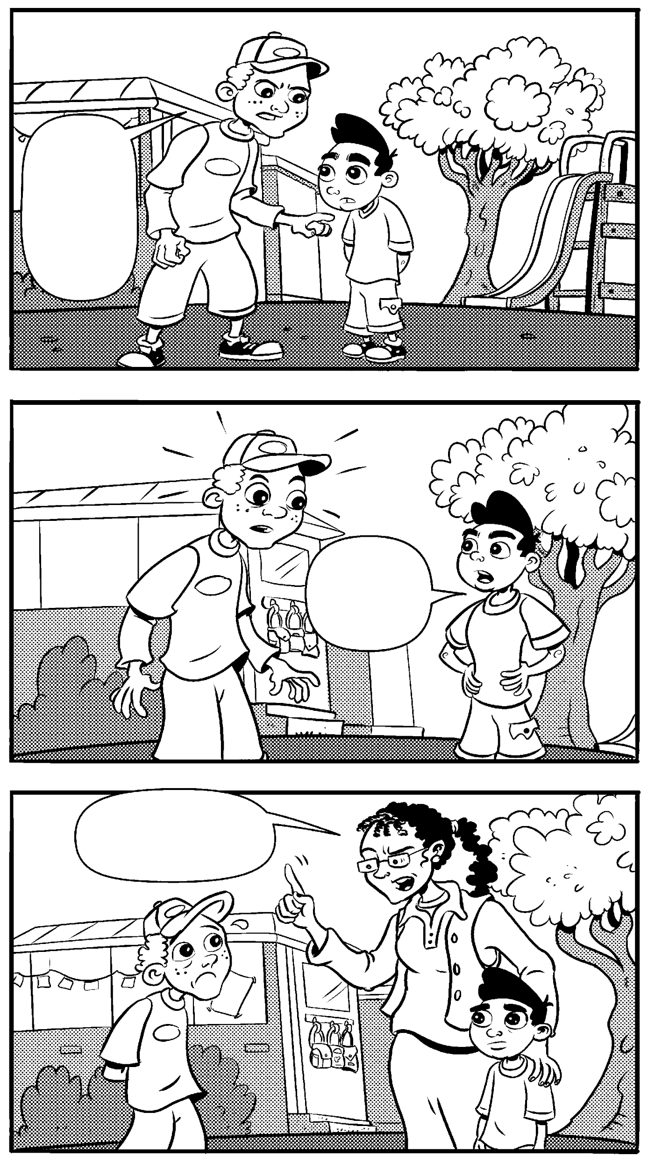



# Copysheet: Saying “no” sequence cards (c)

# Homework activity: Saying “no”

Today in Keeping Ourselves Safe we talked about how important it is for children to say “no” to touch or behaviour that worries or frightens them or makes them feel uncomfortable.

* Respect your child’s right to say “no” to touch they don’t like.
* Don’t ask or force your child to give other people a kiss or a hug.
* Support your child when they say “no” to touch or behaviour they don’t like.
* Help them keep safe online.

Please help your child with the activities below.

Role-play each of the following situations with your child. You may prefer to make up some situations of your own. Your child should respond with one of the following phrases and practise walking away.

* No, I don’t like it.
* No!
* No. I want you to stop.
* Stop it ... I don’t like it.
* Stop it – it’s not allowed.

**Situations**

* Big brother or sister is teasing you.
* Mum or Dad is tickling you too hard.
* Grandma gives you a big kiss.

# Teacher reference: Telling sequence cards – set order

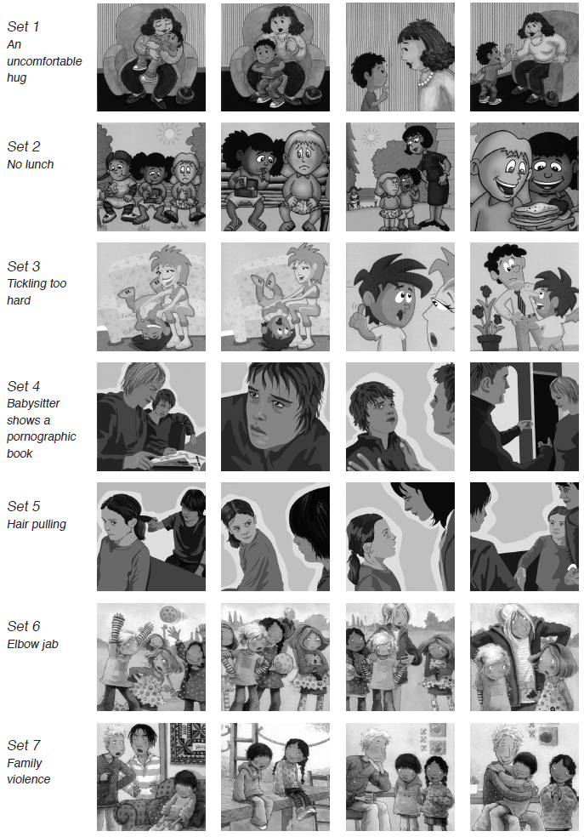

# Learning experience 2 – Secrets and tricks

## Learning intentions

Students are learning to:

* identify the difference between good secrets and bad secrets
* identify the adults they trust about bad secrets
* explain safe practices for trick situations, including online.

## Notes for the teacher

**Secrets**

Children often find it hard to distinguish between a good secret, such as a surprise party, and a bad secret, such as sexual touch. Children need to be able to distinguish the two.

* Generally, a good secret makes people feel good, while a bad secret makes people feel bad and should be told. Always praise a child for reporting a bad secret.
* Some secrets may be unsafe, and yet the person feels okay about it – for example, a girl who gets a text message asking her to meet face to face someone she met online.

Children have often been conditioned not to tell secrets.

* Some families may actively encourage children to keep family secrets, for example, refugee families from war-torn countries, families keeping secrets from police, or families hiding child maltreatment and family harm.
* They may punish children for not keeping these secrets.

During consultation, parents and caregivers need to understand that the secrets being talked about are ones that make the child unsafe – for example, if someone is treating them in a sexually inappropriate way.

Adults sometimes tell children not to tell tales.

* This could discourage the child from reporting inappropriate behaviour or touch in the future. It is best to listen carefully to each report and then decide how to handle it.

Sometimes a person who is abusing a child will tell them that it is a secret and they mustn’t tell anyone.

* The abuser may say that something bad will happen if the child tells – they will get into trouble, no one will believe them, or someone else might get hurt.

**Tricks or bribes**

People who molest children, whether known or unknown to the child, often use tricks or bribes to get the child to go with them or to accept inappropriate behaviour. They may offer a ride on the pretext that the child’s parents have sent them, or that there is an emergency.

* Children need the skills to be able to ignore such offers and to refuse bribes or treats firmly and promptly. They should quickly move away and tell an adult they trust.
* Children can be ‘groomed’ online for abuse with many of the same tricks or strategies that are used in face-to-face situations. Technology can provide easy access to the child, covertly and without a parent’s knowledge.
* There are other ways in which children can be tricked online into viewing explicit material and giving away personal and family information.
* Young children need to be encouraged always to talk with an adult before responding to an online request. Very young children should be supervised when online.

**Keeping safe**

Families should always know where their members are and what they are doing.

* If children are invited to go somewhere, they should ask the person who is in charge of them before going. If they can’t ask their parents, they should ask a responsible adult, such as a teacher.
* If no adult is about, they should make a safe decision and move quickly and confidently away to safety.
* This safety rule applies whether the person is unknown to them or someone they know well, such as a long-time family friend or neighbour.

## Resources

Trick Cards, downloadable PDF, available through the NZ Police School portalat <https://www.police.govt.nz/advice/personal-and-community-advice/school-portal/resources/successful-relationships/kos/junior-primary>

* Cut up and place the cards in a “bag of tricks” (supplied by the teacher)

Bryan and Bobby video, Secrets, available at <https://bryanandbobby.co.nz/video/>

Copysheet: Trick card situations

Story: Too many secrets for Mike

Homework activity sheet: Secrets and tricks

## 

## Activities

### 1 – Trick cards

Explain to students that sometimes other people may try to trick them into doing things they shouldn’t do – for example, going somewhere with somebody without telling the person in charge of them.

Introduce the Bag of Tricks to the class.

* The students take turns at taking out a card.
* The teacher reads out the situation that relates to that card from Copysheet: **Trick card situations.**
* Ask the student what they would do in that situation.

Remember that the student should always say “no” and move quickly away and tell an adult they trust.

### 2 – Too Many Secrets for Mike

Read the story Too Many Secrets for Mike to the class. At each break in the story, ask the questions listed.

### 3 – Secrets and tricks

Show the Bryan and Bobby video [Secrets](https://bryanandbobby.co.nz/video/).

Some students who are newer to New Zealand English may find it harder to understand what is said in the video. Pause the video at relevant places to ask students to predict what will happen or what the person will say next; and to recap on what actually happened or what was said.

Discuss with the children a time they have kept a good surprise, for example a surprise birthday party, to check that the class has a clear understanding of the difference between a good surprise and a bad secret.

## Homework activity

Give students Homework activity sheet: **Secrets and tricks** to complete with someone at home.

# Copysheet: Trick card situations

Card 1 Kitten

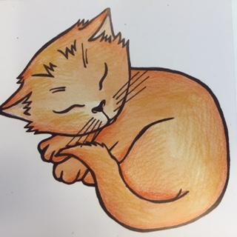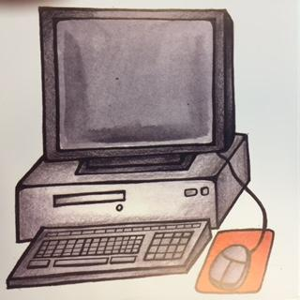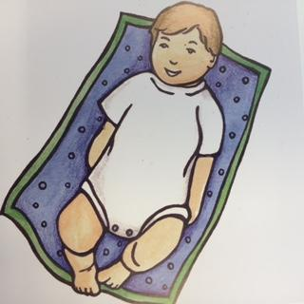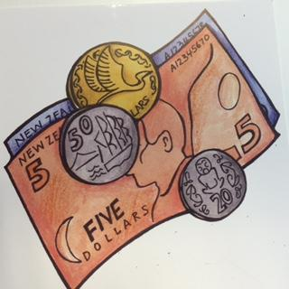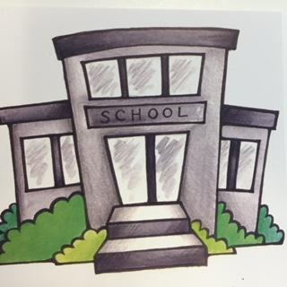

Someone stops you in the street and asks if you would like to come and see their new kittens.

Card 2 Computer

A friend you’ve met online sends you a link to a website. It’s got pictures of nude children and adults.

Card 3 Baby

An adult from your school asks you to go home with them to see their new baby. Your family doesn’t know about this.

Card 4 Money

Your babysitter sits by you on the couch and offers you $20 if you take off your underpants.

Card 5 School

You are waiting for the person who looks after you to pick you up after school. Someone you don’t know comes past in a car and says that they have been asked to pick you up and take you home.

Card 6 Cake

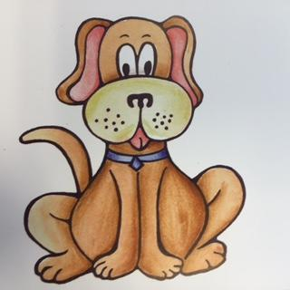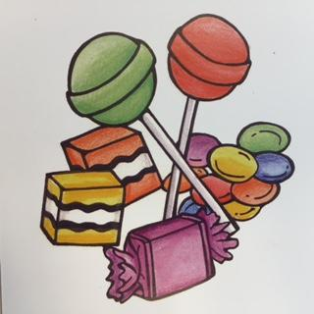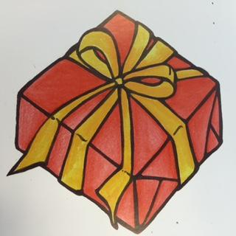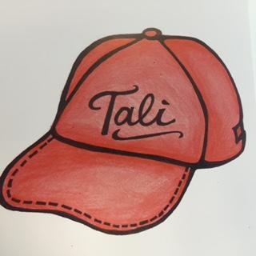

Your brother says he will buy you some cake if you let him take photos of you with no clothes on.

Card 7 Puppy

On the way home from school someone stops you and your brother and asks if you will help find their lost puppy.

Card 8 Lollies

You are at the beach. Some big kids you know offer you lollies if you go up into the sand hills with them.

Card 9 Present

One of your family’s friends says he has a special present for you in his car and wants you to go with him to get it.

Card 10 Cap

Someone stops you in the mall and says “Hello, Tali” and invites you to go and have an ice cream with them. You don’t know them, but they must know you because they know your name.

# Too Many Secrets for Mike

by Caryl Hamer

“Can you keep a secret?” asked Mike’s Dad one morning. “You have to promise not to tell anyone. I want it to be a real surprise.”

“Promise,” said Mike, feeling excited. “I won’t tell anyone.”

“It’s like this,” said Dad. “I want to take your mother out somewhere special for our wedding anniversary on Saturday, but I don’t want her to guess what’s happening. I want her to think she’s not going anywhere, then just when she’ll think I’ve forgotten all about it, I’ll tell her I’ve got a secret surprise for her and off we go.”

“What about me, though?” said Mike. “Who’ll look after me?”

“Well, there’s a bit of luck,” said Dad. “I met your Uncle Steve today and he said he’d come and stay with you on Saturday. How about that?”

Uncle Steve was Mike’s favourite uncle. Mike couldn’t think of anything he’d like better.

“Does anyone else know the secret?”

“No one knows except you,” said Dad. “I want your Mum to have a real surprise.”

**Questions**

What was the secret that Dad wanted Mike to keep?

How did this secret make Mike feel?

Was it a good surprise or a bad secret?

The next day at school, when Mike went to hang up his bag, he nearly bumped into Jason. Jason was standing right behind the door. He had a sandwich in his hand and he was eating it in huge gulping bites. When he saw Mike he looked angry.

“Why are you eating your lunch now?” asked Mike, surprised.

Jason pushed him hard. “You shut up, Mike,” he said. “Don’t you tell anyone about me. I’ll beat you up if you do!”

“OK, I’ll keep it a secret,” said Mike. If Jason wanted to eat his lunch before school, he didn’t see that it mattered. It could be a secret for all he cared.

At lunchtime, Pita was crying because someone had taken his lunch.

“Does anyone know anything about Pita’s lunch?” asked Mrs Haumaha, their teacher.

Mike suddenly remembered Jason and how angry he’d been. He looked around at him. Jason glared and made a fist as if he wanted to hit him.

“Someone must know something,” said Mrs Haumaha. Mike didn’t say anything, but later when school was over he put his things away very slowly so that he was the last person to leave.

Mrs Haumaha came over to sit down next to him.

“Something’s bothering you, isn’t it, Mike?” she said.

He opened his mouth to say something then he thought of Jason’s fist. “I’m OK,” he said. And he ran out to where his mother was waiting.

**Questions**

What was the secret Jason wanted Mike to keep?

Was this a good surprise or a bad secret?

Should Mike tell Mrs Haumaha about this? Why, or why not?

On Saturday Mike’s mother was surprised when Uncle Steve arrived, and really happy when Dad told her he was taking her out.

Uncle Steve and Mike had a wonderful day. They went to a film, had McDonald’s for tea and played games until it was really late.

“Look at the time!” said Uncle Steve. “You should be in bed. Your mother would be mad if she knew. We’d better keep it a secret, eh?”

He grinned at Mike. “If you want, I’ve got another surprise – one for real big kids. But it’s got to be a secret, too. A real secret. Promise?”

Mike felt excited. He wondered what the secret was.

Uncle Steve put a game on the computer, settled himself back on the couch with a drink, and beckoned to Mike to come and sit beside him.

“This is our secret, remember,” he said.

The game was quite good at first, then it started to make Mike feel very uncomfortable. A man was hurting a woman. She screamed. Mike screamed, too. He got up quickly.

Uncle Steve laughed. “Bit much for you, is it?” He didn’t sound like Uncle Steve at all. He stopped laughing and looked hard at Mike.

“You’d better remember this is our secret,” he said. “I’m not doing anything wrong. But if you tell anyone, you’ll be sorry. You’d better believe me!”

“I won’t tell,” said Mike. He felt scared. He wanted to get away.

He got into bed, but he couldn’t sleep. Uncle Steve had said not to tell anyone and the way he looked made Mike feel scared. Why did Uncle Steve want it to be a secret if he wasn’t doing anything wrong?

**Questions**

What was the secret Uncle Steve wanted Mike to keep?

Was it a good surprise or a bad secret?

Who should he tell about this? What could he say?

When Mike got up in the morning, Uncle Steve had already gone home. At breakfast, Mike’s mother gave him a cuddle.

“Thanks for keeping my treat a secret,” she said. “It was a lovely surprise.”

“I hate secrets,” said Mike. “I hate them, I hate them!” And he began to cry.

Mike’s mother held him close.

“I thought something was the matter,” she said. “There’s nothing wrong with a secret that makes everyone feel good, but there are some secrets that have to be shared.”

“I love Uncle Steve. We had a great time,” said Mike.

“I know,” said his mother. “But no one should make other people feel bad.”

Mike told her about what had happened.

“That was a really awful secret to have to keep to yourself,” said his mother, “I’m glad you shared it with me. Now don’t worry anymore. I’ll talk to your Uncle Steve.”

“He said he’d get me if I told on him,” said Mike.

“No way!” said his mother. “No one’s going to get you.” She gave him a hug. Mike felt a lot better.

**Questions**

How did Mum feel about being taken out to dinner by Dad? Was this a good surprise or a bad secret?

Was it a good idea for Mike to tell Mum about Uncle Steve’s bad secret? Why, or why not?

What is Mum going to do about it?

At school on Monday, Mrs Haumaha called the class together and said she had something to tell them. She had an idea, she said, that some of the class were coming to school without any breakfast.

“We can’t have anyone feeling hungry here. So if you miss out on your breakfast, or if you know anyone who might need a bit to eat before school starts, let me know and I’ll rustle up something to eat.”

At lunchtime Mike waited until everyone had gone outside and then he went up to Mrs Haumaha.

“I need to tell you something,” he said. “It’s a sort of secret but I want to share it. I don’t like secrets that make me feel bad inside.”

“That sort of secret isn’t a proper secret anyway,” said Mrs Haumaha. “If a secret makes you feel bad, you should tell someone about it before it gets worse.”

“Yes,” said Mike, “I will.”

**Questions**

Was it a good idea for Mike to tell Mrs Haumaha about this secret? Why, or why not?

How do you think Mike felt once he had told her?

What are some other good surprises that we shouldn’t tell about?

What are some other bad secrets?

How do bad secrets make us feel?

What should we always do when we hear a bad secret?

# Homework activity: Secrets and tricks

Today in Keeping Ourselves Safe we learnt that people who wish to harm children, whether they are known to the child or not, sometimes use tricks or bribes to get a child to go with them, or do what they say. If they have abused a child they may say that it is a secret and that if the child tells, something bad will happen or the child will get into trouble.

* Help your child to tell the difference between good surprises and bad secrets.
* Tell them that a good surprise makes people happy and it is okay to keep this kind of secret.
* Tell them that a bad secret makes people feel sad or scared, and they need to tell an adult.
* Tell them that they can always tell you about a bad secret.
* Listen if they report tricks or bad secrets to you, and do something to help.

Please help your child with the following activities.

1. Write down a good surprise.
2. Write down a bad secret.

Give one of the situations below to your child. Get them to role-play Stop, Walk, Talk (Stop, walk away, tell someone who can help). Repeat with the other situations.

* Your friend has been playing with matches and has asked you not to tell.
* Your cousin showed you ‘rude’ pictures online and said it was a secret.
* Someone you don’t know friended you online and said not to tell anyone.

# 