Keeping Ourselves Safe – Junior primary

Focus area 2 – My body is my own, Nōku tōku tinana

The four focus areas in the Keeping Ourselves Safe (KOS) junior primary programme are:

1. I am unique, He taonga ahau
2. My body is my own, Nōku tōku tinana
3. Unwanted behaviour or touch, Kore e hiahiatia te whanonga me te pā kino
4. Adults who help, Ngā kaiāwhina pakeke

Research suggests that an effective KOS programme should include learning experiences from each of the above focus areas.

**Contents**

Focus area 2 – My body is my own, Nōku tōku tinana 3

Notes for the teacher: preparation 3

Explanation 3

Curriculum links 3

Success criteria 4

Learning experience 1 – Physically me 4

Learning intentions 4

Notes for the teacher 4

Resources 5

Notes on resources 5

Activities 6

Homework activity 6

Copysheet: Body parts labels 7

Copysheet: Body outlines (1) 9

Copysheet: Body outlines (2) 10

Homework activity: My body (1) 11

Homework activity: My body (2) 12

Copysheet: My Amazing Body – Song words 13

Learning experience 2 – Touch 14

Learning intentions 14

Notes for the teacher 14

Resources 15

Activities 15

Homework activity 18

Homework activity: Touch 19

# Focus area 2 – My body is my own, Nōku tōku tinana

## Notes for the teacher: preparation

* Ensure that safety guidelines are in place.
* All school staff, not just the teachers concerned, must know what to do if a student discloses abuse to them during or after Keeping Ourselves Safe.
* Parents should also be made aware of what to do. See the Child Protection Guidelines available on the NZ Police School Portal at <https://www.police.govt.nz/advice-services/personal-community-safety/school-portal/information-and-guidelines/child-protection>

## Explanation

* Students learn the correct names for parts of their body including their genitalia.
* They understand that their bodies are their own and that no one should touch their genitals unless it is for health reasons.
* Students consider touch that they like, touch that hurts, and touch that is confusing.
* Students are moving towards an understanding that sexual touch of children is wrong. This should include other people playing with their genitals or putting things in their mouths. They need to know that this behaviour is wrong and is reportable.
* Students also need to understand that it is not okay for people to physically hurt and abuse them. This kind of behaviour should also be reported.

## Curriculum links

Key Competencies: Managing self, Relating to others, Thinking

Learning areas: Level 1 Health and Physical Education

Strand A: Personal Health and Physical Development:

* Safety Management: Describe and use safe practices in a range of contexts and identify people who can help.

Strand C: Relationships with other People:

* Interpersonal Skills: Express their own ideas, needs, wants, and feelings clearly and listen to those of other people.

## 

## Success criteria

Students can

* explain why it is important to use the correct terms for body parts
* understand the difference between touch they like, dislike, or find confusing
* explain what they can do when someone touches them in a way they dislike.

# Learning experience 1 – Physically me

## Learning intentions

Students are learning to:

* use the correct names for body parts
* say that their body is their own
* understand what consent means.

## Notes for the teacher

This focus area helps students to feel positive about and in control of their own bodies. This is useful for helping them to say “no” to touch and behaviour they do not like. Saying “no” is covered in Focus area 3, including saying “no” to sexual touch and physical hurt and abuse.

**Naming body parts**

It is important that children learn the correct names for all parts of their bodies.

* Teachers should plan well ahead of time for the social, cultural and religious considerations around naming of body parts. Students can be embarrassed, shy or ashamed, as this is not part of regular conversation at home.
* Children may have the impression that it is rude to talk about genitals, because they are not talked about or they are referred to as dirty. This could discourage them from reporting abuse.
* Children need to be able to use the correct medical terms so they can be understood when they describe symptoms to health professionals, or describe any form of abuse.
* Teachers should encourage parents and whānau to use the correct terminology at home.

**Gender identity**

Teachers should not make assumptions about children’s gender identity. They should also be mindful that students’ parents, siblings, friends and family members may identify as gender diverse, or be same or both sex attracted.

Use inclusive language so all children feel that the conversation is relevant to themselves, their bodies, and their families and whānau.

Some phrases you could use are:

* Some children have a penis, some children have a vulva/vagina – rather than boys have a penis, girls have a vulva/vagina.
* Use genitals rather than penis/vagina when the type of genital is unknown – don’t assume that a male presenting child will have a penis.
* Parents, whānau, or caregivers, rather than Mum and Dad.

To find out more about gender diversity and inclusive language, visit these areas of the Inclusive Education website guide: Supporting LGBTIQA+ students:

* [Using inclusive language to affirm diversity](https://www.inclusive.tki.org.nz/guides/supporting-lgbtiqa-students/use-inclusive-language-to-affirm-diversity)
* [Building knowledge of sex, gender, and sexuality diversity](https://www.inclusive.tki.org.nz/guides/supporting-lgbtiqa-students/build-understanding-of-key-concepts-and-terms)

## Resources

Song: My Amazing Body, video available online at <https://youtu.be/_m5iz-Z1rrI>

Copysheet: Body parts labels

Copysheet: Body outline (1), (2)

Copysheet: My Amazing Body – Song words

Video: Consent for kids <https://www.youtube.com/watch?v=h3nhM9UlJjc> (up to 1:30)

Homework activity sheet: My body (1) , (2)

## Notes on resources

Body parts labels

* The correct terminology is used for breasts, penis, scrotum or testicles, anus, vulva, and vagina. Vulva is used for the external female genitalia, and vagina for the internal female genitalia.
* The correct names for the body parts have been given in English and te reo Māori. Use the te reo Māori terms if that is appropriate for your class. There are a number of different, often overlapping, words for vulva and vagina in te reo Māori. Use the terms that are the most appropriate for your students.
* Teachers could also use the correct names from other cultures, if appropriate.

Body outlines

* There are two body outline options. In the first, the body outlines are male and female figures, but without stereotypical male or female hairstyles. In the second option, the body outlines are simple gingerbread people, which are not identified as male or female.

## Activities

### 1 – Naming parts of the body

Decide whether to use **Body outlines (1) or (2)**. Create your chosen outlines as posters.

Ask students to name different parts of the body, including the genitals. Write the names on the outlines poster with a marker.

* You may need to teach the children the word ‘genitals’ if they are not familiar with it.
* If students use pet names for the genitals, list these beside the poster. Also write the correct word in the list. Then work with the students to find the correct name from the list and write it on the poster.

Display the completed posters.

### 2 – Song

Sing the song [My Amazing Body](https://youtu.be/_m5iz-Z1rrI) with the class, using the words and link on the Copysheet: **My Amazing Body – Song words**. Ask students to make up actions for the song that show their amazing body belongs to them.

### 3 – Consent

Watch the video [Consent for Kids](https://www.youtube.com/watch?v=h3nhM9UlJjc) up to 1:30.

Discuss the messages in this video and what consent means.

* Make sure they understand we need to ask for consent and respect the person’s answer.
* Emphasise that they are in charge of their bodies and can make their own decisions about what happens to their bodies.

In pairs, students ask each other whether they would say yes or no in the following situations:

* Your friend asks to hug you when you are sitting on the mat
* Your mum asks you to give your uncle and auntie a kiss goodbye
* Your sister or brother asks to play fight with you while you are playing a game
* Your neighbour asks you to cuddle up close while they share a story with you.

## Homework activity

Students take Homework activity sheet: **My body** to complete with someone at home. Choose the body outline option that is appropriate for your students.

# Copysheet: Body parts labels

Cut into separate labels.

------------------------------------------------------------------------------------

Ankle Punga

------------------------------------------------------------------------------------

Wrist Whatīanga ringa

-----------------------------------------------------------------------------------

Shoulder Pakihiwi

------------------------------------------------------------------------------------

Thigh Heke

------------------------------------------------------------------------------------

Penis Ure

------------------------------------------------------------------------------------

Scrotum Pūraho

------------------------------------------------------------------------------------

Anus Whero

------------------------------------------------------------------------------------

Vulva Tore

------------------------------------------------------------------------------------

Breasts Uma / Poho / Ū

------------------------------------------------------------------------------------

Neck Kakī

------------------------------------------------------------------------------------

Mouth Waha

------------------------------------------------------------------------------------

Knee Pona

------------------------------------------------------------------------------------

Bottom Whero / Tou

------------------------------------------------------------------------------------

Stomach Puku

------------------------------------------------------------------------------------

Testicles Raho

------------------------------------------------------------------------------------

Vagina Nono

------------------------------------------------------------------------------------

# 

# Copysheet: Body outlines (1)

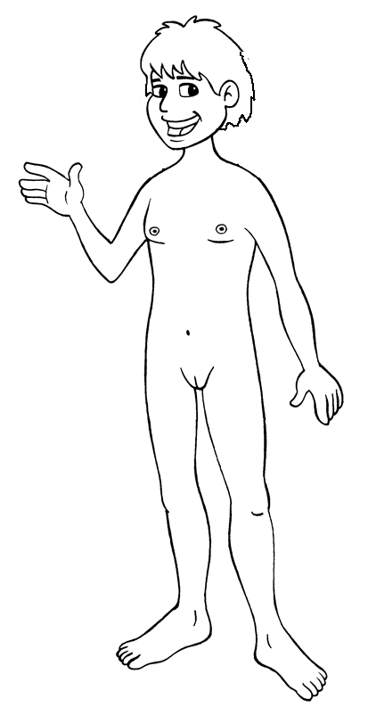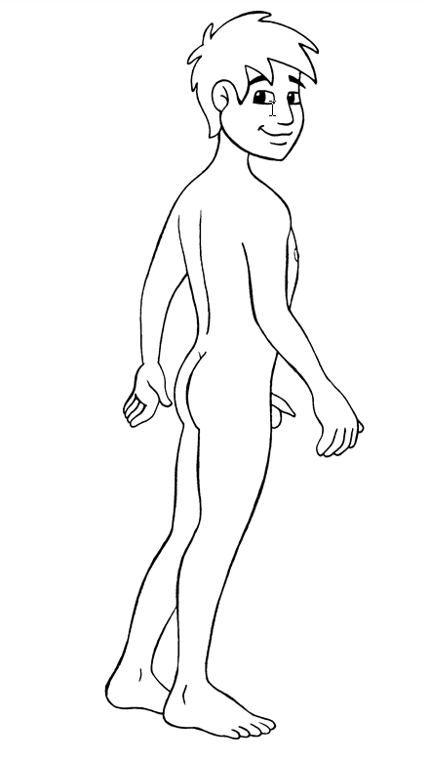

# Copysheet: Body outlines (2)

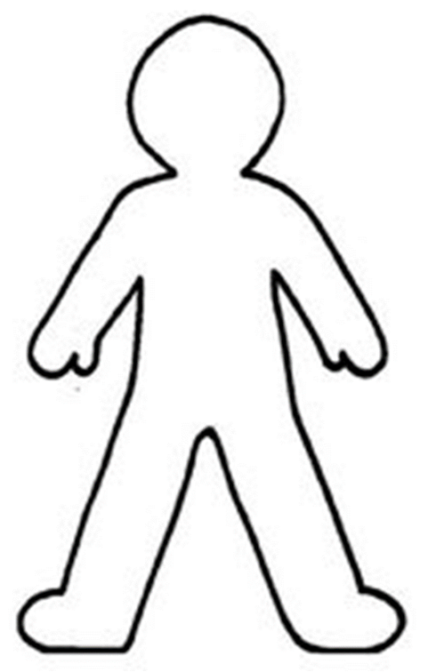

# Homework activity: My body (1)

Today in Keeping Ourselves Safe we practised using the correct names for all the parts of our body. This includes the correct names for the genitals.

* Children need to know the correct medical terms so they can use them when talking to a doctor or nurse, or if they need to explain something that has happened to them.
* Encourage your child to take increasing care of their own bodies, and use the correct names for the genitals with them as much as possible.

Please help your child to write the correct names for the different parts of the bodies below, including genitals.



Tick if your child can:

|  |  |
| --- | --- |
| Clean their own teeth | Wash themselves in the bath |
| Brush their own hair | Go to the toilet by themselves |
| Get dressed by themselves | Wash their hands after going to the toilet |
| Cut their fingernails and toenails | Wash their hair |
| Put on clean underwear every day | Put their dirty clothes in the laundry |

# Homework activity: My body (2)

Today in Keeping Ourselves Safe we practised using the correct names for all the parts of our body. This includes the correct names for the genitals.

* Children need to know the correct medical terms so they can use them when talking to a doctor or nurse, or if they need to explain something that has happened to them.
* Encourage your child to take increasing care of their own bodies, and use the correct names for the genitals with them as much as possible.

Please help your child to write the correct names for the different parts of the bodies below, including genitals.



Tick if your child can:

|  |  |
| --- | --- |
| Clean their own teeth | Wash themselves in the bath |
| Brush their own hair | Go to the toilet by themselves |
| Get dressed by themselves | Wash their hands after going to the toilet |
| Cut their fingernails and toenails | Wash their hair |
| Put on clean underwear every day | Put their dirty clothes in the laundry |

# Copysheet: My Amazing Body – Song words

© 2008 Radha Sahar, UCA Music. Song is online at <https://youtu.be/_m5iz-Z1rrI>

Chorus This is my amazing body

And it’s how it’s meant to be

Noku nei taku tinana (This is only MY body)

It all belongs to me!

This is my amazing body

And it’s special all the time

Wonderful arms and legs and tummy

Mine and only mine!

Verse 1 No one should touch me in a way I do not like

I say “NO,” I say “NO – this is my body!”

No one should touch me in a way I do not like

I say “NO,” I say “NO – this is my body!”

Chorus

Verse 2 I’m the boss of my own body

And I say what I like

I’m the boss of my own amazing body

I’m the boss of my own body

And I say what I like

I’m the boss of my own amazing body

Chorus

Noku nei taku tinana

Kia pai te awhi taku tinana! (I look after my body)

A naa! (I’m telling you! It’s up to you now, to take note and act on it)

# Learning experience 2 – Touch

## Learning intentions

Students are learning to:

* describe whether a touch is one they like, one they don’t like or one that is confusing
* identify how different types of touch make them feel.

## Notes for the teacher

**Touch**

Adults need to respect children’s rights and feelings about being touched in ways that hurt or worry them.

* The safety rule is: touch or play for fun or for affection should be okay with each person; it should be safe; and it should be allowed by the adults in charge.
* While most children will want to stop touch that hurts, some kinds of touch make them feel confused. For example, if a trusted adult touches the child sexually, it may confuse them.
* Adults need to support the child’s right to say “no” if they feel unsafe or uncomfortable.

Sometimes it is hard for a child to say “no” to unwanted touch from family members or a close family friend.

* Children are reluctant to say anything in case it hurts the other person’s feelings, or they or the person get into trouble.
* Adults have to support a child in a situation like this. For example, if the child no longer wants to be kissed by granddad or aunty, parents should support the child’s decision, rather than siding with the other adult. Try an alternative form of greeting such as shaking hands or giving a high five.

Some kinds of sexual touch may be pleasant for children, in particular for boys, although they may sense that it is wrong.

* Adults must help children to understand that sexual touch, which includes the anus and mouth, is wrong and they must tell someone about it.
* The only genital touching that is okay is for hygiene or medical care.

Adult sexual abusers often ‘groom’ their victims for a period of time before the first sexual encounter.

* They may befriend the whole family, doing helpful things such as taking the child out, offering to babysit, or taking the child away on trips. The family come to regard the person as a good friend.
* The behaviour and touching is appropriate at first, for example, tickling and horseplay, but gradually turns to sexual touch.
* If and when the child reports, the family will find it very hard to believe that this could have happened.

It is much less likely for young offenders to groom their victims. Young people often abuse in an opportunistic way without the build-up commonly associated with adults who sexually abuse.

## Resources

Touch Story Boards, downloadable PDF, available through the NZ Police School portal at <https://www.police.govt.nz/advice/personal-and-community-advice/school-portal/resources/successful-relationships/kos/junior-primary>

Homework activity sheet: Touch

## Activities

### 1 – Touch we like

Explain to the students that today they will be learning about different types of touch and how it makes people feel.

Students talk in pairs about touch that they like.

As they report back, the teacher records their ideas around a large smiley face on a large sheet of paper, like the example below.

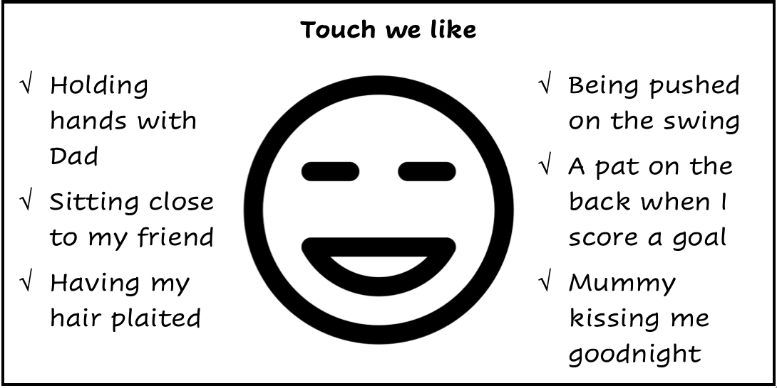

Ask: How does touch we like make us feel?

Record the feelings around the face.

Older students can draw a happy face, and write a touch they like.

### 2 – Touch we don’t like

**Touch that hurts**

Explain that touch they don’t like could be touch that hurts, or touch that feels confusing or touch that doesn’t feel nice.

Students talk in pairs about touches they don’t like.

As they report back, the teacher records their ideas on a large sad face on a large sheet of paper, like the example below.

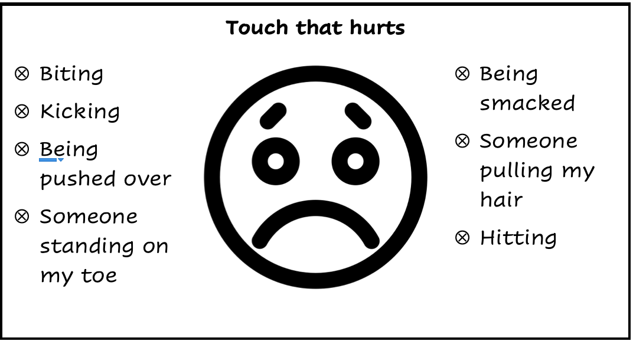

Ask:

* How does touch that hurts make us feel?
* Why do we want it to stop?
* What would you do if this happened to you?

Record the feelings around the face.

Older students can draw a sad or angry face and write a touch they don’t like.

**Confusing touch**

Draw a large confused face on a large sheet of paper, like the example below. Label it ‘Confusing touch we want to stop’. Write in ‘Having my pants pulled down’.

Ask:

* What are some other examples of touch that confuses us? Record these on your chart. (Include examples of sexual touch.)
* Why do these confuse us? (I feel yukky, I don’t know why they are doing it)
* What could you do? (Say: “Stop it” or “Stop it, it’s not allowed” and go and tell an adult)

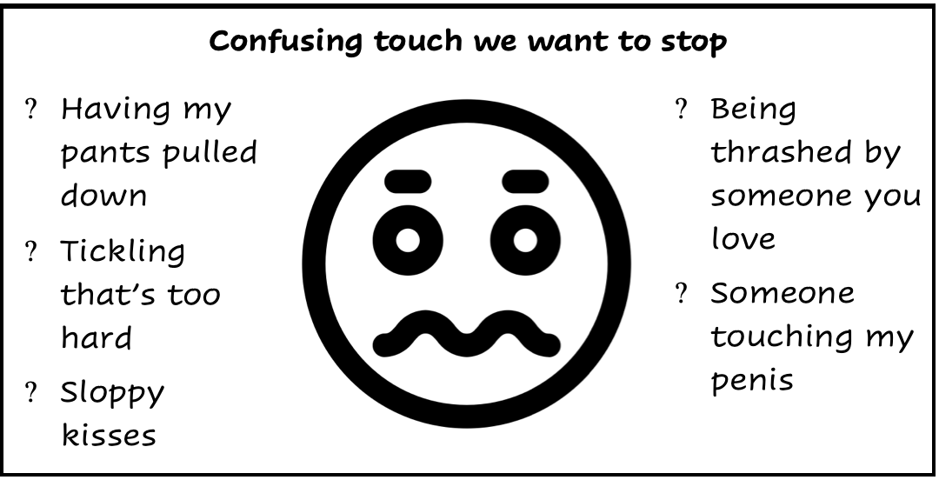

Older students can draw a confused face and write a touch they don’t like.

**Talk about** how sometimes touch can change.

* It may feel good at the start, but it can change or can go on too long, like someone tickling you hard and not stopping.
* Sometimes a person has been giving us good touches that we like, and then starts touching us in a way that makes us feel confused, and in places we don’t want to be touched.
* Explain that it is okay to change your mind and report this unwelcome touch.

(*The three icons used in the diagrams in this activity are by Mata Sapi from* [*The Noun Project*](https://thenounproject.com/)*.*)

### 3 – Touch story boards

Use the **Touch Story Boards** with the class. Show students the picture and read the story from the back of the board. Ask the questions listed on the back of each board.

|  |  |  |
| --- | --- | --- |
| story-board1-kos0-3 | story-board2-kos0-3 | story-board3-kos0-3 |
| story-board1-kos0-3a | story-board2-kos0-3a | story-board3-kos0-3a |

### 4 – What would you do if …

Play "What would you do if ..." with the class using scenarios such as:

* What would you do if someone hugged you too tightly?
* What would you do if someone tickled you too hard?
* What would you do if a child in your class put their hand down your pants?
* What would you do if someone gave you a sloppy kiss?
* What would you do if someone at home gave you a hiding?

## Homework activity

Give students Homework activity sheet: **Touch** to complete with someone at home.

# Homework activity: Touch

Today in Keeping Ourselves Safe we learnt about different types of touch – touch we like, touch that hurts and we want to stop, and confusing touch that we want to stop, such as sexual touch.

* Encourage your child to tell you when someone hurts them or touches them in a way that makes them confused.
* Always listen and act when your child tells you about experiencing unwanted touch.

Please help your child with the activities below.

|  |  |
| --- | --- |
| Y0-1 Happy Face | Ask your child for examples of touch they like, such as hugs. |
| Y0-1 Sad Face | Ask your child for examples of touch they don’t like and that they want to stop. |

Ask your child how each of these situations would make them feel and what they should do about it:

* An adult that you don’t know comes up and takes your hand.
* Someone at school pulls your hair.
* Someone puts their hand down inside your underpants.
* Someone hugs you too tight and gives you a sloppy kiss.