Kia Kaha

Years 7-8 Focus area 3
This section contains one of the focus areas of the Kia Kaha programme for students at years 7–8 (ages 11–12):
- No more bullying
- Knowing and respecting others
- Bully-free zones
- Concluding activity: A gathering in our bully-free zone
Note: Research suggests that an effective Kia Kaha programme should include learning experiences from each of the focus areas.

Focus area 3: Bully-free zones

Contents
Focus area 3: Bully-free zones 3
Explanation 3
Curriculum links 3
Success criteria 3
Learning experience 1: Taking stock of myself 4
Learning intentions 4
Resources 4
Activities 4
Homework activity 4
Copysheet: Could You Sometimes Bully Other People? 5
Copysheet: Friendship Flag 6
Learning experience 2: Hauora, well-being 7
Learning intention 7
Resources 7
Activities 7
Reflection 9
Homework activity 9
Copysheet: Whare 10
Learning intention 11
Resources 11
Copysheet: Submission 12

Focus area 3: Bully-free zones

Explanation
In this Focus area students consider the importance of a sense of well-being, with freedom from bullying. They take stock of themselves, to find out if there is any behaviour of their own that they would like to change, and they set goals for change. They define the features of a bully-free class and school and take steps to put them into practice.

Curriculum links
Key Competencies: Relating to others, Managing self; Participating and contributing
Learning area: Level 3 Health and Physical Education – Strand D: People and the environment
Key learning area: Mental Health: Values and attitudes that support the enhancement of mental health for the students themselves, their class and their school
Concepts:
- Well-being, Hauora: working towards well-being for self, school and class
- Health promotion: creating supportive physical and emotional classrooms and school
- Socio-ecological perspective: actively contributing to their own well-being, and the well-being of their class and school
- Attitudes and values: developing attitudes and values that promote the well-being of self and school

Success criteria
Students can:
- identify behaviour they want to change
- set and work towards personal goals
- identify features that make their classroom a place where everyone has a sense of well-being
- work towards making their school a bully-free zone
- share what they have learnt in Kia Kaha.

Learning experience 1: Taking stock of myself

Learning intentions
Students can:
- identify behaviour they want to change
- set and work towards personal goals.

Resources
Copysheet: Could You Sometimes Bully Other People?
Copysheet: Friendship Flag

Activities

1. Looking at ourselves
Ensure that students by now understand that everyone has a responsibility to do something to make sure that bullying doesn’t occur. Sometimes we need to look at ourselves to make sure we are not behaving in ways that do nothing to help stop bullying.
Give each student Copysheet: Could You Sometimes Bully Other People? Explain that this is a personal activity and they do not need to share it with anyone, unless they want to. They should be honest.
While this is basically a fun exercise, and should be treated as such, students will end up thinking about bullying in relation to their own behaviour. This kind of self-examination is the beginning of the process of change.

2. Friendship flag
Hand out Copysheet: Friendship Flag. Students cut out the flag, fill in the necessary information and decorate it.
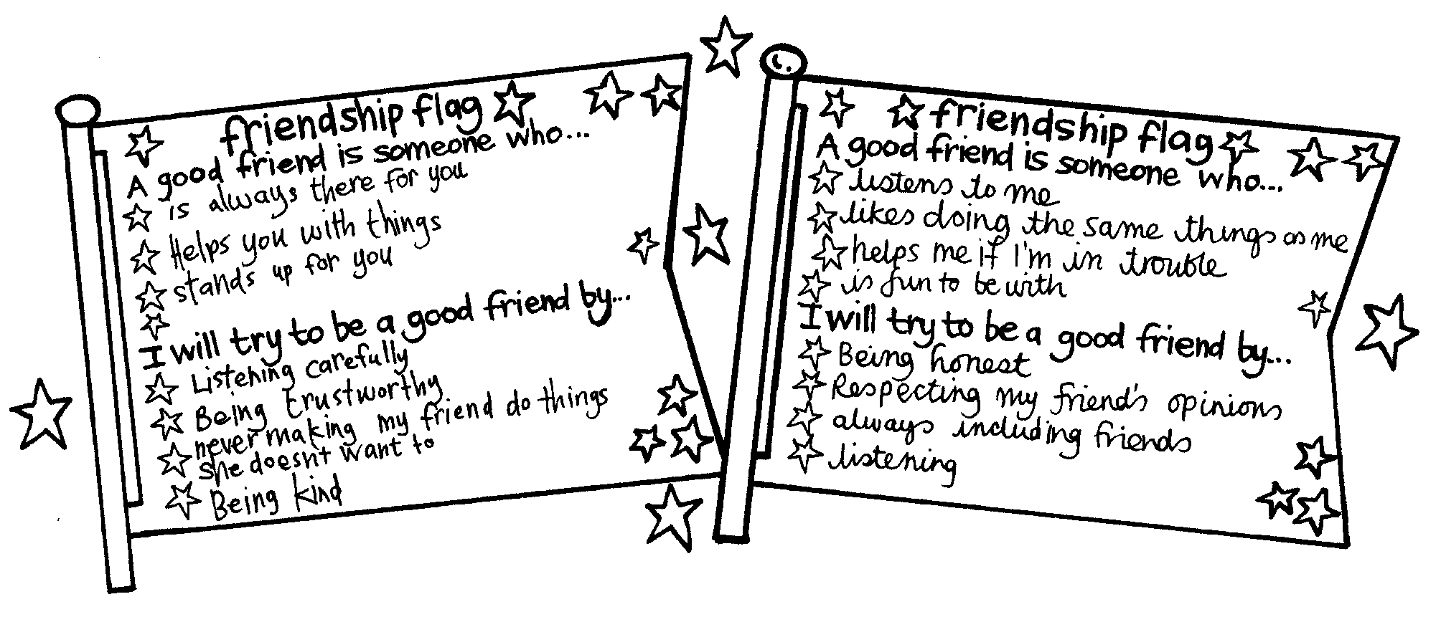

Homework activity
The completed friendship flags could be taken home and shared with the family.

Copysheet: Could You Sometimes Bully Other People?
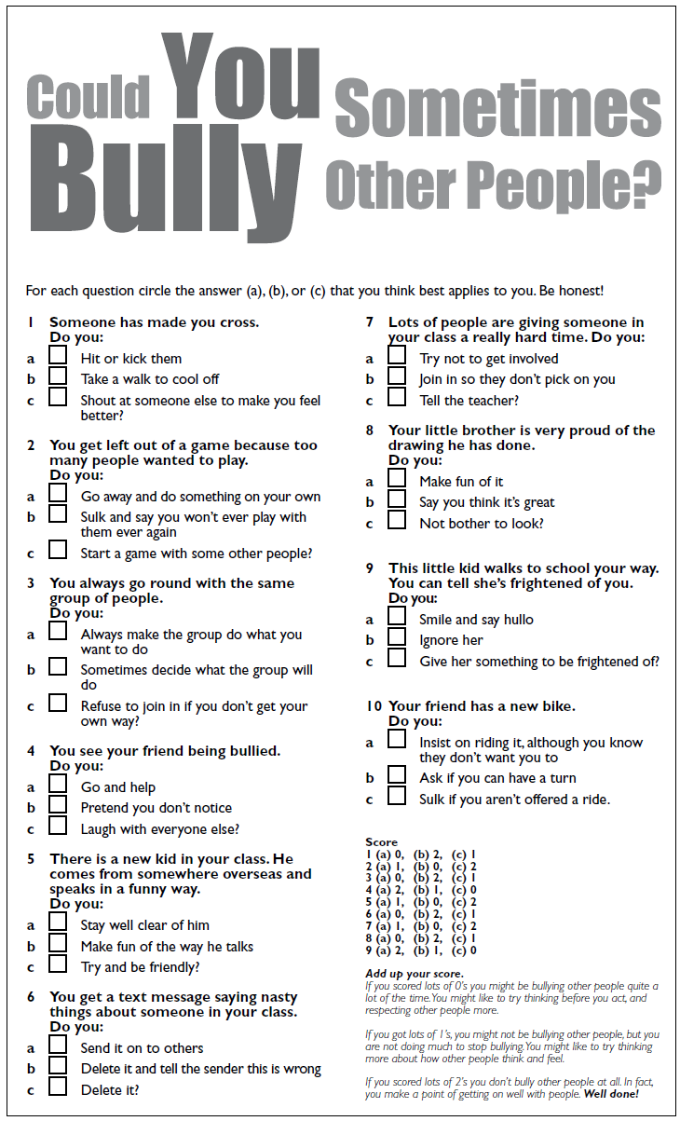

Copysheet: Friendship Flag
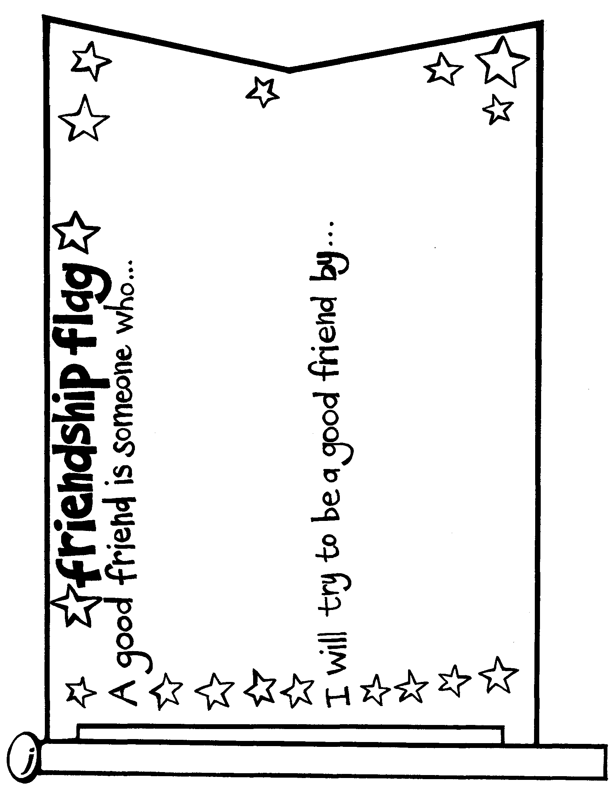

Learning experience 2: Hauora, well-being

Learning intention
Students can identify features that make their classroom a place where everyone has a sense of well-being.

Resources
Copysheet: Whare (Taken from Health and Physical Education in the New Zealand Curriculum 1999, after Dr Mason Durie)
White sheeting or calico; old sheet or large piece of calico or canvas
Crayon and dye
Rods or dowelling
Squares of calico, canvas or heavy paper for each student
Hot glue gun
Art materials – acrylic paint

Activities

1. Hauora
Introduce the concept of Hauora or a sense of well-being to the class. This means that a person can develop fully because all aspects of the person are being cared for. They feel safe and happy. They are not being bullied.
Show students the whare from Copysheet: Whare and use it to explain the ideas below. You could also introduce the Māori terms (see Health and Physical Education in the New Zealand Curriculum 1999).
Concept | Example
Physical well-being Taha tinana | Your physical body, its growth and development, ways of caring for it
Mental and emotional well-being Taha hinengaro | Able to express your own thoughts and opinions; be free from abuse; able to identify your own feelings and respond well to others; able to reach your potential; feel good about yourself
Social well-being Taha whanau | Have friends and family to support you; feel as though you belong; care and support of others; get on well with other people
Spiritual well-being Taha wairua | Have worked out your values and what you believe in; be free to worship as you wish; be sure of your personal identity; understand what life is all about

2. Sense of well-being
Either:
Working in groups, students brainstorm a list of things that would make their class a place where everyone had a sense of well-being, and where there was no bullying.
Work with the whole class to group their ideas on to the appropriate wall in the whare. If there are few suggestions in one wall, the class could come up with examples.
Or:
Ask the students what everyone in their class would be like if they have a sense of well-being. List these things inside the whare. For example: feel good about themselves, treat other people with respect, is cared for and cares for others, accepts difference, doesn’t bully anybody else, isn’t being bullied, thinks before they act.
Completed whares should be displayed on the classroom wall. Move students to the understanding that each and every one of them can work towards making sure that everyone in their class has a sense of well-being, Hauora.
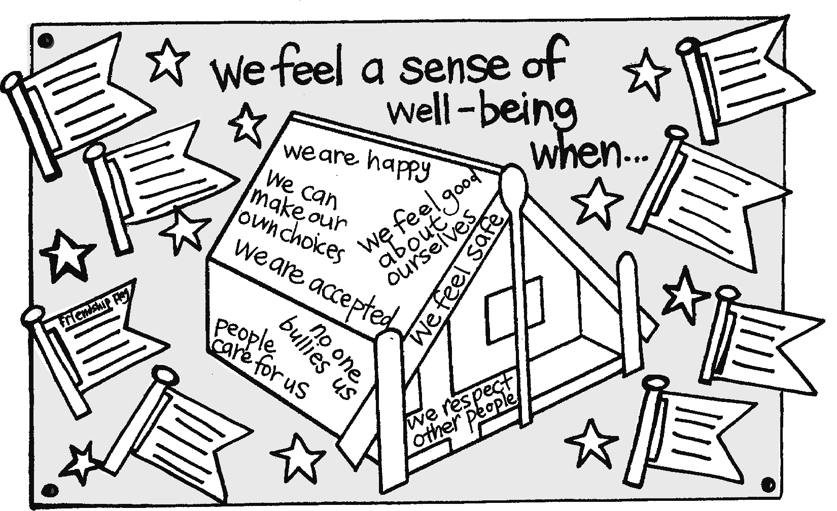

3. Banner or hangers
Class banners
Divide students into groups. They are to come up with an idea for a banner that they think would sum up what they want their classroom to be like – that is, somewhere that everyone feels safe and happy and where there is no bullying. Refer them back to the whare they have created and to the other Kia Kaha work they have done.
The rest of the session is spent in designing and creating the banners. These can be completed over the next week. Designs could be done in dark crayon on to the calico and then dye is painted on.
Completed banners can be displayed hanging from the roof, in the hall or perhaps on poles in the grounds.
A class wall hanging
Explain that the class is going to make a wall hanging entitled Our Bully-free Class.
Each student makes a small square of the wall hanging and decorates it, including their name and a short statement about what they are going to do to stop bullying. This can be done on a square of calico or canvas with acrylic paint. All completed squares are then attached to the sheet with either a hot glue gun or by sewing. This will look especially effective if students all use the same colour tonings, such as green and blue, with a touch of yellow.
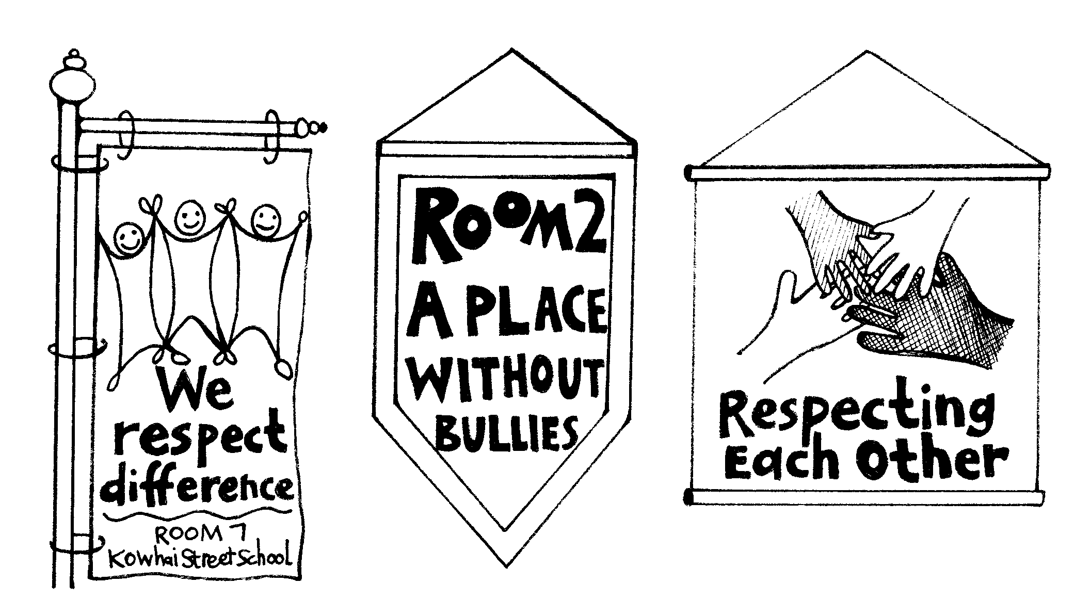
Invite the principal to view the finished products.

Reflection
Refer back to the whare, wall hangings or banners at intervals to remind the class about the ways they have decided they would like their classroom to operate. For example:
Ask: Did we respect everyone’s opinions today?
Did we make sure that everyone felt included?
Have we had any instances of bullying this week?
How should we handle this?

Homework activity
Remind students to tell parents and caregivers that their banners are on display at the school and that they are invited to view them at a convenient time.

Copysheet: Whare

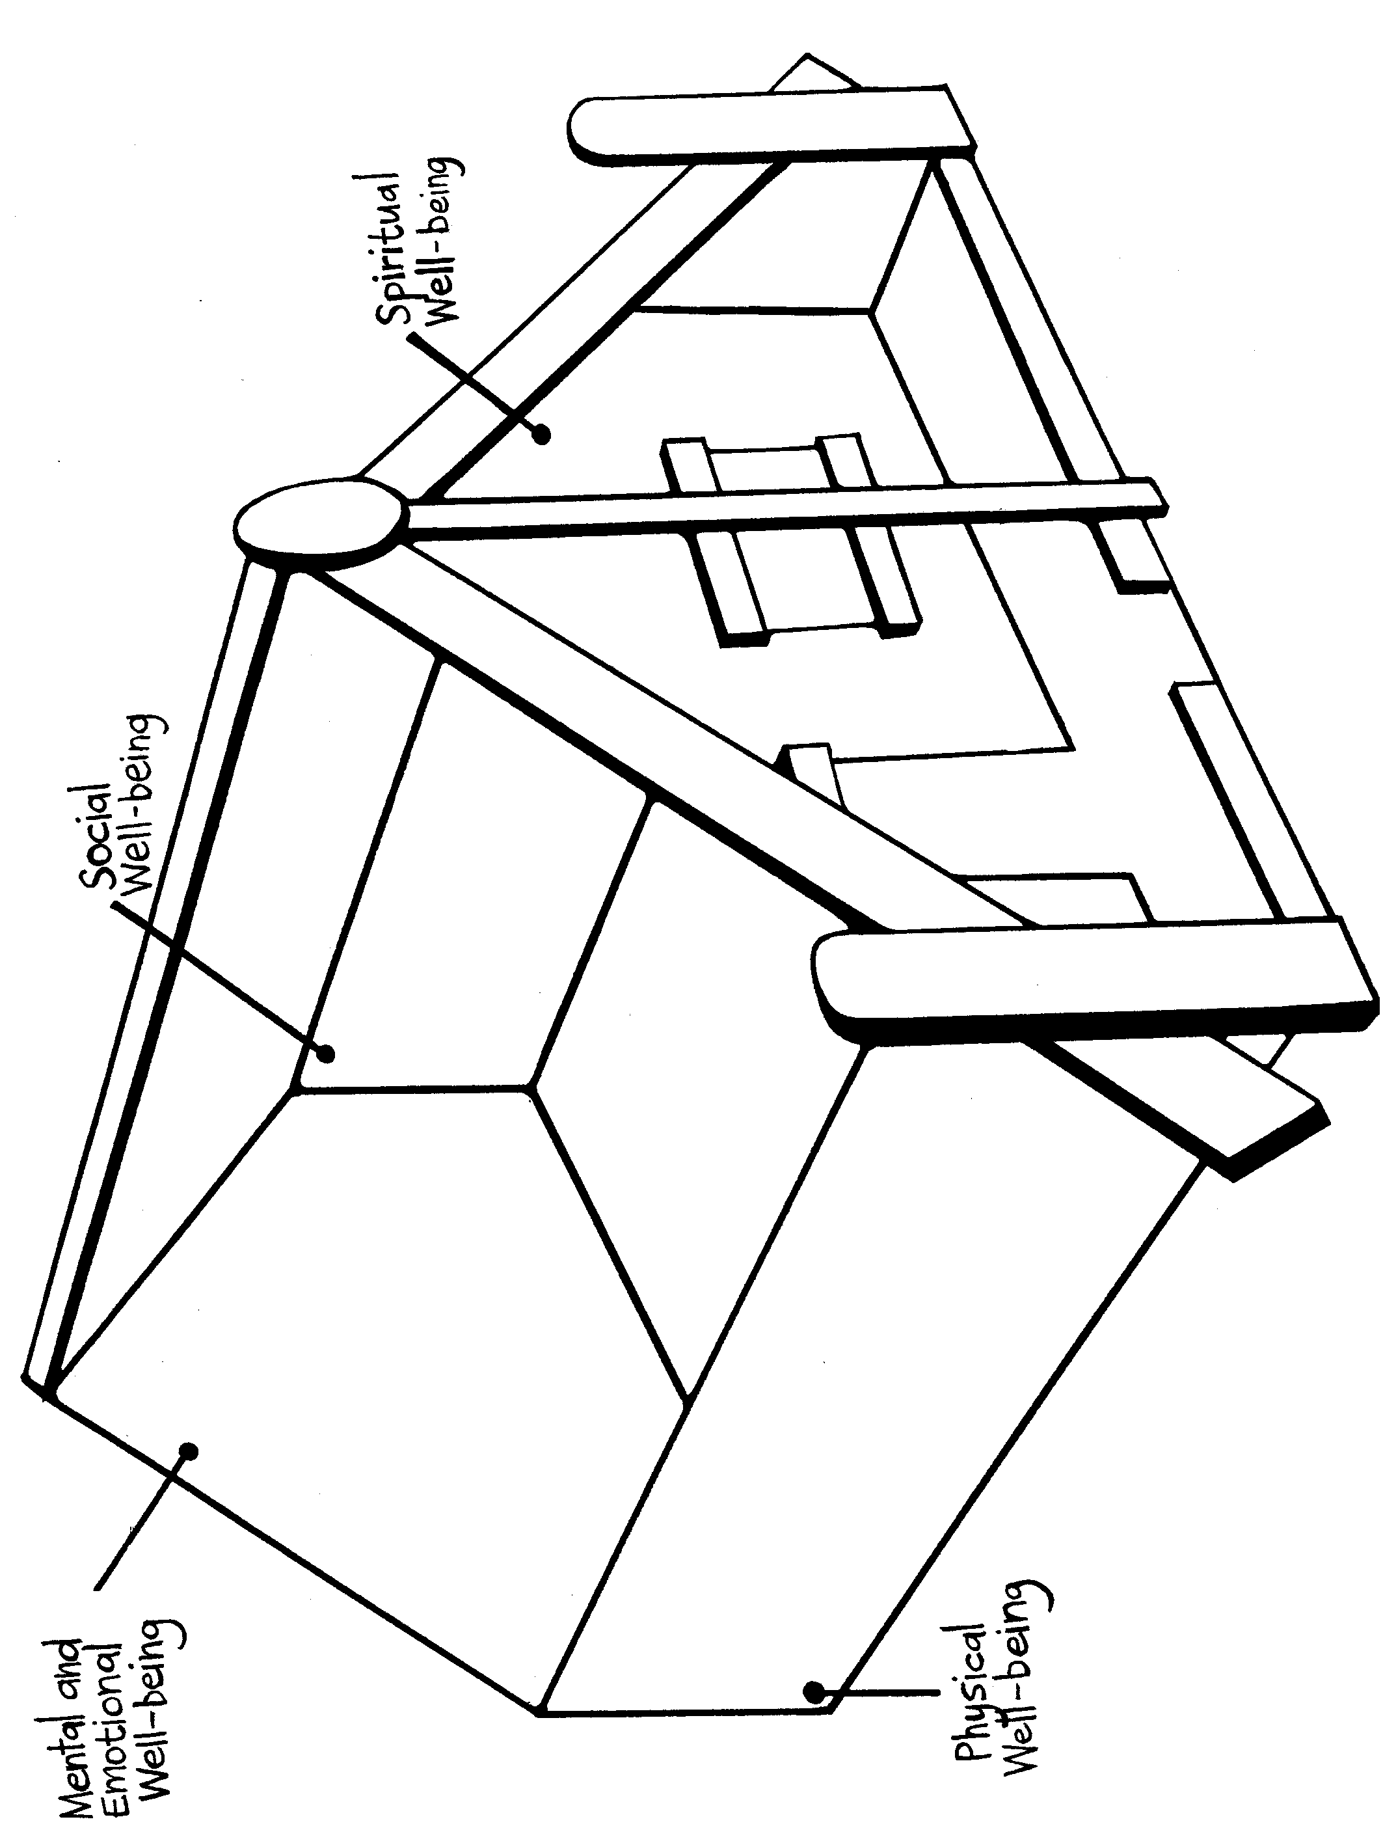
Learning experience 3: A bully-free school

Learning intention
Students can work towards making their school bully-free.

Resources
Data collected from the observations in Focus area 1, Learning experience 1
Copies of school policies relating to violence, bullying, harassment
Copysheet: Submission
Activities
Arrange for a presentation of the data from Focus area 1, Learning experience 1. The form this takes will depend on how the original activity was set up. It could be a group or syndicate presentation, or a presentation to a whole-school assembly.
Ask: Is there bullying in our school?
Are all five types present?
Which types are most common?
Where does it mainly take place?
What can we do about it?
Divide students into groups. Ask each group to come up with a set of simple playground rules or guidelines that they think would stop bullying in the school. Encourage them to state these rules in positive terms, rather than as negatives – for example, Don’t be mean to others becomes Treat others with respect.
Each group reports back and a class list is developed.
Ask: What do you think should happen if these rules are broken?
Now give each group a copy of the relevant policies that the school has which deal with bullying. Ask them to compare these with the rules they have developed.
Ask: What things are the same?
What things are different?
What things do you think should be added to the school policies?
What changes need to be made about the way these policies are enforced?
If there are many differences, work with the class to develop a submission to be sent to the principal and/or Board of Trustees. Copysheet: Submission shows a possible format.

Copysheet: Submission
Submission to____________________________ of ____________________________ School
(Name of principal) (Name of school)

Class:____________________________
(Name of class)
This is a submission to the Principal and the Board of Trustees about changes in school policies that we think are necessary to make our school bully-free. This is the wish of the majority of the class.
We feel strongly enough to present this submission to the Principal for further action. We would be happy to give more information and help in any way we can.
We suggest these changes be made to school policies:
____________________________________________________________________________________
____________________________________________________________________________________
____________________________________________________________________________________
____________________________________________________________________________________
____________________________________________________________________________________

The advantages of these changes would be:
1
2
3
Signed by the class below.

Witnessed by:
______________________________
(Teacher)

