Kia Kaha

Years 7-8 Focus area 1
This section contains one of the focus areas of the Kia Kaha programme for students at years 7–8 (ages 11–12):
- No more bullying
- Knowing and respecting others
- Bully-free zones
- Concluding activity: A gathering in our bully-free zone
Note: Research suggests that an effective Kia Kaha programme should include learning experiences from each of the four focus areas.

Focus area 1: No more bullying

Contents
Focus area 1: No more bullying 3
Explanation 3
Curriculum links 3
Success criteria 3
Learning experience 1: Bullying is … 4
Learning intention 4
Resources 4
Activities 4
Homework activity 6
Copysheet: Kia Kaha Cards 7
Copysheet: Types of Bullying 8
Learning experience 2: The effects of bullying 10
Learning intentions 10
Notes for the teacher 10
Resources 10
Activities 10
Copysheet: Exposing the Girl Bullies 12
Learning experience 3: Dealing with bullying 13
Learning intention 13
Resources 13
Activities 13
Optional learning experience 14
Homework activity 14
Homework sheet: Put a Stop to Bullying 15

Focus area 1: No more bullying

Explanation
Bullying is a problem that will not go away unless it is addressed effectively. The school must use a whole-school approach to deal with the problem. The principal should ensure that students and parents know the school’s policy on bullying and how bullying will be handled.
Through this Focus area, students identify bullying, realise that it is unacceptable, and take positive steps to create a bully-free environment. All forms of bullying should be considered, including cyber bullying, homophobia, racial bullying, sexual harassment, and bullying because of disability. Students learn that everyone has a responsibility to do this – the person who bullies, the person being bullied, and the bystanders (those who watch a bullying incident but do nothing to stop it).
Note: When working through the activities in this Focus area it is important to refer to the bullying behaviour, rather than to label children as bullies. See Kia Kaha in Your School – A Working Booklet.

Curriculum links
Key Competencies: Managing self; Relating to others, Participating and contributing
Learning areas: Levels 3 and 4 Health and Physical Education – Strand A: Personal Health and Physical Development: Safety management, Personal identity; Strand C: Relationships with other people: Interpersonal skills
Key learning area: Mental Health: knowledge, understanding, and skills to recognise and respond to situations of abuse and harassment
Concepts:
- Well-being, Hauora: responding constructively to bullying; social support
- Health promotion: developing personal skills to take action to improve own and others’ well-being
- Socio-ecological perspective: making safe choices about bullying
- Attitudes and values: non-tolerance of bullying

Success criteria
Students can:
- explain what bullying is
- describe the effects of bullying
- identify and use strategies to stop bullying.

Learning experience 1: Bullying is …

Learning intention
Students can explain what bullying is.

Resources
Strips of paper, felt pens, paste
Kia Kaha Box – made by the teacher and decorated by students
Copysheet: Kia Kaha Card
Copysheet: Types of Bullying
Five pieces of large chart paper, each with one of the headings from Copysheet: Types of Bullying placed at the top
Note: For the paste shop activity, five types of bullying have been given on Copysheet: Types of Bullying. If some of these types are not happening in your school, you may decide not to introduce these terms. Emotional bullying has been grouped with verbal bullying. However, all types of bullying affect the emotions.

Activities

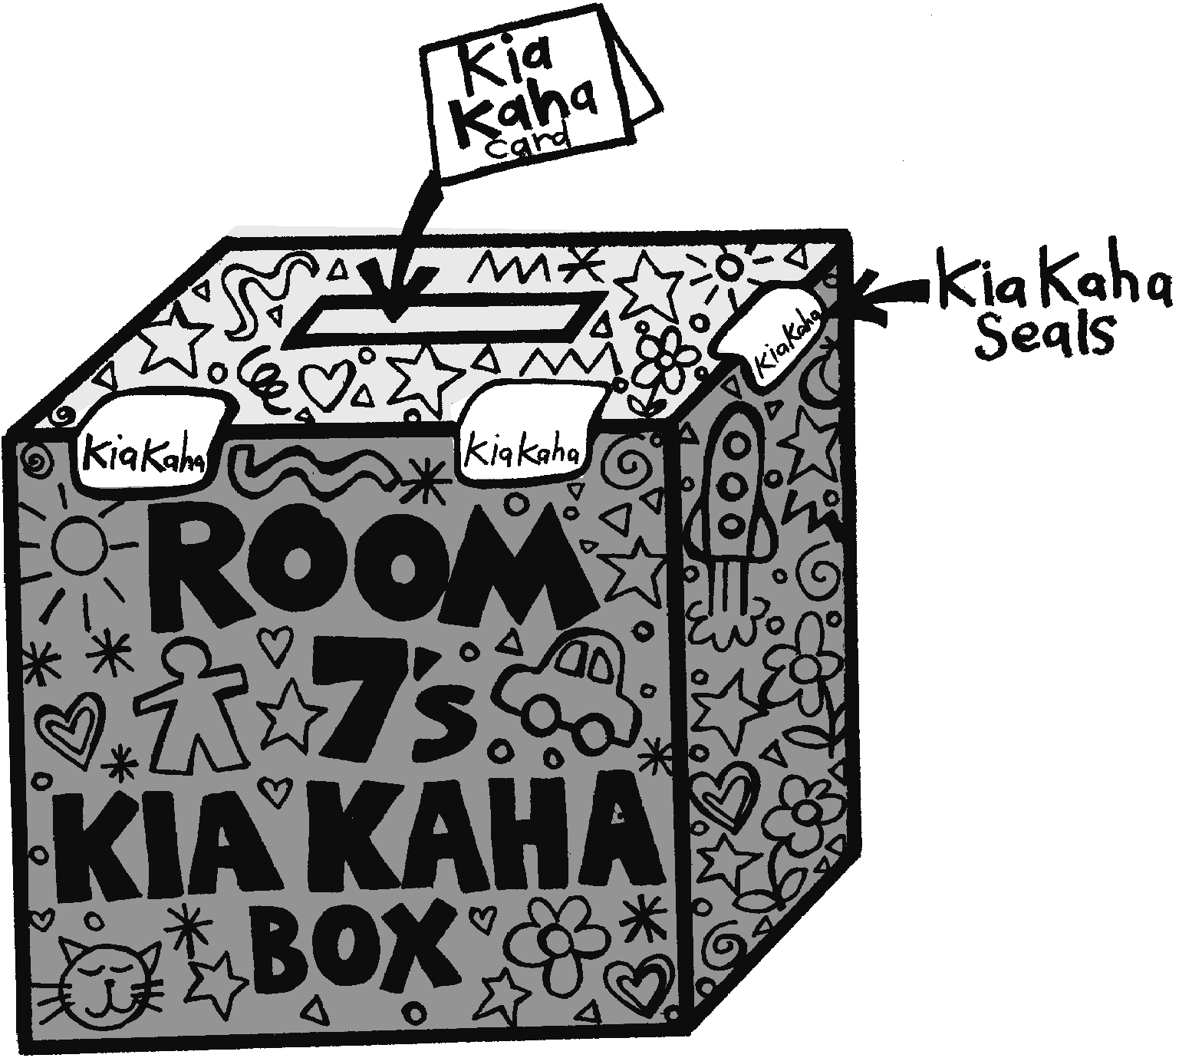
1. Kia Kaha Box
Explain to the class that over the next few weeks they will be doing Kia Kaha, an anti-bullying programme.
Introduce the Kia Kaha Box and the Kia Kaha Cards to students. Decide where in the classroom the box will be kept. Devise a system of sealing the box. Explain that a pile of cards will remain beside the box. Students can complete a card and place it in the box if they wish to report bullying or ask for help. Talk about private times when this could be done. Explain that you will take some action to help.
The Kia Kaha Box should be continued throughout the year.

2. Paste shop
Divide students into groups. Give each group a number of strips of paper. Assign roles within the group, such as recorder, resource person, organiser, and encourager. Ask students to brainstorm all the things that they think constitute bullying. Each suggestion should be recorded on a separate strip of paper.
Place the five large charts around the room, each headed with a type of bullying. Ensure that the class understands the terms written on each. Each group now pastes each of their strips of paper on the chart with the heading they think is most appropriate.
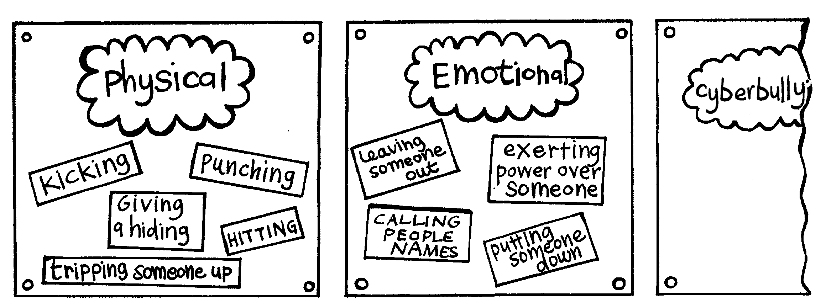
Bring the class back together.
Ask: Which chart has the most examples on it?
Why do you think this might be?
If some of the charts have few examples, return students to their original groups to think of more examples for the headings. These examples are then pasted up.
Ask students to view all the charts.
Ask: Do you think any of these types of bullying are worse than the others? Explain your answer. (All types of bullying are damaging)
Do you think any of the examples of bullying you have given are acceptable behaviour? Why, or why not? (There is never any excuse for bullying; it is unacceptable)
Do you think anybody deserves to be treated this way? Why, or why not? (No one deserves to be bullied)
Return students to their groups. They work together to come up with a definition of bullying. The class then shares these definitions and agrees on a class definition, which is displayed on the wall. Ensure that the following points are covered.
- Bullying is deliberate and hurtful.
- Bullying is usually repeated over a long period of time.
- It is difficult for the person being bullied to defend themselves.
- It is difficult for the person who bullies to learn new social behaviours.
- The bully has power over the person being bullied and exercises that power.
- Cyber bullying can happen round the clock. It can invade home and personal space. Its audience can be very large and reached rapidly.

3. Observation sheet
Work with the class to develop a Bully Observation Sheet, using ideas from the charts around the room. Explain that over the next two or three weeks the class will, at intervals, make playground observations to find out the extent and type of bullying at the school. Decide on a roster of teams for the following parts of the survey process:
- gathering the data
- collating the data
- making the conclusions
- reporting back to class, syndicate, or assembly.
Talk about the need to be discreet when surveying, so that students in the playground are not aware of being observed. Explain that the class will use the results of the survey in Focus area 3.
Note: If a series of year 7-8 classes are working on Kia Kaha, the survey could be done as a syndicate exercise.

Homework activity
Invite each student to complete the two following sentences, which they then take home to share with family members.
Bullying is …
I think it is unacceptable because …

Copysheet: Kia Kaha Cards
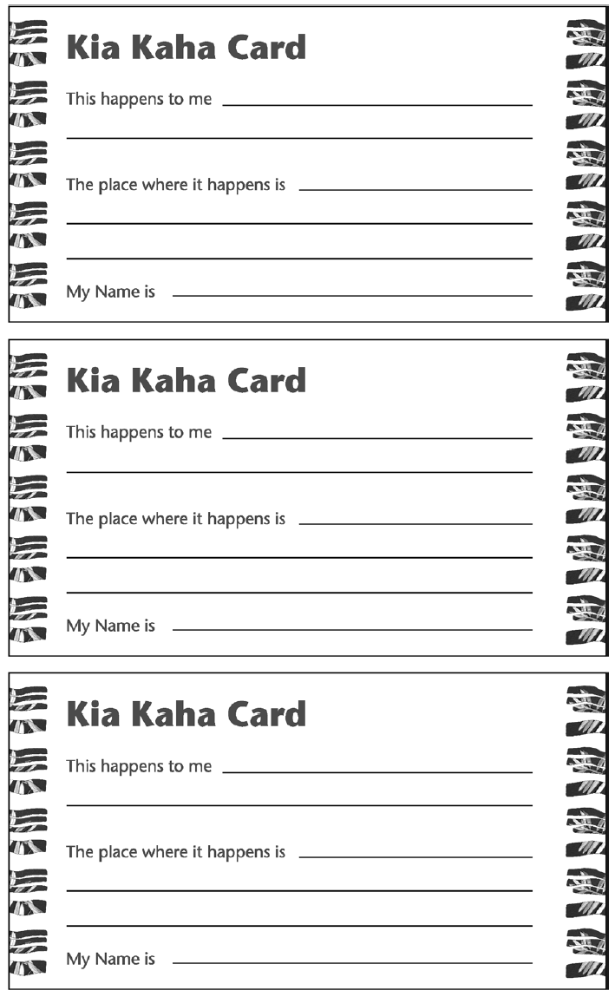

Copysheet: Types of Bullying

Cyber bullying
Physical bullying
Exclusion
Use of violence or threats
to get money or
possessions
Verbal or emotional bullying

Learning experience 2: The effects of bullying

Learning intentions
Students can describe the effects of bullying.

Notes for the teacher
Cyber bullying is often accompanied by other forms of bullying, such as physical. Some cyber bullying incidents can themselves act as evidence. Advise students to:
- refrain from responding
- save the content (message, pictures, online conversations) as evidence
- inform the provider of the digital service if the content is abusive or repeated more than once.

Resources
Copysheet: Exposing the Girl Bullies
Materials for publishing the class book
Computer

Activities

1. Exposing the Girl Bullies
Read the story in Copysheet: Exposing the Girl Bullies.
Ask: What two types of bullying were used in this incident? (Physical and cyber bullying)
What do you think of the behaviour of the ringleader and her accomplices?
Why do you think nobody did anything to help the girl?
Who could have done something?
Do you think the girl deserved to be bullied? Why, or why not?
Why do you think so many people passed on the copies?
How did this bullying make the victim feel?
Do you think the attacker’s punishment was enough? Give a reason for your answer.
Do you think that this was an isolated incident? Why, or why not?
What long-term effects might the victim suffer?
Do you think girl-on-girl violence has increased? Give a reason for your answer.
What do you think about this?

2. Hot seat
This activity allows students to explore the feelings of all the people that may be involved in a bullying incident, such as the perpetrator, the assistants or reinforcers, the bystanders, the victim and the victim’s defenders, and others involved (such as parents and school staff).
Place a chair in the front of the room. Group students close to the chair. Either the teacher or the School Community Officer takes the hot seat. The other adult is the facilitator.
Ask students to think back to the newspaper article and invite them to identify all the people involved. These could be listed on the board and could include the principal, the victim, the mother of the victim, the perpetrator, the perpetrator’s supporter, bystanders, students who passed the copies on, and the parent of the perpetrator.
Ask students to choose one of the people to question. The person in the hot seat takes that role. Students can ask questions to find out more about the situation.
For example, the bystanders might be asked questions such as:
- How did you feel about the incident?
- Why didn’t you do anything to intervene?
- How would you have felt if it was you being bullied?
- What could you have done to stop the bullying?
- What could you do now to support the victim?
This process can be repeated with other characters in the hot seat.

Copysheet: Exposing the Girl Bullies

Exposing the Girl Bullies
SUNDAY MAY 10, 2009. A schoolyard assault filmed on a cellphone and posted on YouTube has raised fresh fears about cyber-bullying and girl-on-girl violence.  Footage obtained by the Herald on Sunday shows a group of high school students surrounding a 16-year-old girl on the school field.  After a verbal altercation, a female ringleader, also 16, repeatedly hits her victim around the head while her accomplices look on laughing.  The victim was later escorted to the school office for medical attention.  “All I could do was cry and say my face hurt,” she said.  A student filmed the incident on a cellphone and the footage was posted on YouTube.  Although the video clip was quickly removed from the Internet site, copies were passed around the school, with one being presented to the Board of Trustees.  After an internal investigation, the attacker was suspended for seven days and has now returned to school. The victim’s mother is ‘disgusted’ the girl was allowed back so soon.  “I would have suspended that student for longer. It would have given her a chance to think about her actions. It would have made an example for other students about this sort of behaviour,” she said. | The principal said that the Board of Trustees did all it could. The attacker had signed a good behaviour agreement on her return and was closely monitored.  “The girl was suspended for seven days, the maximum a board can give,” said the principal.  “On hearing the evidence, there were aggravating circumstances. I’m not going to condone what happened, it definitely was wrong, and the girl has been punished.”  The attacker apologized, but the victim said she still feels terrified and won’t walk between classes on her own. Her mother picks her up early each day so she can avoid her attacker, but defended her decision to keep her daughter at school.  “If she leaves it will feel like she’s running away from the problem, rather than facing it. I don’t want her to live her life like that.”  The principal said the number of violent altercations at school had risen steadily and the most noticeable trend was a rise in attacks involving girls.  “You go back 15 years, violence between girls was pretty rare. More of our disputes now are between girls than boys.”  Adapted from Herald on Sunday, 10 May 2009

Learning experience 3: Dealing with bullying

Learning intention
Students can identify and use strategies to stop bullying.

Resources
Homework activity sheet: Put a Stop to Bullying

Activities

1. Role-play
Each group chooses a typical bullying situation. Ensure the selections cover the full range of types of bullying from learning activity 1.
Each group brainstorms some strategies that could be used to stop this bullying situation.
They choose one of these strategies and develop a role-play to demonstrate it. The role-play should start with a freeze frame showing the bullying situation, and then demonstrate the positive solution or strategy. It is important that students concentrate on the positive solutions rather than on the negative bullying behaviour.
Each group in turn presents their role play to the class. After each:
Ask: How effective do you think this strategy was?
Was it a safe thing to do?
Would the same strategy work every time? Why, or why not?
Will the same strategy work for everyone? Why, or why not?
What could you do if the bullying continues?

3. Who is responsible?
Talk about how everyone has a responsibility to make the bullying stop. Brainstorm on the board who this might be and what they could do – the person who bullies, parents, bystanders who watch the bullying, friends, the person being bullied, teachers, principal, brothers and sisters, neighbours, community.

4. School policy and rules
Invite the principal to explain to the class that the school will not accept bullying and to tell them what will be done for the victim, the person who bullies and the bystanders when bullying is reported (see Kia Kaha in Your School – a Working Booklet for positive suggestions, such as the No Blame Approach).
The principal also needs to explain that this policy has been shared with parents, who will also know what to do if they suspect bullying.

5. Banish Bullying cards
Each student completes a Banish Bullying card, to show strategies to use if they, or someone else is being bullied. This should be small enough to fit into a pocket or wallet.
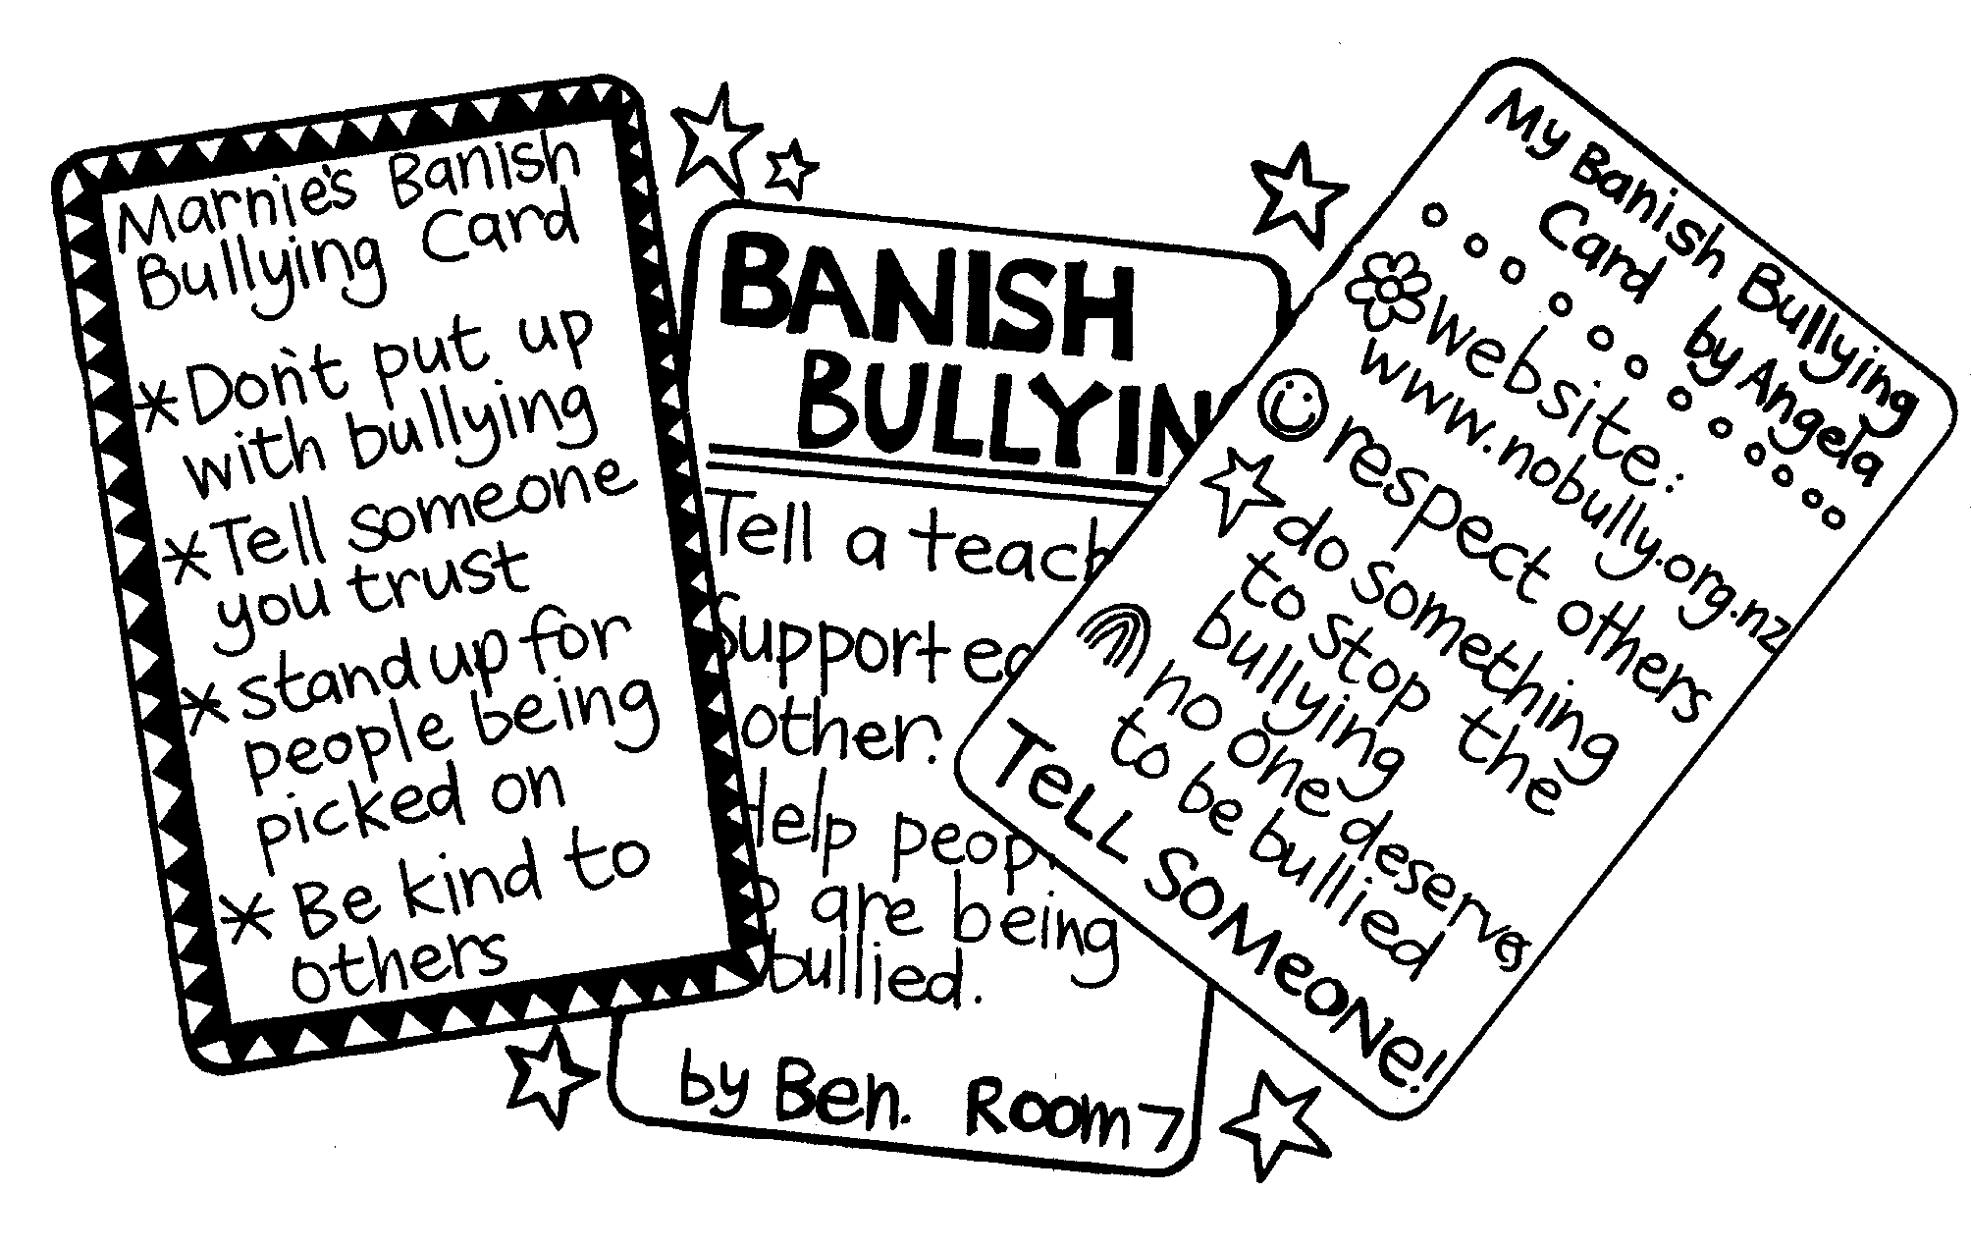

Optional learning experience
Hold a debate. This could be between syndicates, or between groups in the class. Invite parents and caregivers to attend. Suitable topics could be:
- Cyberbullying is worse than any other forms of bullying.
- It’s best not to get involved in someone else’s bullying.
- Bullying is the victim’s fault.
- Kia Kaha means to fight your way out.

Homework activity
Students take home Copysheet: Put a Stop to Bullying to complete with a parent or other adult. It should be brought back to school by the date shown, for filing with the student’s other Kia Kaha work.

Homework sheet: Put a Stop to Bullying
Dear Parents and Caregivers
In Kia Kaha we have been looking at different types of bullying and how it makes people feel. Your child has thought of, and practised, different ways of handling bullying. As a school we won’t tolerate bullying, and we encourage students and parents to report it.
Please complete the following activity with your child.

- Some examples of bullying that our family has seen are:

- What our family thinks about bullying is ...

- If we suspect bullying, a positive thing we could do is ...

If you would like to discuss bullying, and the school’s policy on bullying, in more detail, please contact me, or the principal.
Thank you for your help. Please return this copysheet to school by:

(Name of Teacher)

