Kia Kaha

Years 4-6 Focus area 4
This section contains one of the focus areas of the Kia Kaha programme for students at years 4–6 (ages 8–10):
- You and me
- Hurting
- Put a stop to bullying
- A cool community
Note: Research suggests that an effective Kia Kaha programme should include learning experiences from each of the focus areas.

Focus area 4: A cool community

Contents
Focus area 4: A cool community 3
Explanation 3
Curriculum links 3
Success criteria 3
Learning experience 1: A kid-safe community? 4
Learning intention 4
Resources 4
Activities 4
Optional learning experience 5
Copysheet: Post Box Questions 6
Copysheet: Template for Developing a Survey Sheet 7
Learning experience 2: Making changes 8
Learning intention 8
Notes for the teacher 8
Resources 8
Activities 8
Learning experience 3: Planet Kaha 10
Learning intention 10
Notes for the teacher 10
Resources 10
Activities 10
Optional learning experience 11
Copysheet: Planet Kaha 12
Copysheet: Qualities, Skills and Materials 13
Copysheet: Features of a Bully-free Community 14
Learning experience 4: Setting goals 15
Learning intention 15
Resources 15
Activities 15
Copysheet: Personal Goals 16
Copysheet: Class Charter 17

Focus area 4: A cool community

Explanation
In this focus area students will identify qualities that make an environment safe for young people. They will decide which areas in their community are unsafe and will seek solutions to overcome this. Through the creation of a hypothetical bully-free community, students will apply the understandings they have gained throughout the programme. This process will help them to define the personal qualities and environment that will generate bully-free behaviour. They will set personal and class goals to be proactive in enhancing their everyday environment.

Curriculum links
Key Competencies: Managing self; Relating to others, Participating and contributing
Learning areas: Level 2 Health and Physical Education – Strand A: Personal Identity; Strand D: Rights, Responsibilities, and Laws; People and the Environment
Level 3 Health and Physical Education – Strand A: Personal Identity; Strand C: People and the Environment
Key learning area: Mental Health: creating an emotionally safe classroom environment
Concepts:
- Well-being, Hauora: creating the four dimensions of hauora within the classroom
- Health promotion: making a positive contribution to their own and others’ well-being
- The socio-ecological perspective: concern for their own well-being, that of peers and of the whole school
- Attitudes and values: care and concern for others in their classroom and school

Success criteria
Students can:
- work towards making their class a bully-free zone
- set and work towards personal goals.

Learning experience 1: A kid-safe community?

Learning intention
Students can identify the qualities of a kid-safe community.

Resources
Copysheet: Post Box Questions
Copysheet: Template for Developing a Survey Sheet
Chart paper and felt pens, slips of paper

Activities

1. Post Box questions
Write each Post Box Question from the Copysheet on a large sheet of paper and place these around the room. Place a posting box beneath each one.
Divide students into seven groups. Each group must consider each Post Box Question, decide on a consensus answer, and write it in a slip of paper and ‘post’ it.
Each group could be given a different-coloured paper for their answers so that the teacher can clearly identify the thinking of each group, for assessment purposes.

2. Collating solutions
Allocate each group the answers to one of the Post Box Questions to collate. This could be done as a graph, a chart, a diagram, or a summary statement. Each group reports back to the class.
Refer students back to:
- the chart they made in Focus area 2, Learning experience 1, about where bullying occurs
- the results of their parent and caregiver survey.
Ask: What have we found out about places where you feel safe?
What have we found out about places where you feel unsafe?
Why is bullying more likely to occur in the places where you feel unsafe?
Overall, is our school and our community safe from bullying? Why, or why not?
What are some major problems that need to be solved if bullying is to be stopped? (Examples might be: nothing happens when we report bullying, lack of supervision in the playground, bullying by older students at a nearby school)
Record answers to the last question on a chart headed Major Problems, for use in the next learning experience.

Optional learning experience
Work with the class to develop a survey sheet that they can use to gather information from people in the community about unsafe places in the community and improvements needed. A template to help develop the survey is provided on Copysheet: Template for Developing a Survey Sheet. Before the next Kia Kaha lesson each student must complete the survey and collate their results. This could be done as homework or in class time. The results could be used as part of the next learning experience.

Copysheet: Post Box Questions

1 Where do you feel safe?

2 What things that people do make you feel unsafe?

3 What are the most safe places in our community?

4 What are the least safe places in our community?

5 What are the most safe places at our school?

6 What are the least safe places at school?

7 What things that people do make you feel safe?

Copysheet: Template for Developing a Survey Sheet
- List the five least safe places in your community that were given by the class. Interview five people, at least three of them adults. Ask them to rank the least safe places listed, from 1–5 (1 = most unsafe).
- List five of the suggested improvements to make the community safer, that were given by the class. Interview five people, at least three of them adults. Ask them to choose the improvement that they think is the best.
- Ask the five people interviewed above to each give four ideas about how this improvement could be made.

Learning experience 2: Making changes

Learning intention
Students can plan and implement improvements to make their school community a safer place.

Notes for the teacher
If the class did the optional learning experience in Learning experience 1, their survey results may contain useful information they can use as they seek solutions.

Resources
List of problems drawn up by the class in Learning experience 1
Art materials
Results of the survey, if done as optional learning experience work

Activities
Explain that students have the opportunity to design some changes that would help make their school community a safer place, free from bullying. Refer them back to the list of problems they drew up in Learning experience 1.
The students can work individually, in pairs, or in groups for this learning experience. They each choose one of the major problems and work through a problem-solving process to come up with possible solutions. Examples could be:
Bullying occurs when people line up for the bus.
Solution: Paint lines to show where to line up; make sure the bus warden does his or her job; have a teacher on duty.
The intermediate school next door gets out at the same time as our school. The older students bully the younger ones as they leave.
Solution: Change the school hours for one of the schools; set up a buddy system for younger children.
Students send bullying texts to other people during class.
Solution: The school develops a policy to prevent the use of mobile phones in class.
Bullying occurs in the underpass, which is very dark.
Solution: Design better lighting for the underpass; draw the problem to the attention of the local council.
Students could work on their proposed changes. Solutions could be presented as letters to the editor, promotional posters, letters to the council, presentation to the principal and Board of Trustees, photographic displays, pamphlets to parents, petitions, canvassing relevant professionals, or as part of becoming a Health Promoting School.

Learning experience 3: Planet Kaha

Learning intention
Students can design a bully-free community.

Notes for the teacher
If all steps are completed, this learning experience could take a week or more. This time could be justified as this is a cross curricular learning experience.

Resources
Copysheet: Planet Kaha
Copysheet: Qualities, Skills and Materials
Copysheet: Features of a Bully-free Community
Dictionary
Art materials

Activities
Explain to students that they are going to design a community, called Planet Kaha, that is a bully-free zone. They will need to consider the physical environment as well as what the people in the community are like. They will be using new knowledge and skills that they have gained throughout Kia Kaha.
Invite them to form working groups. Remind them about what they have learned about respecting others, taking roles, and rights and responsibilities. Give each group Copysheet: Planet Kaha and go over the steps. Some classes may be able to move unguided through the steps at their own pace. Others may need to be given one step at a time and lots of teacher guidance. New language has been deliberately included here.
Step 5 is an additional, optional learning experience. The steps are:
Step 1 Choosing the sort of people you want on Planet Kaha. Copysheet: Qualities, Skills and Materials can be used to help groups select qualities and skills.
Step 2 Choosing the materials needed to build Planet Kaha. Copysheet: Qualities, Skills and Materials can be used to help groups select materials.
Step 3 Deciding what Planet Kaha should be like. Copysheet: Features of a Bully-free Community can be used to give the class ideas about the sort of features they want their community to have.
Step 4 Coming up with a map or plan for Planet Kaha. This involves turning the ideas in Step 3 into a plan.
Step 5 Making a model. Each group makes a 3D model of their plan. This could be done with clay or papier maché, using any sort of materials for trees, buildings and so on.
When all the work on Planet Kaha has been completed, groups can set up learning centres and invite parent, caregivers, other teachers and students to come and view their bully-free communities.

Optional learning experience
Groups can design a flag or national anthem for Planet Kaha.

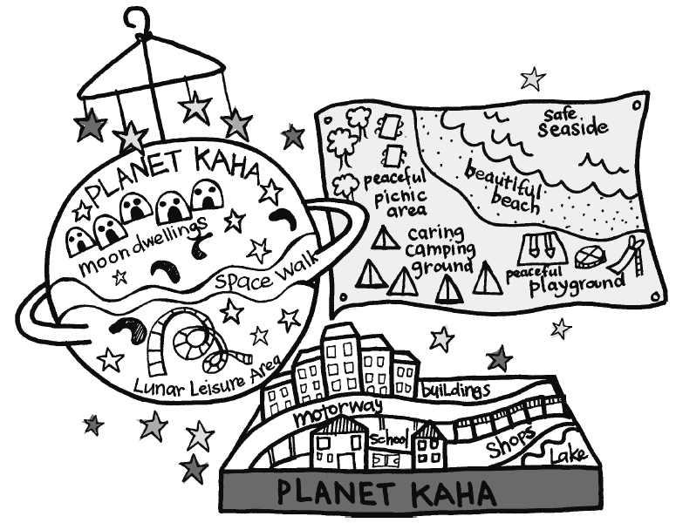

Copysheet: Planet Kaha
Your mission, should you choose to accept it, is to create a planet where there is no bullying.
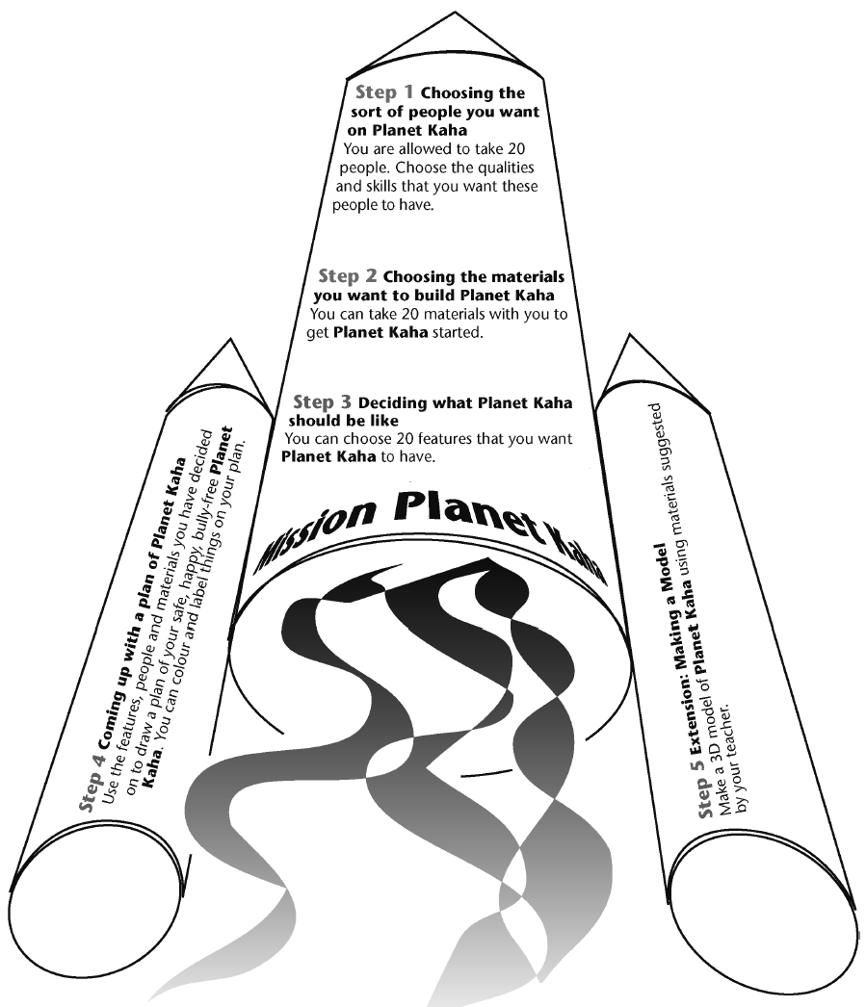

Copysheet: Qualities, Skills and Materials
Qualities | Skills | Materials
generous | doctor | seeds | books
caring | nurse | blankets | soil
brave | teacher | play station | torch
kind | plumber | bikes | credit cards
strong | police officer | takeaways | beer
helpful | gardener | wood | money
bossy | farmer | water purifier | computer
nosy | grocer | generator | toothpaste
selfish | baker | batteries | candles
critical | taxi driver | tool box | solar panel
leader | pop star | toilet paper | perfume
friendly | entertainer | spades | sunscreen
humorous | professional person | tinned food | deodorant
experienced | sports person | coke | nit shampoo
thoughtful | TV personality | warm clothing | cigarettes
enthusiastic | artist | matches
has initiative | journalist | mobile phone
tenacity | photographer | marbles
popular | firefighter | TV
trendy | electrician | DVDs
envious | shopkeeper | photos
affirming | carpenter | teddy bear
jealous | minister | pets
responsible | tax inspector | farm animals
flexible | florist | fertilisers
faithful | counsellor | nails/hammer
athletic | cook | first aid kit
good looking | waiter | tent
wealthy | computer programmer | camping equipment
famous | professor | tyres
truthful | designer | petrol
honest | train driver | cars
has integrity | drain layer | watch/clock
respectful | accountant

Copysheet: Features of a Bully-free Community
Choose 20 of the following features, or use ideas of your own.
Lots of trees Pubs
Expanses of concrete Discos
Blocks of flats Night clubs
Ponds Child care centres
Small, individual houses Universities
Movie theatres Supermarkets
River or lake Gardens
Skateboard ramp Farms
Satellite dish Petrol stations
Cave dwellings Tents
Schools Cyber cafe
Churches Underground houses
Community centre Telecom
Police station Railway station
Prison Creche
Parks Corporate offices
Beach Game parks
Mountains Flying saucer launch pads
Hotels Airport
Holiday park Bus depot
Bush walks Good lighting
Video parlours Footpaths
McDonald’s Cycling parks and lanes
Parking buildings Sandpits
Playing fields Stables
Shopping malls Hospital
Indoor cricket Drop-in centre
Children’s playground Women’s refuge
Motorways Seating areas
Picnic places

Learning experience 4: Setting goals

Learning intention
Students can set and work towards individual and class goals.

Resources
Copysheet: Personal Goals
Copysheet: Class Charter
Musical instruments, audio tapes and tape recorder (optional)

Activities

1. Personal goals
Review with students some of the qualities that they decided they would like the people on Planet Kaha to have. Ask students to think about the following question. They do not need to answer out loud.
Ask: Do you think you have the qualities to be accepted on Planet Kaha?
Hand out Copysheet: Personal Goals. Invite each student to complete their personal goals. This could be taken home and shared with an adult and then stored in a safe place where it can be reviewed regularly.

2. Bully-free class charter
Explain to the class that you are all going to work together to make a Bully-free Charter for your class. Put up Copysheet: Class Charter, made into a large poster. Invite students, individually, to go to the poster and contribute one idea that will make their classroom a bully-free zone. They then sign the poster. The Class Charter should remain up throughout the year. Review it regularly, to ensure that the class is living up to these goals.
Ask: Are we still a bully-free zone?
Is there anything we need to work on a bit harder?

3. Anti-bullying song
Develop an anti-bullying anthem, rap, or song. A rhythm could be worked out first and then different groups could contribute a verse. A variety of musical instruments could be used, and the finished song could be recorded.

Copysheet: Personal Goals
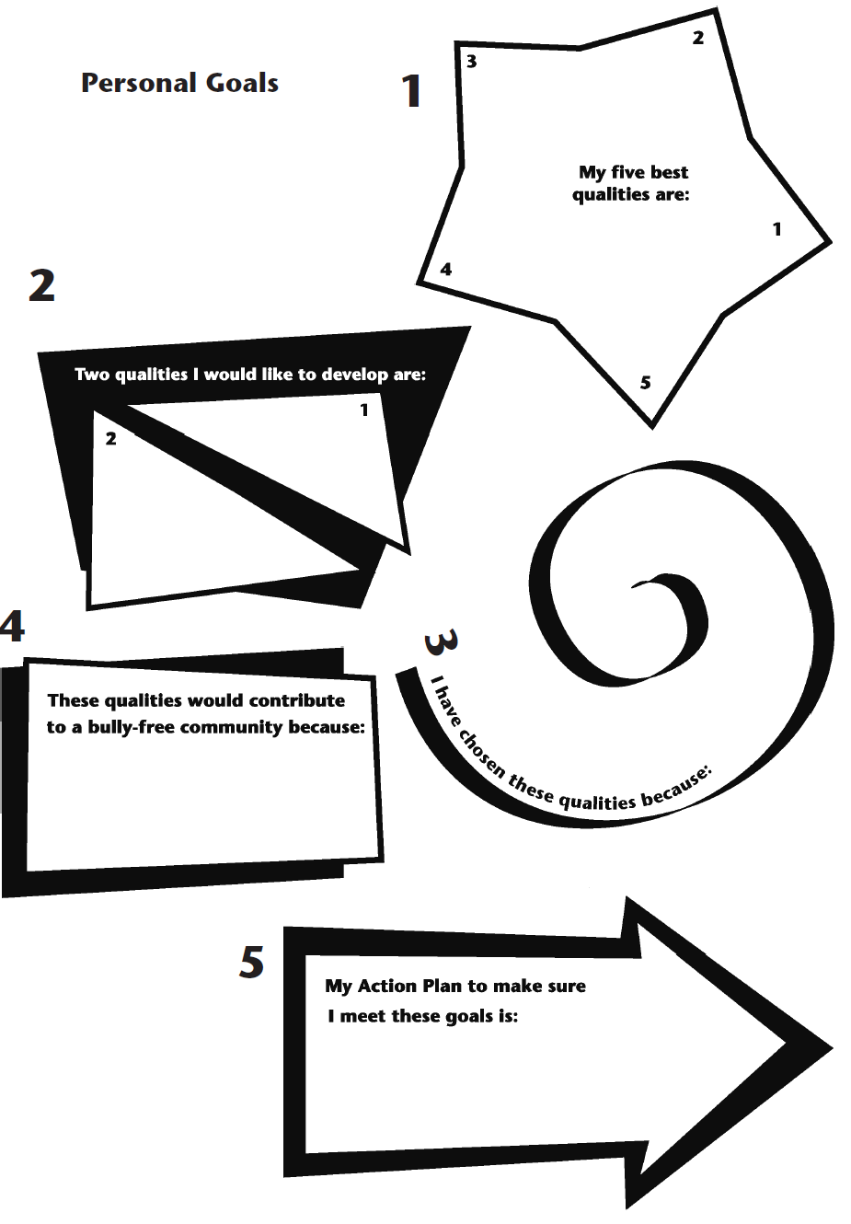

Copysheet: Class Charter

Class Charter

