Kia Kaha

Years 4-6 Focus area 3
This section contains one of the focus areas of the Kia Kaha programme for students at years 4–6 (ages 8–10):
- You and me
- Hurting
- Put a stop to bullying
- A cool community
Note: Research suggests that an effective Kia Kaha programme should include learning experiences from each of the focus areas.

Focus area 3: Put a stop to bullying

Contents
Focus area 3: Put a stop to bullying 3
Explanation 3
Curriculum links 3
Success criteria 3
Learning experience 1: Confidently me 4
Learning intention 4
Resources 4
Activities 4
Homework activity 5
Copysheet: Confident Kid 6
Learning experience 2: Positive strategies 7
Learning intention 7
Resources 7
Activities 7
Copysheet: Bullying Scenarios 9
Learning experience 3: Getting help 10
Learning intentions 10
Notes for the teacher 10
Resources 10
Activities 10
Homework activity 12
Optional learning experience 12
No More Muesli Bars 13
Copysheet: Bookmark 15
Copysheet: Putting a Stop to Bullying 16
Copysheets: Help Cards 17

Focus area 3: Put a stop to bullying

Explanation
In this focus area students develop and practise a range of strategies to stop bullying. They learn about being confident and how to interact in confident ways with others. They explore a range of things that they can do to produce a positive outcome for a bullying situation, whether they display bullying behaviour themselves or are victims or bystanders.
It is important that children know that they must ask for help in bullying situations. This is not telling tales. The school should, in fact, foster a ‘telling’ ethos. Students identify whom to ask for help and explore a range of different ways of asking for help.
Students must know, however, that when they tell about bullying, the school will do something to stop it. The school’s policy on how bullying will be handled must be shared with the class. It is also important that the school makes it clear to parents that it has adopted a ‘telling ethos’ with regard to bullying, and that parents know what steps to take if they suspect bullying.

Curriculum links
Key Competencies: Managing self; Relating to others, Participating and contributing
Learning areas: Level 2 Health and Physical Education – Strand A Safety Management;
Level 3 Health and Physical Education – Strand C Identity, Sensitivity, and Respect; Interpersonal Skills
Key learning areas: Mental Health: use strategies to counter bullying; be aware of the school’s policy on bullying
Concepts:
- Well-being, Hauora: a sense of well-being when bullying is no longer a problem
- Health promotion: develop personal skills that empower them to report bullying
- The socio-ecological perspective: recognise the need to take responsibility when others are being bullied
- Attitudes and values: develop a positive and responsible attitude to their own and other’s well-being

Success criteria
Students can:
- interact confidently with others
- ask for help appropriately
- use strategies to stop bullying.

Learning experience 1: Confidently me

Learning intention
Students can interact confidently with other people.

Resources
Copysheet: Confident Kid

Activities

1. Body language exercise
Divide the class into groups of three. The teacher calls out some or all of the following in turn (make sure that feeling confident is included):
Happy, sad, friendly, selfish, angry, brave, strong, co-operative, feeling confident, meeting a friend, watching sport, saying goodbye to someone
As each is called, the group has 30 seconds to get into a statue to represent it. After each, stop and comment on the body language and expressions used. Build these up into a word bank on the board – for example:
Smiling, standing up straight, scowling, looking at the ground, engrossed, eyes down, head up
Now repeat the above exercise, but this time students work as individuals. Finish with feeling confident. Again comment on expression and body language and add descriptions to the word bank.

2. What is confidence?
Refer students back to the word bank. Work with them to remove all the words that do not describe a confident person. Give each student Copysheet: Confident Kid. They cut out the figure and the flag. Inside Confident Kid they write all the qualities that a confident person has. On the flag they write situations in which they feel confident.
Talk about how it is good to be confident, but that it is still important to respect other people’s personal space. Put the students in two lines, A and B, facing each other. Line A stays still. Line B moves slowly forward towards Line A. People in Line A each say “Stop!” when their partner from Line B has entered their personal space. Repeat the process with Line B moving forward.

3. Practising confidence
Give students the opportunity to practise being confident in some or all of the following situations. This could be done in pairs, or using parent helpers. Make sure that all students have a turn at being confident.
Telling about a movie you saw
Asking someone home to play
Talking to your parents about what you did at school today
Standing up for yourself
Saying how you feel about something
Explaining to your coach (Scout leader, music teacher ...) why you can’t come to practice next week
Telling someone in your class that you don’t like the way they are treating you
After each role play, ask the following questions of some pairs. Direct the question to the appropriate person in the pair.
Ask: Was you partner confident?
How could you tell?
How did it make you feel when your partner was confident?
Was it easy to be confident? How did this make you feel?
Make sure that you praise students when you observe them being confident.

Homework activity
Students take their completed Copysheet: Confident Kid home and tell an adult what they have learnt about being confident.

Copysheet: Confident Kid
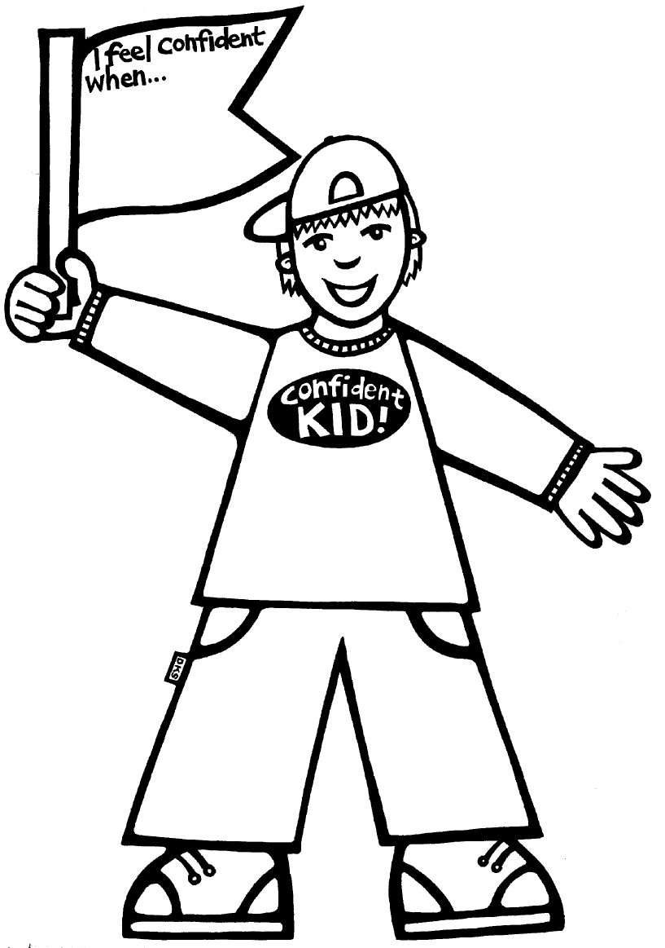

Learning experience 2: Positive strategies

Learning intention
Students can use positive strategies to deal with bullying.

Resources
Copysheet: Bullying Scenarios

Activities

1. What we can do
Choose one scenario from Copysheet: Bullying Scenarios to use with the whole class.
Ask: What is happening?
Who is being bullied?
Who could help stop the bullying?
What things could these people do?
Build up the ideas into a class chart, divided into three columns, like the one below.
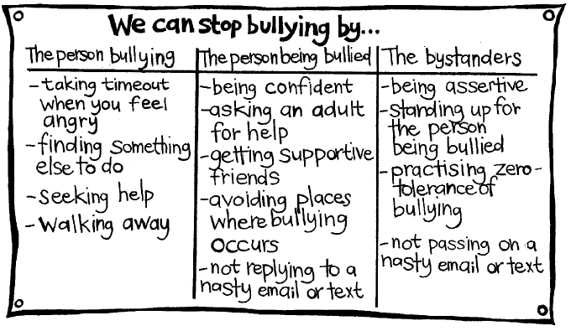
Ask students for other ideas to add to the chart. Stress that all three groups – those who display bullying behaviour, bystanders, and people being bullied – have a responsibility to do something to stop it.

2. Role play
Divide students into groups. Give each group one of the scenarios from Copysheet: Bullying Scenarios. Ask them to discuss the same questions from the previous activity for their card. They then choose ideas from the Stop Bullying Chart and role-play the scene to show a positive outcome. Groups present their role plays to the class in turn. After each:
Ask: Was this an effective way of stopping the bullying? Why, or why not?
Could any of the people in the situation have done more to stop it? Give details.
Do you think you could all do these things to stop bullying in real life? Why, or why not?
If a group has not chosen an effective way of stopping the bullying, they could choose other alternatives to try.
It is important that students do not role-play the negative behaviour on the card. Stress that the role-play should show only a positive resolution. You may choose to start from a freeze frame.

3. Support squad
Work with students to introduce a Support Squad for the class. Explain that anybody can belong to the Support Squad as long as they do something to stop bullying and to make the person being bullied feel better. The class designs and produces a Support Squad Chart, like the one below. If members of the class observe a class member doing something to stop bullying, they can write that person’s name, and a comment, on the Support Squad Chart. When the chart is full, those names can be taken off to make room for more.
Support Squad members should be affirmed regularly.
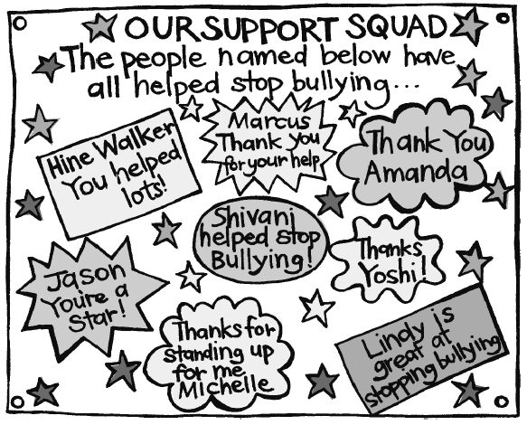

Copysheet: Bullying Scenarios
Mandy and Shalini were walking home from school. Mandy stopped to read a text on her mobile phone. The message said, “I’m going to get you, Mandy Davis”.
Rakesh was eating his lunch on his own. There were other people from his class close by, but no one had asked him to sit with them. They laughed at the food he had to eat and said it had a funny smell.
Susie was late. She was scared to go in and face the class, but knew that she couldn’t put it off much longer. The teacher would be here soon. She pushed open the door and immediately paper, apple cores, shoes, and books flew in her direction. “Here’s Woozy Soozy,” shouted Vanessa. Susie stumbled to her desk with her head down so that the others couldn’t see her tears. Someone stuck their foot out and Susie went sprawling to the floor. Everyone screeched with laughter.
Leah was feeling terrible. Everyone else in her group was going to the mall after school, but they had deliberately not asked her. She could see them now, giggling and laughing as they looked in her direction. Even Trudy, who was meant to be her best friend, was doing it. And they had started calling her awful names. It just wasn’t fair.
Kefeng had broken his leg badly and was on crutches. Darryl and Wiremu took the crutches and threw them in the hedge. Glen and some others stood watching.
Sila and Warren were friends – sort of. But Warren was always the boss. He decided what they would play, always made Sila give him his things, and made Sila do things he didn’t want to do, like take stuff from the dairy. Today Sila had gone to show Warren his new bike. Warren went for a ride and then wouldn’t give the bike back. He said he was going to keep it to go to football practice.
Tony liked it when other kids were scared of him. He would push them around, take their stuff, and even tell them where they could play. This day Reuben and some friends went to play on the adventure playground. Tony was there and told them they had to leave. He started walking towards them, swinging his arms by his sides. Some other kids were watching to see what would happen.

Learning experience 3: Getting help

Learning intentions
Students can:
- identify people to ask for help
- ask for help in a way that suits them
- explain what will happen when bullying is reported.

Notes for the teacher
Students, staff, and parents and caregivers need to be aware of the school’s policy on how bullying will be handled.
This is a long learning experience, but a very important one. Teachers may prefer to use the Help Cards for practice at asking for help at intervals throughout the year.

Resources
Story: No More Muesli Bars, by Norman Bilbrough
Art materials
Chart paper and felt pens
Copysheet: Book Mark
Copysheet: Putting a Stop to Bullying
Copysheets: Help Cards
Primary School Anti-bullying Ads - video clips made by primary school students as part of the Fair Go Ad Awards (available from your Police School Community Officer)

Activities

1. No More Muesli Bars
Read the story No More Muesli Bars to the class.
Ask: What was Ricky’s problem?
How was it making him feel?
Why do you think Matt Arnold was being so mean?
Do you think Ricky’s decision to tell was a good one? Why, or why not?
Do you think he made a good choice about who to tell? Why, or why not?
How do you think the teacher handled the situation?
What sort of a friend do you think Jason was? Why?
Would you have felt comfortable telling this teacher about a problem? Why, or why not?
What would you want the teacher to do?
Divide the students into groups. Each group must retell the story, choosing another person that Ricky could have told. Some suggestions could be:
A parent or family member An adult friend
Another adult at school The minister
A friend’s parents School Community Officer
An older brother or sister An elder
They can retell the story as:
A play A written story
A cartoon strip On an OHP
A wall story in words and pictures
Completed stories can be shared with the class over the next week.

2. Bookmarks
Ensure that students understand that they can also ask any of the people they talked about in the previous activity for help. They must choose someone that they feel safe and comfortable about talking to.
Give each student a bookmark made from Copysheet: Bookmarks. On one side they write the people who can help them and on the other side they write what they would like that person to do. Completed bookmarks should be taken home and shared with the family.
Ask: Once you have told, what would you like the person to do? (Listen, make me feel better, do something to help, tell me it’s not my fault)

3. Role play
Divide students into six groups. Give each group a card made from Copysheets: Help Cards. The group role-play asking for help for the situation on their card, using the method indicated on the card.
Ask each group to present their role-play to the rest of the class. After each:
Ask: Was this a good way to get help?
How could it have been better?
What could you do if you hadn’t got any help? (Keep on telling other people until you do)
Which of these ways do you think might be best for you?

4. Class talk
Invite the Principal to explain to the students that the school will not accept bullying and to tell them what will be done for the victim, the person who displays bullying behavior, and the bystanders when bullying is reported. (See the Bullying-Free NZ for positive suggestions, such as the no blame approach). The Principal also needs to explain that this policy has been shared with parents and caregivers, so they also know what to do if they suspect bullying.

Homework activity
Give each student Copysheet: Putting a Stop to Bullying to take home and complete with a parent or other adult. This should remain at home on the fridge door, or a notice board, as a constant reminder that bullying should be stopped.

Optional learning experience

Using Anti-bullying Ads
Explain to the class why the anti-bullying video clips were made. Invite the class to rate each of the ‘ads’ as it is shown. Decide on a suitable rating scale with the class. View the results and discuss the winning three.
Ask: Why were these ads so effective?
Students work in groups to make their own anti-bullying videos. These could be judged by the class, or by all year 4–6 classes.

No More Muesli Bars
by Norman Bilbrough
Ricky didn’t want to go to school.
“You’re not feeling sick, are you?” His Mum was rushing to get to work early.
Ricky shook his head. He wished he’d woken up with stomach ache. But his body was fine.
His Mum looked puzzled. “You like your new school. You’ve made friends, and you said Mrs Church was the best teacher you’ve had … is there something worrying you?”
Ricky shook his head again. He wasn’t going to tell what the problem was. He didn’t want to look like a wimp, even in front of his mother.
“Okay, see you at five. Don’t forget your lunch.”
Ricky pushed the lunch box into the bottom of the bag, and wondered if he’d get to eat it.
His mother ran for the bus and he started down the street, wishing his friend Jason didn’t live on the other side of town. They could walk to school together then. And he’d be well away from Matt Arnold.
Matt Arnold, the big Year 7 kid who lived at the bottom of the street.
Ricky walked really slow, wishing he had a secret potion that would make him invisible: one that would wear off when he was inside the school gate.
Matt Arnold’s house was at the bottom of the street – the place where he lived with his big brothers. Ricky stopped. Now he did feel sick: his stomach gripped up and he was hardly breathing. Maybe he could go home and hide in his room all day … but Mum would be sure to find out, she always did. “How was your day, Ricky?” she’d ask.
And he’d have to lie. She always discovered when he was lying. And what about the next day, and the day after? The problem would still be there.
He took a deep breath. The street was empty. He started running. If he ran flat out, he might out-run Matt Arnold.
Fat chance!
He reached the end, turned left towards the school – and ran straight into Matt. The big boy yanked him to a stop.
“What’s the big hurry, kid?”
“I’m not a kid!”
“What you got for lunch?” Matt Arnold squeezed Ricky’s arm.
“I’m buying my lunch today!” he said desperately.
“Give us your lunch money, then.” Matt Arnold took a look at Ricky’s miserable face and gave a laugh. “Liar!”
He ripped open the zip of Ricky’s bag and dug out the neatly wrapped sandwiches from the lunch box. “Hey, muesli bar. These suck, kid! Tell your Mum to buy chocolate next time!” And he threw the muesli bar onto the road and shoved the sandwiches in his pocket. He gave Ricky’s arm an extra-hard squeeze
“And remember, if you tell anybody I’ll thump you so hard you won’t be running anywhere.”
Ricky picked up his bag and when he was well away from Matt Arnold he started crying. At the school gate he managed to stop, but all morning his throat was tight and he didn’t trust himself to speak. And he got his maths all wrong.
At lunch break Jason said, “Where’s your lunch?”
Ricky shrugged, holding back his tears. “I’m not hungry.”
Jason looked puzzled. “You said that yesterday.”
Suddenly Ricky couldn’t stop himself. “Matt Arnold pinched it from me.” And he told Jason everything that had happened. “Promise you won’t tell anybody!”
“But you’ve got to report him. He can’t do that! Tell your Mum. Tell Mrs Church!”
“I can’t, he’ll kill me!”
Jason pushed his sandwiches across and ripped open his bag of crisps for Ricky to share.
“He won’t kill you, he wouldn’t dare. I’ll tell Mrs Church for you.”
“No!”
“I’ll come with you then. We’ll go to the staffroom now.”
“But what if he sees us going there?” Ricky imagined Matt Arnold breaking his arm – even his leg, so that he wouldn’t be able to run to school.
“Look,” Jason pointed, “he’s up on the soccer field, he won’t see.
Ricky shivered at the sight of the bigger boy racing after the ball, pushing other kids aside. “Okay,” he said reluctantly.
But when Jason knocked on the staffroom door, Ricky had to stop himself from running off.
“Hullo, you two, what’s up?” It was Mrs Church.
“I want to report – “Jason began, then remembered himself and looked at Ricky.
“Ricky?” Mrs Church said. “What’s the problem?”
Ricky felt really scared. It wasn’t too late not to tell. Maybe he could try and take two lunches to school, one for Matt Arnold and the other for himself.
“Come into the office,” Mrs Church said firmly. They followed her into the empty room and she shut the door. “What’s happened, Ricky?”
He took a deep breath, then the words rushed out. “Matt Arnold takes my lunch from me before school and says he’ll beat me up if I tell.”
“Ahh …“ Mrs Church nodded. “Matt Arnold … his brothers give him a tough time, so he picks on somebody, too.” She looked quietly at Ricky. “He won’t be taking your lunch again, Ricky, and he won’t be threatening you, either. We’ll do some serious talking to him. And to his Mum and Dad.” She smiled then. “You did the right thing, Ricky, coming and telling me. And you’re a good mate, Jason.”

Copysheet: Bookmark
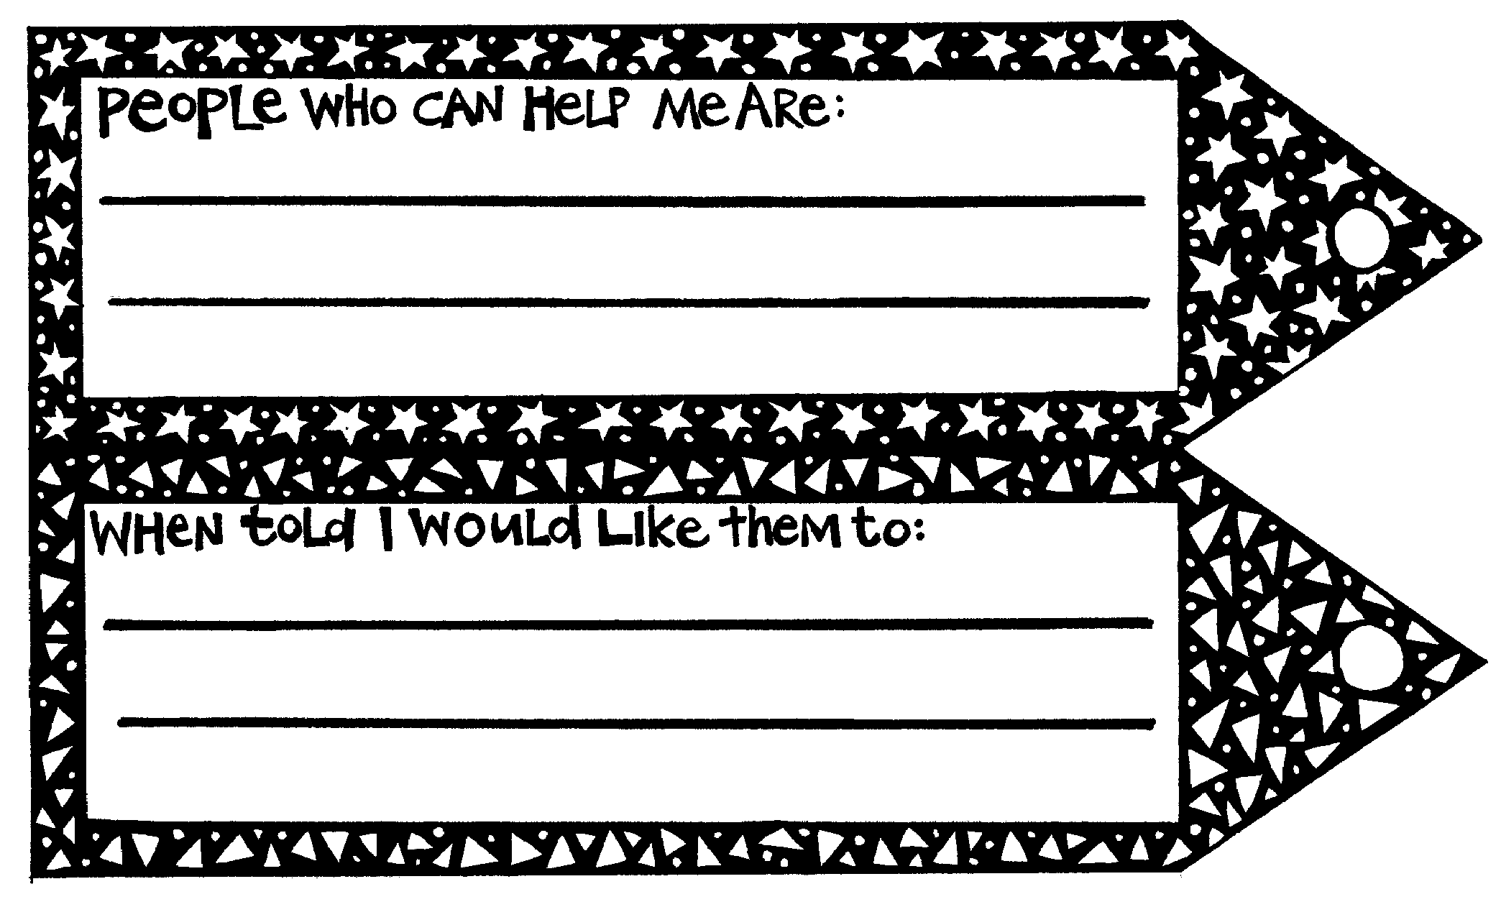

Copysheet: Putting a Stop to Bullying

Dear Parents and Caregivers
As part of Kia Kaha, we have talked about how bullying is unacceptable and how nobody has to put up with it. At school we encourage children to tell a staff member if they are being bullied, so that the school can find a suitable, safe way of sorting it out. We also encourage children who see bullying happening to report it.
Your child has made a bookmark to show the people he or she would feel comfortable telling about bullying. Ask to have a look at the bookmark.
It is important that you also encourage your child to tell you if they are being bullied, if they are bullying someone else, or if they know about bullying. Then you can contact the school to find a way of stopping this.
We appreciate your help in making this a safe school.

______________________________________________
(Name of teacher)

Copysheets: Help Cards

Help Card 1
Ben is being bullied by a group of boys who wait for him on the way home.

Method of getting help
Ask for help directly from your teacher.

Help Card 2
Josie doesn't want to go to her dancing class anymore because other kids laugh when she finds it hard to do new steps.

Method of getting help
Write a letter to the dancing teacher.

Help Card 3
Jayant hates school because the other kids are picking on him. This is making him feel sick and unable to do his schoolwork.

Method of getting help
Tell his grandfather how he is feeling.

Help Card 4
Awhina is being bullied by her big sister. It is making her very unhappy. It usually happens at home where they share a bedroom.

Method of getting help
Fill out a Kia Kaha Card.

Help Card 5
Rangi’s lunch has been pinched for the third day running. He knows that Lucy has taken it. She has threatened to give him a hiding if he tells.

Method of getting help
Hanging around the staff room door, hoping someone will ask what is wrong.

Help Card 6
Helen is being threatened by a group of older kids at school. They take her things and say they will hurt her if she tells.

Method of getting help
Tell a friend.

