Kia Kaha

Years 4-6 Focus area 2
This section contains one of the focus areas of the Kia Kaha programme for students at years 4–6 (ages 8–10):
- You and me
- Hurting
- Put a stop to bullying
- A cool community
Note: Research suggests that an effective Kia Kaha programme should include learning experiences from each of the focus areas.

Focus area 2: Hurting

Contents
Focus area 2: Hurting 3
Explanation 3
Curriculum links 3
Success criteria 3
Learning experience 1: Identifying bullying 4
Learning intentions 4
Resources 4
Activities 4
Learning experience 2: How bullying makes us feel 7
Learning intention 7
Notes for the teacher 7
Resources 7
Activities 7
Optional learning experience 8
Learning experience 3: The outcomes of bullying 9
Learning intention 9
Resources 9
Activities 9
Homework activity 10
Copysheet: Sione’s Lunch 11
Copysheet: Interview Form 12
Learning experience 4: Bullying is wrong 13
Learning intention 13
Notes for the teacher 13
Resources 13
Activities 13
Optional learning experience 14

Focus area 2: Hurting

Explanation
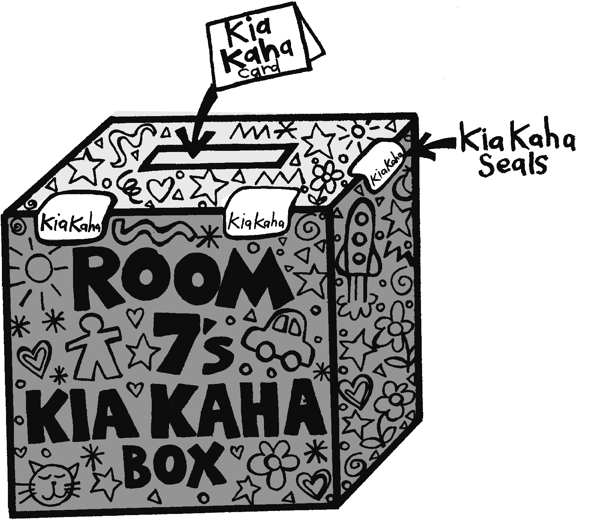
Children need to recognise bullying, and know where it is likely to occur, before they are able to take positive action to stop it. Children who can recognise bullying as hurtful behaviour are more likely to empathise with other children who are hurt by the words and actions of others. Bullying can have long-term consequences for the victim’s health and attainment (for example, problems with depression, lack of self-worth, loss of confidence, and diminished quality of life). People who bully may have failed relationships and end up breaking the law. They often repeat the cycle of bullying.
Use of the Kia Kaha Box should be reinforced in this focus area.

Curriculum links
Key Competencies: Managing self; Relating to others, Participating and contributing
Learning areas: Level 2 Health and Physical Education – Strand C Interpersonal Skills;
Level 3 Health and Physical Education – Strand A Safety Management, Strand C Identity, Sensitivity, and Respect; Interpersonal Skills
Key learning area: Mental Health: examine bullying and its impact on people’s health
Concepts:
- Well-being, Hauora: mental and emotional well-being; social support
- Health promotion: collective action to create zero-tolerance of bullying
- The socio-ecological perspective: mutual care and support of those who are bullied
- Attitudes and values: care and concern for those who are bullied; sense of social justice

Success criteria
Students can:
- identify bullying
- support those who are bullied
- practise and promote zero-tolerance of bullying.

Learning experience 1: Identifying bullying

Learning intentions
Students can:
- identify different types of bullying
- identify areas where bullying occurs.

Resources
Art materials
Video At a Distance – Standing up to Cyberbullying availble at: www.cyberbullying.org.nz/at-a-distance-film/index.php
Available from School Community Officer:
- Photo Pack Interactions
- CD Interactions Photos

Activities

1. Photo pack
Show the students the photographs in the Photo Pack, either by using the CD or passing the photos around the groups. After each one:
Ask: Who is in the picture?
Where do you think they are?
What are they doing?
Do you think this is bullying? Why, or why not?
Do you think this is appropriate behaviour? Why, or why not?
Do you think everyone in the picture has equal power? Why, or why not?
How do you think each person in the photo is feeling?
Why do you think they are feeling like this?
Have you, or someone you know, ever been in a situation like this? Give details.
Students will have a variety of views on what is happening in each picture, which is to be encouraged. However, to help them decide if bullying is taking place, you could ask:
Is anyone looking frightened or threatened?
Does anyone look to have more power than the others?
For example, the photo of the two boys standing head-on is unlikely to be bullying, as they are equally matched.

2. Mobile phones
Show the photo with the mobile phones.
Ask: How is this form of bullying different from the others?
What could you do if someone was sending you nasty messages on your mobile phone or computer?
Share the following information with the class.
Show the video At a Distance.
Discuss the material included below about cyberbullying.
Cyber bullying
This is the use of Information and Communication Technology (ICT), particularly mobile phones and the Internet, to deliberately upset someone else. It differs from other forms of bullying because:
- it can be at any time, day or night
- it can invade a person’s home and personal space at any time
- the audience can be very large and reached rapidly
- cyberbullies may attempt anonymity
- the bully or victim can be any age
- bystanders can become accessories to the bullying – for example, by passing on a humiliating message.
Advise students being bullied this way to:
- refrain from responding
- save the content, message, pictures, and online conversations as evidence
- report to an adult
- inform the provider of the service if content is abusive or repeated more than once
- contact NetSafe for help on what to do; text and online bullying and harassment can be stopped.

3. Where does bullying happen?
Brainstorm with the class places in the community where bullying occurs. Record these as a class mind map like the one on the next page. Keep this on the board, explaining to the class that it will be used again in Focus area 4.

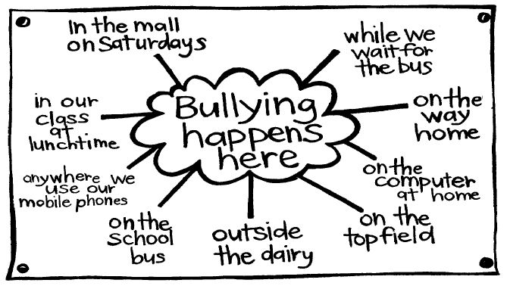

Learning experience 2: How bullying makes us feel

Learning intention
Students can explain how bullying makes us feel.

Notes for the teacher
Discourage students from labelling someone as a ‘bully’. Rather, encourage them to see that anyone can display bullying behaviour.

Resources
Poster: The Birthday Party (available from your Police School Community Officer)
Note: The picture is to be revealed a part at a time (disclosure method). Teachers should cover the poster with paper cut into three parts, as shown in the diagram below.
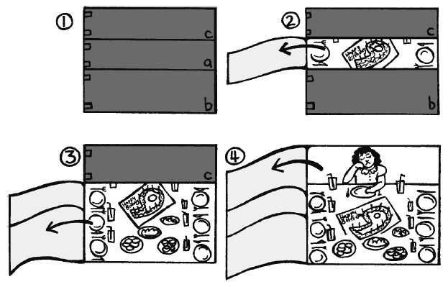

Activities
Place the covered poster in front of the class. Show Part A of the poster, the birthday cake.
Ask: What is this?
What do you think is going to happen?
Show Part B of the poster, the party table.
Ask: Does this look like a good party? How can you tell?
How would you be feeling if this were your party? Why?
Show Part C of the poster.
Ask: Do you think this birthday girl looks happy?
Why do you think she might be looking like this?
Give the following information to the class.
Ten friends were invited to the party. They all accepted. Not one of them turned up.
Ask: Why do you think the children who had been invited to the party didn’t come?
How has this made the girl feel?
What sort of behaviour is this?
Tell the class that this girl has been bullied for a long period of time. This is just the last straw. You may like to tell the class that this story is based on a true incident.
Ask: How do you think the girl will feel at bedtime?
How do you think she will feel at school tomorrow?

Optional learning experience
Ask each member of the class to imagine that they were invited to that party and didn’t turn up. They now know what an awful, hurtful thing they have done. They have an opportunity to put it right. They can either write a letter to the birthday girl saying how sorry they are, or draw a cartoon strip with captions showing what they would say to her the next day at school and how they could make her feel better in the future.

Learning experience 3: The outcomes of bullying

Learning intention
Students can describe the impact and effects of bullying.

Resources
Copysheet: Sione’s Lunch
Drawing materials
Copysheet: Interview Form

Activities
Read the scenario on Copysheet: Sione’s Lunch out to the class.
Ask: How would you describe Matthew’s behaviour?
How would you describe Sam’s behaviour?
What could Sam have done to help?
Do you think Sione deserved this treatment? Why, or why not?
Use this example to reinforce the role that bystanders can play in a bullying incident.
Sam was watching the incident and yet he chose not to do anything to help. Had he intervened, sought help, or reported the incident, Matthew wouldn’t have got away with bullying Sione this time, or probably ever again.
Brainstorm with the class all the possible outcomes for Sione that might result from this bullying incident. Put these on the board. Some examples might be:
Sione is hungry.
Sione is sad.
Sione’s parents are cross because he has lost his lunch box.
Sione’s teacher growls at Sione because he is not concentrating.
Sione walks to school in future because he doesn’t want to meet Matthew.
Sione is afraid to come to school.
Matthew takes other things from Sione.
Matthew might slash Sione’s bike tyres anyway.
Divide the class into small groups. Explain that each group is going to draw one ‘frame’ of Sione’s story. Some groups will draw the initial incident and some will draw outcomes.
Allocate one group to Frame 1, one to Frame 2, and one to Frame 3 of the Copysheet. The remainder of the groups choose one of the outcomes to draw. Each drawing should be A4 size. Arrange the drawings on the wall as shown in the diagram on the next page.
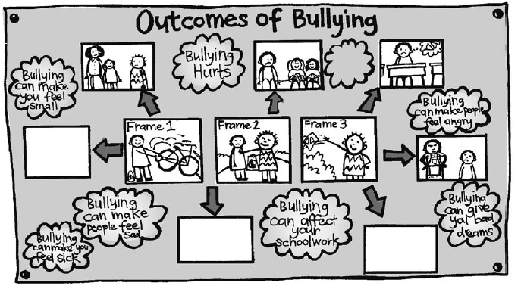
Ask each group to make a summary statement about the impact of bullying, to be arranged around the drawings.
Brainstorm with the class the possible long-term consequences of bullying for the person who displays bullying behaviour. The School Community Officer can give examples from personal experience of how bullying can easily become assault, which is a crime and will result in penalties and an uncertain future for the perpetrator.

Homework activity
Copysheet: Interview Form should be sent home so that it can be brought back completed for the next learning experience.

Copysheet: Sione’s Lunch

Frame 1
Sione had just arrived at school on his bike. He wheeled it to the bike sheds where he locks it during the day. His heart sank when he saw Matthew standing there. Matthew always picked on Sione. He was bigger than Sione, too. Sione locked his bike, took off his cycle helmet, and got his lunch box from the saddle bag.

Frame 2
Quickly Matthew snatched the lunch box and held it high above his head.
“I’m having this,” he said. “Say anything and I’ll slash your tyres.”
Sione didn’t know what to do. The only other person around was Sam, and Sam was pretending that he hadn’t seen anything. He was probably afraid of Matthew, too.

Frame 3
Sione stood and watched as Matthew went off. He saw Matthew take the lunch out of the box, which he threw over the hedge.

Copysheet: Interview Form
Dear Parents and Caregivers
We are trying to find out what people in our community think about bullying. Please help us by completing this survey.

1 Were you bullied at school?

2 How did you feel about it then?

3 What new types of bullying, such as cyber bullying, do you know about?

4 When you think about being bullied at school, does it still upset you?

5 Are you concerned about bullying at your child’s school?

6 What do you think the school should do to stop bullying?

7 If your child was being bullied, what could you do?

8 Do you think bullying is acceptable or unacceptable behaviour?

Please return this form to school by _____________________________ as your child needs it to work on a class exercise.
___________________________________
(Name of teacher)

Learning experience 4: Bullying is wrong

Learning intention
Students can practise and promote zero-tolerance of bullying.

Notes for the teacher
In developing Kia Kaha, Police are concerned that students learn to distinguish right from wrong and to recognise what constitutes acceptable and unacceptable behaviour. For example, students need to know that bullying is wrong and unacceptable.
The Interview Form (given at the end of Learning experience 3) needs to be sent home before this learning experience. It could be completed by an adult at home or another adult the student knows.

Resources
Completed Copysheet: Interview Form
Members of the school community
Art materials
Rulers and equipment for graphing
Morning tea (option)
Poster: Stop Bullying (available from your Police School Community Officer)

Activities
Ask each student to take out their completed Interview Form. Each student cuts their form up into separate questions.
Divide the class into eight groups. Give each group one of the interview questions to process. This could be done by graphs, pictorially, or by a written statement, on a piece of chart paper. The group should decide on the most appropriate method.
Ask each group to report back. Completed charts should be displayed on the wall. Arrange for parents and caregivers to hear the outcome of the survey.
Invite a panel of resource people to school. This could include parents, teachers, the School Community Officer, public health nurse, Resource Teacher of Learning and Behaviour, spokesperson from the school’s ICT provider, a representative of the Board of Trustees, and people in public office such as the mayor.
The panel needs to be carefully briefed on the desired outcome of this session, which is to reinforce for students that bullying is wrong and that their community will not tolerate it.
For the session:
- Show the visitors the work that has been done on Kia Kaha, including the processed survey results.
- Invite each panel member to tell the class how they feel about bullying and why they feel like this.
- Invite students to ask questions of the panel.
- Possibly have a shared morning tea.

Optional learning experience
After the panel, invite students either individually or in groups to complete a poster summing up what they have learnt about bullying. Completed posters should be put up around the school and/or taken into other classes and discussed.
The poster Stop Bullying could also be displayed.

