Kia Kaha

Years 4-6 Focus area 1
This section contains one of the focus areas of the Kia Kaha programme for students at years 4–6 (ages 8–10):
- You and me
- Hurting
- Put a stop to bullying
- A cool community
Note: Research suggests that an effective Kia Kaha programme should include learning experiences from each of the focus areas.

Focus area 1: You and me

Contents
Focus area 1: You and me 3
Explanation 3
Curriculum links 3
Success criteria 3
Learning experience 1: Being special 4
Learning intentions 4
Notes for the teacher 4
Resources 4
Activities 4
Optional learning experience 5
Copysheet: Kia Kaha Cards 7
Copysheet: Shield 8
Learning experience 2: Mixing well 9
Learning intention 9
Notes for the teacher 9
Resources 9
Activities 9
Homework activity 10
Copysheet: Recipes 11
Learning experience 3: Our waka 12
Learning intention 12
Notes for the teacher 12
Resources 12
Activities 12
Copysheet: Waka 14
Copysheet: Templates 15
Learning experience 4: Playing my part 15
Learning intentions 16
Resources 16
Activities 16
Homework activity 17
Copysheet: Our Family 18

Focus area 1: You and me

Explanation
In this focus area students consider the things that make them, and other groups, the same yet different. They consider the roles that people take in order to keep a group functioning properly and the qualities that they all bring to their class.
Students explore their rights and responsibilities as class members, and understand how important it is to respect these.
Work in this programme may be distressing to some students who are the victims of bullying. It may also encourage them to disclose bullying. For this reason, the Kia Kaha Box and Kia Kaha Cards are introduced so that students can ask for help privately.
The box should be opened by the teacher in private and responses handled in accordance with school policies, such as those for abuse, violence, and harassment.

Curriculum links
Key Competencies: Managing self; Relating to others, Participating and contributing
Learning areas: Level 2 Health and Physical Education – Strand A Personal Identity; Strand C Relationships; Identity, Sensitivity, and Respect; Level 3 Health and Physical Education – Strand A Personal Identity; Strand C Relationships
Key learning area: Mental Health: enhancing feelings of self-worth, respecting difference, working co- operatively with the class
Concepts:
- Well-being, Hauora: social well-being
- Health promotion: taking action to improve their class environment
- The socio-ecological perspective: rights and responsibilities in their class
- Attitudes and values: valuing themselves and others; care and concern for others

Success criteria
Students can:
- take a full role in the running of their classroom
- ensure that their rights are respected
- behave responsibly towards others
- affirm diversity.

Learning experience 1: Being special

Learning intentions
Students can:
- describe how people are the same
- describe the ways that people are different
- appreciate similarities and differences.

Notes for the teacher
Gradually accustom the class to thinking about things that are the same as similarities.

Resources
Black-and-white photo of the class (five copies)
Colour photo of the same class (five copies)
CD of class photos (available from your Police School Community Officer)
Large sheets of paper
Felt pens
Blu-tak
Materials for graphing
Kia Kaha Box made by the teacher and decorated by the students
Copysheet: Kia Kaha Cards
Copysheet: Shield

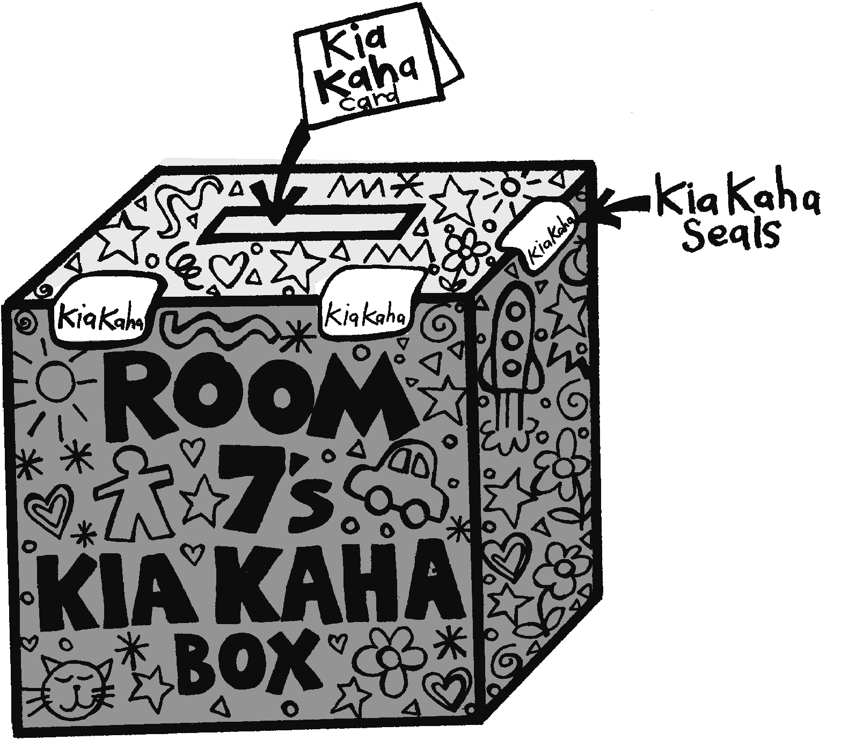
Activities

1. Kia Kaha Box
Explain to students that they are beginning a new unit of work called Kia Kaha. The things they will learn will help them make their classroom a bully-free zone. Introduce the Kia Kaha Box and the Kia Kaha Cards to students. Decide where in the classroom the box will be kept. Devise a system for sealing the box. Explain that a pile of cards will remain beside the box.
Students can complete a card and place it in the box if they wish to report bullying or ask for help. Talk about private times when this could be done. Explain that you will take some action to help. The Kia Kaha Box should be continued throughout the year, or introduced regularly for shorter periods of time.

2. The same, but different
Tell students that they are going to begin by finding out about the ways in which people are the same, yet different. Divide students into five groups. Give each group the black-and-white class photo, a large sheet of paper, and a felt pen. Ask the class to record all the things that are the same about the members of the class in the photo (that is, their similarities). For reporting back, ask each group to contribute one new idea in turn, and record these on a chart. You can use the photo on the CD for display.
Ask: What things are the same about members of our class?
Return students to the same groups. Give each group the colour photo of the same class. Ask them to make a list of all the things that are different about the members of the class (that is, the differences). Examples could be hair colour, colour of clothing, skin colour – things they couldn’t see before. For reporting back, ask each group to contribute one new idea in turn and record these on a chart. You can use the photo on the CD for display.
Ask: What differences would you notice about our class, if you looked at a colour photo?
Give each student a copy of the shield from Copysheet: Shield. The students complete and personalise these with words and/or drawings. Display the completed shields.

Optional learning experience
Divide students into groups. F or this learning experience they can use either the colour class photo, or their own class. Allocate each group one of the following characteristics:
- expressions – happy, sad, worried, dreamy, eyes closed
- length of hair
- hair styles
- hair colour
- colour of clothing
- style of clothing
- height
- size
- skin colour
- boys or girls.
They must gather data from the photograph or class and graph the results. Each group presents its completed graph to the class.
Ask: What is so good about having children with a lot of different qualities and characteristics in a class?

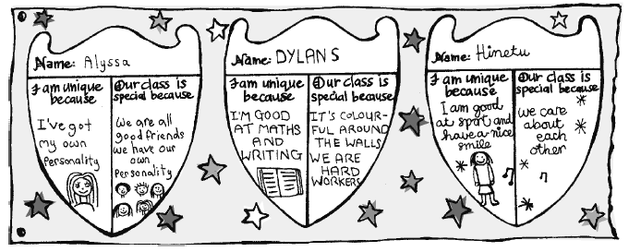

Copysheet: Kia Kaha Cards
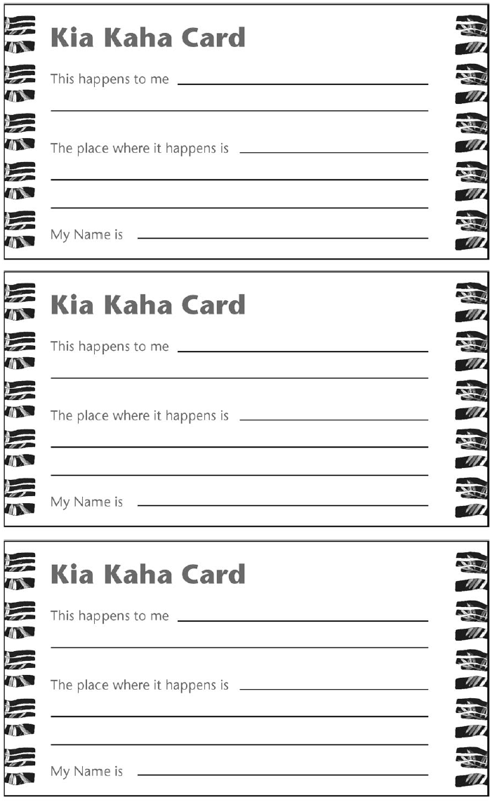

Copysheet: Shield
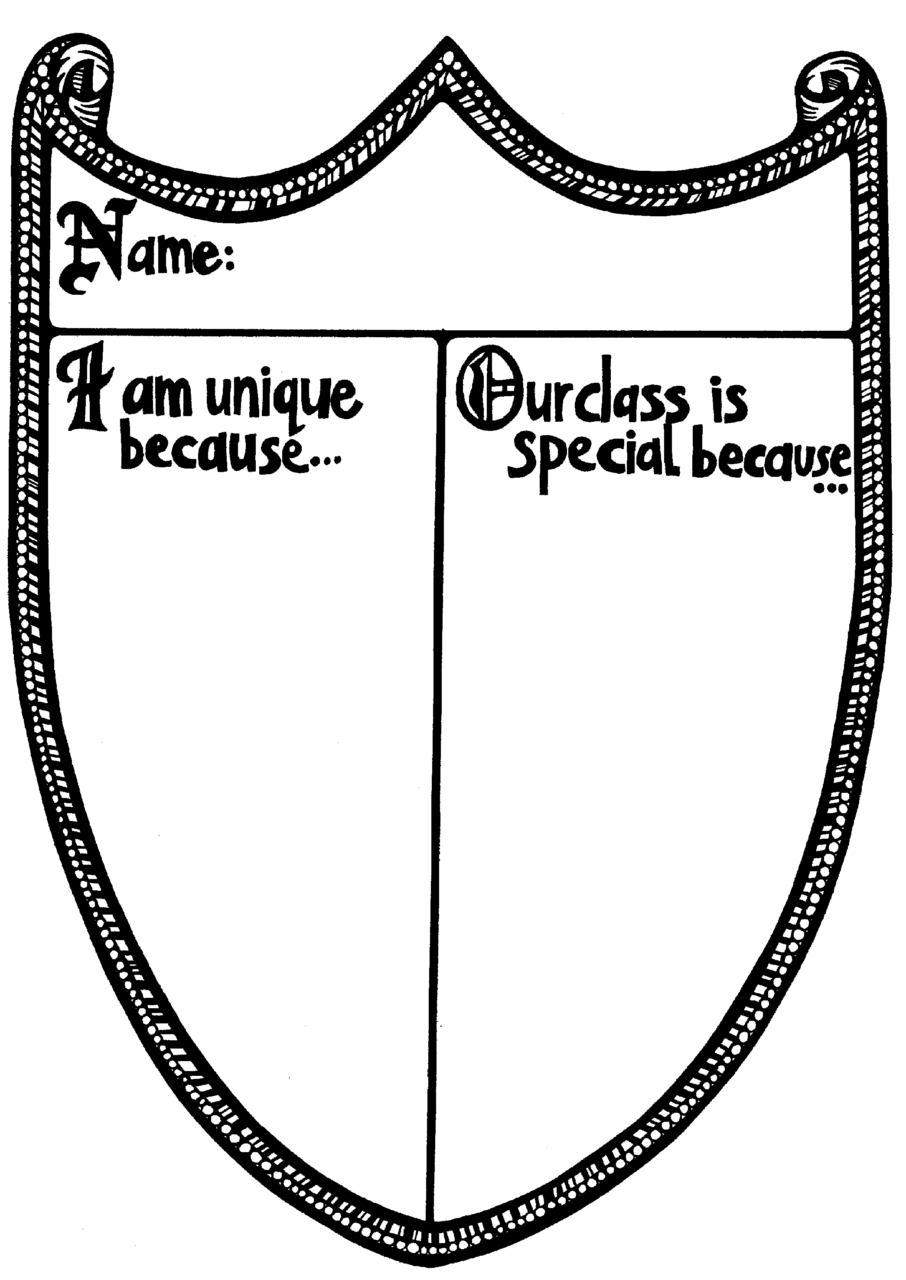

Learning experience 2: Mixing well

Learning intention
Students can explain the importance of roles.

Notes for the teacher
This learning experience can be carried out within the classroom, depending on the recipe chosen. However, it may be easier in a cooking room if one is available.
If it is difficult to set up a full cooking learning experience, choose a cooking learning experience that doesn’t need heat or many utensils. Alternatively, use another co-operative learning experience altogether, such as a group mural.

Resources
Copysheet: Recipes (or recipes brought by the class)
Utensils for cooking

Activities
Divide students into groups and allocate roles such as the ones below. These may vary according to the recipe you choose.
Collector of ingredients
Collector of equipment
Recipe reader
Adder of ingredients
Mixer
Taster
Cutter
Dishwasher
Give each group the recipe and they set about making it, with people carrying out their set roles. The completed product can be tasted by all. At the end:
Ask: Did you have a successful end result? Why, or why not?
Did your group have any problems? If yes, how did your group solve them?
Do you think everyone carried out their roles as required? Give details.
How could we have improved this activity?
Talk about how in any group there are roles that the members carry out so that the group can function properly. Give examples from the school, family, and other groups you belong to.

Homework activity
Students can either take home a taste of their cooking for family members to try or can be given a copy of the recipe to make at home. They can explain what they learnt about roles to their family.

Copysheet: Recipes

Lynette’s fudge cake
1 packet wine biscuits
½ cup sugar
125 g butter
½ tsp vanilla essence
1 tbsp cocoa
1 egg
½ cup sultanas
Crush biscuits. Boil other ingredients in pot for 1 minute, then pour over biscuit crumbs. Mix together, then press into flat cake tray and ice with chocolate icing.
Icing: 1½ cups of icing sugar, 2 tsp cocoa, milk to mix.

Mallow treats
1½ cups biscuit crumbs
100 g butter
½ can condensed milk
½ cup brown sugar
2 tsp cocoa
1 tsp vanilla essence
1 large packet Griffins marshmallows
Crush biscuits. Heat other ingredients (except marshmallows), then pour over biscuit crumbs. Take 1 dessertspoon of mixture into hands and pat out flat and wrap around marshmallows. Makes about 22.

Fruit smoothie
Almost any fruit – bananas, peaches, strawberries
1 tsp honey
About 2 glasses trim milk
3 tbsp yoghurt
Fruit juice (optional)
Blend the fruit in an electric blender. Add the honey and yoghurt and fill up with either trim milk or fruit juice, or a mixture of both.

Learning experience 3: Our waka

Learning intention
Students can play a part in making sure their classroom functions well.

Notes for the teacher
Qualities will probably be a new term that will need to be taught. Take opportunities to reinforce it by commenting on qualities within the class. For example: Katie has helped Caleb with his maths. One of Katie’s qualities is being helpful.

Resources
Copysheet: Waka
Copysheet: Templates
Art materials

Activities

1. Class roles
Work with students to review the roles within the class. These could include responsibility for such things as: resources, the paint corner, pets, keeping the room tidy, welcoming and looking after guests, care of flowers and plants, ICT equipment, wall displays, maths helper.
Discuss whether the present system of allocating roles is satisfactory or if anything needs to be changed.
Ask: How do you feel when someone doesn’t carry out their role properly?
How do you feel when roles are carried out well?
How could we make sure that we all do carry out these roles the way we should?
Students’ ideas could be recorded in a chart like the one below.
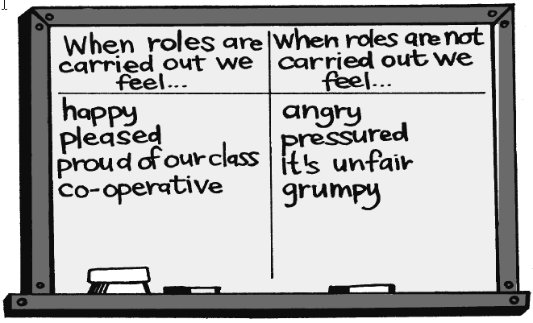

2. Kia Kaha
Put the term Kia Kaha on the board and discuss its meaning. Explain that if we all stand strong for what we believe in and respect others and their views, our mana will increase. Our classroom will also be a nicer, more pleasant place.
Talk about how everyone in the class has strengths and qualities and how they can all pull together to make the class strong and happy. Brainstorm these ideas on the board. Examples could be willingness, helpfulness, being a good listener, supporting others, sharing skills or talents. If you wish to do so, name students who have these strengths or qualities.

3. Waka
Explain that the class is going to make a waka, representing their class, with people inside pulling together to make the waka go smoothly. List the following tasks on the board:
- Make the waka, using Copysheet: Waka as a guide. This could be a paper or 3D version.
- Design and make a backdrop where the waka can be displayed.
- Make the paddles, using the template from Copysheet: Templates.
- Make the people to sit in the waka, using the person template from Copysheet: Templates.
- From the brainstorm list in Activity 2, choose words that they want in their class waka. Each word is written on a paddle and placed in the waka.
Allocate students to complete each task.
Size for the people and the paddle will depend on the size of the waka, so groups will need to liaise with each other.
View the completed waka.
Ask: Can we feel proud of our waka? Why, or why not?
Do you think our waka will flow smoothly ahead? Why, or why not?
What can we all do to make sure this happens?
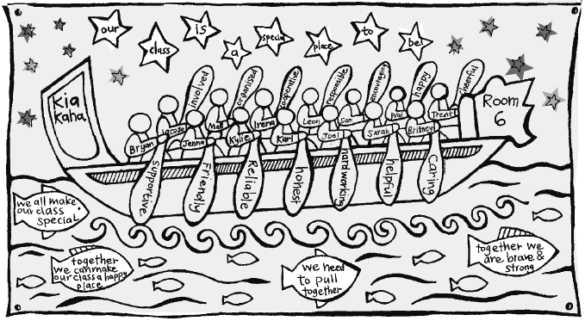

Copysheet: Waka
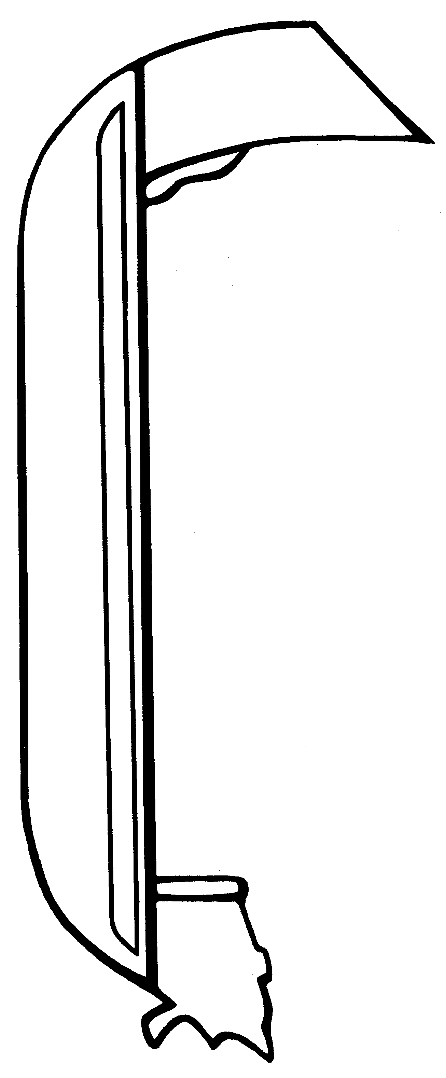


Copysheet: Templates
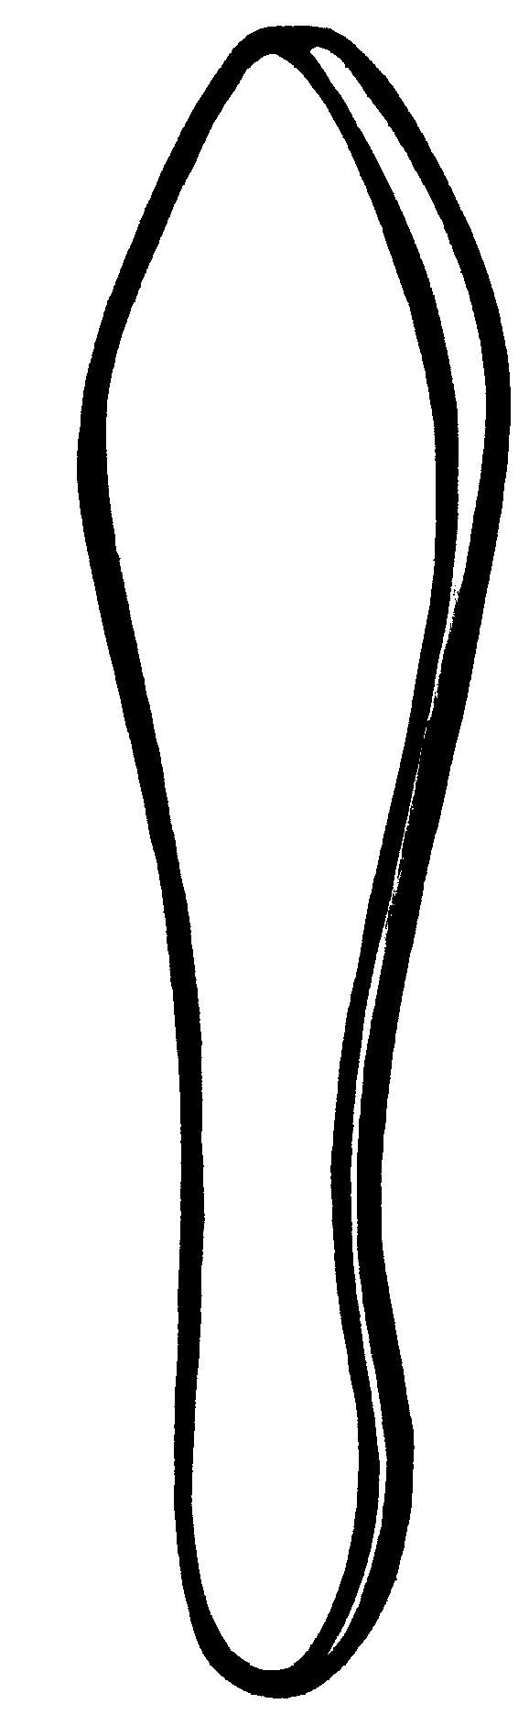

Learning experience 4: Playing my part

Learning intentions
Students can:
- list six rights they have as members of the class
- list six responsibilities they have as members of the class.

Resources
Set of Rights Cards (available from your Police School Community Officer)
Set of Responsibility Cards (available from your Police School Community Officer)
Materials for making the noughts and crosses grid, such as metre rule, skipping ropes, chalk, hoops
Copysheet: Our Family

Activities

1. Warm-up
Enlist students’ help to make a noughts and crosses grid in the classroom or playground. The squares need to be large enough for students to stand in. Divide the class into two even groups. One has the Rights Cards and the other the Responsibility Cards. Each group has a leader who directs group members on to the board, with the aim of getting three in a row. As each person steps onto the grid they say whether they are a ‘right’ or a ‘responsibility’ and read out their card. When there are three in a row the group leader shouts either ‘Three Rights’ or ‘Three Responsibilities’. The game then begins again. The new leaders are the two people who were last on the grid.

2. Rights and responsibilities
Either
Arrange students in a circle with a large floor space in the centre. Spread the Rights Cards down in a line. Have the Responsibility Cards in a pile. Invite students, one at a time, to take a Responsibility Card and place it next to the right with which they think it best matches. The class then comes to a consensus decision as to whether this is a match.
Or
Play memory with the Rights and Responsibility Cards, as a way of introducing them to the class. Put all the cards face down. Students take turns at turning over two cards, trying to match a Rights Card with a Responsibility Card. The class will need to read a consensus decision as to whether it is a match.
Ask: How does it make you feel if your rights are not being respected?
How do you think others feel if their rights are not respected?
What can you do if your rights are not being respected?
Why is it important that you act responsibly towards others?
How does it make you feel when you act this way?

Reinforcement
Arrange the Rights and Responsibility Cards around the room as a permanent display, at least during Kia Kaha. Use them at intervals to reinforce the importance of rights and responsibilities – for example, at the end of the day ask students to stand by a responsibility that they think best matches their behaviour that day.
Reinforce behaviour – for example, Jane helped Sara with her reading today. Which responsibility was Jane showing? Which right of Sara’s was being respected?

Homework activity
Give each student Copysheet: Our Family to take home and work on with an adult. They should be returned to class on the date given. Copysheets can be shared or displayed.

Copysheet: Our Family
Dear Parents and Caregivers
This week we began work on the Kia Kaha programme. We talked about being the same and being different, how individuals are unique, and the roles, rights and responsibilities in our class.
Ask your child to tell you about what has been learnt.
Please help your child with the following activity.
1 What are four things that make our family the same as other families?
i)
ii)
iii)
iv)
2 What are four things that make our family different from other families?
i)
ii)
iii)
iv)
3 Three rights that members of our family have are:
i)
ii)
iii)
4 Three responsibilities that members of our family have are:
i)
ii)
iii)

Please return this copysheet to school by________________________________________.
______________________________________
(Name of teacher)

