Kia Kaha

Years 0-3 Focus area 6
This section contains one of the focus areas of the Kia Kaha programme for students at years 0–3 (ages 5–7):
- The same but different
- A happy, safe classroom
- Let’s all be friends
- I have choices
- Helping hands
- We have made a difference
Note: Research suggests that an effective Kia Kaha programme should include learning experiences from each of the focus areas.

Focus area 6: We have made a difference

Contents
Focus area 6: We have made a difference 3
Explanation 3
Curriculum links 3
Success criteria 3
Learning experience 1: Playing co-operatively 4
Learning intention 4
Resources 4
Activities 4
Learning experience 2: Working together 5
Learning intention 5
Notes for the teacher 5
Resources 5
Activities 5
Copysheet: Daisy Chain 7
Learning experience 3: Sharing food and learning 8
Learning intention 8
Resources 8
Activities 8
Copysheet: Come for Lunch 10
Copysheet: Star of the Week 11

Focus area 6: We have made a difference

Explanation
In this focus area students bring together a lot of the new learning from Kia Kaha as they work and play with their peers, older students, and parents.

Curriculum links
Key Competencies: Managing self; Relating to others, Participating and contributing
Learning areas: Level 1 Health and Physical Education – Strand C: Relationships; Identity, Sensitivity, and Respect; Level 2 Health and Physical Education – Strand C: Relationships; Interpersonal Skills

Success criteria
Students can:
- play in a positive way with others
- work and play co-operatively with older students
- share what they have learnt
- behave in appropriate ways
- enjoy sharing a meal with others.

Learning experience 1: Playing co-operatively

Learning intention
Students can play in a positive way with others.

Resources

Year 1
Spoons
Objects such as stones, marbles, or maths shapes

Activities

Year 1
Take students out to the playground. Review some of the things they have learnt about working together, such as co-operating, sharing, helping, caring, and supporting others. Talk about co-operative games – how they should be enjoyable for everyone and should include everyone. Try some of the following activities, choosing those that best suit the age and capabilities of children. There will be other co-operative games that you know of that could be included.
- Pairs practise carrying an egg and spoon together (oranges, marbles or maths shapes could be used instead of eggs).
- Groups of six students stand in circles and pass the spoon and object around the circle.
- Make two circles. Each circle begins by passing the one spoon and object around the circle; gradually introduce more spoons and objects to each circle.
- Repeat the above with the whole class in one circle.
Students join hands in a circle. Keeping hands linked, they form shapes: square, triangle, half circle, circle star, hexagon, rectangle, spiral.
Now students form single-digit numbers. They are allowed one break in the circle, at a place the teacher decides. Explain that they are still working as a team.
Ask: How did it feel to work together?
Was it easy to include everybody? Why, or why not?
Did everyone behave in an acceptable way?
Did anyone make good, safe choices?
What did we learn?

Learning experience 2: Working together

Learning intention
Students can work and play co-operatively with older students.

Notes for the teacher
The first part of this learning experience needs to be done before the second part. Schedule the second part of the learning experience before play time.

Resources

Year 1
One daisy invitation for each child, made from Copysheet: Daisy Chain
Students from a senior class (a suitable time will need to be arranged with the senior class teacher)

Years 2–3
Class computer
Students from a senior class
Food for a shared morning tea

Activities

Year 1
Give each student a daisy made from Copysheet: Daisy Chain. Choose a buddy for them from a senior class. Help each student to write the name of their buddy (these could be already prepared on stickers) and their own name on their Daisy invitation. Arrange for the daisies to be delivered to the senior class.
On the chosen day, each student and their buddy colour their daisies in and join them together by stapling a corner of a leaf and petal, to make the beginning of a chain. They then join another group and join their daisies, and so on until all the daisies are joined together.
Decide where the daisy chain can go – for example, around the white board, around some of the displays, around the door. Make sure that the ends are joined, too.
Each pair now takes turns to read a story or poem to their partner and to talk about it. Some suggestions are:
- “Daisy Chains”, School Journal Part 2 No. 1 1985
- “The Daisy Chain”, School Journal Part 1 No. 5 1990; School Journal Part 1 No. 2 1995
The buddy takes their partner out to play or to lunch, eats with them, and plays suitable games with them.
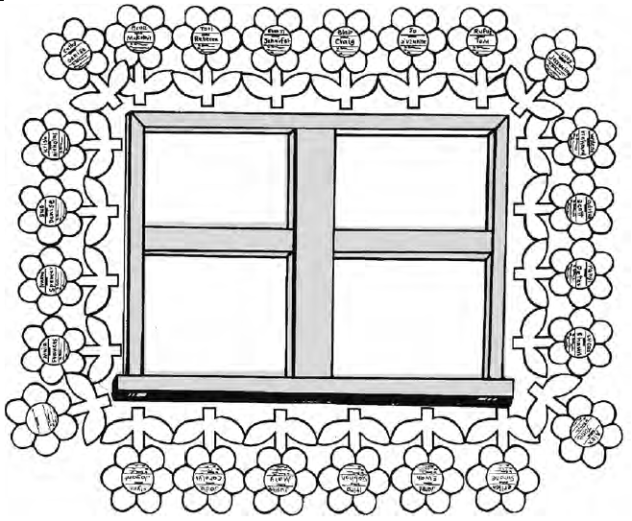

Years 2–3
Explain to students that they are going to invite some older students to their class, to tell them about the work they have been doing in Kia Kaha. Help students to decide whom they would like to invite and what sort of invitations they would like to make and send that use modern technology – for example, using computer graphics or email. Decide who will bring what for morning tea.
Each student is responsible for taking their buddy around the classroom and showing them the work that they have been doing in Kia Kaha.
Play donut with the class. Arrange students in two circles, inside each other and facing each other, with the older students on the inside circle. The younger student tells the person facing them one thing they have learnt from Kia Kaha, then moves to the next person and tells them something they have learnt, and so on round the circle. This could be repeated with some of the following ideas, with people from both circles sharing information:
One thing I am good at …
One thing I am learning …
One thing that makes me special …
A learning activity I like doing …
Share morning tea.

Reinforcement
Provide ongoing opportunities for the class to work and play co-operatively. Praise appropriate behaviour. Ask those who behave inappropriately to consider the possible consequences of their behaviour.

Copysheet: Daisy Chain
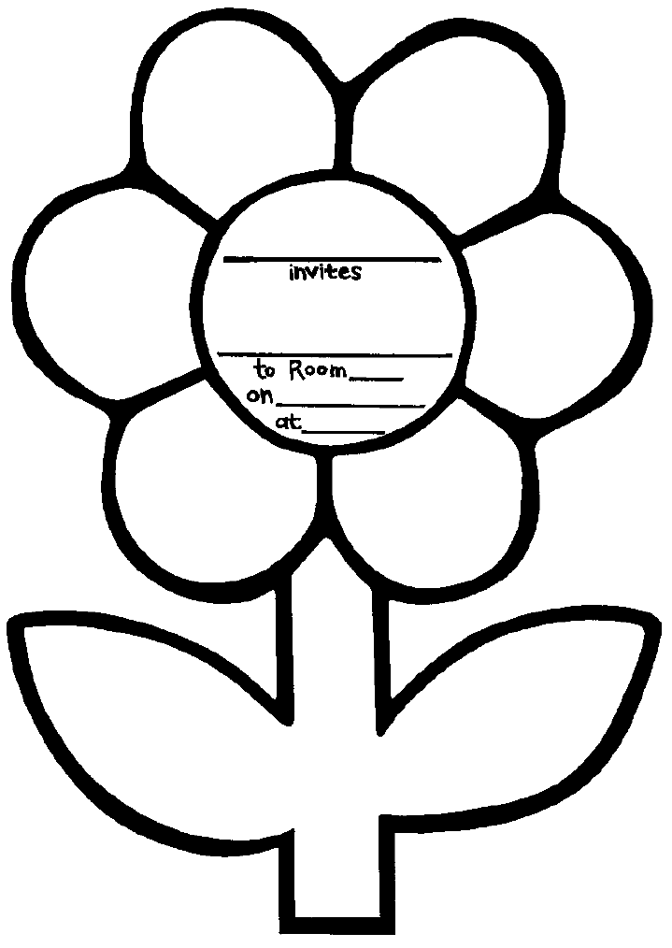

Learning experience 3: Sharing food and learning

Learning intention
Students can:
- share what they have learnt
- behave in appropriate ways
- enjoy sharing a meal with others.

Resources
Food for lunch (brought by parents)
Materials for TV show, such as old TV, big box, rolls from inside wall paper, rods
Parents and caregivers, principal and representative of the Board of Trustees
Copysheet: Come for Lunch (this should be sent home well before this learning experience)
Copysheet: Star of the Week

Activities

Year 1 and years 2–3
Involve the whole class in preparing some items or materials about Kia Kaha to share with parents – for example, a TV show (use an old TV with no screen or a big box with one side cut out of it). Children can either do role-plays directly in the ‘TV’ or can prepare display materials that can be rolled past the screen. Invite parents and caregivers to class, using Copysheet: Come for Lunch.
Entertain parents and caregivers by:
- giving them the TV show
- giving them a guided tour of the wall displays
- helping serve the shared lunch.
Ask one of the adults to present the first Star of the Week Award. Explain that this will be given to one student each week who has achieved learning intentions from Kia Kaha such as:
- been a good friend
- supported someone
- made a good, safe choice
- behaved appropriately
- asked for help
- helped someone else
- included someone.

Copysheet: Come for Lunch
Dear Parents and Caregivers
We have nearly finished our work on Kia Kaha. We have worked hard to make our classroom a safe and happy place, where no-one gets bullied.
We would like to show you what we have done, and what we have learnt.
Could you please come to school and bring something for a shared lunch?
Date _________________________________________
Time _________________________________________
Place _________________________________________
We are sure you will feel proud of our achievements.
See you there!

Child’s name _________________________________________
I/we will be attending the shared lunch. Yes No
Number of people coming ________
I will bring some food to share Yes No
Please return this slip to school by __________________________. Thank you for your help.
_________________________________________
(Teacher’s name)

Copysheet: Star of the Week
