Kia Kaha

Years 0-3 Focus area 5
This section contains one of the focus areas of the Kia Kaha programme for students at years 0–3 (ages 5–7):
- The same but different
- A happy, safe classroom
- Let’s all be friends
- I have choices
- Helping hands
- We have made a difference
Note: Research suggests that an effective Kia Kaha programme should include learning experiences from each of the focus areas.

Focus area 5: Helping hands

Contents
Focus area 5: Helping hands 3
Explanation 3
Curriculum links 3
Success criteria 3
Learning experience 1: Needing help 4
Learning intentions 4
Resources 4
Activities 4
Copysheet: Leaves 7
Copysheet: Apples 9
Learning experience 2: Asking for help 10
Learning intention 10
Notes for the teacher 10
Resources 10
Activities 10
Homework activities 11
Copysheet: Sun Badge 12
Copysheet: Asking for Help 13
Learning experience 3: Consequences 14
Learning intention 14
Resources 14
Activities 14
Copysheet: Helping Hands 16

Focus area 5: Helping hands

Explanation
In this focus area students identify situations in which they may need help from bullying and decide who the appropriate person would be to ask for help. They practise what to say when they ask for help. Together they explore ways in which they can help other people in their class.

Curriculum links
Key Competencies: Managing self; Relating to others, Participating and contributing
Learning areas: Level 1 Health and Physical Education – Strand A3: Safety Management; Level 2 Health and Physical Education – Strand A3: Safety Management

Success criteria
Students can:
- identify times when they could ask for help
- identify whom they could ask for help
- ask for help
- demonstrate ways of helping others.

Learning experience 1: Needing help

Learning intentions
Students can:
- identify times when they could ask for help
- identify whom they could ask for help.

Resources

Year 1
Copysheet: The Helping Tree (use this as a template to enlarge to wall chart size)
Copysheet: Leaves
Copysheet: Apples
Blu-tak

Years 2–3
Confident Kids resource (available from your Police School Community Officer)

Activities

Year 1
For this learning experience you will need a large version of The Helping Tree (enlarged from the copysheet provided) and a number of leaves and apples made from the copysheets.
Ask: What are some times when you might need to ask for help?
Answers could include:
If I fall over.
If someone calls me names.
When my brother is unkind to me.
Write each of the times on one of the leaves. Ensure, through questioning, that some examples of bullying are included. Place all completed leaves around The Helping Tree, on the wall.
Read each leaf in turn.
Ask: Who could you go to for help with this problem?
Why would you choose this person?
Would anyone have chosen someone else? Why?
Write the name of each person who could help with the problem on an apple and place it on the tree near the leaf it refers to. The apple and leaf could be linked with string. Talk about how there are lots of adults we can ask for help and how not everyone will choose the same person.
Ask: What will you do if the first person does not listen to you?
Reinforce that they need to go on telling until someone does listen and does something to help.
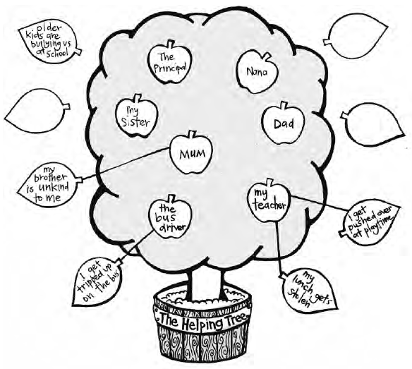

Reinforcement
Be alert to students who look as though they are sad or unhappy. Use these opportunities to reinforce the people we can ask for help. The Helping Tree should remain displayed in the classroom so that it can be used in this way.

Years 2–3
Ask each class member to turn to a partner and talk about a time when they needed help and what they did about it. Some of these experiences could be shared with the class by the partner. Stress the importance of asking for help with problems such as bullying and the need to go on asking until someone does something to help.
Divide students into pairs. One person is a teacher and the other is a student. Explain that the student is telling the teacher how they have been bullied by some other students in the class and is asking for help. Once students have practised this, they change roles and repeat the exercise. Ask some pairs to share with the class.
Students can write responses to the following in their books.
One time I needed help was …
The person I asked for help was …
Other people I could ask for help are …
We should ask for help because …
Optional learning experiences
Try some of the activities from Confident Kids pages 50-55.

Copysheet: Helping Tree

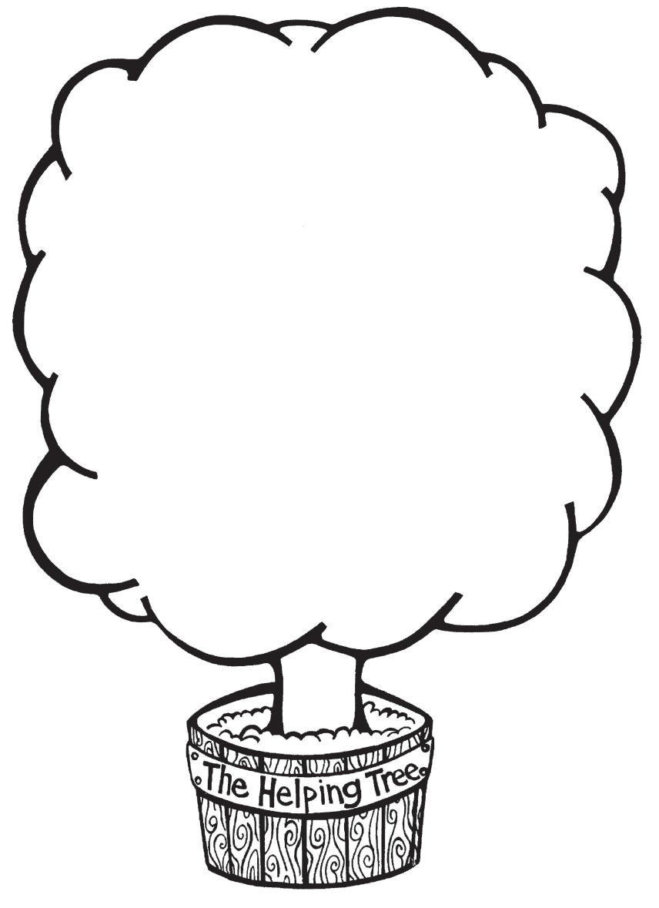

Copysheet: Leaves


Copysheet: Apples


Learning experience 2: Asking for help

Learning intention
Students can ask for help.

Notes for the teacher
This learning experience would lend itself to a workshop involving parents or older students as helpers.

Resources

Year 1
An older student
Copysheet: Sun Badge (print on sheets of sticky label paper and cut out)
Copysheet: Asking for Help

Years 2–3
Either puppets (or materials to make puppets) or soft toys
Copysheet: Sun Badge (print on sheets of sticky label paper and cut out)
Copysheet: Asking for Help
An older student or adult helper

Activities

Year 1
Read the following story to the class.
Akeisha is unhappy. Fraser keeps on pinching her and pulling her hair. He won’t stop. Akeisha decides to tell the teacher.
Ask the older student or adult helper to pretend that they are Akeisha and to ask you, the teacher, for help with the problem. The teacher responds.
Ask: What do you think of the way 'Akeisha' asked for help?
Was the teacher helpful?
Now get students to pretend they are Akeisha and to ask for help. This could be done one at a time, or with a partner.
Ask: How easy was it to ask for help?
Do you think you will be able to do that again?
Put the sun stickers made from Copysheet: Sun Badge around The Helping Tree. Whenever you see a student asking for help with a problem, fill out a sticker with their name. Also, provide opportunities for students to ask for help, and praise them when they do so.

Years 2–3
Ensure that each student has a puppet or a soft toy that they can use to ask for help.
Read the following situation to the class.
Tamara is frightened to go home because some big kids wait for him and say they are going to beat him up.
Ask: Who could Tamara ask for help?
Each student now pretends that their puppet or soft toy is Tamara and they make it ask for help. This could be done on their own or with a partner.
Ask: How did you feel when you asked for help?
Was it hard or easy to do? Why?
What do you think might happen now?
What could you have done if your ‘helper’ hadn’t listened?
You could make up other situations for the children to ask for help using use their puppet, or soft toy.
Present each student with a sticker made from Copysheet: Sun Badge. Alternatively, students could make their own badge.

Homework activities

Year 1
Give each student Copysheet: Asking for Help to take and work on with a parent or other adult. It should be brought back to school by the date given.

Years 2–3
Give each student Copysheet: Asking for Help to take and work on with a parent or other adult. It should be brought back to school by the date given.

Reinforcement
Encourage students to practise asking for help when they are being bullied or when something else is making them unhappy.

Copysheet: Sun Badge
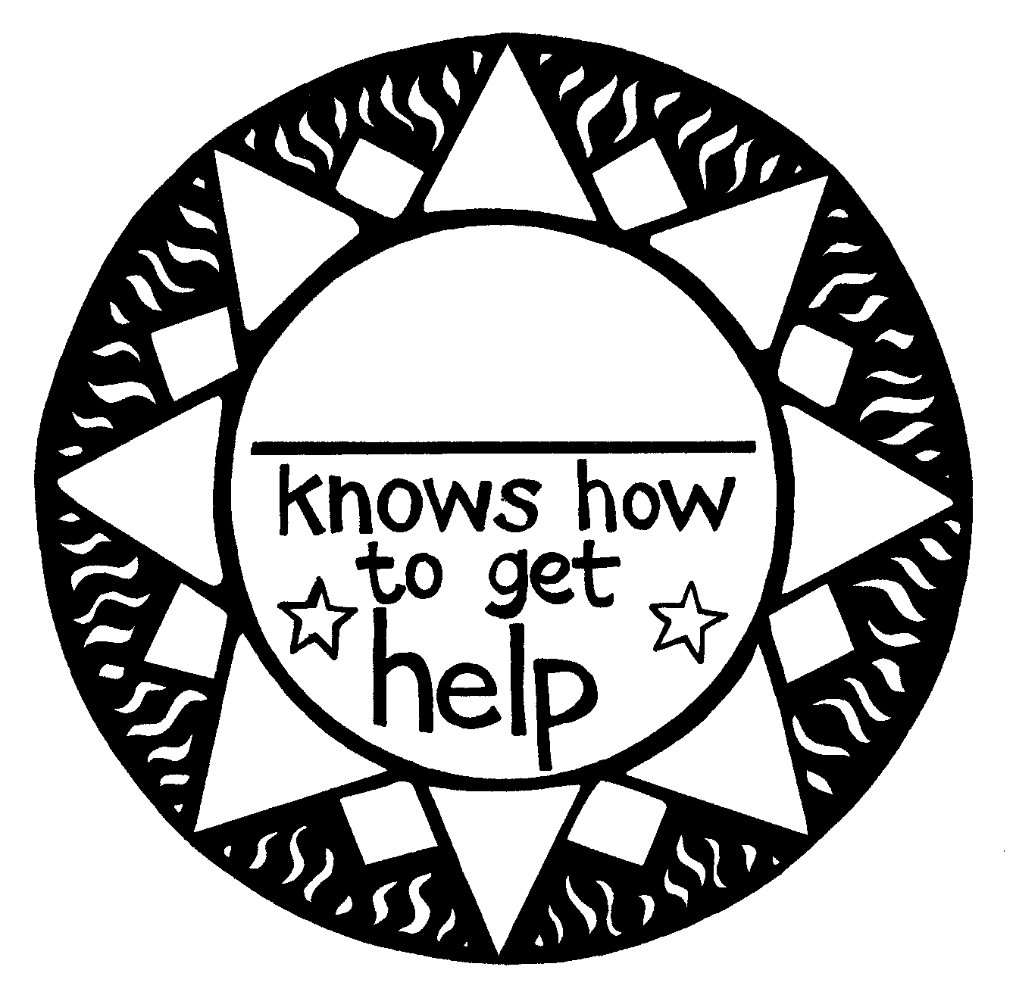

Copysheet: Asking for Help
Dear Parent and Caregiver
Today in Kia Kaha we have been talking about who we can ask for help and what we can say. It is important that children know that they should ask for help if someone bullies them. This is not telling tales.
Please help your child with the following activities.
- Read out some of the situations below and ask your child who they could go to for help in each situation. Praise them for their answers.
A big kid pushes you over on the way home.
Your sister (brother) keeps bothering you when you are trying to read.
Some other kids won’t let you into the toilets at school.
Someone in your class keeps taking your things without asking.
Someone sends you an unkind email.
- Help your child practise asking for help in the following situation. Encourage them to say what has happened, how they feel about it, and what they would like to happen. Praise your child when they have finished.
The other children in your class are being mean to you. They won’t let you eat lunch with them or play games with them. This is making you very sad.
Thank you for your help. Please return this copysheet to school by _____________________ so that it can be included with your child’s work.
_____________________________
(Name of teacher)

Learning experience 3: Consequences

Learning intention
Students can demonstrate ways of helping others.

Resources

Year 1
Copysheet: Helping Hands
Scissors, art materials

Activities

Year 1
Talk about how we are all good at some things and still learning other things. Give an example from your own experience. Go round the class and ask each student:
What are you good at?
What are you still learning?
Give each student a hand made from Copysheet: Helping Hands, or get them to trace around one of their own hands and cut it out. Invite each student to write their name in their hand, and one thing they are still learning and would like some help with. Put the completed helping hands up on the wall.
Over the next day or two, with your help, other students can take another helping hand, write their name on it and put it up beside the hand of the person they would like to help. At appropriate times, check how the helping hands are getting on. This system of asking for and offering help can be continued throughout the year. Ensure that help is offered to everyone.
The helping hands could be colour coded – one colour for the people asking for help and another colour for those offering help.
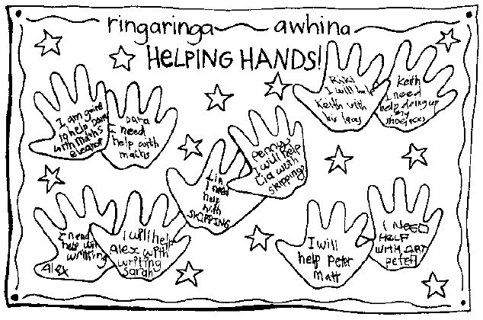

Years 2–3
Invite students to do one of the following to show how they could help a friend or classmate:
- write a poem or story
- draw a picture or cartoon
- write a song
- prepare a role-play or mime.
Students share their completed work.

Copysheet: Helping Hands


