Kia Kaha

Years 0-3 Focus area 4
This section contains one of the focus areas of the Kia Kaha programme for students at years 0–3 (ages 5–7):
- The same but different
- A happy, safe classroom
- Let’s all be friends
- I have choices
- Helping hands
- We have made a difference
Note: Research suggests that an effective Kia Kaha programme should include learning experiences from each of the focus areas.

Focus area 4: I have choices

Contents
Focus area 4: I have choices 3
Explanation 3
Curriculum links 3
Success criteria 3
Learning experience 1: Making a choice 4
Learning intentions 4
Notes for the teacher 4
Resources 4
Activities 4
Homework activities 6
Copysheet: Making good, safe choices 7
Copysheet: Questions for the Choices Photo Pack 8
Learning experience 2: Putting choices into practice 9
Learning intention 9
Notes for the teacher 9
Resources 9
Activities 9
Copysheet: My Choice Would Be … 11
Learning experience 3: Consequences 12
Learning intention 12
Notes for the teacher 12
Resources 12
Activities 12

Focus area 4: I have choices

Explanation
In this focus area students come to see that they make choices all the time, every day. They understand that they can make choices about the way they behave, and turn a potentially negative situation into a positive one. They realise that there are positive things they can do about bullying, whether they are being bullied, displaying bullying behaviour themselves, or observing bullying.
They understand that all behaviour has consequences and that the consequences for good behaviour are more rewarding. .

Curriculum links
Key Competencies: Managing self; Relating to others, Participating and contributing
Learning areas: Level 1 Health and Physical Education – Strand C: Relationships; Identity, Sensitivity, and Respect; Level 2 Health and Physical Education – Strand C: Relationships; Interpersonal Skills

Success criteria
Students can:
- explain that they have choices
- identify choices that they and other people can make
- make a good, safe choice and put it into practice
- explain that all behaviour has consequences.

Learning experience 1: Making a choice

Learning intentions
Students can:
- explain that they have choices
- identify choices that they and other people can make

Notes for the teacher
The situations shown in the photos illustrate unacceptable behaviour. You can work with the students to identify positive outcomes.

Resources

Year 1
Two pictures from the Choices Photo Pack (available from your Police School Community Officer)
Copysheet: Making Good, Safe Choices

Years 2–3
Pictures from the Choices Photo Pack (available from your Police School Community Officer)
Audio of about five pieces of very different music
Copysheet: Making Good, Safe Choices
Copysheet: Questions for the Choices Picture Pack

Activities

Year 1

Warm-up
Ask each of the students in turn what they would like to eat if they could choose anything at all. Ask them to give a reason for their choice. Answers could include:
I would choose an ice cream because it’s my favourite.
I would choose some fruit because it’s good for me.
I would choose mallow puffs because we don’t have them at home.
Ask students to go to somewhere they would like to stand in the classroom.
Talk about how each of them chose where to stand. They made this choice themselves. Ask students in turn why they chose to stand where they did. Answers could include:
I chose to stand by the window because it was sunny.
I chose to stand by the paints because I really like painting.
I chose to stand by the door so that I could go outside first.
Write the word choice on the board. Explain how each of them has just made two choices – where to stand and what they would most like to eat. Give some examples of choices you have made today, such as what to eat for breakfast, or what to wear, what story to read the class, how to come to work.

Choices photos
Seat students on the mat. Choose one of the photos from the Choices Photo Pack.
Ask: Who are the people in this picture?
What is happening?
Where do you think this might be?
Point to each of the children in the photo in turn:
Ask: What could this person choose to do?
What would happen if they did this?
What would be the best and safest choice?
What choice would you make?
This process could be repeated with another picture.

Years 2–3

Warm-up
Ask each student in turn what they would choose to do on a sunny day if they could choose to do anything at all. Ask them why they made that choice. Answers could include:
I would choose to go to the beach so I could have a swim.
I would choose to go to the park to play with my friends.
I would choose to play under the hose to cool me down.
Explain to the class that you will play some different pieces of music. You would like each of them to choose which music they liked best.
Ask: Which piece of music did you like best? (Could be done by a show of hands, or individual answers)
Why did you choose that piece of music?
Answers could include:
I liked the loud music because it blocked out everything else.
I liked the soft, floaty music because I could dance to it.
I liked the last music because we listen to that at home.
Write the word choice on the board. Explain how each of them has just made two choices –what music they like and what to do on a sunny day. Give some examples of choices you have made today, such as what to eat for breakfast, what to wear, what time to get up, when to take the class to the library.

Choices photos
Model the use of one of the pictures in the Choices Photo Pack.
Ask: Who are the people in this picture?
What is happening?
Where do you think this might be?
Point to each of the children in the picture in turn and ask the following questions.
Ask: What could this person choose to do?
What would be the best and safest choice?
What would happen if they did this?
What choice would you make?
Divide students into pairs or small groups. Give each group one of the pictures and Copysheet: Questions for the Choices Photo Pack.
Ask them to discuss each of the questions for their picture. Ask selected groups to report back.
Ask: Why is it best to make good, safe choices?
Who is it best for?
What might happen if you make unsafe choices?
Who would unsafe choices be unsafe for?

Homework activities

Year 1
Give each student Copysheet: Making Good Safe Choices to take home and work on with an adult at home. These should be returned on the date given. Completed copysheets could be displayed and discussed.

Year 2–3
Give each student Copysheet: Making Good Safe Choices to take home and work on with an adult at home. These should be returned on the date given. Completed copysheets could be displayed and discussed.

Copysheet: Making good, safe choices
Dear Parents and Caregivers
Today in Kia Kaha we talked about choices we make, such as what game to play, what to eat, or what to wear. Talk to your child about choices they make at home.
We also talked about how some choices are good and safe, and how some other choices are unsafe.
Talk about what is happening in the picture below. Decide on good, safe choices that each child in the picture could make.
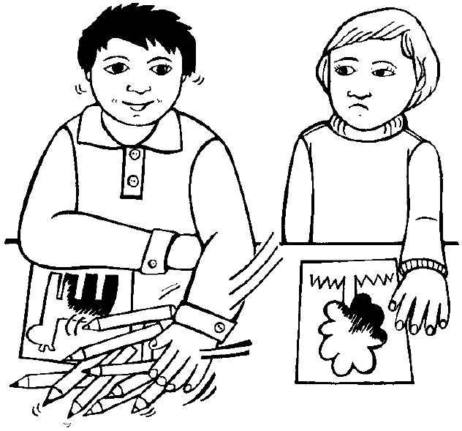
You might like to help your child to colour in the picture, too.
Thank you for your help. Please return this copysheet to school by _____________________
_________________________
(Name of teacher)

Copysheet: Questions for the Choices Photo Pack

1 Who are the people in this picture?

2 What do you think is happening?

Look at each of the children in the photo in turn.

3 What could this person choose to do?

4 What would happen if they did this?

5 What would be the best and safest choice?

6 What choice would you make?

Learning experience 2: Putting choices into practice

Learning intention
Students can make a good, safe choice and put it into practice.

Notes for the teacher
In the role-play session it is important that students do not role play negative behaviours but rather positive solutions. For this reason, each role-play starts with a freeze frame of the situation shown in the picture.

Resources

Year 1
Copysheet: My Choice Would Be …

Years 2–3
Pictures from the Choices Photo Pack (available from your Police School Community Officer)
Video camera

Activities

Year 1
Seat students in a circle, along with any adult helpers. Read each student in turn one of the scenarios from Copysheet: My Choice Would Be ... Choose examples that are relevant to your class, or make up your own scenarios.
Help students to suggest a good, safe choice they could make in that situation.
Ask: Is this a good, safe choice?
What would happen if you did this?
What else could you do?
At the end:
Ask: How does it feel to make a good, safe choice?
Who thinks they can make good, safe choices all the time?

Reinforcement
Reinforce making good, safe choices throughout the year, praising students whom you see making such choices. When you see students making unsafe choices:
Ask: Was this a good, safe choice? Why, or why not?
What might happen if you did this?
What else could you choose to do?

Years 2–3
Show students one of the pictures from the Choices Photo Pack. Brainstorm with them the choices that the people in the picture could make. List these on the board. With the class put a tick beside all the good, safe choices.
Divide students into small groups. Ask them to choose one of the good, safe choices to role- play. Remind them to start the role-play from a freeze frame. Ask some groups to show their role-play to the class.
Ask: Who had to make a choice?
Was this a good, safe choice?
How did it feel to make that choice?
This could be repeated with other pictures if desired.
Optional learning experiences
Brainstorm with the class some other times when they might need to make good, safe choices. Put these on the board. Have students form new groups.
Each group chooses one of the situations on the board and discusses good, safe choices they could make. They choose one of these to role-play. If possible, video the groups role-playing. The role-plays could then be played back and analysed.
Ask: Who had to make a choice?
Was this a good, safe choice?
How did it feel to make that choice?
What were other good, safe choices that could be made?
Do you think you could make choices like this all the time?

Copysheet: My Choice Would Be …

Someone snatches your drink bottle.  What would you choose to do? | Someone sends a nasty message about your friend to your mobile phone.  What would you choose to do?
The others won’t let you join in.  What would you choose to do? | You haven’t got a pencil so you snatch someone else’s.  What else could you choose to do?
You tell lies about someone.  What else could you choose to do? | Someone makes you give them your lunch.  What would you choose to do?
You feel like kicking someone.  What else could you choose to do? | You don’t want to listen to the story.  What could you choose to do?
You are angry with someone and want to hit them.  What else could you choose to do? | You won’t let anyone share your felts.  What else could you choose to do?
Someone pushes you and makes you fall over.  What would you choose to do? | Someone spills paint on your clothes.  What would you choose to do?
You want to play with someone else’s toy.  What would you choose to do? | Someone wants your lunch money.  What would you choose to do?

Learning experience 3: Consequences

Learning intention
Students can explain that all behaviour has consequences.

Notes for the teacher
For some students in the class, bullying might be behaviour that they like and enjoy because for them it has positive consequences. It is hoped that by seeing the views of the class as a whole they, too, will come to recognise that bullying is unacceptable.

Resources

Year 1
Copysheet: My Choice Would Be …

Years 2–3
Pictures from the Choices Photo Pack (available from your Police School Community Officer)
Video camera

Activities

Year 1
Read the following situation to the class.
Leah and Riki were playing in the sandpit. Leah wanted the truck that Riki was playing with. She pushed Riki and grabbed the truck. Riki got his face in the sand and some went in his mouth. He started to cry. Leah started to play with the truck. Just then Mr Thomas came over. He had seen what happened. He made Leah get out of the sandpit and go inside. He helped Riki get the sand out of his mouth and dried his tears.
Ask: Does our class like the way Leah behaved? Why, or why not?
What happened because Leah snatched the truck?
What else could she have done?
Read the following story to the class.
Everyone in the class was drawing a picture to go on the wall. Caleb had only two different coloured felts. Amber said he could use some of hers. Caleb was pleased and he told Amber how good her picture was. Mrs Henare said that Caleb and Amber had both done lovely pictures and gave them a star because they had worked well together.
Ask: Does our class like the way Amber behaved? Why, or why not?
What happened because Amber shared her felts?
Talk about the positive things that happen when we behave in friendly, helpful ways.
Talk about the negative things that happen when we behave in unfriendly, unhelpful ways.

Reinforcement
Watch for opportunities throughout the year to reinforce the consequences of behaviour.

Years 2–3
Seat the students in a circle. Read them some of the scenarios of unacceptable behaviour in the questions below, and add some of your own. After each, put the ideas they offer on one side of the board, under the heading Consequences of Unfriendly, Unhelpful Behaviour.
Explain the word consequences.
Ask: What might happen if Kevin punches Tutu on the arm?
What might happen if Craig always takes all the felts and won’t share?
What might happen if Summer won’t help the teacher give out the books when she is asked?
What might happen if Wiremu is always rude to other people?
What might happen if Sonya left a nasty message on Mindy’s cell phone?
Read students some of the scenarios of acceptable behaviour in the questions below, and add some of your own. After each, put the ideas they offer on the other side of the board, under the heading Consequences of Friendly, Helpful Behaviour.
Ask: What might happen if Rangi offers to help Amy put out the paints?
What might happen if Lace is friendly and helpful to a new person in class?
What might happen if Taina offers to share his pencil sharpener when Jo breaks her pencil?
What might happen if Jason helps Nick when he falls over and hurts his knee?
What might happen if Margie told Darryl not to bully Lindy?
Students could work in groups to make mobiles of the consequences of behaviour, as shown in the examples below.
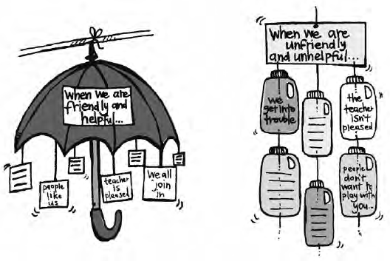

Reinforcement
Watch for opportunities in the classroom to reinforce ideas on the mobiles. For example:
Thomas has helped Jay with his reading. This is friendly, helpful behaviour. Let’s check the consequences on our mobile.

