Kia Kaha

Years 0-3 Focus area 3
This section contains one of the focus areas of the Kia Kaha programme for students at years 0–3 (ages 5–7):
- The same but different
- A happy, safe classroom
- Let’s all be friends
- I have choices
- Helping hands
- We have made a difference
Note: Research suggests that an effective Kia Kaha programme should include learning experiences from each of the focus areas.

Focus area 3: Let’s all be friends

Contents
Focus area 3: Let’s all be friends 3
Explanation 3
Curriculum links 3
Success criteria 3
Learning experience 1: Bullying 4
Learning intentions 4
Notes for the teacher 4
Resources 4
Activities 4
The Crocodile on the Roof 7
Copysheet: Bullying 9
Learning experience 2: Safe places to play 10
Learning intention 10
Notes for the teacher 10
Resources 10
Activities 10
Homework activities 11
Copysheet: Safe Places 12
Learning experience 3: Survey 13
Learning intention 13
Notes for the teacher 13
Resources 13
Activities 13
Copysheet: Survey 14

Focus area 3: Let’s all be friends

Explanation
In this focus area students identify what bullying behaviour is and know that it is wrong and unacceptable. They know some strategies to overcome it. They identify places in their school environment where they feel safe to play.

Curriculum links
Key Competencies: Managing self; Relating to others, Participating and contributing
Learning areas: Level 1 Health and Physical Education – Strand A: Safety Management; Strand D: Community Resources; Level 2 – Health and Physical Education Strand A: Safety Management

Success criteria
Students can:
- explain what bullying is and recognise it in relation to themselves and others
- explain that bullying is wrong and unacceptable
- identify places that are safe for them to play in
- identify bullying and non-bullying behaviour that affects them.

Learning experience 1: Bullying

Learning intentions
Students can:
- explain what bullying is and recognise it in relation to themselves and others
- explain that bullying is wrong and unacceptable.

Notes for the teacher
If students in your class have mobile phones, or use the computer and email confidently, it is important that you cover cyber bullying.

Resources

Year 1
Story: The Crocodile on the Roof by Diana Noonan
Picture Sequence Cards
Note: Suggested sequence for cards:
1 One girl kicks the other.
2 The girl who has been kicked is sad. A friend comes to support her.
3 She tells the teacher what has happened.
4 The teacher talks to the victim and to the girl who did the kicking.
5 The girls shake hands and agree to be friends.

Years 2–3
Copysheet: Bullying
Optional: Videos: Bryan and Bobby “Bully” and/or Positive Play” online at http://bryanandbobby.co.nz/video/

Activities

Year 1
Read the class the story The Crocodile on the Roof.
Ask: What happened in the story?
How did Zoe and Aroha make Cherry feel?
Was this behaviour that we like?
Do you think Cherry should have told Liam what happened? Why, or why not?
Do you think Liam should have told Mr Argus? Why or why not?
What did you think of the ending to the story?
How do you think Zoe and Aroha will treat Cherry next time?
Work with the class to define this type of behaviour as bullying. A suitable definition might be:
Bullying is when someone hurts you or makes you sad, on purpose. A person who is bullying might kick or hit you, might call you nasty names, threaten you, take your things or make you do things you don’t want to do. Sometimes other people can threaten you or leave nasty messages on your mobile phone or by email.
Ask: Is bullying OK in our class?
Why don’t we like it?
How does it make us feel?
Establish that bullying is behaviour the class doesn’t like, that it is wrong and that you won’t accept it in your class.
Hold up each picture from the Picture Sequence in random order.
Ask: What do you think is happening here?
With the class, decide on the right order for the pictures and make up suitable captions for each. The completed sequence could be pinned on the wall.
Note: The cards are numbered on the back to indicate the correct sequence, although children may justify another order. Look at each picture in turn and ask how they think the people are feeling.
Ask: Do you think this was a good ending? Why, or why not?
What could you do if someone was bullying you?

Years 2–3
Write the word bullying on a chart. Ask for examples of bullying and record these. Make sure, through questioning, that examples of all types of bullying are included – physical, emotional, exclusion, damage to property, cyber bullying, and coercion.
Work with the class to decide on a definition of bullying. An example is given below, but it is preferable that students devise their own.
Bullying is when someone hurts you or makes you sad, on purpose. A bully might kick or kick you, might call you nasty names, threaten you, take your things or make you do things you don’t want to do. The bully wants to be more powerful than you. They can do these things face to face, or by mobile phone or email.
Ask: Is bullying acceptable (good, OK) behaviour? Why, or why not?
How do we feel about bullying behaviour?
Will we accept bullying in our classroom? Why, or why not?
What can we do to stop it?
Divide students into small groups. Give each group Copysheet: Bullying. The group cuts out the pictures and decides on their correct order. They then paste these on to a new page, writing captions under each. In the blank square they draw a picture to show what they think might happen next.
As an alternative, this could be done as an individual or whole class activity.
Ask: Do you think this was a good ending? Why, or why not?
What might have happened if the child being bullied hadn’t asked for help?
What could you do if you were being bullied?

Optional learning activity
Show the videos Bryan and Bobby “Bully” and/or “Positive Play”, both available online at http://bryanandbobby.co.nz/video/

The Crocodile on the Roof
by Diana Noonan
Cherry got a new crocodile backpack for her birthday. It was green with big white teeth poking out over the zip. She was in such a hurry to show it to everyone at school that she forgot, and took the short-cut track behind the swimming pool. Zoe and Aroha were there. They popped out from behind the sticking-out bit of the changing shed wall.
“This is our track, four eyes,” said Zoe. She looked really mean.
“We told you before,” said Aroha, “you can’t come this way.”
Cherry’s tummy felt hot and tight. She didn’t want to run, or they’d chase her, and hit her like last time. She turned around very slowly and started walking back the way she had come.
“What’s that stupid thing on your back?” shouted Zoe. Then Cherry heard them coming after her. She ran, but Aroha caught up to her and pushed her over. Her glasses went skidding along the concrete path. Zoe pulled off the crocodile backpack, and when Cherry rolled over she saw a fuzzy blob of green go flying up and onto the changing shed roof.
Aroha was puffing hard. “You tell anyone,” she said, “and Zoe’s big brother will get your bag and chuck it away.”
When Cherry got to school the long way, Aroha and Zoe were already at their desks.
“You’re late, Cherry,” said Mr Argus.
Then right in front of everybody, he asked her how she’d skinned her knee. Zoe was watching.
“I fell over,” said Cherry quietly.
At spelling time, Mr Argus put a cross on the whiteboard beside Cherry’s name because she didn’t have her spelling notebook with her. She wished she could tell him that it was in her bag and that her bag was on the changing shed roof, but what if Zoe heard and told her brother …
At morning break Cherry didn’t have any play-lunch. “You can have one of my crackers,” said Liam. Cherry didn’t feel like eating anything but she did whisper to Liam what Zoe and Aroha had done. “Don’t tell anyone,” she said.
Cherry felt really miserable all morning. What if someone saw her crocodile bag on the roof and stole it before she could get it back? Then it started raining. She stared out of the window. Her backpack would get ruined.
“Cherry?” said Mr Argus. His voice seemed a long way off. “Cherry, it’s raining and we’re having lunch inside. Did you bring your Lion King video for everyone to watch?”
“Lion King!” shouted the class. “Yay! Cool!”
Everyone was jumping up and down with their lunch boxes. Zoe and Aroha were already sitting on the mat in front of the video player.
“Hurry up! Get your video, Cherry,” called Aroha.
Cherry didn’t know what to say. The video was in her bag and her bag was on ... Suddenly she started to cry.
Mr Argus wanted to know what was going on. Cherry was too scared to tell. But Liam wasn’t. “They chucked it on the changing shed roof,” he said, pointing to Zoe and Aroha. “And they pushed Cherry over.” Now Aroha looked like she was going to cry. Zoe went red.
Mr Argus sent Zoe and Aroha to Mr Fa’avae’s office. Then he put on his coat and went away with the school ladder on his shoulder. When he came back, he had Cherry’s bag.
Cherry still felt miserable but the crocodile was all right and, when she pulled open its zipper mouth, she found that everything inside was safe and dry.
“Don’t worry,” Liam whispered to Cherry when Mr Argus was putting on the video. “I’ll walk home with you after school. I’m not scared of them.”
Cherry gave a big sniff. Then Mr Argus sat on a chair behind her, and Liam sat on the mat next to her. She gave them both a bit of her left-over birthday cake. She wished she could be as brave as the Lion King.

Copysheet: Bullying
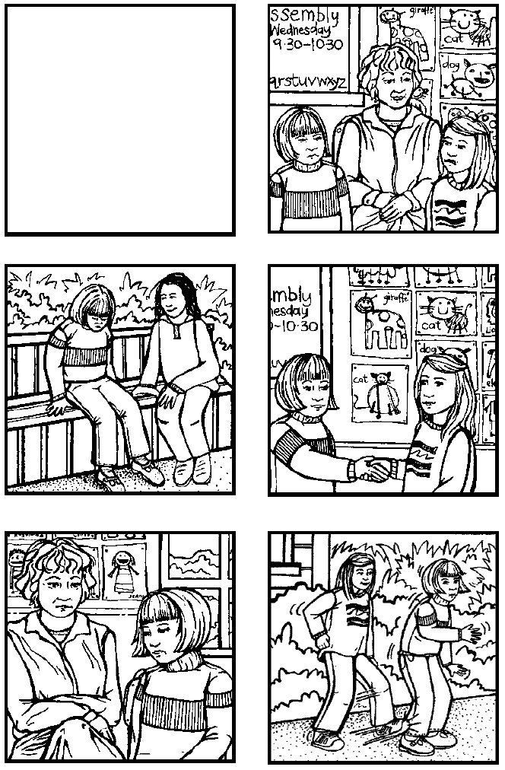

Learning experience 2: Safe places to play

Learning intention
Students can identify places that are safe for them to play in.

Notes for the teacher
The emphasis in this learning experience is safety in relation to other people, rather than safety from hazards such as water or traffic. Older students could be involved in this learning experience to see where younger students feel unsafe and to decide what they could do to help. It is advisable that the whole school is aware that this learning experience is taking place to avoid sabotage (in one of the trial schools, senior students popped the balloons at lunchtime). Choose a sunny, still day.

Resources

Year 1
Balloons – one for each student (balloons with happy faces already on them are helpful)
Paints
Copysheet: Safe Places

Years 2–3
Large map or outline of the school, clearly labelled
Art materials

Activities

Year 1
Ask: Where do you feel safe playing at school?
Why do you feel safe in these places?
Where does it feel unsafe to play?
Why does it feel unsafe here?
Some answers might be:
I feel unsafe on the field because the big children run fast and could knock me over.
I feel safe in the sandpit because everyone shares.
I feel unsafe by the trees because the teachers can’t see what is happening.
I feel safe on the bottom playground because only little kids go there.
You may need to teach the words safe and unsafe.
Give each student a balloon. Help them to paint a happy face and their name on their balloon. Go outside with the class. Walk around the playground identifying the places they have said were safe and unsafe for them to play. Invite each student to tie their balloon in a place where they feel safe to play.

Years 2–3
Put up, or draw, a map or outline of the school and help students to identify and label landmarks.
Ask: Where do you feel safe playing at school?
Why do you feel safe playing there?
Where does it feel unsafe to play?
Why do you feel unsafe there?
Mark the safe places on the map with a tick. Mark the unsafe places with a cross. The map could be shared with the principal.
Each student completes the following sentences:
One place I feel safe playing is …
I feel safe here because …
They could draw a picture of themselves playing in this place.

Homework activities

Year 1
After school each student can collect their balloon and take it home. Also give them Copysheet: Safe Places to take home and discuss with an adult.

Year 2–3
Each student takes home their picture and completed sentences to share with an adult.

Copysheet: Safe Places

Dear Parents and Caregivers
Today in Kia Kaha we talked about places at school where your child feels safe to play. Your child tied a balloon in one of these places.
Please ask your child to show you the balloon and to talk about where he or she put it, and why they put it there.
Talk about the following with your child.

1 What places are safe to play in at home?

2 What places are safe to play in outside home?

Thank you for your help. Please return this copysheet to school by _____________________

_____________________________
(Name of teacher)

Learning experience 3: Survey

Learning intention
Students can identify bullying and non-bullying behaviour that affects them.

Notes for the teacher
The results of both Learning experience 2 and Learning experience 3 could be shared with the principal and Board of Trustees so that they can work to make the school a safe, happy place.

Resources

Years 2–3
Copysheet: Survey

Activities

Years 2–3
Remind students of the behaviour that they decided was bullying in Learning experience 1.
Give each child Copysheet: Survey. Go over each question. As you explain each one, students can colour in their choice of answer, either Yes or No. The choice should be made individually, without influence from any other class members.
Either:
Divide students into six groups. Give each group the responses to one of the questions. They graph the results. Display the completed graphs around the walls. Help could be enlisted for this learning experience from older students.
Or:
Take responses to each question from the class by a show of hands. Graph the results of some questions on the board and make summary statement of others. For example:
All members of our class have been bullied.
Half the people like helping others.

Copysheet: Survey
Colour in either the YES or NO symbol to show your answer.
1 Has anyone ever bullied you at school? |  | YES | NO
2 Has anyone ever left nasty messages on your mobile phone or email? |  | YES | NO
3 Have you ever bullied or been unfair to other people? |  | YES | NO
4 Do you like helping other people at school? |  | YES | NO
5 Do other people help you at school? |  | YES | NO
6 Do you know what to do if someone bullies you? |  | YES | NO
7 Do you feel safe at school? |  | YES | NO
NO

