Kia Kaha

Years 0-3 Focus area 1
This section contains one of the focus areas of the Kia Kaha programme for students at years 0–3 (ages 5–7):
- The same but different
- A happy, safe classroom
- Let’s all be friends
- I have choices
- Helping hands
- We have made a difference
Note: Research suggests that an effective Kia Kaha programme should include learning experiences from each of the focus areas.

Focus area 1: The same but different

Contents

Focus area 1: The same but different 3
Explanation 3
Curriculum links 3
Success criteria 3
Learning experience 1: Who am I? 4
Learning intentions 4
Resources 4
Activities 4
Homework activities 6
Copysheet: Who am I? 7
Learning experience 2: Size and shape 8
Learning intentions 8
Resources 8
Activities 8
Homework activity 9
Optional learning experiences 9
Copysheet: When I Was Small 11
Learning experience 3: Families 12
Learning intention 12
Resources 12
Activities 12
Homework activity 13
Optional learning experiences 13
Copysheet: My family 14

Focus area 1: The same but different

Explanation
In this focus area students come to understand that although each of them is different, unique and special, and may come from very different families, they share similarities with all members of the class. This will help them to accept and celebrate diversity rather than single out for ridicule those who are different. They will come to empathise with other members of the class and to realise that the ways in which we are the same are more important than the ways in which we are different.

Curriculum links
Key Competencies: Managing self; Relating to others, Participating and contributing
Learning areas: Levels 1 and 2Health and Physical Education – Strand A: Personal Health and Physical Development: Personal identity; Strand C: Relationships with other people: Interpersonal skills; Identity, sensitivity and respect

Success criteria
Students can:
- describe special things about themselves and other members of their class
- explain how members of their class are different, but the same
- describe themselves in relation to other class members
- describe similarities and differences within their class
- describe similarities and differences within families.

Learning experience 1: Who am I?

Learning intentions
Students can:
- describe special things about themselves and other members of their class
- explain how members of their class are different, but the same.

Resources
Year 1
Copysheet: Who Am I?
Art materials

Activities

Year 1
Ask students to stand up, allowing plenty of room between them. Explain that you will touch and name a part of your body, for example, “This is my head”, “This is my tummy”. Students repeat the words and actions after you.
This could be made into a game (for example, by playing it to music). The song Heads, Shoulders, Knees and Toes could also be used.
When the students are familiar with the names of the different body parts, leave the naming to them.
Ask each student to draw a picture of themselves. When they have finished they can share this picture with a neighbour or, if the class is small, with the whole group, naming different parts of the body.
Ask: What is special about …?
What is special about …?
(Continue with this line of questioning, making sure that something special is said about the appearance of everyone in the class)
What makes us all different and special? (Some are taller, some have bigger hands ...)
What makes us all the same? (All have hair, noses …)
Talk about how there is nobody that is quite like us – we are all special. Yet we are all people, who hurt when we fall over, like to eat yummy food, go to sleep and so on.

Years 2–3
Each sudent makes a Who am I? Card like the one below. These could be shared with a partner or displayed on the wall.
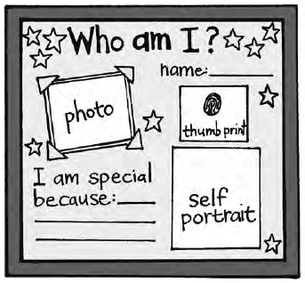
A photograph could be taken of each student, or one brought from home. If this proves difficult, use only the self-portrait.
Talk about how each of us is unique and special, yet we are the same as others in lots of ways. Brainstorm with the class how we are all the same and build up a class diagram like the one below.
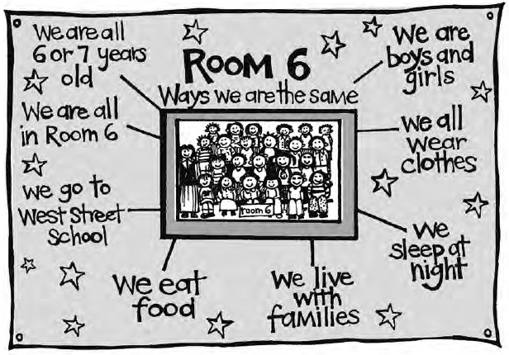
Students could write a sentence in their books beginning:
I think our class is special because …

Homework activities

Year 1
Students can take their drawings home to talk about with a parent or another adult, along with Copysheet: Who am I? This should be completed at home and returned on the date specified, to be discussed in class.
Later, each drawing could be placed on the wall with the child’s name, around the caption We are all the Same, but Different.

Years 2–3
Students can take home their Who am I? Cards to share with their families.

Copysheet: Who am I?

Dear Parents and Caregivers
Today in Kia Kaha we talked about the size and shape of our bodies and your child drew a picture of themselves. Please listen while your child talks about their picture with you.
Please talk about the following things with your child and help them fill in the gaps.

is special because:
(Name of child)

is good at:
(Name of child)

One thing is still learning is:
(Name of child)

Thank you for your help. Please return this to school by .

(Name of teacher)

Learning experience 2: Size and shape

Learning intentions
Students can:
- describe themselves in relation to other class members
- describe similarities and differences within their class.

Resources

Year 1
Parent and preschooler
Chart paper and pens

Years 2–3
Tape measure
Copysheet: When I Was Small
Newspaper pictures of local or national sports teams

Activities

Year 1
Arrange for a parent to bring a preschooler to class. Compare the size of some or all of the following, for the preschooler and members of the class: height, weight, foot size, hand size, head size, length of hair.
Alternatively, this could be done by comparing the most recent class entrant to a 6-year-old.
Ask: How have you changed since you were preschoolers?
Are you still changing?
Do we all change and grow in exactly the same way?
Divide students into small groups. Each group chooses one person to have their outline traced onto a big sheet of paper. Help students to name the body parts. If the class is small, each student could have their outline traced.
Display the body shapes along a long wall (for example, in the corridor). Walk along them with the class.
Ask: How are we different?
How are we the same?
You may need to teach the words different and same.
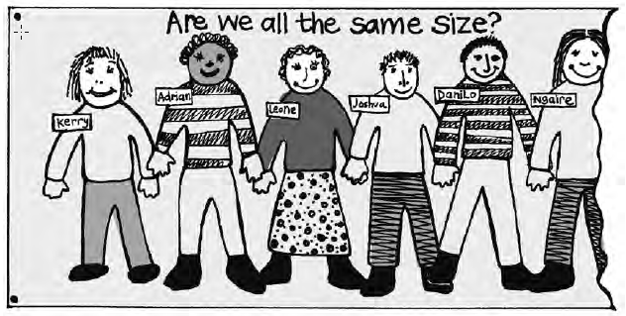

Years 2–3
Talk to the class about how everyone grows at different rates and, while it may look as though we are all different shapes and sizes, our size and shape varies only slightly.
Note: The following exercise will need to be handled with care, as students can be sensitive about their body shape. The objective is to help them respect the differences and know that it is okay to be different. It is important that students understand that people are really just variations on a common size and shape.

Working in small groups or pairs, children can measure some or all of the following: length of hair, foot size, hand size, height, length of arm. These could be done first as estimations.
Ask: What have we found out about our class?
Why is it good that we are not all the same?
What things are the same about us all?

Homework activity
Give students Copysheet: When I Was Small to take home and work on with an adult. Completed copysheets should be returned by the date given for discussion and display.

Optional learning experiences
Show the class photos of local or national sports teams. Talk about how teams need players of different shapes and sizes to take different roles. Use examples from the photos.
Divide students into groups. Explain that soon the class is going to play a game involving teams. Each team will have a team leader. Every team leader is going to have a team.
The task of the group is to work out a way for a team leader to pick their team so that everyone is included and nobody feels left out.
The game could be an outside game, or something such as a spelling game.
When each group has discussed the problem and come up with a solution, get them to try out their method of selecting a team.
Ask: Was your way of picking a team a fair one?
How did you make sure that everyone felt included?
When every group has had a turn, choose one of the methods for picking teams and proceed with the game.
Ensure that when teams or groups are picked in future, a fair, inclusive method is used.

Copysheet: When I Was Small

Dear Parent/Caregiver
Today in Kia Kaha we talked about how everyone is a different size and shape and how this makes us special and interesting. Please ask your child what he or she found out.
Together can you look at your child’s Plunket Book, and/or photos of your child when they were small. Please help your child to complete the following activity.

One thing I noticed about me when I was small was:

One thing I liked about me when I was small was:

Two ways I have changed are:
1._________________________________________________________________________

2._________________________________________________________________________

One thing I really like about me now is:

Thank you for your help.
Please return this to school by ___________________________________.

___________________________________________
(Name of teacher)

Learning experience 3: Families

Learning intention
Students can describe similarities and differences within families.

Resources

Year 1
Picture Pack Families (available from your Police School Community Officer)
Art materials

Years 2-3
Picture pack Families (available from your Police School Community Officer)
Copysheet: My Family

Activities

Year 1
Choose three photos from the Picture Pack to show students. After each:
Ask: Who do you think these people are?
What are they doing?
Why do you think they are together?
What other things do you think they do together?
Introduce the term family to the class. Talk about your own family. If the School Community Officer is present, he or she can talk about their family as well. Then invite children to talk about their families, using the starter questions below.
Ask: Who is in your family?
What things do you do together?
Invite each student to draw a picture of their family. Help students to write their names on their drawings. Display completed drawings, with the caption Our Families.

Years 2–3
Display the family pictures around the classroom. Invite students to walk round and view each picture. Explain that these are all families. Check students’ understanding of the term families.
Ask: What things are the same in all these families?
What things are different?
Which family photo looks most like your family?
Ask students to turn to a neighbour and describe their own family.

Homework activity
Give each student Copysheet: My Family to take home and complete with a parent or other adult. It should be brought back to school on the date given. Ask students to report back and build up responses into a chart headed Things Families Do Together.

Optional learning experiences
Read children stories of different families such as the following (from Learning Media):
- A Quilt for Kiri
- A Gift for Aunty Nga
- Uncle Timi’s Sleep
- The Safe Place
- The Big Surprise
Play music from different cultures for music appreciation.
Play Rhada tapes of greetings in different languages.

Copysheet: My family

Dear Parent/Caregiver
Today in Kia Kaha we talked about how families are the same yet different.
Please help your child to complete the following activity.

Three things that our family does together are:
1._________________________________________________________________________

__________________________________________________________________________

2._________________________________________________________________________

__________________________________________________________________________

3._________________________________________________________________________

__________________________________________________________________________

Here is a drawing or photograph of our family doing one of these things.

Thank you for your help. Please return this to school by ______________________________

___________________________________________
(Name of teacher)

