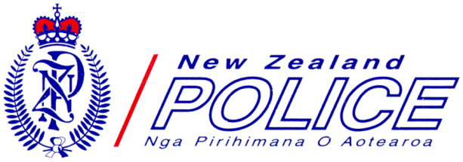

Registration Form 9 & 10 July 2015
AML/CFT SEMINAR
The Financial Intelligence Unit and ACAMS joint venture

Please complete no later than
19 June 2015
Participant Details (please ensure that ALL sections are completed)
Name | Position
Company | Postal Address
Telephone | Email

Registration Fee (registration fee is not inclusive of travel or accommodation costs)
9th & 10th July $632.50 (incl. GST) ACAMS member $569.25 (incl.GST)
ACAMS membership number if applicable ……………………
NOTE: Invoice to be raised

Dietary Requirements (please list or describe specific dietary requirement or food allergies)
Click here to enter text.
Networking Evening
I will be attending the networking evening | Yes No

Sharing of Contact Details
I agree that my contact details can be circulated to all seminar attendees | Yes No
I agree that my email address can be shared with all major sponsors | Yes No


Anti-Money Laundering & Countering Financing of Terrorism Seminar
A joint venture between the Financial Intelligence Unit & Association of Certified Money Laundering Specialists
9 & 10 July | Te Papa | Wellington | New Zealand

