Burglary Free

Years 7-8 Focus area 3
This section contains one of the following Focus areas from the Burglary-Free programme, aimed at years 7-8 (ages 11-12):
- Burglary in our community
- Partnerships
- Kids’ Watch
Note: An effective programme should include learning experiences from each of the focus areas.

Focus area 3: Kids’ Watch

Contents
Focus area 3: Kids’ Watch 2
Explanation 2
Curriculum links 2
Key messages 2
Success criteria 2
Resources 2
Learning experience 1: An invitation to burglars 3
Learning experience 2: The Kids’ Watch contract 3
Optional learning experiences 4
Evaluation 4
Holiday Job 5
Copysheet: Describing Our Property 9

Focus area 3: Kids’ Watch

Explanation
In this Focus area students consider the safety of property when people are away. They come up with a list of strategies that families could do to make their property safer when the house is empty. Students are introduced to Kids’ Watch. They produce Kids’ Watch flyers to discuss with their parents and caregivers, and then to distribute to suitable families. The school may wish to identify if its community has an established Junior Neighbourhood Support (www.ns.org.nz) or whether community members would like to start one.

Curriculum links
Key competencies: Managing self; Participating and contributing; Relating to others.
Learning areas:
Level 3 and level 4 Health and Physical Education – Strand A: Safety management; Strand C: Relationships; Strand D: Rights, responsibilities, and laws
Level 3 and level 4 English – Purposes and audience.

Key messages
- I can take an active role to make my community safer.
- I am trustworthy.
- I care, and take pride in, our community.

Success criteria
Students will:
- offer help to neighbours who are going away
- demonstrate responsibility and trustworthiness.

Resources
Story: Holiday Job
Copysheet: Describing Our Property

Learning experience 1: An invitation to burglars
Share the story Holiday Job with students.
Ask: Do you think the family considered for a moment that their house would get burgled while they were away?
How did they feel when they found out?
What evidence is there that Gran and Grandad are good neighbours?
What do you think of Nick’s scheme?
Do you think that is something that would work in your community? Why, or why not?
Divide the students into groups. Ask them to brainstorm a list of all the things that kids like Nick could do help neighbours keep their properties safe while they are away. Take reports from each group and build up a main list. Consider all the points on the list to make sure that they are sensible and safe.

Learning experience 2: The Kids’ Watch contract
Introduce the concept of Kids’ Watch to the class. This is kids taking responsibility for keeping a neighbour’s property safe while they are away. Explain that many of the things that they have listed on the board could be done by responsible young people who are neighbours or friends. Brainstorm with the class a list of qualities that a member of Kids’ Watch would need to have.
Each student creates a Kids’ Watch flyer that states clearly what services they could offer to people when they were away. It might look something like the one below.
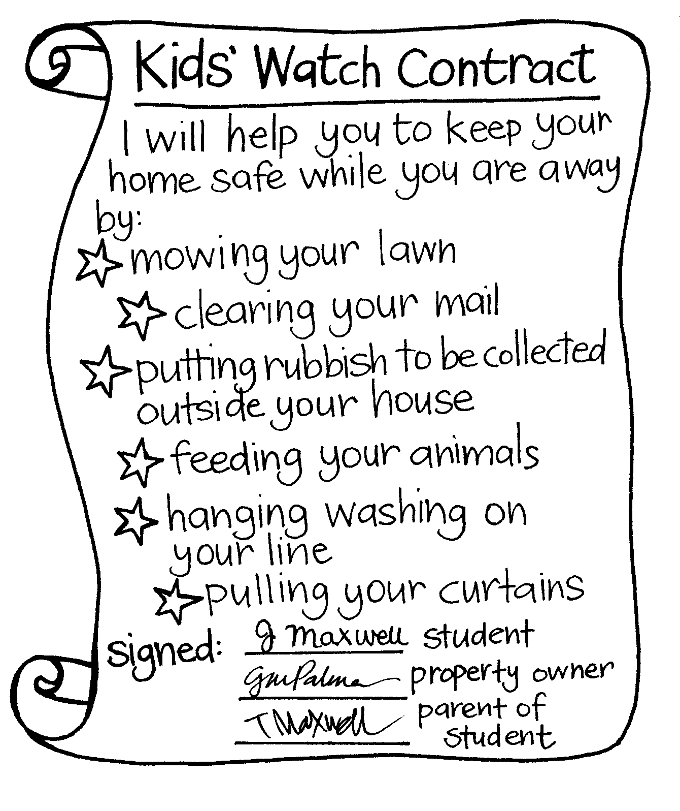
Talk about the importance of getting permission from parents before entering into a Kids’ Watch Contract. Students and their parents would also have to feel very safe and comfortable with the family whose house they were minding. In turn, this family would need to trust the Kids’ Watch member.
Discuss the issue of payment.
Students take their Kids’ Watch Contracts home to discuss with parents. If parents are agreeable, then the flyer could be delivered to suitable families who lived close by.

Optional learning experiences
Provide opportunities for students to heighten their observation skills, which would assist them to give accurate information to the police. For example:
- Show them a picture for a short time. Take the picture away and ask them to record details.
- In pairs, students stand in front of each other and observe the other person. They then sit and write a description of each other.
Design a burglary-free home.
Design a burglary-free logo. This could be done as a competition. The winning logo could be presented to the council. The local mayor could assist with judging – with suitable media coverage.
Students could take home and carry out a property check. See Copysheet: Describing Our Property.
Students could work together to form a Junior Neighbourhood Support or Rural Support group. The School Community Officer or community constable could help with ideas. The group would watch out for each other and each other’s property, hold meetings, and email or send newsletters. They could share ideas about keeping houses and property safe, with adults.

Evaluation
At intervals ask students to report back on Kids’ Watch.
Students write a poem/rap about what makes a burglar-free community.

Holiday Job

"Come on you lot!" Dad called. "We want to get on the motorway before rush hour." Dad was outside on the drive, loading the trailer with all the things my sisters kept passing him, and saying "You can't take that on holiday. There's no room for it!"
My best friend, Nick, who lives a few doors down the street, was busy blocking up our hallway. "Want me to carry your pack out to the car?" he offered. He looked like a Labrador that someone had just shouted at. Nick dreads Christmas holidays. His parents run motels so while everyone else is off at the beach or the river, having fun, Nick's stuck at home vacuuming.
"Not going away this Christmas?" asked Mum, as she tried to squeeze past him.
"No show, Mrs Shannon."
"Well," said Mum, trying to be cheerful, "you never know what might turn up on your own doorstep."
"Huh?" said Nick.
"You might just find something special to do right here in Holly Street."
Nick looked kind of doubtful. I passed him my pack.
By the time I'd found my snorkelling gear in the hall cupboard – I never go to Gran and Grandad's without it because they're right by the sea – everyone was sitting in the car, waiting.
"Just have to put my bike inside," I called to Dad, who looked like he was going to explode. Don't want to leave it on the lawn. It might get pinched."
I could hear my sisters laughing. "No one in their right mind would steal that pile of junk!" they shouted.
"Bye!" we all waved to Nick when I was finally in the car and we were moving out of the drive. "See you in three weeks!" Nick looked so miserable. I sure hoped that Mum was right about something turning up for him to do.
The drive to the coast took almost three hours. By the time we arrived, I was fed up with being jammed in between my sisters. "Made it in one piece," said Dad, turning left into Tapati Street. I craned my neck to be the first to see Gran and Grandad's place but before we'd even got there, my sister Jamie spotted Grandad. He was mowing the lawn in front of a two-storeyed place.
"Grandad!" we all called out as Dad stopped the car. Grandad looked up and came jogging over to us.
"Didn't know you were back to earning pocket money lawn mowing!" joked Dad.
Grandad laughed. "Just as well you're here. I've got four lawns to mow in this street. Said I'd do it to keep the places looking lived in while the folk are away on holiday."
"Huh?" I asked.
"Don't want to give any burglars the idea that there's no one at home," said Grandad with a wink.
"Mm," said Mum, "he's got a point there."
It was next morning, at breakfast, that we found out that Gran was busy keeping burglars away, too.
"Who's coming along the street with me to collect the mail?" she asked.
"I will," I said.
"Good," said Gran. "You can carry the rubbish bag."
"Rubbish bag?"
"I'll only be collecting junk mail," explained Gran. "Folk who are away on holiday cancel their mail but the junk stuff still arrives. Nothing like an overflowing mailbox to let burglars know there's no-one home."
"Mm," said Dad. "That's cunning.”
Over the next week and a half, in between swimming and snorkelling and lazing on the beach, we discovered that Gran and Grandad knew a few other tricks to keep burglars away.
"Must be seven o'clock," said Gran one night. She was looking out the living room window.
"See that light on in the house over the road? It switches on automatically at seven every night while the Beatties are on holiday. Nothing like a light on in the evening to make people think there's someone home."
"I thought there was someone home there, anyway," said Mum. "There's washing on the line."
"Oh, that's ours," said Grandma. "We use the Beattie's line while they're away on holiday."
"Keeps the places looking lived in," said Grandad.
"You two could run a business with all these anti-burglar tactics," smiled Dad. "You know, ten dollars to mow a lawn, a dollar a day to clear the mail box, two dollars to hang washing. You'd be rich in no time!"
Then the telephone rang.
"It's for you," Gran said to Dad. As Dad went to take the phone, Gran looked worried. "Not good news," she told us. "It's the police. Seems that ..." She hesitated as though she didn't want to tell us. "Seems that your place has been broken into."
And that was the end of our holiday. We had to go back home early, said Dad, to check our house out and let the police know what was missing.
I felt mad and scared at the same time: mad that our holiday was being cut short by a whole week, and scared that – I don't know what, really. Maybe scared that the burglars would still be in our house when we got back, even though I knew that was a crazy idea.
Mum and Dad were the first to go inside when we reached home. After a few minutes they came out to talk to us.
"Try not to be too upset, kids," said Mum. "The place is a real mess."
"Not that you'd know the difference where your room is concerned, Tom," smiled Dad. He was trying to joke to cheer us up, only no one laughed.
Inside, there was stuff all over the floors. All the clothes from our drawers had been tipped out. My model aeroplanes that I've taken years to build were in bits, as though they'd been deliberately stood on. Suddenly I heard someone crying.
It was Jamie. She was standing in her room in front of her shelves. "My CDs have gone! All of them!" she sniffed. "Why would anyone take my CDs?"
That night, after we'd made a list of the stuff that was missing, and had fish and chips for tea, we unpacked our sleeping bags and all piled into Mum and Dad's room for the night.
We felt a whole lot better being together like that. We even started to joke a bit.
"Strange," said Dad, "that your bike wasn't stolen, Tom."
Jamie and Lucy started to giggle.
"Even stranger that that painting you did at night class is still on the wall, Dad," I said. Mum spluttered as she tried not to laugh.
"At least we've learned a few tips from Gran and Grandad on how to keep burglars away," said Mum. "Next time we go away on holiday, we just have to find a willing neighbour to mow our lawns, collect the mail, and hang up some washing."
"And I'll have to buy one of those automatic timers for the living room light," mumbled Dad just before he started snoring.
As it so happened, the willing neighbour turned up at our front door before we were even out of our pyjamas. It was Nick. He was carrying a notebook and pushing a lawn mower. He looked pretty pleased with himself.
"Hi," he said. "Sorry to hear about your house being burgled. There were four other break-ins in this street and five in the next."
"What's with the lawn mower?" I asked.
"Well," said Nick, looking kind of awkward, "since the break-ins the police have been door knocking - you know, giving people tips on what to do with their house and grounds when they go on holiday."
"And?" asked Mum.
"Well," said Nick. He hesitated again. Then he gulped and opened his notebook. "The bottom line, Mrs Shannon, is that I can clear your mailbox of junk mail for fifty cents a day, mow your lawn for ten bucks, and check round your property every day for a dollar."
I could see Dad beginning to smile. "I'm doing it for a couple of places already," said Nick. "But I'm giving you guys a discount – you know, mates’ rates."
"Nick," said Mum, "I told you that something special would turn up in the holidays, and it did. Sounds like you're in business!"
"You know," said Dad, "we haven't actually unpacked yet. Why don't we finish tidying up the house and then just head on back to Gran and Granddad's for the rest of our holiday?"
"Sounds good to me," said Mum.
"Nick," I grinned, "sounds like you've got yourself a job!"

Copysheet: Describing Our Property

Serial number
Value
Date of purchase
Colour
Description or model number
Brand/type/make
Item

