Burglary Free

Years 7-8 Focus area 2
This section contains one of the following Focus areas from the Burglary-Free programme, aimed at years 7-8 (ages 11-12):
- Burglary in our community
- Partnerships
- Kids’ Watch
Note: An effective programme should include learning experiences from each of the focus areas.

Focus area 2: Partnerships

Contents
Focus area 2: Partnerships 3
Explanation 3
Key messages 3
Curriculum links 3
Success criteria 3
Resources 3
Learning experience 1: Setting the scene 4
Learning experience 2: Partnership in action 4
Learning experience 3: Sharing decisions 4
Optional learning experiences 5
Community check 5
Sharing our findings 5
Copysheet: Character Descriptions 6
Copysheet: Number of Burglaries in Roseville by Time and Day 9
Copysheet: Newspaper Article 10
Burglary on the increase 10
Copysheet: Some Possible Solutions 11
Copysheet: Summary of Solutions 12

Focus area 2: Partnerships

Explanation
In this Focus area, students come to understand that communities need to work together to solve problems such as burglary. They take part in a role play that allows them to explore the way community partners work and to consider solutions to burglary. They analyse the effectiveness of their partnership.

Key messages
- Communities need to work together to reduce the number of burglaries.
- Communities can put a range of strategies into place to help reduce burglary.

Curriculum links
Key competencies: Managing self; Participating and contributing; Relating to others.
Learning areas:
Level 3 and level 4 Health and Physical Education – Strand A: Safety management; Strand C: Relationships; Strand D: Community resources
Level 3 and level 4 English – Purposes and audience
Level 3 and level 4 Social Sciences – Events, causes and effects
Level 3 and level 4 Mathematics and statistics – Statistical literacy.

Success criteria
Students will:
- be able to explain the purpose of community partnerships.
- be able to describe some strategies a community could use to reduce burglaries and increase the solved rate.

Resources
The School Community Officer or council Safer Community Officer
Copysheet: Character Descriptions
Copysheet: Number of Burglaries in Roseville by Month
Copysheet: Number of Burglaries in Roseville by Day and Time
Copysheet: Newspaper Article
Copysheet: Some Possible Solutions
Copysheet: Summary of Solutions

Learning experience 1: Setting the scene
Divide students into groups of six. Allocate one of the following characters to each person in the group. Choose a strong person to take the role of Boris.
Joy Osmond school social worker
Sergeant Ross Young police officer
Cynthia Smith victim support
Boris Harper Safer Community Officer at local council
Hikitia Rooper district council
David Kaipo school principal
Give each student the description of their character, taken from Copysheet: Character Descriptions. Allow them time to become familiar with their role.
Give each group Copysheet: Number of Burglaries in Roseville by Month, Copysheet: Number of Burglaries in Roseville by Day and Time, and Copysheet: Newspaper Article.
Allow the groups time to read and process all this information. The resource people can move from group to group helping with this process.

Learning experience 2: Partnership in action
Explain that Roseville community is very worried about its current rate of burglary. A group of people representing schools, social workers, council Safer Community Officer, police, and victim support (the six students in each group) have got together to see if they can come up with some solutions.
Give the groups Copysheet: Some Possible Solutions. The students, all in role, must discuss each possible solution and make a decision about which ones they think would work for Roseville. Each person must say how much time, money, or support they can put into each solution. Boris will chair the meeting.
The resource people present can move from group to group to ensure that all the solutions are understood and that the ‘meeting’ doesn’t get stuck. As decisions are made Boris lists them on Copysheet: Summary of Solutions.

Learning experience 3: Sharing decisions
The Boris character from each group in turn reports back the decisions the group has made. The resource people present comment on the decisions.
Ask: Do you think partnerships are an effective way of solving community problems? Why, or why not?
What is good about partnerships?
What might make it hard for a partnership to work?
Did your partnership work well? Why, or why not?

Optional learning experiences

Community check
Students can carry out a check or audit on their local community to find out if it has strategies in place to make the community safer from burglary. Students can devise their own checklist, using ideas from the Focus area just completed. This will ensure that the list is suitable for the local area. Students will need to go out into the community to talk to people and to make observations.
Possible questions include:
- Is there adequate lighting in public places?
- Is there evidence that neighbourhood or rural support groups are operating?
- Are trees and shrubs trimmed well back from buildings?
- How many buildings have security lights?
- Is there evidence of graffiti?
- Is the country part of town as well cared for as the town itself?
- Are there a range of out-of-school activities for young people?
- What is the level of truancy?
- Are there common behaviours that invite burglars, such as garage doors or implement sheds left open?
- Are there alleyways and entry and exit points that make it easy for burglars to get in and out?
- Do parks, recreation areas and shopping malls have good lighting and security systems?
- Is there security in areas that carry lots of people, such as bus and railway stations?

Sharing our findings
Students collate the data from their audit and draw up some findings.
These could be used to:
- write an article for the local newspaper
- write a letter, or visit the local council to present findings
- write an article for the school newsletter.

Copysheet: Character Descriptions

Sergeant Ross Young
Ross is very concerned about the high burglary rate in Roseville and the amount of repeat victimisation. One of the tasks he has been given is to reduce these figures. His district commander has also told him that it is important that they improve the way the community views police. From the statistics, Ross has worked out that most burglaries occur during school hours and in the early evenings. Burglaries increase in the school holiday.
Ross is managing the new police directed patrolling units aimed at keeping a high police presence in the high burglary areas, during high risk times. He is also thinking about making a bid for funding for a burglary reduction strategy.
Ross is a keen rugby player, and would quite like to do some coaching for young players. He also wants to develop a good working relationship with local schools, so they can find a way to tackle truancy, which he thinks is a major cause of burglary. The local school principal doesn’t agree on this point.

Joy Osmond, social worker
Joy is a social worker based at Barton Street School. She does a lot of work with at-risk youth and families in crisis. Some of her caseload are young offenders with convictions for burglary, but Joy feels that it is wrong to say that young people are mainly responsible for burglary. Joy really wants to get something done. She is sick of meetings where everyone talks but no decisions are made.
Most of the young people Joy deals with complain about being bored and say there is nothing for them to do. They are scared to play outside because of angry dogs and speeding cars. They say the after school programmes that are available are just boring places to do homework.
Joy is very keen to develop a programme that will help train young people in the area in real skills, which might help them get work later. She knows that lots of the kids are good artists.

Cynthia Smith, Victim Support
Cynthia is a co-ordinator of Victim Support for Roseville. The group’s job is to support people who are the victims of crime. Cynthia sees a lot of distress caused by burglaries. Some of the members of the Safer Community Council think Victim Support are just do-gooders who only offer tea and sympathy.
Cynthia has visited a lot of homes that have been burgled several times. She knows that the families can’t afford the expense of getting better locks or security systems. She read a news article about another area's Safer Community Council that has a trust fund to provide home security for low-income families in high-burglary areas. She thinks this is a good idea.

Boris Harper, Safer Community Officer at the local council
Boris and the Safer Community Council know that rates of burglary are high in Roseville and that there is a lot of fear among the people. The Safer Community Council wants to get a project of the ground to help solve this. The council wants results, and Boris has a month to get something off the ground.
Boris is sure that there is a link between where young people are concentrated and where the burglaries occur. He also knows that a lot of people in Roseville are living on low incomes and many can’t afford to have their property insured.
Boris has also heard a rumour that the District Council has some money that could be used for crime prevention – about $20,000. But he can’t come out and ask Hikitia directly.

Hikitia Roper, District Council
Hikitia’s main job with the council is to look after the maintenance and repair of public spaces and amenities. She has been told that they have to reduce the amount of money they spend on this.
Most of the damage occurs on Friday night when people drink in the park opposite Barton Street and leave lots of smashed bottles and rubbish. They also cause damage like graffiti and damage to letter boxes and fences. Hikitia has just done a review of lighting in the area and has found that there are not a lot of street lights in the area. A lot of businesses have complained that the whole area looks run-down and dilapidated.
Hikitia has a budget of about $10,000 that can be used for ‘safety’ purposes. She is under strict instructions from her manager not to offer any money at the meeting, unless there is a really worthwhile project.

David Kaipo, School Principal at Barton Street School
David is really keen to see the community working together. Several local shopkeepers have contacted the school in recent months saying that kids from the school (they don’t wear uniform) have been shoplifting in school hours. David reckons people are just down on his kids. He does worry, though, about the lack of things for young people to do out of school hours. Many of the kids are good at sports and have energy to burn – but there is no one to supervise them.
Barton Street School has a role of 350 students, of whom about 20 are regular truants. David has noticed that truancy is highest just after lunch and on Friday afternoons. He is keen to work with Police and others to reduce truancy, as long as it doesn’t damage the reputation of the school.
David tried to get a volunteer programme for supervised after-school activities off the ground, but he wasn’t successful. A lot of the students are Māori. David knows that some other areas have set up successful Kapa Haka groups with district funding.
David is also worried about the extent of graffiti at the school and in the community.
Copysheet: Number of Burglaries in Roseville by Month

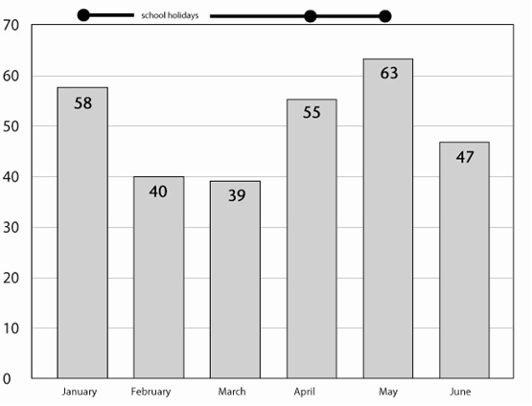

Copysheet: Number of Burglaries in Roseville by Time and Day

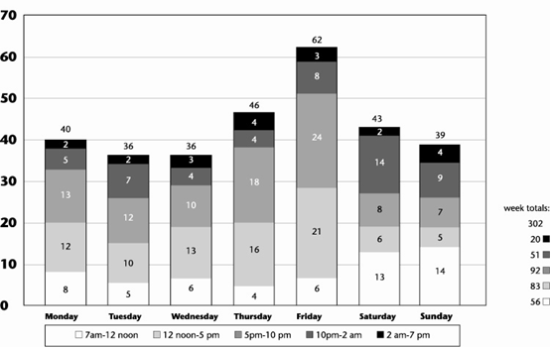

Copysheet: Newspaper Article

Burglary on the increase
T
here is fear in Roseville. Families  are worried about the high rate of  burglary and they feel unsafe.  Everyone knows someone who has been burgled. People are reluctant to leaves their homes because they fear what they will find when they get back. People who like to improve their home security, but have little spare money to do this.  Sergeant Ross of the Roseville Police understands people’s concern. He agrees that burglary is on the increase, but says that Police are taking steps to reduce offending. He cites the new police directed patrolling units as one strategy that police are using.  Victim Support Co-ordinator Cynthia Smith says this is not enough. | “This community has got to work together to solve this problem’, she said, “It won’t go away on its own. Someone has to help families make their homes secure.”  Local community leaders and businesses point the finger at local school children. Crime figures show that burglary locations are clustered around schools in the area. Principal Dave Kaipo admits that some kids do play truant and some do go off the rails. “There is not enough in Roseville to keep our young people busy and out of mischief.”  Boris Harper, the Safer Community Officer, has scheduled a meeting of interested partners. Hopefully they will come up with some solutions which will allow the people of Roseville to sleep sound at night.

Copysheet: Some Possible Solutions
Consider all the burglary risk factors below and the possible solutions given. You will need to think about cost, who will fund it and who will help to make it work.
You may choose more than one solution, dependent on funding.
You may also decide on some other solutions that are not listed here.

Burglary risk factors | Possible solutions
Young people are potential offenders because:  - high level of truancy  - not enough activities for young people to do out of school time | Set up exciting out-of-school programmes for young people that are based on sport and creative activities.  Help local schools deal with truancy.
Lack of sense of pride in community because:  - people don’t know each other  - graffiti and vandalism make it seem as though people don’t care | Set up Neighbourhood or Rural Support groups to help people get to know one another.  Remove graffiti and repair damage in the area around Barton Street.  Improve rubbish removal systems.
Insecure homes, properties and streets means burglars have easy access because:  - offenders are hidden from sight  - it is easy to get in through insecure doors and windows  - poor street lighting and areas with trees | Provide security devices for families. This could include security lighting, alarms and assistance with marking property.  Improve lighting throughout Roseville  Install security cameras at trouble spots.
Lack of awareness among people because:  - people don’t understand how to make their properties safe  - people often don’t report a burglary | Run a community awareness raising campaign with advertising and public meetings.  More visible presence of police through increased patrolling units.

Copysheet: Summary of Solutions
- Complete the chart to show what solutions the group has decided on.

Solution | Who will pay?  How much? | Who will oversee?

- Did all the agencies present agree with these decisions?

- What is good about this plan?

- What is not so good?

