Burglary Free

Years 4-6 Focus area 3
This section contains one of the following Focus areas from the Burglary-Free programme, aimed at years 4-6 (ages 8-10):
- Burglary – the facts
- Burglary – a crime against people
- Safe homes
Note: An effective programme should include learning experiences from each of the focus areas.

Focus area 3: Safe homes

Contents
Focus area 3: Safe homes 3
Explanation 3
Key messages 3
Curriculum links 3
Success criteria 3
Notes for the teacher 3
Learning experience 1: Home security 4
Learning intention 4
Resources 4
Activities 4
Copysheet: Is this House Safe? 5
Copysheet: Home Security Check 6
Learning experience 2: Keeping details of property 7
Learning intention 7
Resources 7
Activities 7
Optional learning experiences 7
Copysheet: Letter to Families 9
Copysheet: Describing Our Property 10
Evaluation 11
Copysheet: Self Assessment 12

Focus area 3: Safe homes

Explanation
In this focus area students brainstorm ways of making homes safer from burglary. They consider safe and unsafe home security practices. Students actively work with their parents to check their own home security and to record details of valuable property.

Key messages
- I can help my family make our home safer.
- I can help record details of my family’s property.

Curriculum links
Key competencies: Managing self; Participating and contributing.
Learning areas:
Level 2 and level 3 Health and Physical Education – Strand A: Safety management; Strand C: Interpersonal skills; Strand D: Rights, responsibilities, and laws
Level 2 and level 3 English – Purposes and audience.

Success criteria
Students will:
- be able to help their families make their homes safer.
- be able to help their families record details of their property.

Notes for the teacher
In this focus area, teachers should be aware of the needs and circumstances of their students' families – for example, whether they are rural or urban and what sort of incomes they have. For this reason a definitive list of property to record has not been given here. Families should make this for themselves.
The decision of where to store serial numbers should also be made to suit your local situation. Some schools may agree to store these on students’ school record cards. Others may suggest places that families could use, such as a fire-proof container at home or with the insurance company.
The return slip that is part of Copysheet: Letter to Families will allow the school to calculate how many homes have recorded serial numbers. This information could be provided to police so that figures could be made public for the whole community. This helps deter burglars, as it sends a message that the community will not tolerate burglary.
The recording of serial numbers enables police to return stolen property to the rightful owners.
Teachers should be alert for students who may become upset or frightened. Students who have had their homes burgled should be treated sensitively.

Learning experience 1: Home security

Learning intention
Students will be able to help their families make their homes safer.

Resources
Copysheet: Is this House Safe?
Copysheet: Home Security Checklist

Activities
Divide students into groups. They will work in these groups for this whole activity.
Ask each group to brainstorm and record things a family could do to keep their house safe from burglary. These ideas should be put to one side.
Give each group Copysheet: Is this House Safe? Go over the suggestions listed. Group members work together to complete the activity. They can add some of their own ideas from the brainstorm above.
Using the information from their brainstorm and from Copysheet: Is this House Safe?, groups design their own checklist to make their home secure. When this list has been checked by the teacher, School Community Officer or another police officer, each student should receive a copy to take home and complete with their family. A sample is provided as Copysheet: Home Security Checklist

Copysheet: Is this House Safe?

Situation | ✓ if safe thing to do  × if not a safe thing to do | How could we make the house safer?
- There is a large rubbish bin near the back door. There is a skylight on the roof above.
- A small window is left open so that the cat can get in.
- A spare key hasn’t been left in an obvious place outside.
- Dad keeps his ladder lying by the garage.
- The doors are locked even if the family is at home.
- A lot of mail collects in the letter box while the family is away.
- Mum leaves her handbag on the table just inside the door.
- A window is broken. It is covered by a piece of cardboard.
- At night, all the lights are turned off when nobody is home.
- There are a lot of shrubs close to the house.
- The front door has a faulty lock.

Copysheet: Home Security Check

Things that make your house safe | ✓ if this applies to your family and home
- Do you belong to a Neighbourhood or Rural Support Group?
- Do all the doors have locks that work properly?
- Can all windows be closed securely?
- Are your trees and shrubs trimmed well back from the house?
- You never leave a spare key outside.
- Do you know your neighbours and do you keep a watch over each other’s properties, especially when you are out?
- Do you keep all tools and ladders locked away?
- Have you made sure that trees and fences aren’t tall enough to give a burglar privacy?
- Do you have security lights?
- Do you arrange for someone to look after your house and lawns while you are away?
- Can you lock your garage securely?
- Do you lock the doors when you are in the garden or out on the farm?
- Do you tell your neighbour when you will be away, and cancel your newspapers?
- Have you got a plan to get everyone safely out of the house if there is a fire?
- Do you keep valuables where they can’t be seen from a window?
- Do you have a sensible arrangement when trades people have to get into your house when you’re not there?

Learning experience 2: Keeping details of property

Learning intention
Students will be able to help their families record details of their property.

Resources
Copysheet: Letter to Families
Copysheet: Describing Our Property

Activities
Brainstorm with the class items that they have at home that burglars might want. The list could include such things as cash, smartphones, stereos, tablets, scooters, Ipods, TVs, jewellery, play stations, food (the list should reflect the local community). The School Community Officer or another police officer can talk about what items are particularly attractive to burglars.
Lead a discussion on ways of keeping the property listed above safe. The discussion could include things such as:
- Record all serial numbers.
- Keep serial numbers in a safe place.
- Update the serial number list regularly.
- Put some identifying marks on your property (e.g., a date of birth).
- Take photos of the property.
- Write a description of the property.
- Keep jewellery in a safe place.
Give each student Copysheet: Letter to Families and Copysheet: Describing Our Property to take home and complete with their family. Remind them of safe places to store the completed list. Offer a small reward to students who return the tear-off strip.

Optional learning experiences
Make a big book on ways to keep our property safe. Share it with the junior school.
Design a burglar-proof home.
Write a poem or rap to help remember either what to do if there is a burglary or ways to make a house safe.
Design a brochure to advertise ways to keep your home safe while on holiday.
Design and make a board game (snakes and ladders type) to help teach others what you have learnt.
Do a safety check of the classroom to find out:
- how burglar-proof the classroom is
- if all property is labelled and put away in the correct place.
Copysheet: Letter to Families

Kia ora! Talofa! Kia orana! Hello!

Dear Family
Today we have been talking about ways to keep our property safe. Could you help your child with two things?
- The Home Security Checklist
This has a simple checklist you can do to see how safe your house is. You may then decide there are some things that you can do to make your house less inviting to burglars. If burglars can’t get in easily, they give up and go somewhere else. Your child can help you with some of these things.
- Describing Our Property
On this sheet you can write down all the things you think a burglar might be interested in taking and write down details of them. Keep this sheet in a safe place, or give it to a relative living somewhere else. If you have these descriptions you are more likely to get your property back if you are burgled. Also if burglars know that people in our community are recording serial numbers it will put them off.
Your child can also help you with this.

Thank you for your help. Please complete the tear-off strip and send it back to school with your child.

(Teacher’s name)

-------------------------------------------------------------------------------------------------

I have completed the following:

1) Home Security Checklist 2) Describing Our Property

Name: Signature:

Copysheet: Describing Our Property

Serial number
Value
Date of purchase
Colour
Description or model number
Brand/type/make
Item

Evaluation
Teacher observation of students and their work during Burglary Free.
Students' self assessment based on the messages from each Focus area. See the example in Copysheet: Self Assessment.

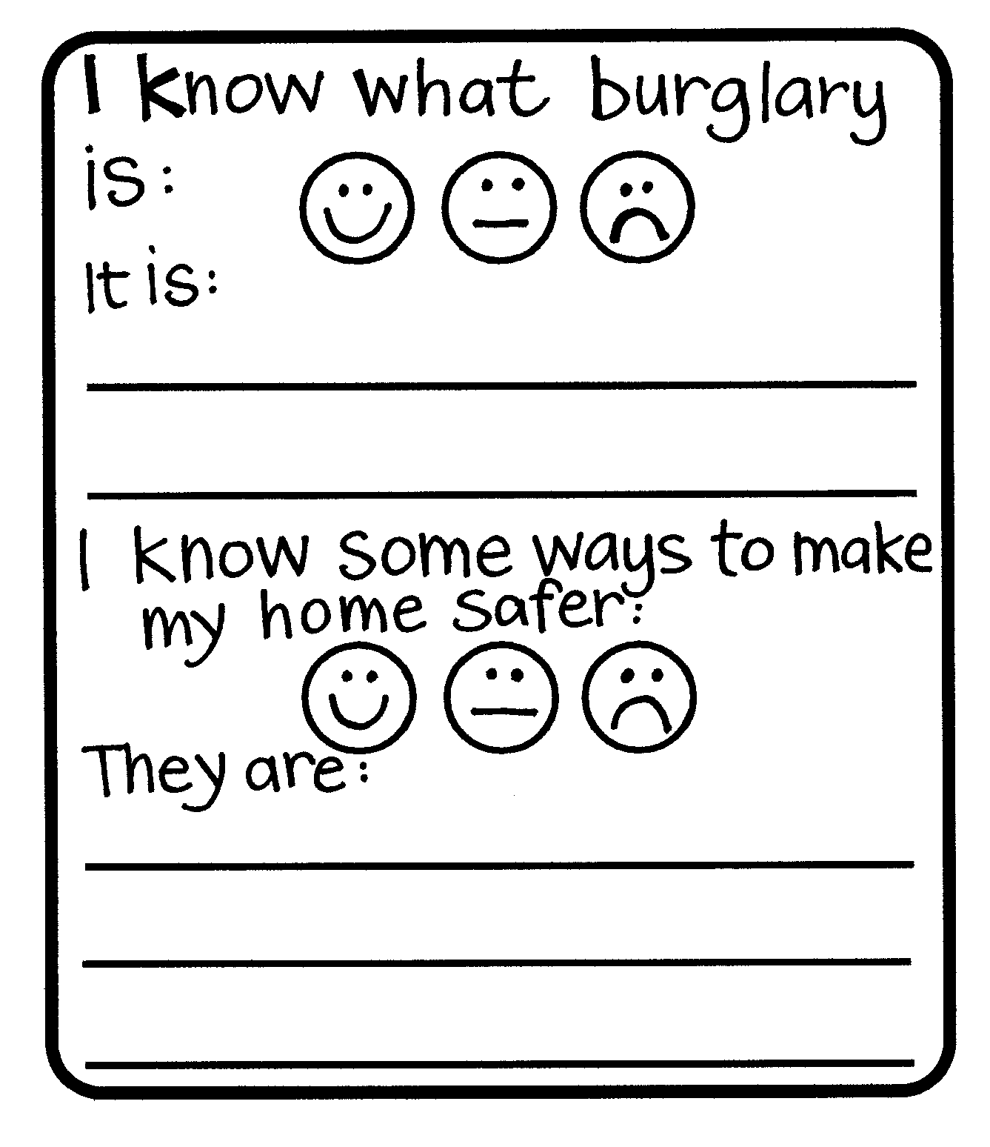
Copysheet: Self Assessment

