Burglary Free

Years 4-6 Focus area 2
This section contains one of the following Focus areas from the Burglary-Free programme, aimed at years 4-6 (ages 8-10):
- Burglary – the facts
- Burglary – a crime against people
- Safe homes
Note: An effective programme should include learning experiences from each of the focus areas.

Focus area 2: Burglary – a crime against people

Contents
Focus area 2: Burglary – a crime against people 2
Explanation 2
Key messages 2
Learning experience: Feelings 3
Learning intentions 3
Resources 3
Activities 3
Copysheet: Burglary Situations 6
Copysheet: Victim Impact Report 7
Copysheet: Summary of Facts 7

Focus area 2: Burglary – a crime against people

Explanation
In this focus area students clarify their own feelings about burglary and identify the feelings of others. They learn that burglary is a crime and is hurtful. They discover some of the consequences of burglary.

Key messages
- Taking other people’s things is hurtful and unacceptable.
- Burglary has consequences.

Curriculum links
Key competencies: Managing self; Participating and contributing; Relating to others.
Learning areas:
Level 2 and level 3 Health and Physical Education – Strand A: Safety management; Strand C: Interpersonal skills; Strand D: Rights, responsibilities, and laws
Level 2 and level 3 English – Purposes and audience
Level 2 and level 3 Social Sciences – Implementing rules and laws.

Success criteria
Students will:
- be able to describe how burglary affects people
- be able to list some of the consequences of burglary.

Learning experience: Feelings

Learning intentions
Students will:
- be able to describe how burglary affects people
- be able to list some of the consequences of burglary.

Resources
Resource people – School Community Officer or another police officer, victim support person
Copysheet: Burglary Situations
Copysheet: Victim Impact Report
Copysheet: Summary of Facts

Activities
Note: In this learning experience the teacher should be alert for students who may become upset. If there are students in the class whose homes have been burgled, they should be treated sensitively.
Explain to students that you are going to be asking them how they would feel if they were involved in a burglary. Mark out a continuum along the length of the classroom. Explain that one end is Very Upset and the other end is Not Very Upset.
Read out one of the scenario cards from Copysheet: Burglary Situations. Ask students to position themselves along the line according to how they would feel if that happened to them. Ask some students to explain their positions.
Repeat with another card. Ask students to stay in the same place on the line. Now introduce another continuum line crossing the first, one end of which is Very Angry, while the other is Not Very Angry (see diagram B below). Students now, while still maintaining their relative position on the first line, move to a position on the second line. Each of them now is showing two feelings.
Ask some students to explain why they would feel like that. Repeat this with other scenarios. The feelings on either continuum could be altered to such things as Frightened, Sad, or Concerned.

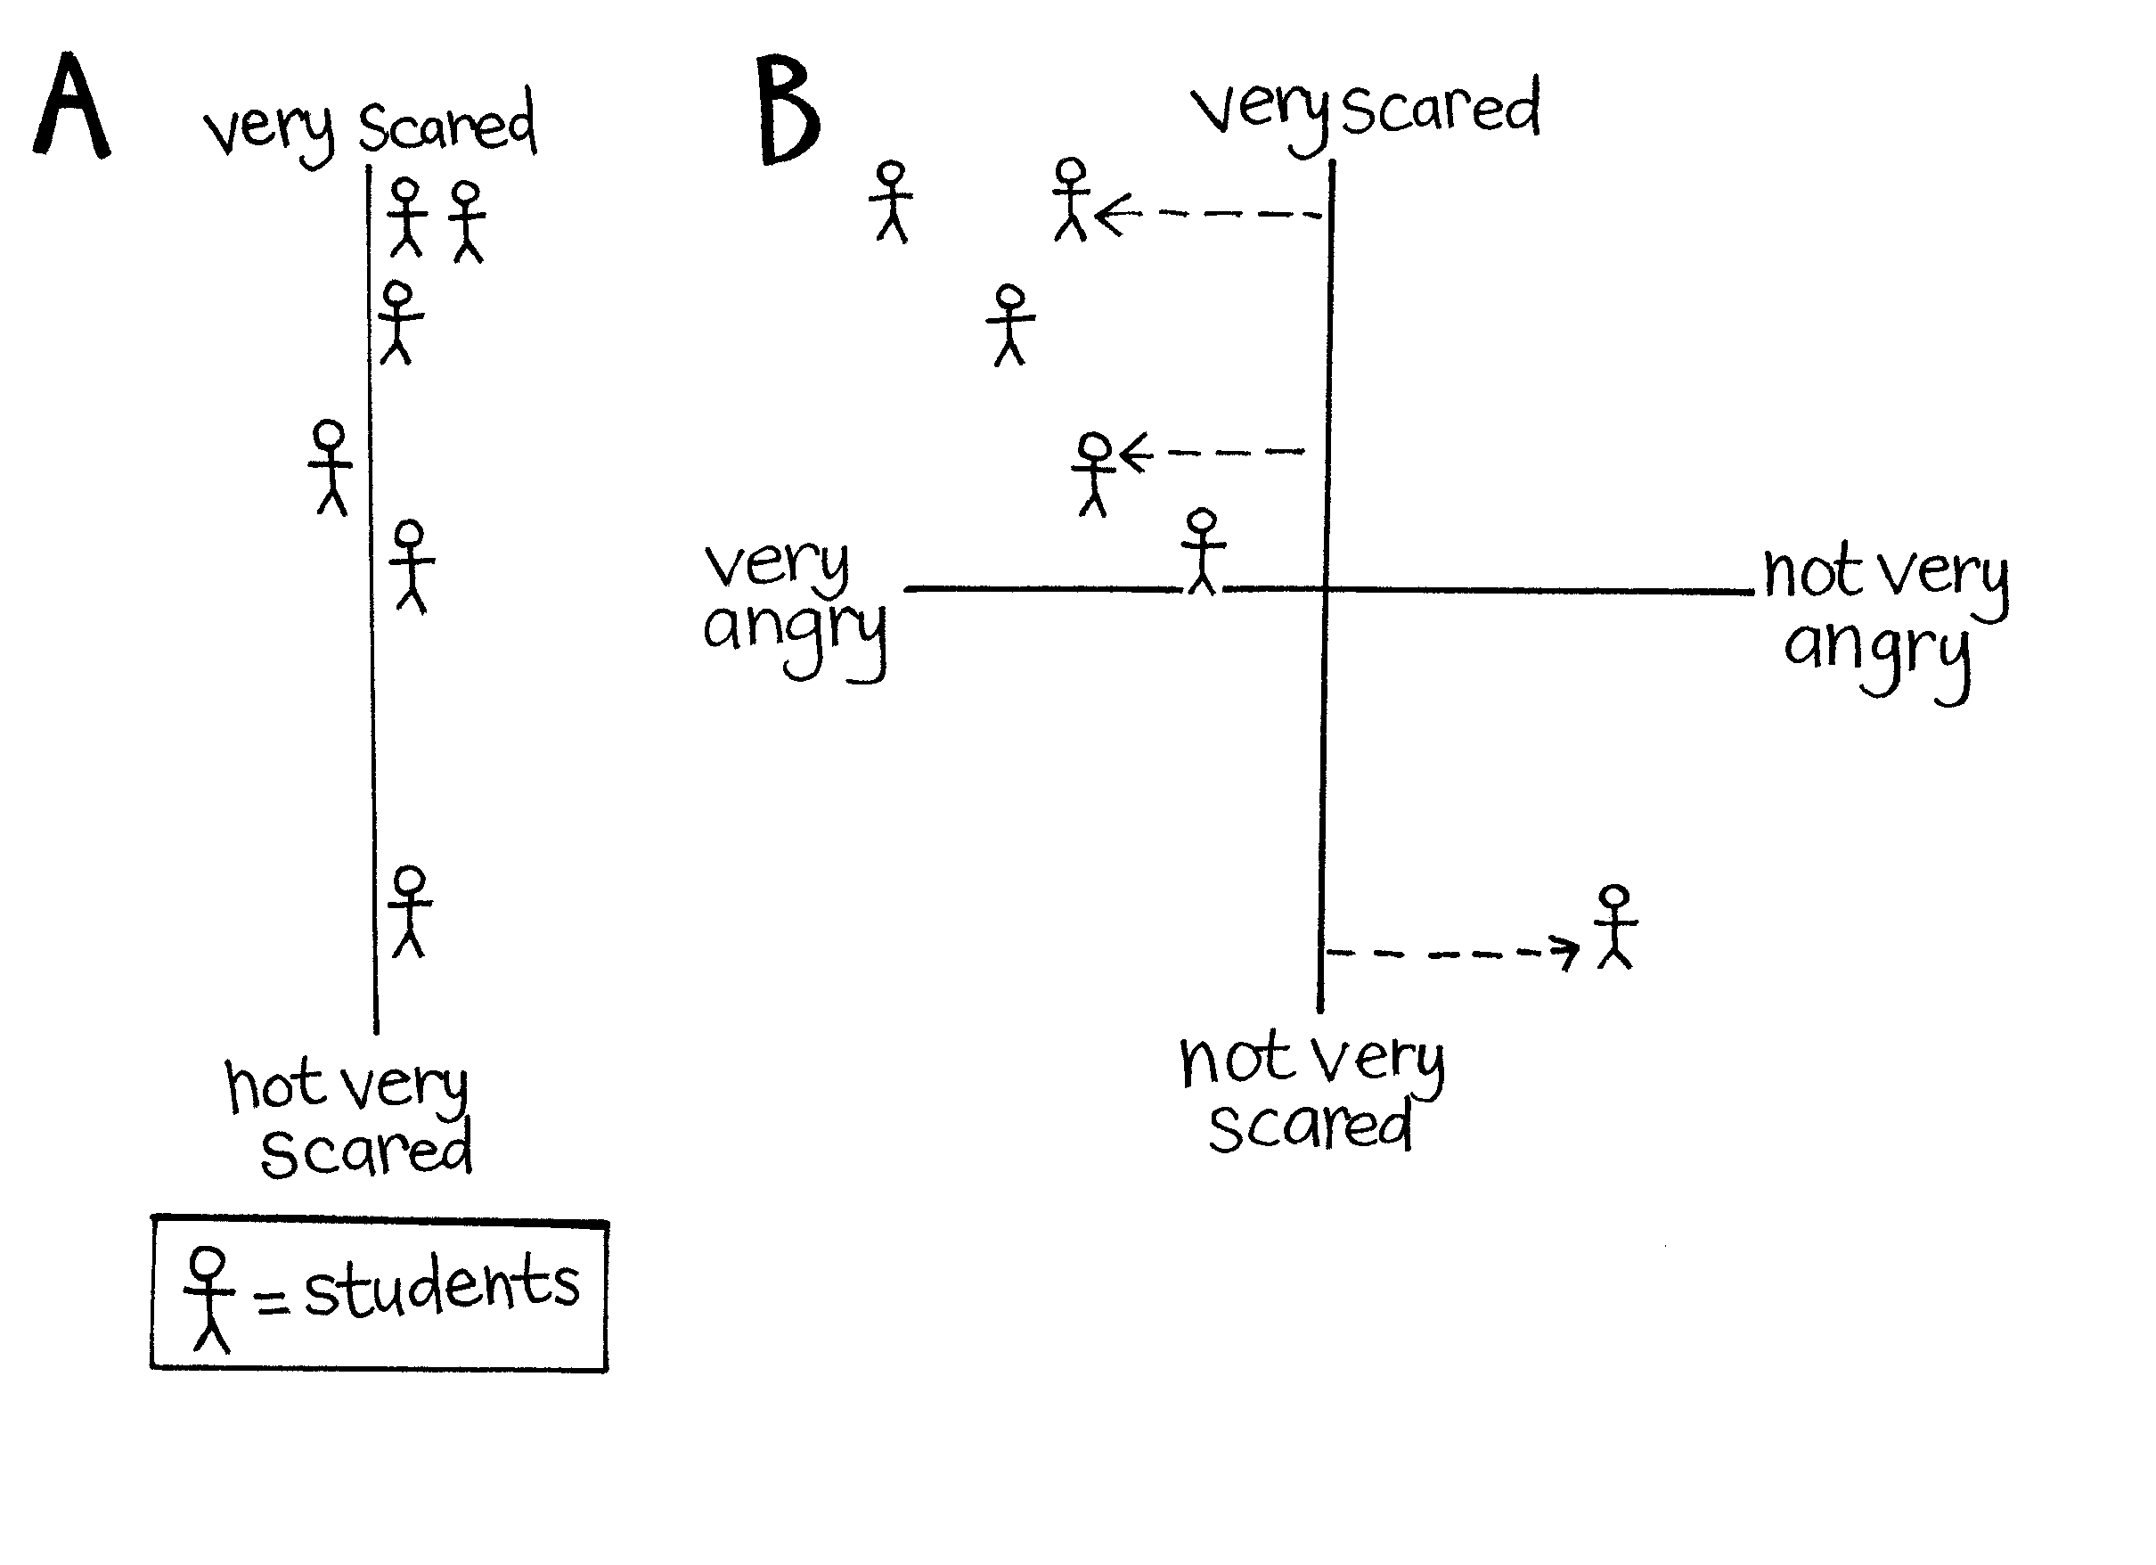
Introduce Copysheet: Victim Impact Report the class. Students use the information to complete a chart similar to the one below.

Person | How they are feeling/behaving
Jacinta | Cries a lot  Frightened to sleep in her own bed  Doesn’t trust people  Won’t be left alone  Is very quiet
Tommy

Ask: What could happen to make this family feel better?
Do you think the person who burgled their house knows how they are feeling?
What do you think should happen to the burglar?

If a person from Victim Support is present, they could talk to the class about their role and how they can help people like the family.
Introduce Copysheet: Summary of Facts to the class. The School Community Officer or another police officer could answer any questions the students might have.
Ask: Do you think the maximum penalty for a crime like this is enough? Why, or why not?
Do you think it will stop the burglar from burgling again? Why, or why not?
What do you think should happen to young people who take other people’s things?

Copysheet: Burglary Situations

You arrive home to find that your house has been broken into but nothing has been taken. | Someone has broken into one of the sheds on your farm and damaged some machinery.
You arrive home, see the door open and can see someone you don’t know inside looking at your things. | Your grandma’s house has been burgled and lots of things have been taken.
Your best friend has had her scooter taken in a burglary. | You buy something off someone at school and you later find out it has been stolen.
Your house needs all new locks because a burglar has stolen the keys. | You see a big truck up the drive next door. Some men are loading things into it. You know the people are not moving.
A burglar has been through your house looking in all the drawers and cupboards. The place is a mess. | Your friend tries to sell you something that you know belongs to someone else.
Your precious family photos have been ripped up by a burglar. | Your house has been burgled for the third time.
A precious greenstone pendant that has been in your whānau for many years has been taken. | Burglars have taken some fine mats that came from your family in the Cook Islands.

Copysheet: Victim Impact Report

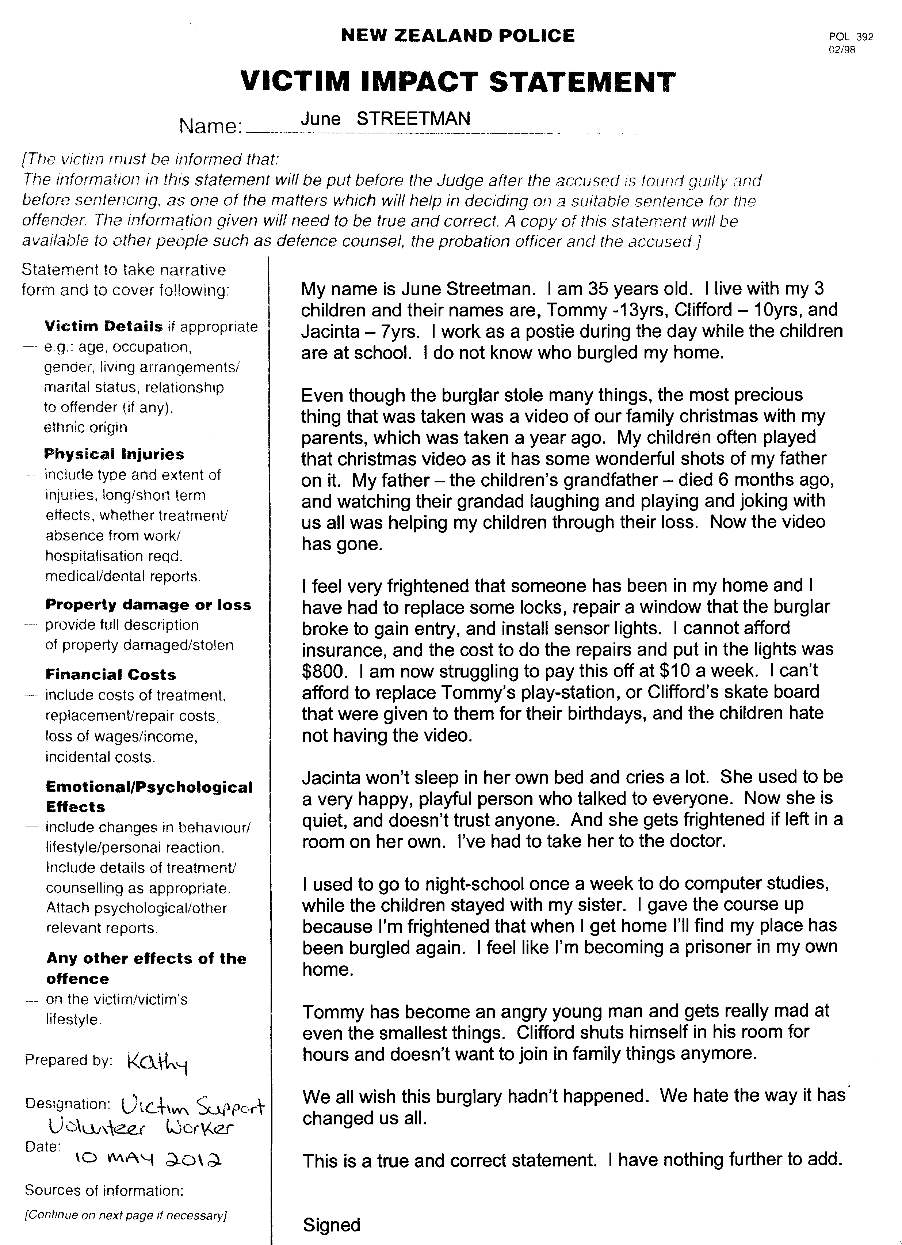

Copysheet: Summary of Facts

POLICE v Barry Green
DOB 04/05/81

___________________________________________________________
CHARGE Burglary
Crimes Act 1961 Section 241(a)
Penalty: 10 Years Imprisonment
___________________________________________________________
SUMMARY OF FACTS

Between 9 am and 3:30 pm on Friday 4 May 2012, the defendant GREEN was at 9 Mine Street, the property of June STREETMAN.

While at the address, the defendant used a screwdriver to force a bedroom window. The defendant then entered the house through the window.

Once inside, he rifled through the draws and cupboards of the bedroom, taking an EFG skateboard valued at $200.

The defendant then went into the lounge and took a Sony DVD player valued at $200 that contained a DVD valued at $25 and a Playstation valued at $300.

The defendant then carried out a search of the rest of the home, before leaving by the same window he entered through.

On Monday 7 May 2012, the defendant GREEN was located and interviewed by Police. He admitted the facts as outlined.

The stolen property has not been recovered.

GREEN is a 31-year-old unemployed male. He has not previously appeared before the Court.

Constable S Smith

