Burglary Free

Years 4-6 Focus area 1
This section contains one of the following Focus areas from the Burglary-Free programme, aimed at years 4-6 (ages 8-10):
- Burglary – the facts
- Burglary – a crime against people
- Safe homes
Note: An effective programme should include learning experiences from each of the focus areas.

Focus area 1: Burglary – the facts

Contents
Focus area 1: Burglary – the facts 2
Explanation 2
Curriculum links 2
Key messages 2
Success criteria 2
Learning experience 1: Burglary – a definition 3
Learning intention 3
Resources 3
Activities 3
Learning experience 2: What to do 5
Learning intention 5
Resources 5
Activities 5
Copysheet. Burglary Is … 7

Focus area 1: Burglary – the facts

Explanation
In this lesson students define burglary and share personal experiences. They have questions about burglary answered by a police officer. They identify the correct procedures to take when their home has been burgled, or when they suspect a burglar is in their house. They make posters and notices to share what they have learnt with their family and the community.

Curriculum links
Key competencies: Managing self; Participating and contributing.
Learning areas:
Level 2 and level 3 Health and Physical Education – Strand A: Safety management; Strand D: Rights, responsibilities, and laws
Level 2 and level 3 The Arts – Visual arts: Communicating and interpreting
Level 2 and level 3 English – Purposes and audience
Level 2 and level 3 Social Sciences – Implementing rules and laws.

Key messages
- I know what burglary is.
- I know what to do if my home is burgled.

Success criteria
Students will:
- explain what burglary is
- describe what to do if their home is burgled.

Learning experience 1: Burglary – a definition

Learning intention
Students will be able to explain what burglary is.

Resources
Dictionaries
School Community Officer (or another police officer)
Copysheet: Burglary Is ...

Activities
Brainstorm with students what they understand by the term burglary. Accept the words the students give. Put the words they suggest on a chart like the one below.
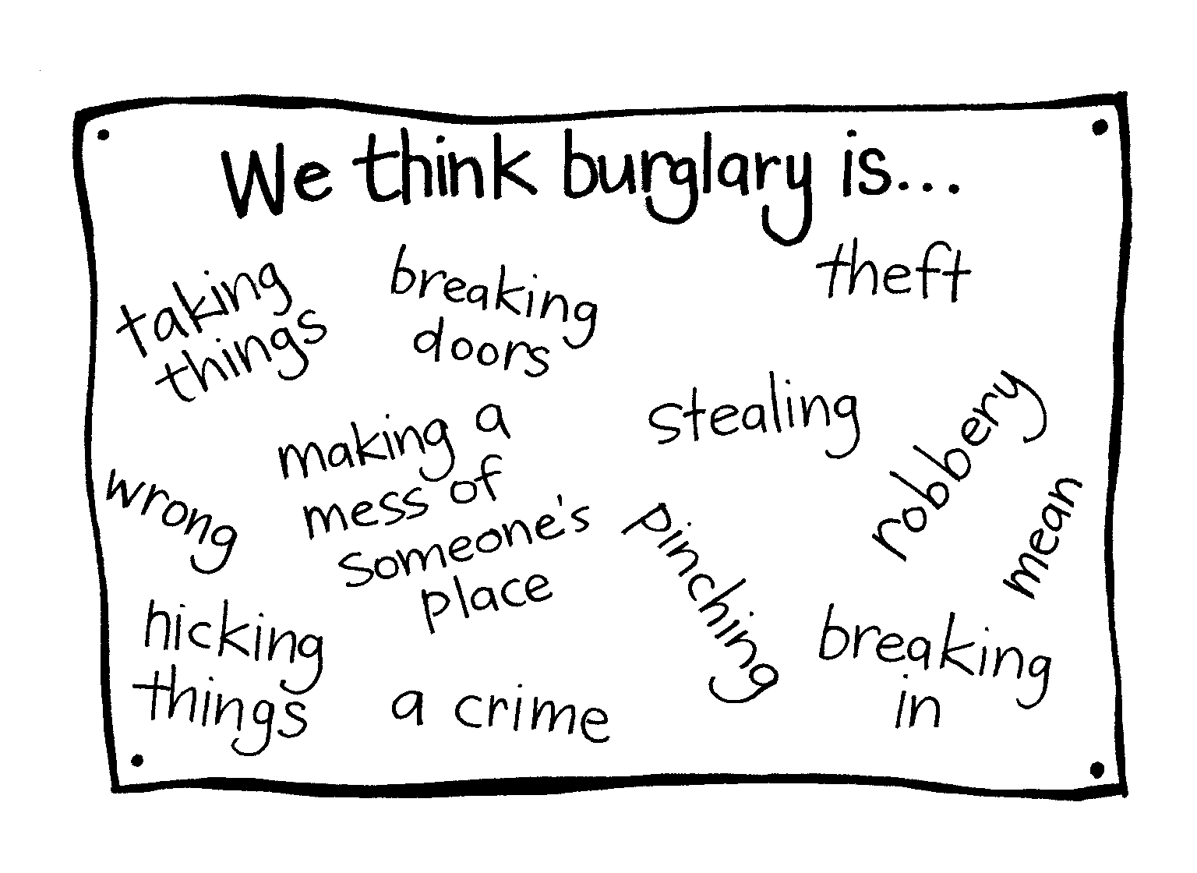
Ask students to find and write down a definition of burglary from the dictionary. Put up the definition adapted from the Crimes Act, shown on Copysheet: Burglary Is ... Ask students to compare this definition with their own. The School Community Officer or teacher should explain various words used in the definition such as:
Enter – when any part of the person, or anything such as a tool they are holding, goes into the building
Building – can include such things as a tent, caravan, enclosed yard
Authority – permission given by a person in a position to determine whether another person may enter or remain on premises
Crime – this can be any illegal act, but in the case of a break-in it is usually theft.
Refer students back to their brainstorm list. Remove any words that they think no longer belong. The School Community Officer can help explain differences between various crimes, such as theft, robbery and stealing. The officer may also give examples of burglaries they have attended. Students may also like to give examples of a burglary they know about. This activity will need to be handled with care to avoid students becoming upset or fearful.
Introduce the term receiving to the students – that is, accepting or buying something when you know or think that it may be stolen. Explain that this is also a crime. Some of the following points about receiving could be covered:
- Receiving stolen goods is a crime.
- People who receive, or buy stolen goods can be arrested.
- A person becomes involved in receiving, when they take possession of any property that they think has been stolen or illegally obtained.
- Some indications that goods may be stolen include that:
  - the serial numbers or distinguishing marks have been removed or defaced
  - the goods are being sold at well below market prices.
  - the goods are being sold in unusual places, such as hotels or flea markets
  - the seller doesn’t give their name and/or won’t give a receipt
  - the seller can’t or won’t give any information about when or where they bought the property or how much they paid for it.

Learning experience 2: What to do

Learning intention
Students will be able to describe what to do if their home is burgled.

Resources
School Community Officer (or another police officer)

Activities
This section is taken by the School Community Officer or another police officer. Describe the correct procedures if a house or property has been burgled or is in the process of being burgled.
This should include such things as those listed below.
What to do if your house is burgled
Leave things as you find them. ‘Preserve the scene’.
Call the Police as soon as possible, on the local station number.
Arrange a time for the Police to come, as soon as possible.
Ask for help from Victim Support.
When the Police arrive
Give the police officer information such as who was the last to leave the house and who discovered the burglary, how the burglar got in and left.
Provide a written list of what was taken.
Provide serial numbers or photos of the missing items.
Report any suspicious activity you saw before the burglary.
Talk about setting up a neighbourhood or rural support group with your neighbours.
If you surprise a burglar or someone who doesn’t have permission to be in your house
Don’t enter the house.
If you are already inside, don’t confront the burglar.
Go to a friend or neighbour close by, dial 111 and ask for Police.
Wait for the Police to arrive.
Keep a safe watch on your house and note down anything you see.
Provide opportunities for the students to ask questions. Remind the students that burglaries are never the victim’s fault.
Working individually, in pairs or small groups, students could either:
- prepare a notice to go on the fridge door at home outlining what to do when there is a burglary; or
- prepare a poster to go in a shop window outlining what to do in event of a burglary.
In both cases the police officer should check the accuracy of the information.
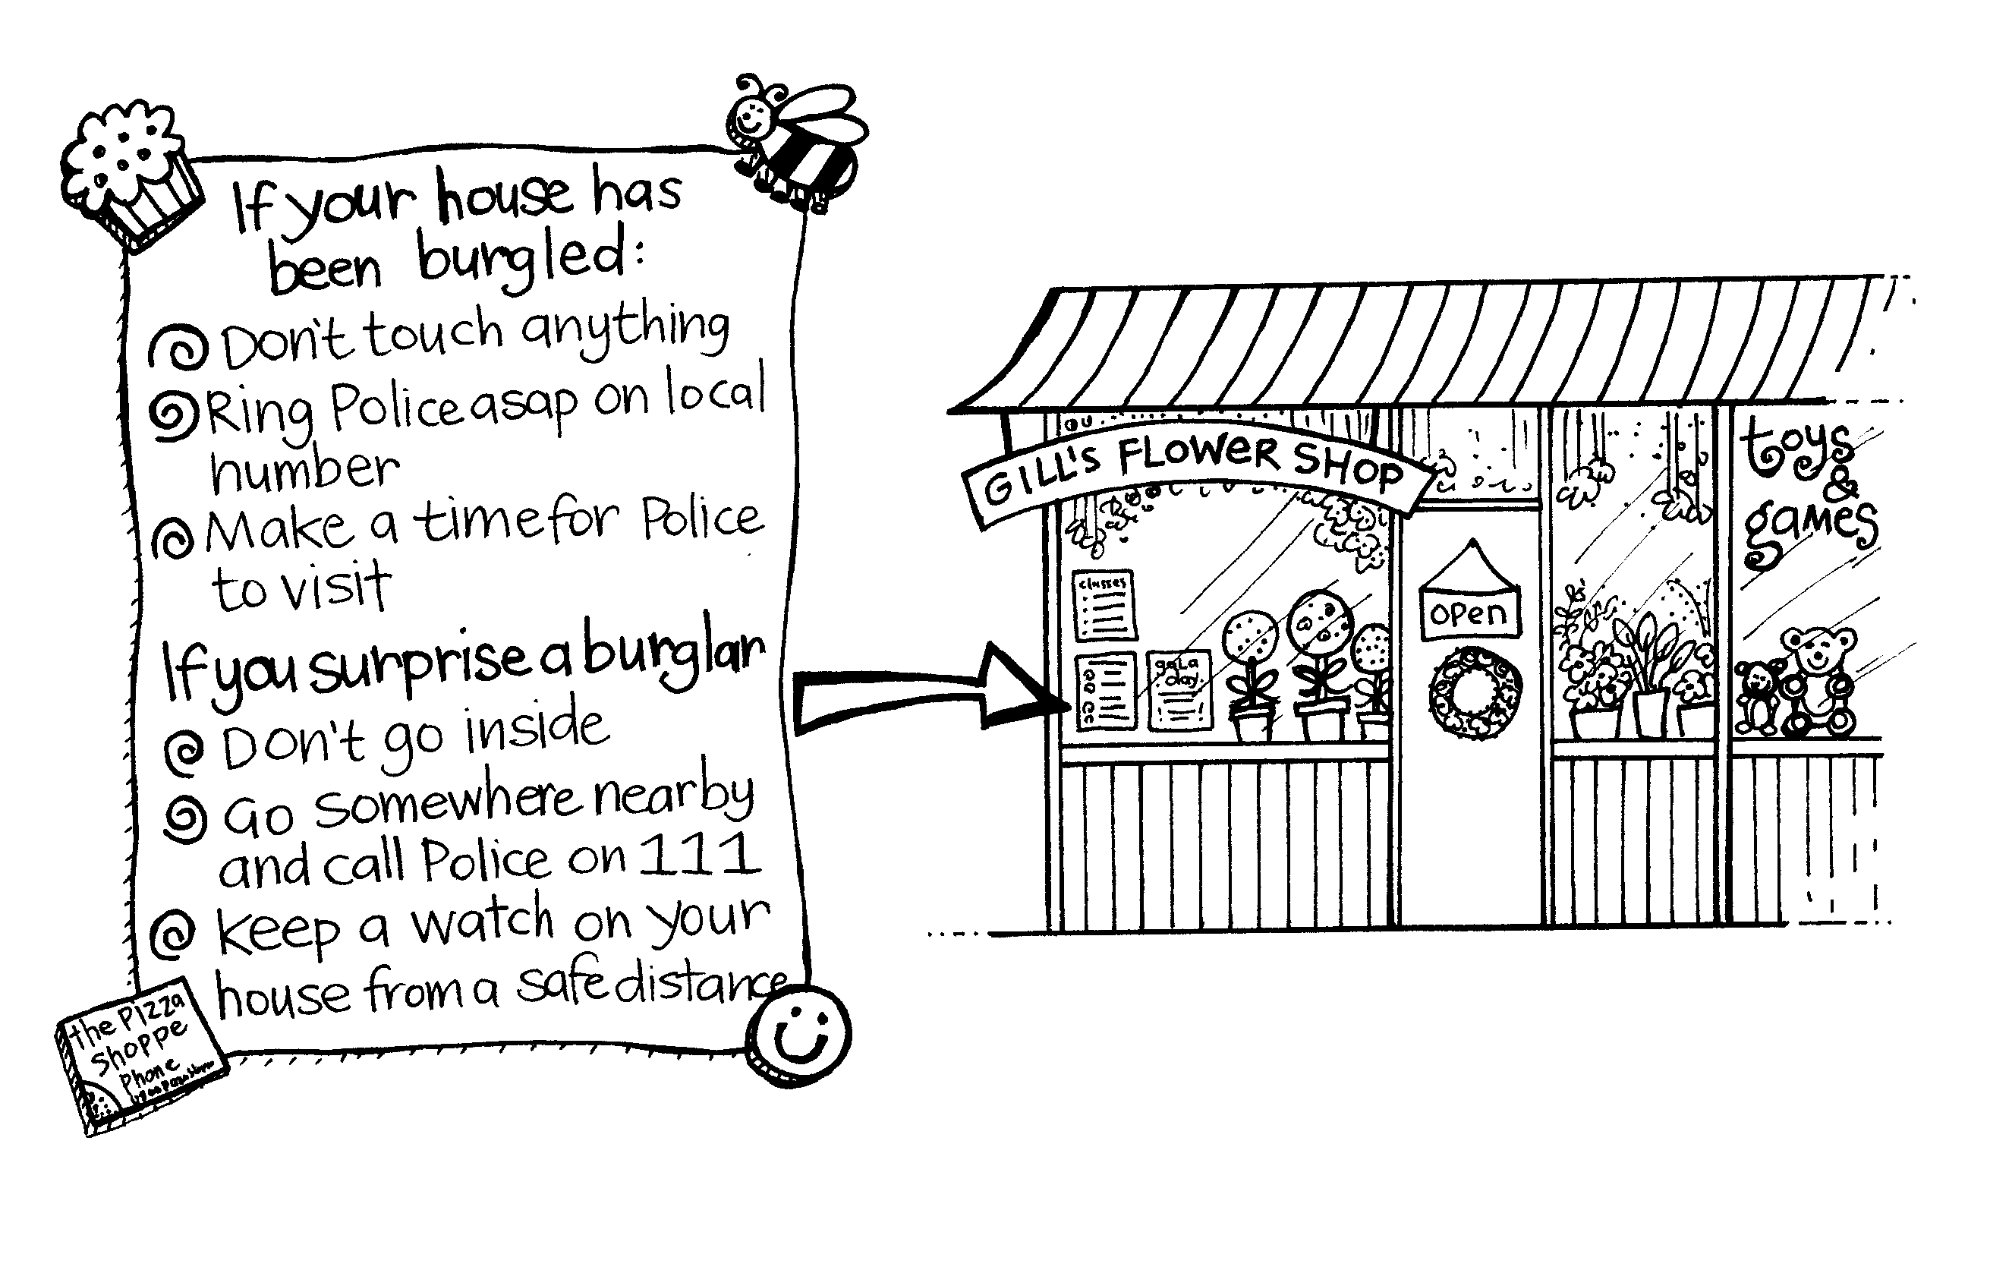

Copysheet. Burglary Is …
Burglary is committed when a person:

either enters a building etc
without authority
with intent to commit an offence in the building

or remains in a building etc
without authority
with intent to commit an offence in the building.

