Burglary Free

Years 0-3 Focus area 3
This section contains one of the following Focus areas from the Burglary-Free programme, aimed at years 0–3 (ages 5–7):
- Mine!
- Looking after my stuff
- Getting help
Note: An effective programme should include learning experiences from each of the focus areas.

Focus area 3: Getting help

Contents

Focus area 3: Getting help 3
Explanation 3
Curriculum links 3
Key Messages 3
Success criteria 3
Resources 3
Learning experience 1: Feeling scared 4
Learning intentions 4
Resources 4
Activities 4
Homework 5
Optional learning experiences 5
Evaluation of focus area 5
Copysheet: Police Officers 6
Copysheet: Homefun 7
Copysheet: Evaluation 8

Focus area 3: Getting help

Explanation
In this lesson, students talk about times when they feel scared and when they need to get help. They identify people who can help them at home, at school and in the community. They are introduced to a police officer who comes to their school often. They learn how to recognise a police officer and how to use the 111 system. While the concept of having someone break into your house is introduced here, it is very important that children are not made fearful.

Curriculum links
Key competencies: Managing self; Participating and contributing.
Learning areas:
Level 1 and level 2 Health and Physical Education – Strand A: Safety management; Strand D: Community resources
Level 1 and level 2 The Arts – Visual arts: Communicating and interpreting
Level 1 and level 2 English – Purposes and audience
Level 1 and level 2 Social Sciences – Roles and responsibilities in groups.

Key Messages
• I know who to talk to when I am scared.
• I can ask a police officer for help.

Success criteria
Students will:
- know who to go to for help when they feel scared
- be able to recognise a police officer
- be able to use the 111 system

Resources
The School Community Officer, Community Constable or another police officer should be present for this session.
Copysheet: Police Officers
Copysheet: Homefun
Copysheet: Evaluation
Learning experience 1: Feeling scared

Learning intentions
Students will:
- know who to go to for help when they feel scared
- be able to recognise a police officer
- be able to use the 111 system

Resources
The School Community Officer, Community Constable or another police officer should be present for this session.
Copysheet: Police Officers
Copysheet: Homefun

Activities
Talk about how we all feel scared sometimes. The teacher and police officer give examples of times when they were scared. Ask children to share times when they feel scared. There should be no compulsion about this – allow them the opportunity to pass. Record ideas on the board.

Talk about people who can help us when we are scared.
Ask: Who can you talk to at home when you are scared?
Who can you talk to at school when you are scared?
Make a chart of people who can help (mum, dad, whanau, grandparents, teacher, the principal, the police education officer, the person in the office…)

Talk about how there are people in the community who can also help us. Help children to think of some of these by asking leading questions such as those below.
Ask: Who could help us if our house was on fire?
Who could help us if we were sick?
Who could help us if somebody broke into our house?

Introduce the police officer to the class. Ask them to describe what the officer is wearing.
Ask: How could it help us if we know what a police officer looks like?

The police officer talks to the children about what to do if they need help, how to make a 111 call and the importance of knowing their name and address.
Invite children to colour in the pictures of the police officers on Copysheet: Police Officers. Encourage them to use the correct colours. Help them to complete the sentence at the bottom.

Homework
Send home Copysheet: Homefun for children to complete with their family. Also invite children to take home completed Copysheet: Police Officers to share.

Optional learning experiences
Arrange for some of the other community people who help us to come to class and talk about what they do.
Bring play telephones to class to give children the experience of making 111 calls for emergencies.
Give children practice in knowing and writing their names, addresses and telephone numbers. (See also Keeping Ourselves Safe Years 0-3 and Road Safe Years 0-3. Both are available from the Police Schools portal).

Evaluation of focus area
Observe children regularly to find out if they:
- put things away in the right place
- ask and say please when they borrow things
- return things and say thank you
- usually have their own possessions.

Ask students to complete Copysheet: Evaluation by colouring in the face that best describes how they would feel in each situation.

Copysheet: Police Officers
I can talk to Constable ___________________ when I am scared.
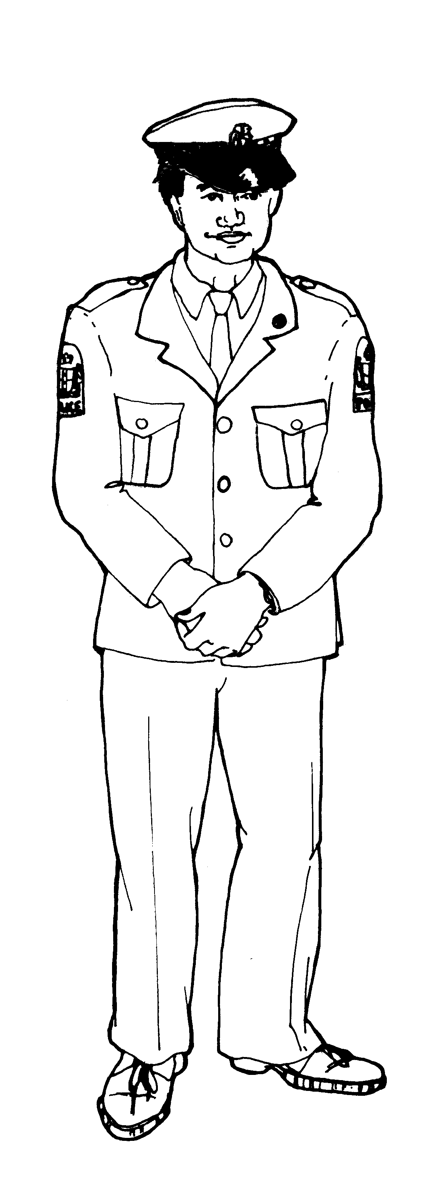
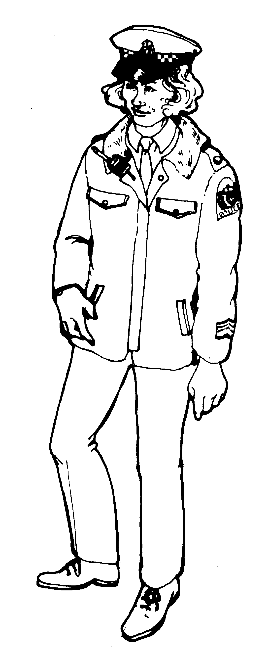
Copysheet: Homefun

Kia ora! Talofa! Kia orana! Hello!

Dear Family
Today in class we talked about people who can help us when we are scared. Please help me write down who I can talk to at home when I am scared. Help me draw a picture of them.
When I am scared at home I can talk to:
1 Name | Picture
2 Name | Picture

Today I met the police officer who comes to our school. The officer's name is:

______________________________________________________________

We found out about using the 111 system in an emergency. Please talk to me about this.
Thank you for your help.

___________________________________________
(child's name)

Copysheet: Evaluation
For each line colour in the face that best describes how you feel.

1 When I put things away I feel ... | 
2 When someone takes my things without asking I feel ...
3 When I find something I have lost I feel ...
4 When someone helps me I feel ...

