Burglary Free

Years 0-3 Focus area 2
This section contains one of the following Focus areas from the Burglary-Free programme, aimed at years 0–3 (ages 5–7):
- Mine!
- Looking after my stuff
- Getting help
Note: An effective programme should include learning experiences from each of the focus areas.

Focus area 2: Looking after my stuff

Contents

Focus area 2: Looking after my stuff 2
Explanation 2
Key messages 2
Curriculum links 2
Success criteria 2
Learning experience 1: Putting things away 3
Learning intentions 3
Resources 3
Activities 3
Copysheet: The Right Place 4
Copysheet: Classroom 5
Copysheet: Put Me Away 6
Learning experience 2: Practising ‘please’ and ‘thank you’ 7
Learning intention 7
Resources 7
Activities 7

Focus area 2: Looking after my stuff

Explanation
In this lesson, children learn the importance of putting their things, and the classroom things, away. They identify the proper places for things, and practise putting things away in the proper place. They explore the reasons why people borrow things, and know that it is important to give things back. They practise saying 'please' and 'thank you'.

Key messages
- I can put things away in the right place.
- I can ask to use something.
- I must give back things that I borrow.

Curriculum links
Key competencies: Managing self; Participating and contributing; Relating to others.
Learning areas:
Level 1 and level 2 Health and Physical Education – Strand C: Identity, sensitivity, and respect; Strand D: Rights, responsibilities, and laws.
Level 1 and level 2 English – Purposes and audience; Ideas.

Success criteria
Students can:

- explain that putting things away in the right place helps keep them safe
- identify where classroom and personal things are kept
- put classroom things away in the right place
- ask when borrowing something and return it with thanks.

Learning experience 1: Putting things away

Learning intentions
Students will:
- be able to explain that putting things away in the right place helps keep them safe
- know where classroom and personal things are kept
- be able to put classroom things away in the right place.

Resources
Copysheet: The Right Place
Copysheet: Classroom
Copysheet: Put Me Away

Activities
The teacher or School Community Officer gives an example of a time when they didn’t put something away in the right place. Because of this they couldn’t find it and didn’t know if it had been taken. This made them cross and sad.
Ask students to talk about times when they didn’t put things away properly.
Ask: Why should we put our things away?

Play the matching game. Children could work in pairs or small groups. Give each pair Copysheet: The Right Place cut up into separate cards. The things to be matched up are marked A. Each one should be matched up with the place where it is kept, marked B. The cards could also be used to play Memory.

Children can work in pairs or small groups. Give each group Copysheet: The Classroom (you may like to enlarge to A3), or provide a drawing of your own classroom. Go over the plan with the children, to help them identify places such as the paint corner and the place where scissors are kept. Give each group Copysheet: Put Me Away cut up into individual items. The group puts each item on the map in the place where it would be put away.

Practise putting classroom things away. This could be done at regular intervals until all children know where things go and readily put them away. Remind them of safety rules such as holding scissors carefully, and not running where there may be water on the floor.
Copysheet: The Right Place

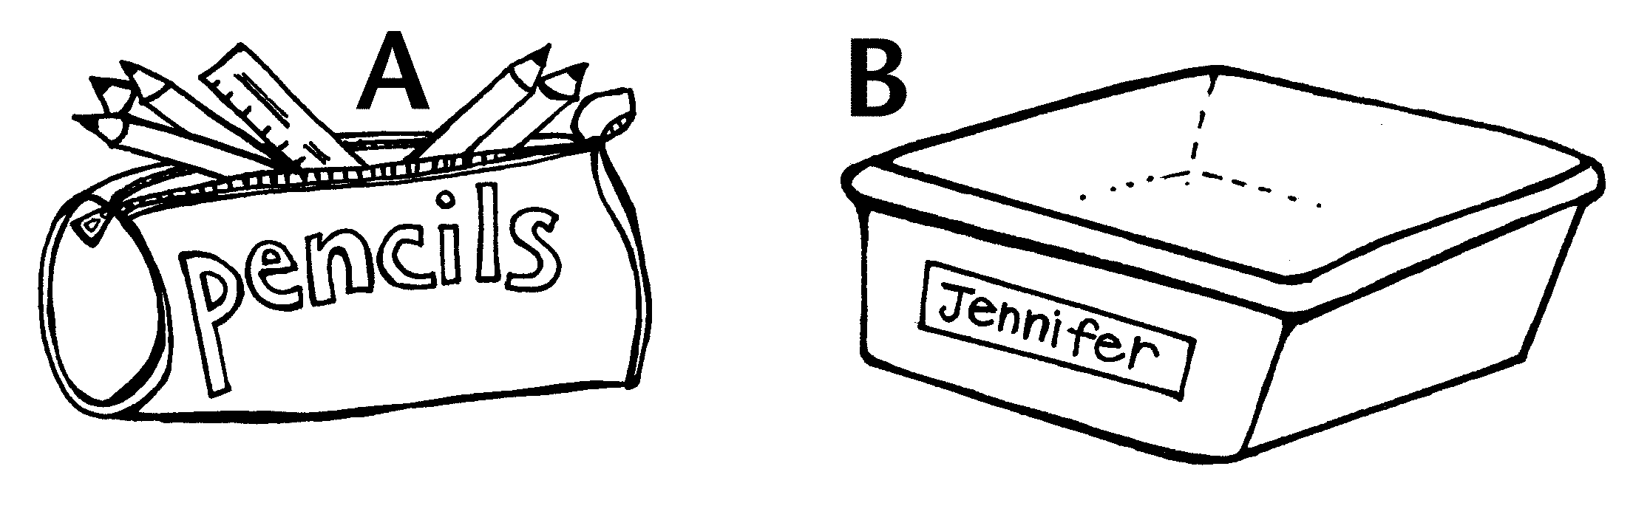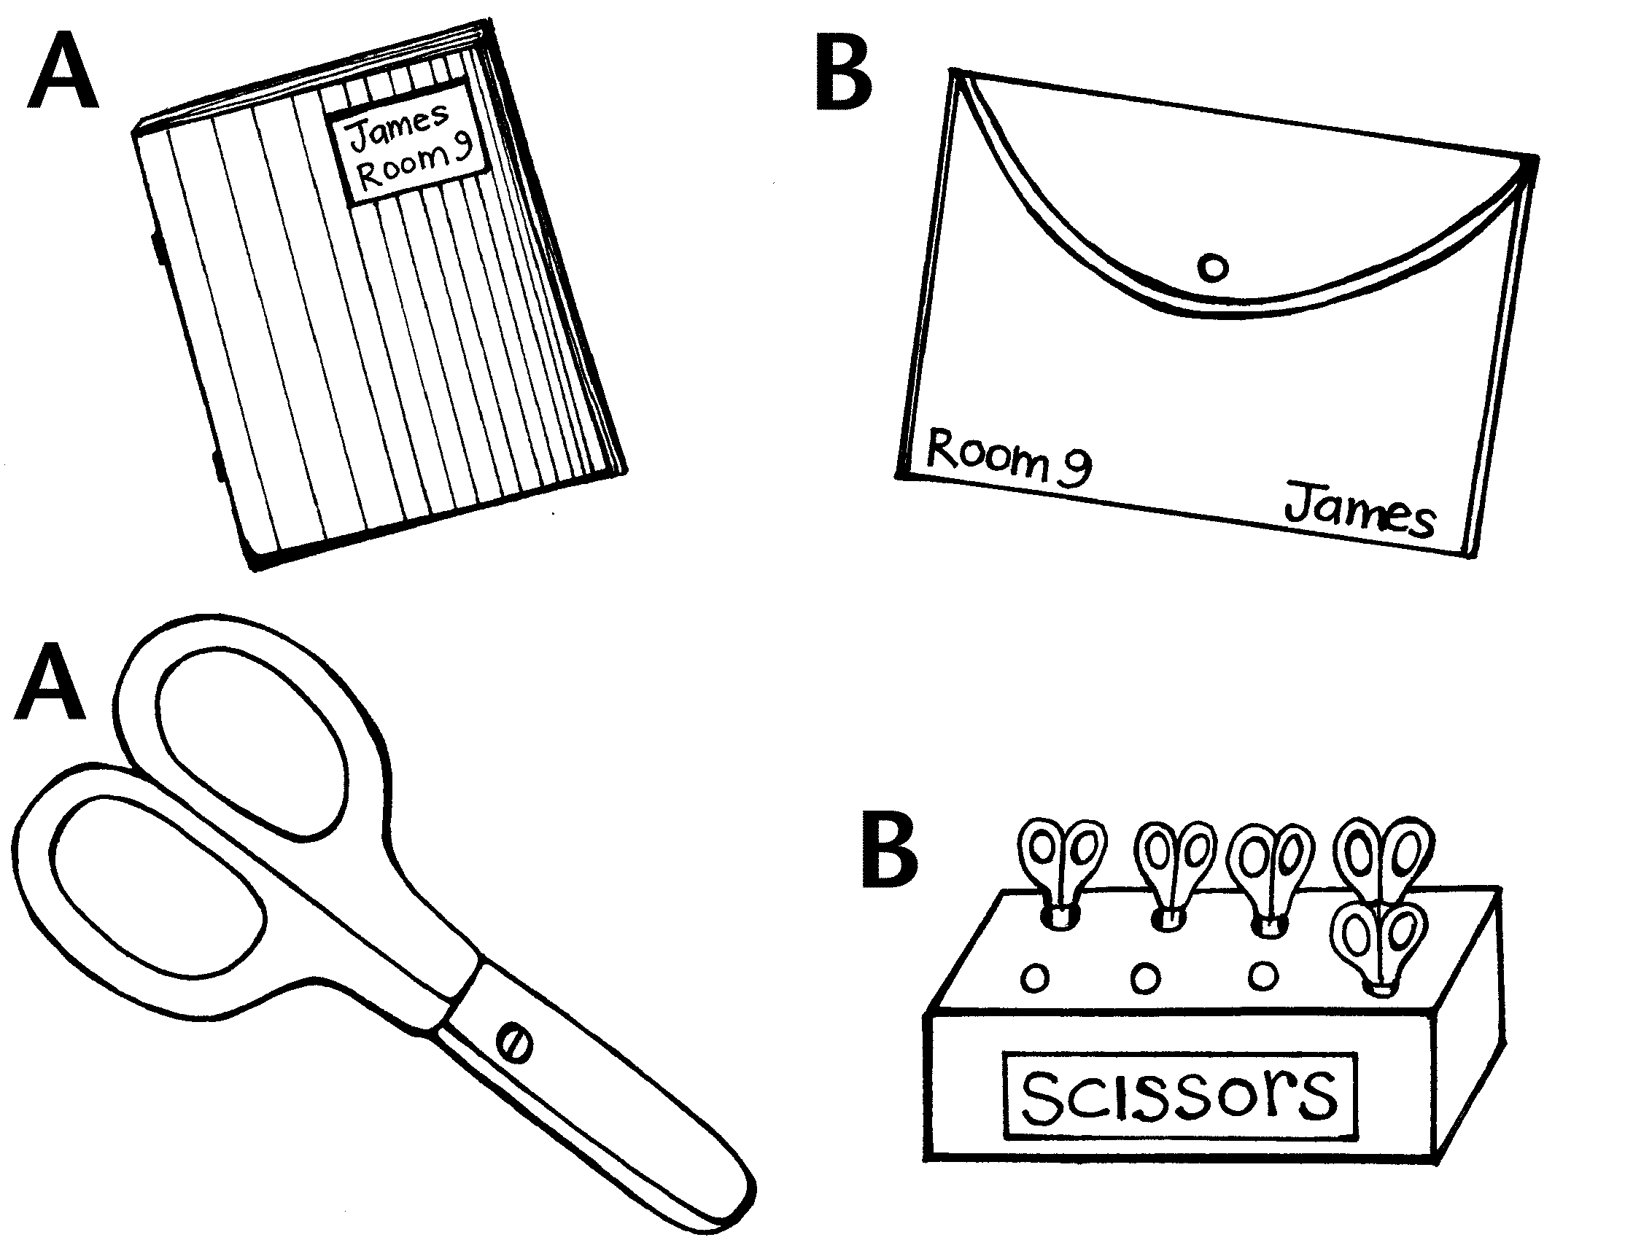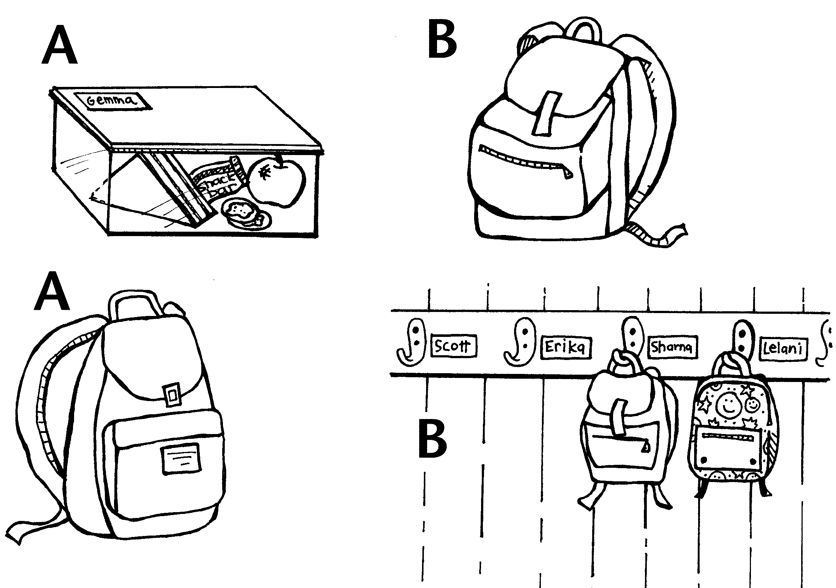

Copysheet: Classroom
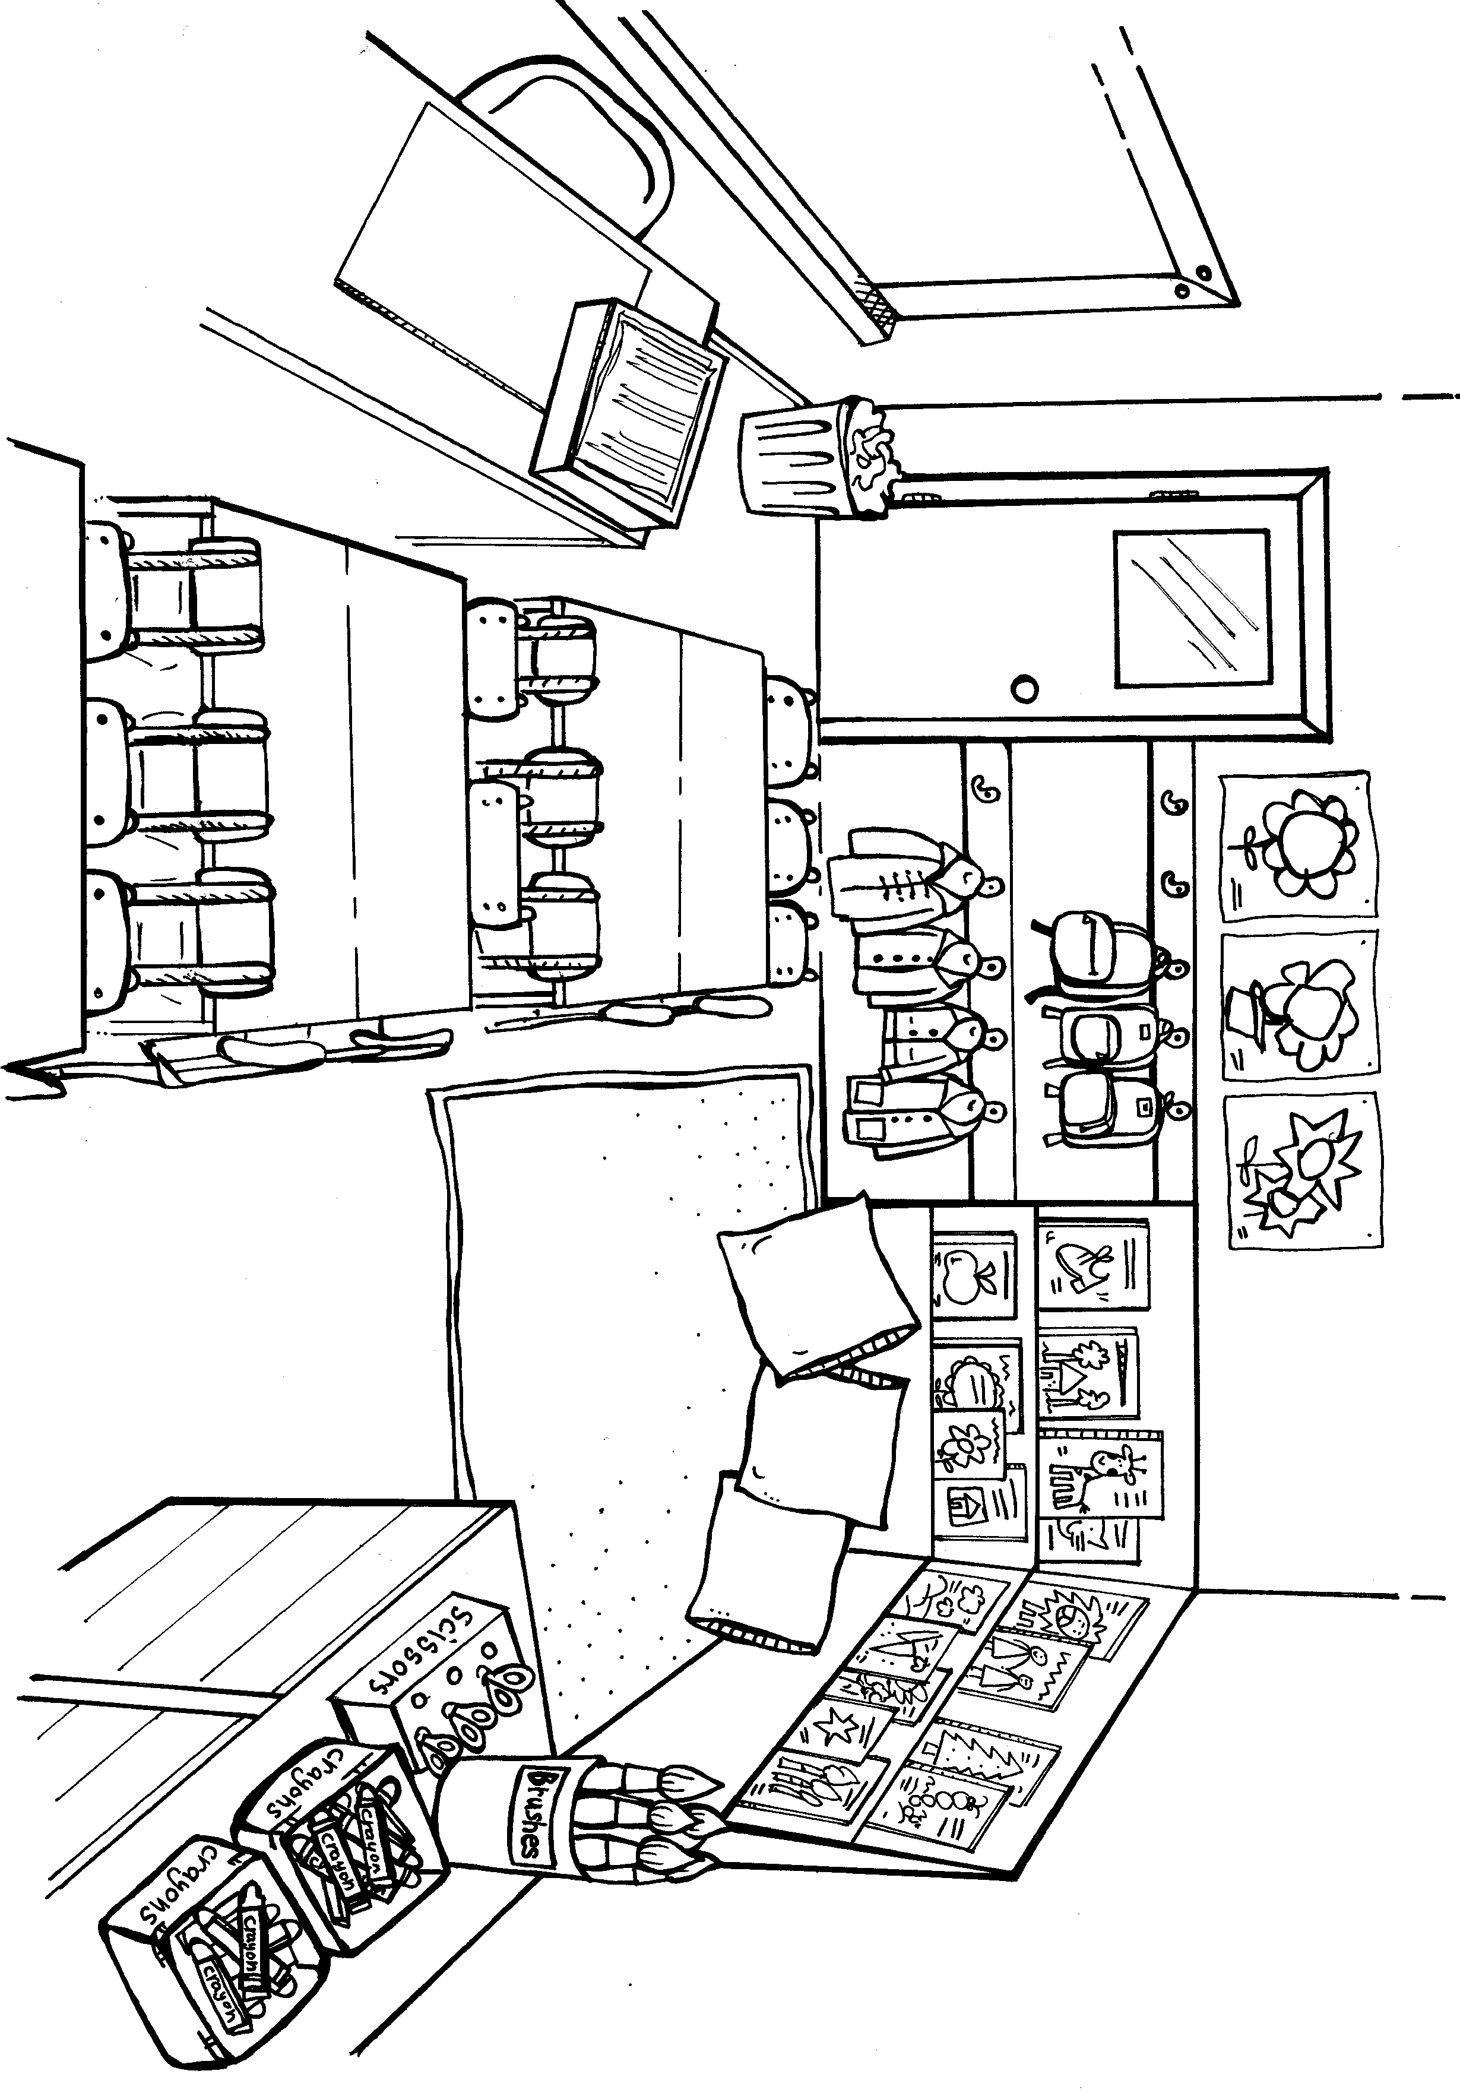

Copysheet: Put Me Away

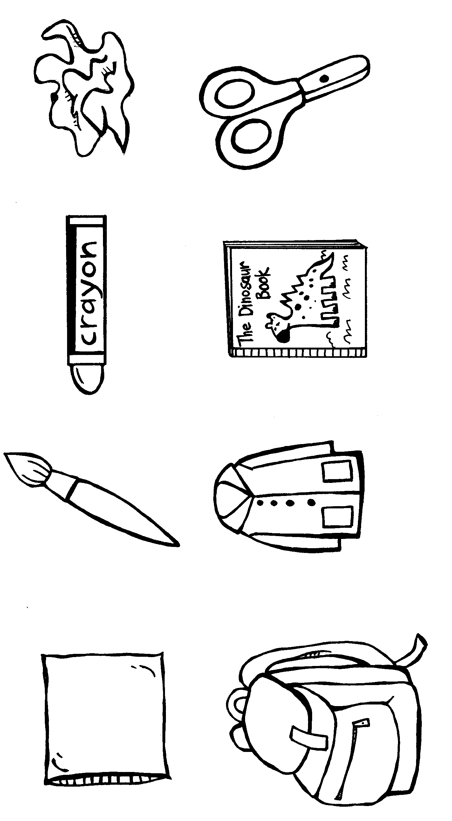

Learning experience 2: Practising ‘please’ and ‘thank you’

Learning intention
Students will
- be able to ask when borrowing something and return it with thanks.

Resources
Nil.

Activities
Put up the words borrowing, lending and giving. Explain, using examples, the difference between these.
Brainstorm or ‘Think, Pair, Share’ about why we ask to use things belonging to other people. Build answers up into a chart like the one below.
Talk about how it is okay sometimes to borrow other people’s things if we ask them. However, we should all make sure we have all the things we need for school –our own books, our own pencils and so on.
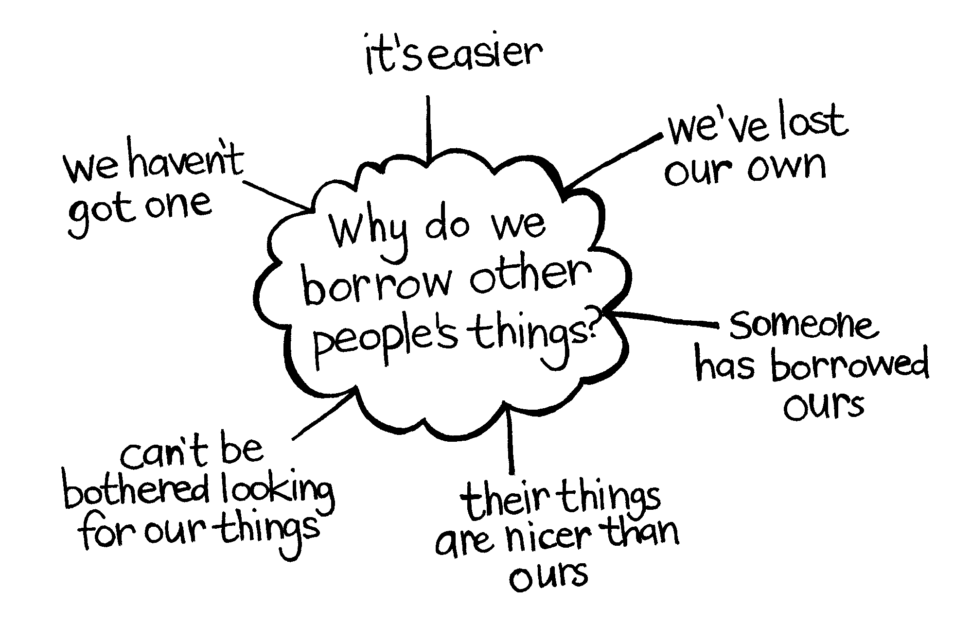
Ask children to get into pairs. Each child practises asking the other for things, using ‘please’ and ‘thank you.’ To extend this try ‘please’ and ‘thank you’ in different languages, such as Maori, Samoan, Somali, Hindi, Cook Island Maori, or any other language that is appropriate for the class.
Ask: What must we remember to do when we have borrowed something?
(take care of it and give it back)

Now each pair practises giving something back and saying thank you.

