Burglary Free

Years 0-3 Focus area 1
This section contains one of the following Focus areas from the Burglary-Free programme, aimed at years 0–3 (ages 5–7):
- Mine!
- Looking after my stuff
- Getting help
Note: An effective programme should include learning experiences from each of the focus areas.

Focus area 1: Mine!

Contents
Focus area 1: Mine! 2
Explanation 2
Key messages 2
Curriculum links 2
Success criteria 2
Learning experience 1: Feelings 3
Learning intention 3
Resources 3
Activities 3
Zoo Talk 5
Copysheet: Scenario Cards 8
Learning experience 2: Naming possessions 9
Learning intention 9
Resources 9
Activities 9
Copysheet: Letter to Parents 10

Focus area 1: Mine!

Explanation
The focus in these learning experiences is to make students aware that they should not touch, use, or take other people’s possessions. They learn that this can be a hurtful thing to do. In order to keep possessions safe, students learn that it is important to have them labelled with their names and to be able to describe them. It is acknowledged that most children in this age group will be too young to label their own property, and so the help of parents and caregivers is enlisted. Teachers should also be sensitive about labelling students’ things themselves – the parents may not like this or, in some cases, the property may belong to another family member.

Key messages
- Finders isn’t keepers.
- I only touch my own things.
- I can recognise my own things.

Curriculum links
Key competencies: Managing self; Participating and contributing.
Learning areas:
Level 1 and level 2 Health and Physical Education – Strand C: Identity, sensitivity, and respect; Strand D: Rights, responsibilities, and laws.
Level 1 and level 2 English – Purposes and audience; Ideas.

Success criteria
Students can:
- explain that taking other people's things is hurtful
- say why possessions should be named
- describe some of their own property.

Learning experience 1: Feelings

Learning intention
Students will be able to explain that taking other people’s things is hurtful.

Resources
Story: Zoo Talk
Copysheet: Scenario Cards

Activities
Share the story Zoo Talk with the students. Choose some of the following activities to do with the class.
Talk about the story.
Ask: How was Mareka feeling when he went to school?
Why was he feeling like that?
Why do you think Lilly took the roaring lion?
Do you think this was a good thing to do?
Why do you think this?
How did Mareka feel when he went to get the roaring lion out of his bag?
How did Lilly feel?
What did the teacher do?
How did Mareka feel at the end?
How did Lilly feel?
You may like to write some of these feelings on the board.
Do a PMI (Plus, Minus, Interesting) chart with the class. It might look something like this:
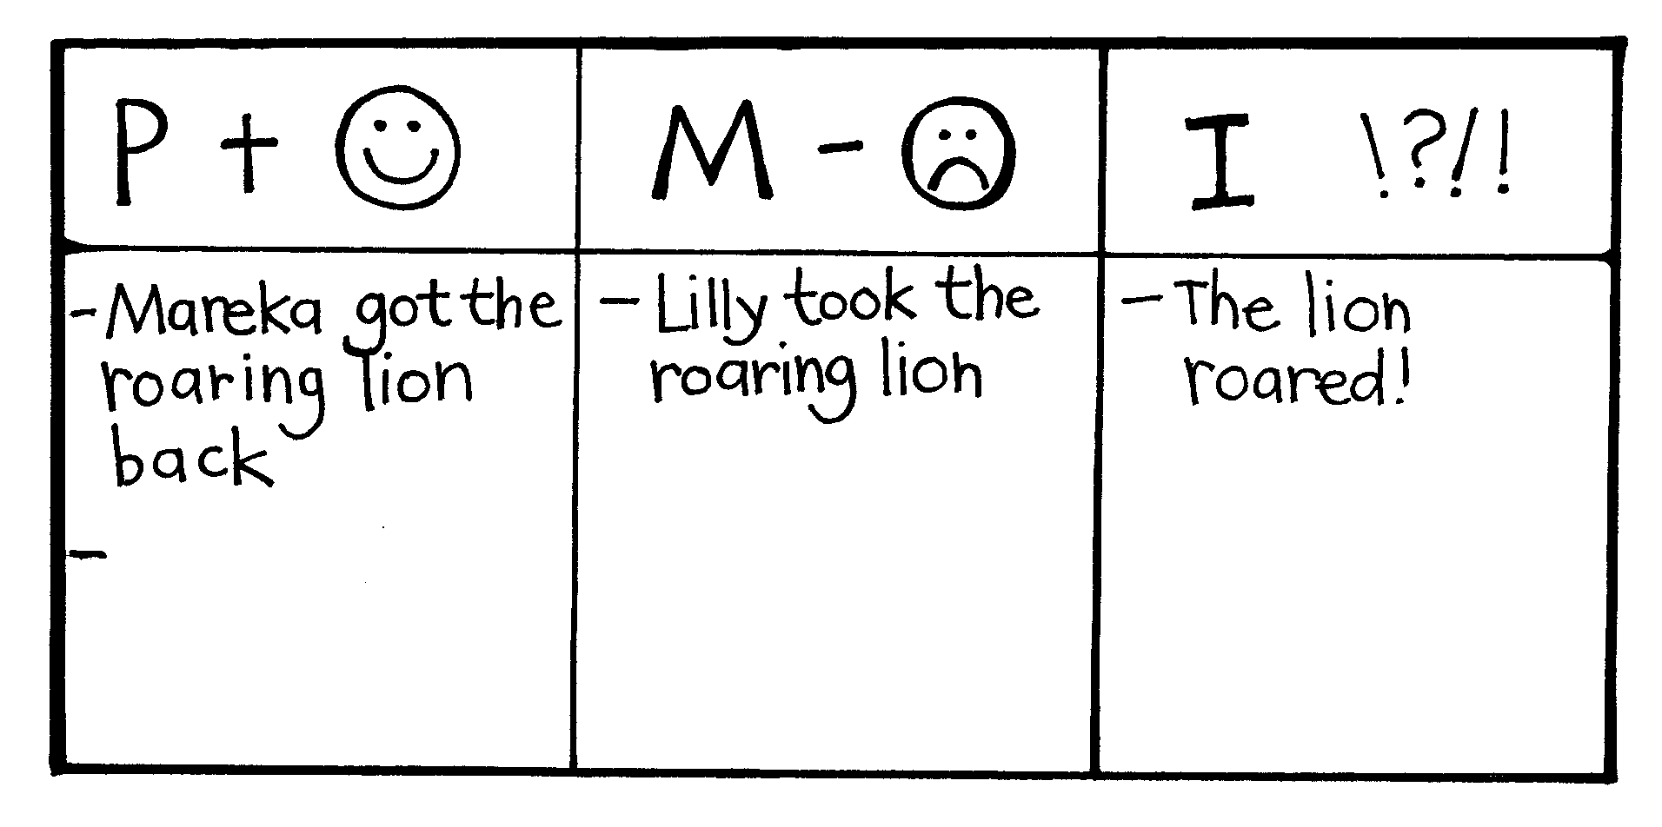
Either
The teacher or School Community Officer tells students about a time when they had something taken and how they felt about it.
Or
Ask if anyone in the class has had something taken and how they felt about it.
Use some of the Scenario Cards with students, or make up scenarios to suit the class. Suggested questions are provided, but you may like to make up questions of your own. Students could role-play the solutions to some of the scenarios.
Use de Bono’s six thinking hats for some of the Scenario Cards. Introduce and count the hats.
Choose a scenario and read it out to the class.
Use a hat to brainstorm ideas.

The Six Thinking Hats
Red Hat = Feelings – How do you think … might be feeling? Why?
Blue Hat = Thinking about – What do you think about this story?
Green Hat = New ideas – What do you think might happen next?
Black Hat = Bad things – What sad thing could happen?
Yellow Hat =Good thing – What is something good that might happen?
White Hat = Facts – What happened? Tell me what has happened.

Zoo Talk
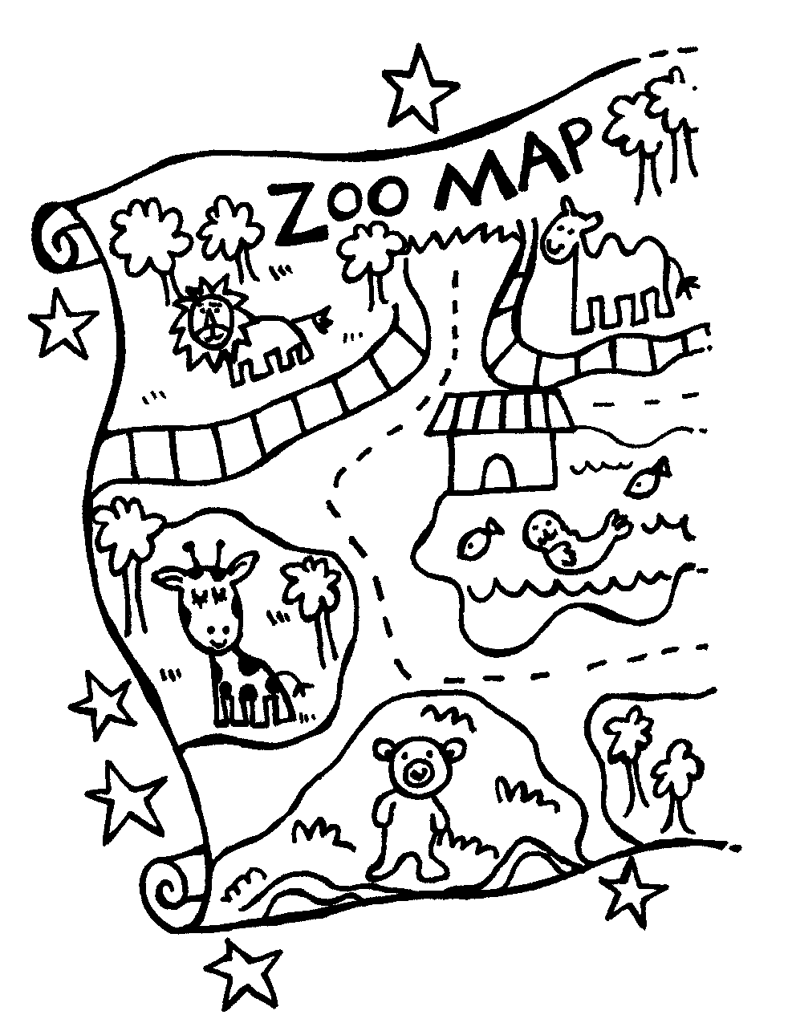
It was the week after Easter. Mareka couldn’t wait to get to school. This morning it was his turn to give his holiday news.
“Have you got everything you need for your talk?” asked Mum, after breakfast.
Mareka checked in his backpack.
“I’ve got my map of the zoo,” he said, “and my zoo sticker. It’s got giraffes on it.”
“It’s a cool sticker,” said Mum.
“And I’ve got my zoo pencil with the seals on it.”
“How about the special surprise that you’re going to show everyone at the end of your talk?” asked Mum. She smiled a secret smile, and Mareka giggled.
“It’s at the bottom of my bag,” he grinned, “so that no one will see it till news time!”
When Mareka got to school, he unzipped his bag and unloaded everything into his tote-tray – everything except for the special surprise. Then, just as he was hanging his bag on its hook, he felt excited all over again. He looked around. There was no one else in the room. Very quickly, he reached into the bottom of his bag. His hand touched something soft and furry. He gave it a little squeeze and, suddenly, from inside his backpack, a lion roared!
Mareka was grinning so hard, he didn’t see Lilly open the classroom door. He didn’t see her close it again, either, but when Mareka went outside to play, Lilly came back into the classroom.
Lilly knew what was in the bottom of Mareka’s bag. It was a toy lion that could really roar. She’d squeezed one in the toyshop in the holidays. Dad had said that she could have a lion when it was her birthday – but her birthday was four whole weeks away. What if the toyshop didn’t have any lions left by then?
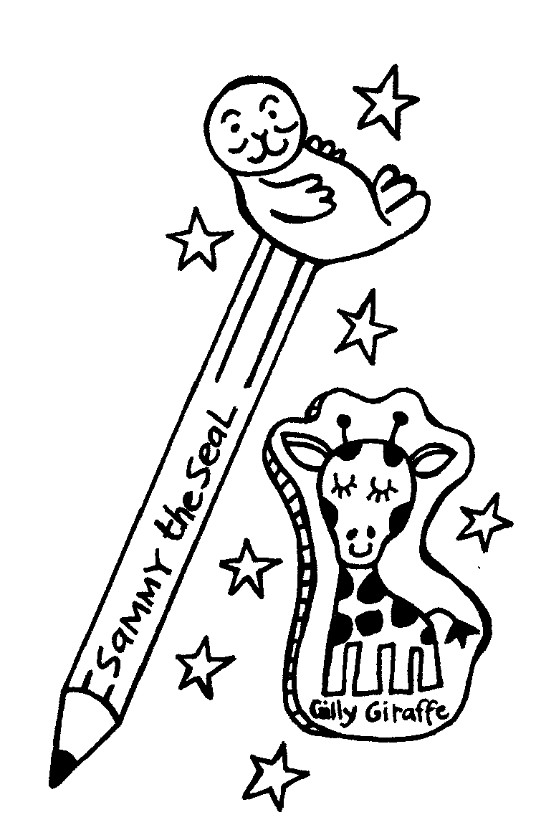
Lilly looked around the empty classroom. Her face was hot and her tummy felt full of butterflies. Then, very quietly, she ran over to Mareka’s bag.
“Everyone on the mat, please!” said Ms Jones, after the bell had gone. She looked at the children.
“Mareka, it’s your turn to give your holiday news. What have you got to tell us?”
Mareka put his tote-tray on the desk beside Ms Jones. He put his backpack on the floor behind her chair. He took a big, deep breath.
“Kia ora, everyone,” he said. “In the holidays my Nanna Henarata took me to the zoo.”
He held up the map and pointed to all the different animals he’d seen. He took the seal pencil and the giraffe sticker out of the tote-tray and let the children pass them around.
“Giraffes eat hay,” he told everyone. “And one giraffe had a baby.”
“Ka pai, Mareka,” said Ms Jones. “This is an awesome talk.”
Mareka bent down to unzip his bag.
“What have you got in there?” asked Ms Jones.
Now all the children were looking at him. Mareka was so excited that he thought he might be going to burst. “A surprise,” he said. He reached into the bag. “It’s a big roaring ...”
Mareka stopped. He couldn’t feel anything soft and furry. The bag was empty!
“What’s he going to show us?” asked someone on the mat.
“My lion’s gone!” said Mareka. His voice was all wobbly. “Someone’s taken my lion that roars!”
Mareka started to cry – he couldn’t help it – and everyone began talking at once.
“Lilly’s got a lion that roars,” said someone over the top of all the voices. Suddenly, everyone went quite.
“No, I haven’t,” said Lilly, but her face was bright red. “Well, I have, but it’s mine. My Dad got it for me in the holidays.”
Ms Jones looked worried. “I want you all to go to your desks and start today’s printing,” she said firmly. “Lilly and Mareka, I want you to come over to the reading corner with me.”
Ms Jones spent a long time talking to Lilly and Mareka. When she finished, she asked everyone to leave their printing and to sit on the mat again.
“You all know not to take something that belongs to someone else without asking them first,” said Ms Jones. “We’ve talked about that before. But who knows what to do if you bring something very special to school?”
Mareka put up his hand. “You should give it to the teacher to look after,” he said.
“That’s a very good answer,” said Ms Jones. “That way it can be kept safe until you need it. How else can we look after the things that belong to us?”
“You can put your name on your things,” said Caleb.
“That’s a very good idea,” said Ms Jones. “Some of you are good at putting your names on your books and bags and pencils, but a lot of you forget to do that.”
Ms Jones held up some name stickers.
“Remember these?” she asked. “The people at the milk factory gave them to us on our class visit. This morning we’re going to have a naming time,” she said. “I want everyone to take as many stickers as they need to name all their things.”
Everyone went to their desks with some stickers but Lilly went to the reading corner. She took some scissors and cardboard and tape with her. When she came back she was carrying a fluffy gold lion. It had a collar round its neck and on the collar was written “Mareka.” She showed it to Ms Jones.
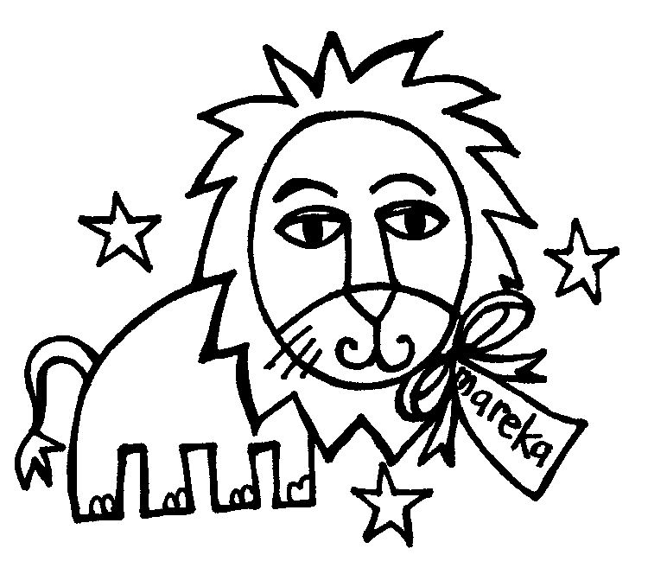
“Thank you, Lilly,” said Ms Jones. “That’s a very good name tag for a lion.”
When no one was looking, Lilly gave the lion to Mareka. “Sorry,” she said.
Mareka didn’t know what to say. For a minute he just looked at the floor. Then he looked at Lilly. She seemed really sad.
“Do you want to make him roar?” he asked.
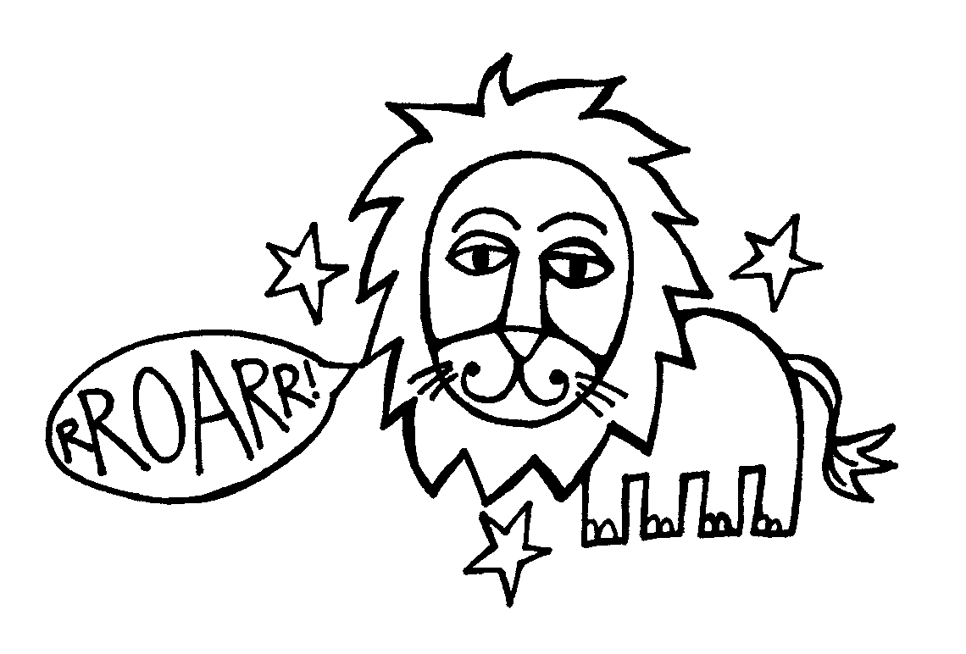
Lilly nodded. She reached out and squeezed the lion’s tummy.
“What was that!” said Ms Jones.
Mareka and Lilly started giggling.
“Can I have a turn?” asked everyone at once.
“One at a time, one at a time!” laughed Ms Jones.
“We don’t want Room Six turning into a zoo!”

Copysheet: Scenario Cards

1 Elia’s lunch has been taken from his bag. He had his favourite sandwiches today.  How does Elia feel?  What should do?  Who can help Elia? | 2 Maria has lost her pencil with her name on it. Jan has got two pencils on her desk.  How does Maria feel?  What should Maria do?  Who can help Maria?
3 John took off his jersey at lunch time. So did Ane. The jerseys look the same. After lunch they don’t know which jersey to put on.  Why could help John and Ane?  What could they do so that this problem does not happen again? | 4 Tyson finds $1.00 in the playground. He puts it in his pocket. A teacher sees him do this.  What should Tyson do with the money?  How do you think the child who has lost the money feels?
5 Helen goes to her tote tray and finds her new Pokemon ruler is missing. It has her name on it.  Who can help Helen?  What could the teacher do to help Helen?  How can the class help Helen? | 6 Rob sees Leesha taking something out of Loni’s bag.  What should Rob do?  Who could help Rob?  What should Leesha do?
7 Paul sees Dalla take something from Hina’s tote-tray.  What should Paul do?  Who can help Paul?  How do you think Hina will feel when she finds that something missing? | 8 Rana lends Emma a felt pen. After she has used it, Emma puts it in her pencil case. She says it is hers now.  Did Rana give the felt pen to Emma?  Who can help Rana?  What should Emma do?
9 Sarda borrows Carolyn’s ruler without asking. Carolyn thinks it is lost.  Who can help Carolyn?  What should Sarda do next time? | 10 Kerry can’t find his shoes. There are three pairs, but he doesn’t know which pair is his.  Who can help Kerry?  What can Kerry do so that this doesn’t happen again?

Learning experience 2: Naming possessions

Learning intention
Students will be able to say why possessions should be named.

Resources
Copysheet: Letter to Parents

Activities
Show students examples of clothing and possessions that have been named.
Ask: Why should we have names on our things?
What things should we name?
What might happen if we don’t name our things?
Show students some items from the lost property box.
Ask: Why do you think these things are here?
Why can’t the teachers give them back?
Send a letter home to parents and caregivers, encouraging them to name students’ possessions. This could be followed up with checks on names and suitable rewards for those with everything named. A reminder notice may need to be sent out, or a permission slip to allow the teacher to label items (for an example, see Copysheet: Letter to Parents).

Copysheet: Letter to Parents

Kia ora! Talofa! Kia orana! Hello!
Dear Family
At school we are learning to take care of our own things and to return things we find to the right owners.
You can help us do this by naming your child’s clothing, school bag, lunch box and drink bottle, and anything else they bring to school.
You could use vivid pens, sewn-in names, or iron-on labels.
In the next few weeks we will be rewarding children who have all their things named.

Thank you for your help.

(Class teacher)

